NAZWA GRY

Instruction for game

# Car repairing

## Car jack

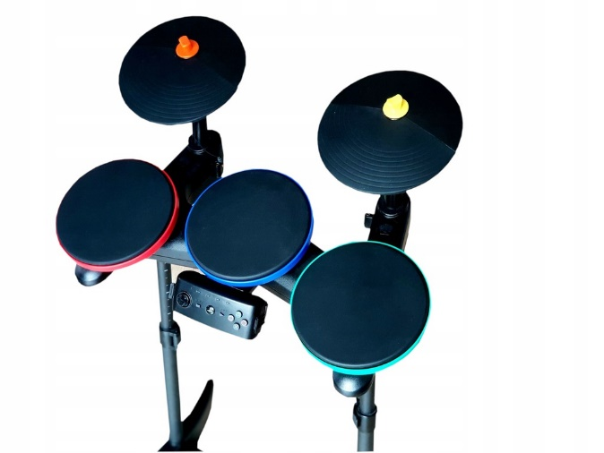

|  |  |  |  |  |
| --- | --- | --- | --- | --- |
| Sequence number |  |  |  |  |
| 1. | KICK | YELLOW | ORANGE | YELLOW |
| 2. | RED | ORANGE | ORANGE | KICK |
| 3. | RED | BLUE | KICK | YELLOW |
| 4. | BLUE | ORANGE | GREEN | YELLOW |
| 5. | KICK | RED | YELLOW | YELLOW |
| 6. | YELLOW | RED | GREEN | ORANGE |
| 7. | GREEN | BLUE | GREEN | GREEN |
| 8. | KICK | RED | BLUE | ORANGE |
| 9. | RED | YELLOW | KICK | KICK |
| 10. | BLUE | YELLOW | KICK | YELLOW |

## Screw

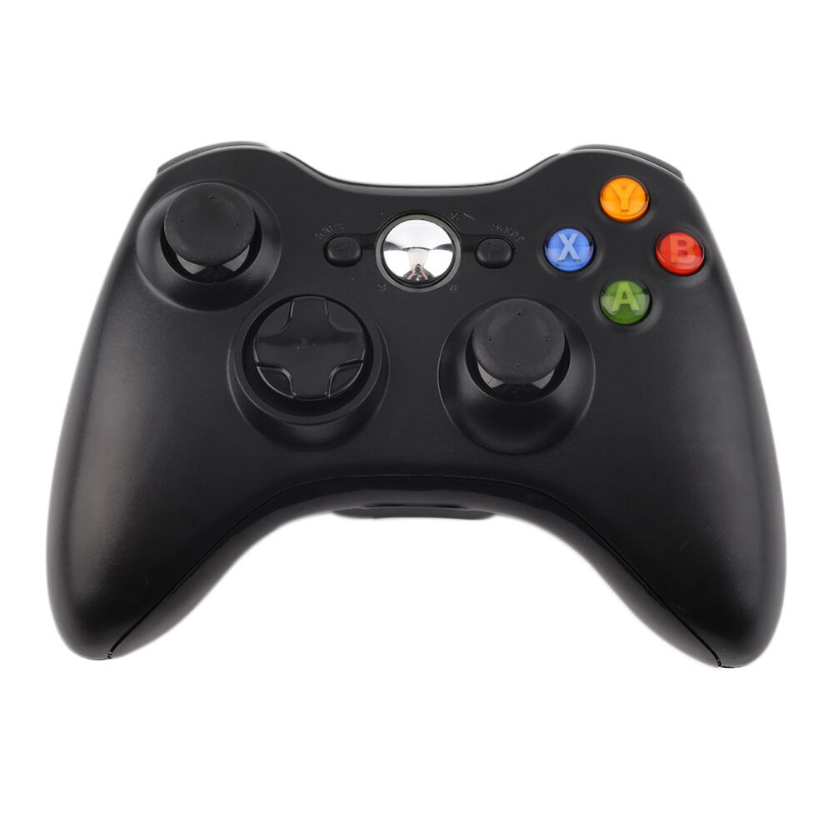

|  |  |  |  |  |
| --- | --- | --- | --- | --- |
| Sequence number |  |  |  |  |
| 1. | LA-LEFT | LA-CENTER | LA-LEFT | LA-RIGHT |
| 2. | LA-CENTER | LA-RIGHT | LA-RIGHT | LA-UP |
| 3. | LA-UP | LA-CENTER | LA-CENTER | LA-CENTER |
| 4. | LA-RIGHT | LA-DOWN | LA-RIGHT | LA-LEFT |
| 5. | LA-CENTER | LA-CENTER | LA-CENTER | LA-CENTER |
| 6. | LA-RIGHT | LA-LEFT | LA-RIGHT | LA-DOWN |
| 7. | LA-UP | LA-CENTER | LA-CENTER | LA-RIGHT |
| 8. | LA-LEFT | LA-UP | LA-LEFT | LA-UP |
| 9. | LA-CENTER | LA-RIGHT | LA-DOWN | LA-CENTER |
| 10. | LA-DOWN | LA-UP | LA-RIGHT | LA-UP |

## Lock

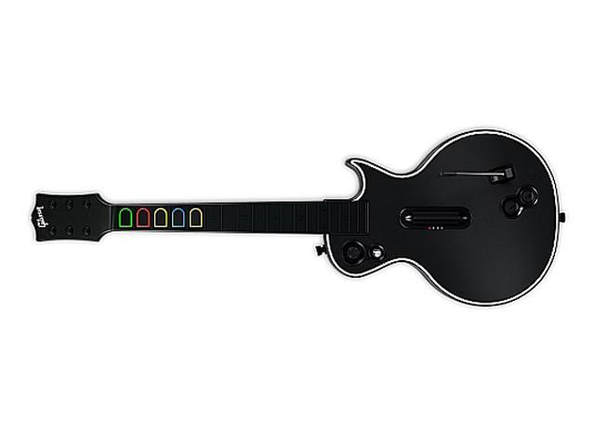

|  |  |  |  |  |
| --- | --- | --- | --- | --- |
| Sequence number |  |  |  |  |
| 1. | ORANGE | RED | ORANGE | RED |
| 2. | ORANGE | YELOW | ORANGE | YELOW |
| 3. | BLUE | GREEN | RED | BLUE |
| 4. | ORANGE | RED | ORANGE | BLUE |
| 5. | GREEN | RED | RED | RED |
| 6. | YELOW | YELOW | RED | RED |
| 7. | ORANGE | ORANGE | YELOW | ORANGE |
| 8. | BLUE | YELOW | GREEN | GREEN |
| 9. | GREEN | RED | GREEN | BLUE |
| 10. | YELOW | YELOW | GREEN | YELOW |

# Wardrobe repairing