Simulation of N-body Systems in Python

Abschließende Arbeit

Mika Pauser
7arg

Betreuer: Mag. Haidinger Felix

GRG 15
Auf der Schmelz 4,
1150 Wien

12. 02. 2027

The Basics of N-Body Simulations

What is an N-Body Simulation?
An n-body Simulation is a simulation of an arbitrarily large set of objects (n) and the relationships between them. Examples of such Simulations are:
- n-body Gravitational Simulations
- Large Social Networks
- Large Chemical Reactions
For the remainder of this project, I will focus on gravitational simulations.
Such simulations are very computing power intensive especially if the number of simulated objects is very high. Nowadays they have become more common due to increases in the availability of the necessary computing resources.
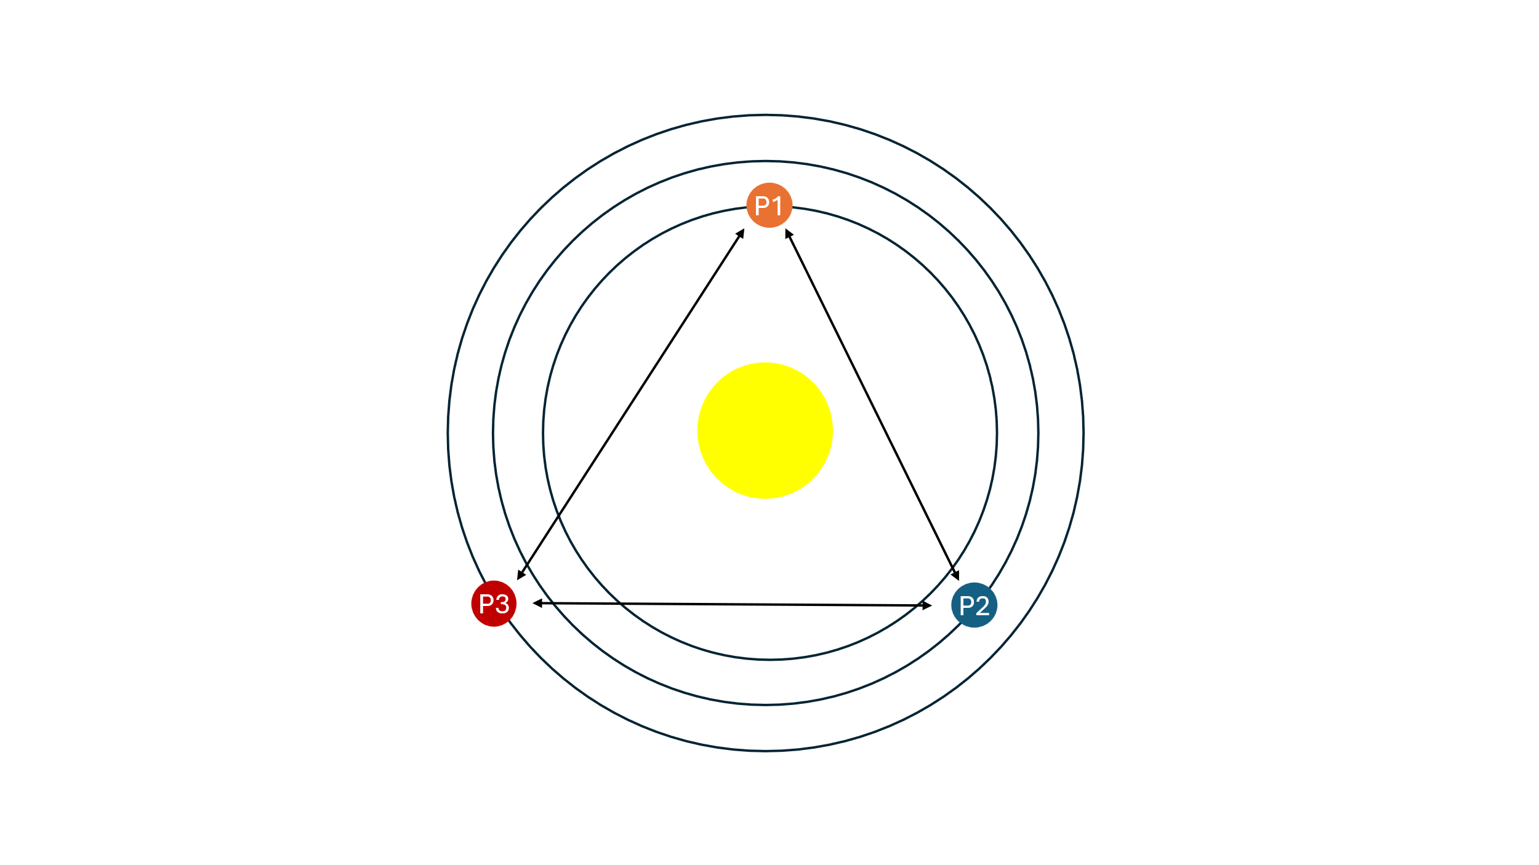
Figure 1: Basic example of solar system
In Figure 1 you can see the makeup of a typical small-scale n-body simulation. The objects (P1-3) represent the simulated objects – in this case the planets of a hypothetical solar system. The two-way arrows describe the direction of the gravitational force acting in between the planets. In this case an n-body simulation would simulate the movement of the planets and how it is affected by the gravitation of the planets and their star, over time.
Since the number of gravitational forces acting on each planet is equal to the number of other planets in a simulation of n planets, there are n-1 other planets present.
$$other Planets=n-1$$
The total number of gravitational forces is the number of forces of each individual planet times the number of planets (n).
Therefore the following applies:
$$total number of gravitational forces=n*(n-1)$$
This is almost the square of n, and thus the function for applying gravitational forces is approximately quadratic.
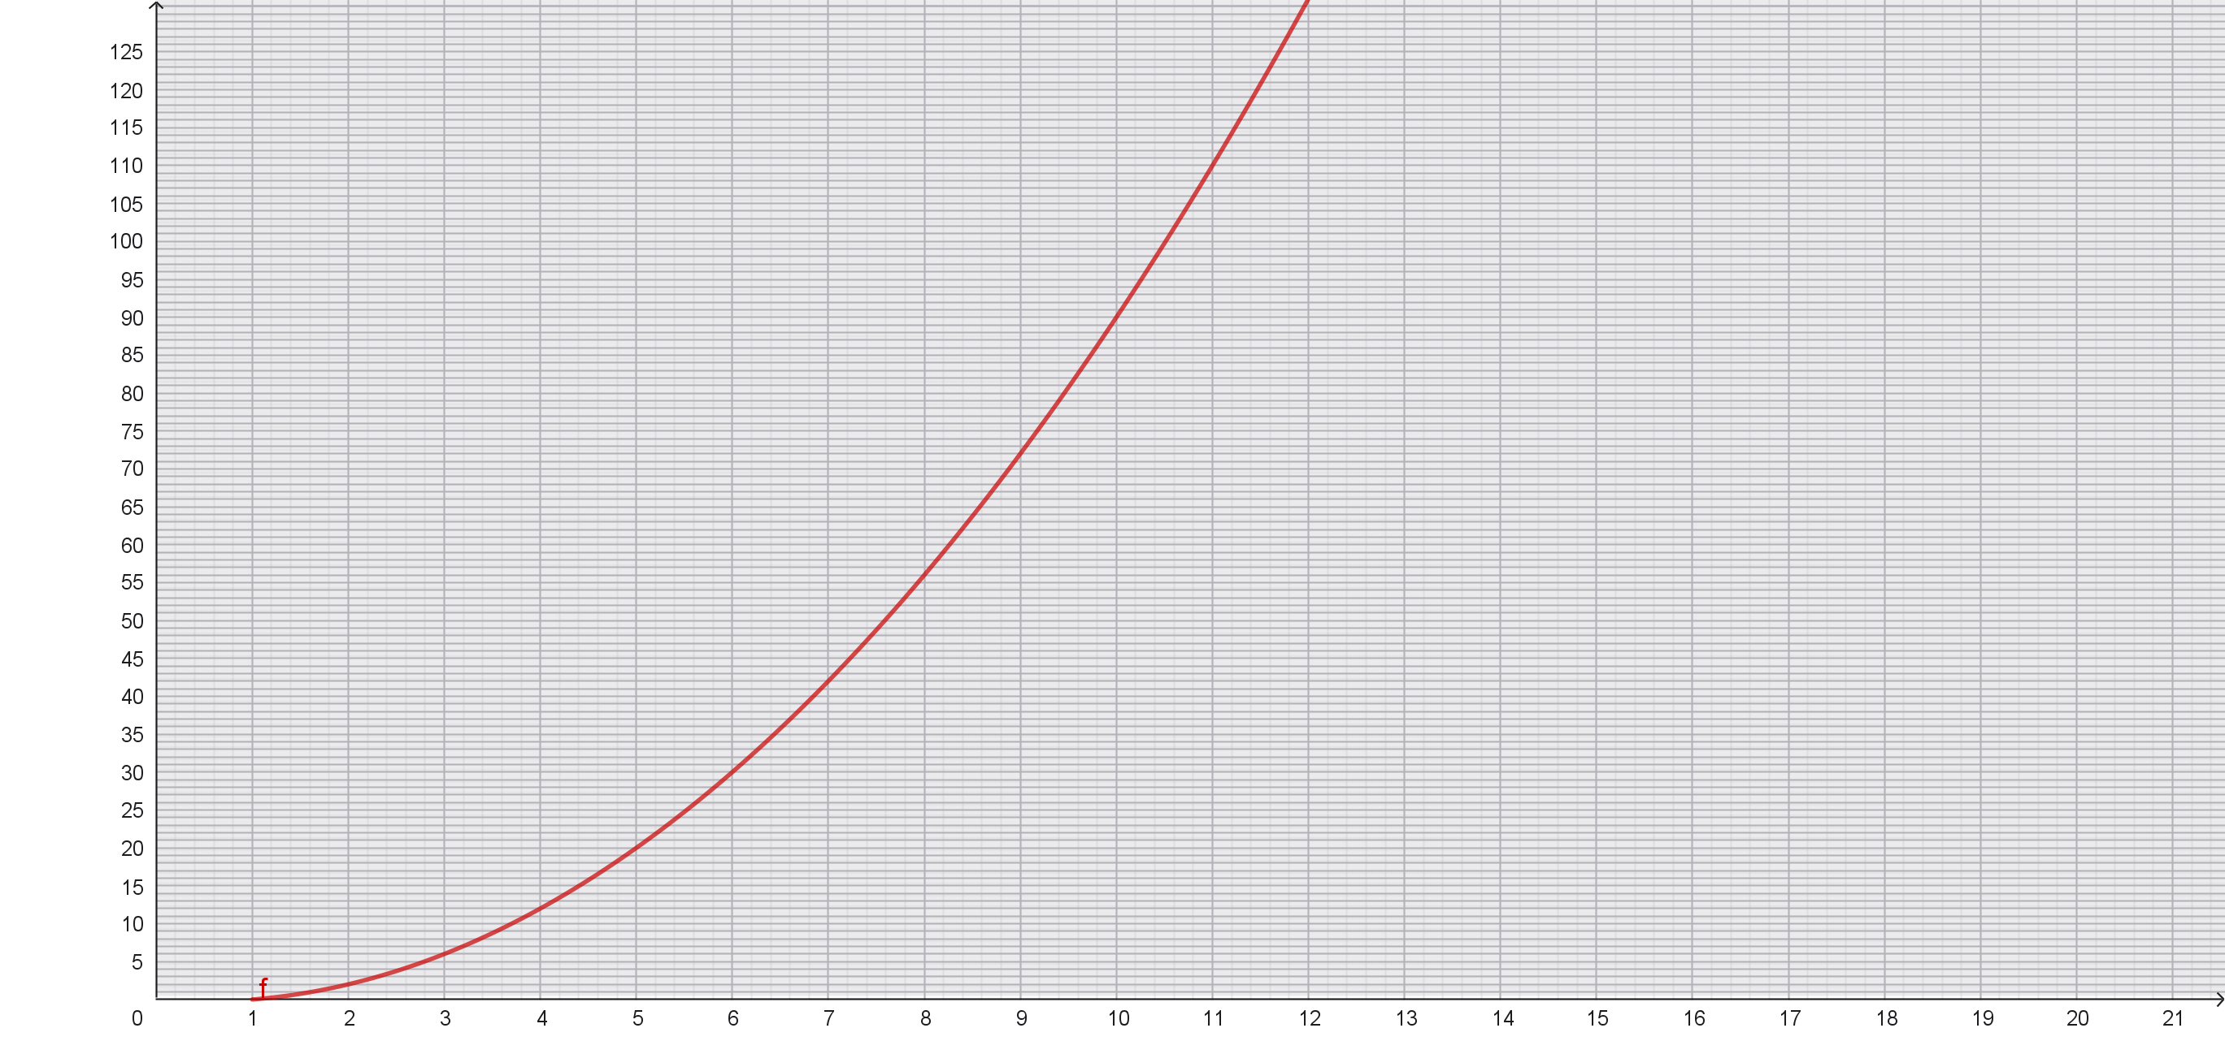
Figure 2: the relationship between the number of objects (x) and the number of gravitational forces (y)
Figure 2 depicts the total number of gravitational forces in relation to n, as f(x). This relationship is the reason why computational simulation of n-body environments used to not be possible in large scales due to restrictions in computational output of computers at the time.

The N-Body Problem
What all of these have in common is that they are limited by the fact that there is no formula that lets you quickly calculate the exact future positions of the objects in one step. Instead, one must recalculate the velocity after each simulated step in time to then move the objects by said velocity, divided by the length of the step. Thus, the results will vary wildly depending on the length of each step, becoming more inaccurate as the length increases.
This also creates another issue; one must go through hundreds of simulations for each tick for larger simulations. Let’s say we have a set of one hundred objects that should be calculated over 1000 ticks, that alone would mean that you have to do 9,9*10^6 calculations of F_{g} over the course of the simulation.

Common Types of N-Body Simulations
There are many different ways to solve for the positions of objects in an n-body gravitational environment. All of these use the basic formula for gravitational force (F_{g}):
$$F_{g}=G\frac{m_{1}m_{2}}{r^{2}}$$
Here I will go over some of the most relevant methods of calculation.

Direct N-Body gravitational Simulation
The direct n-body simulation is the simplest way to simulate an n-body environment. It takes each object and calculates its new velocity by taking its starting velocity and accelerating the object by calculating its F_{g} towards each object and applying said force to the starting velocity. After this has completed for one object it is repeated for all other objects. This process is repeated during each step of the simulation. This method calculates all steps in sequence and is therefore relatively slow.

Parallelized N-Body gravitational Simulation
This method of n-body simulation utilizes parallel processing to drastically speed up the simulation method used in 1.3.1. This means that some parts of the process of the simulation (e.g. calculating the total F_{g}) can be sped up by using multithreading to calculate them in parallel instead of in sequence. This does not change the number of calculations that are necessary, it does however increase the speed at which they are completed.

Barnes Hut Algorithm
The Barnes Hut algorithm is a different approach to optimizing the calculation of the force acting on objects from a faraway cloud of objects. Unlike a direct n-body simulation this lowers the number of calculations that are necessary whilst also decreasing the accuracy of the simulation. The algorithm achieves this by splitting up the 2d space into a special data structure called a quadtree. Each node of the tree represents a part of the simulation area. Each of these nodes has exactly four child nodes therefore splitting the area into four sub-pieces. Figure 1Figure 3 shows an example setup.

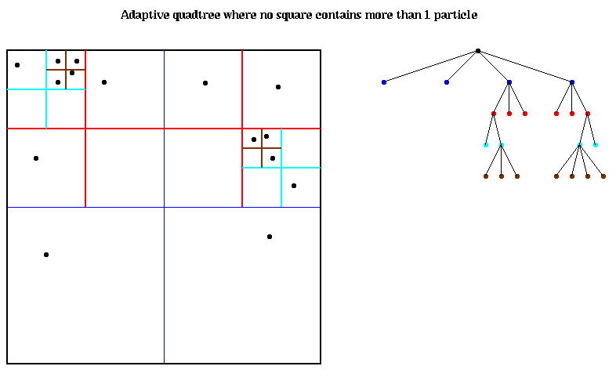
Figure 3: adaptive quadtree where no square contains more than one particle

In addition to the links to the sub-nodes, each node of the quadtree knows its centre of mass and the total mass of all nodes beneath it. During the calculation of F_{g,} the algorithm works with varying degrees of precision (adjustable by the parameter θ). The further objects are apart from each other the lower the required calculation precision. This relationship is expressed through the following formula:
$$θ> \frac{area of the current node in the quadtree}{distance to the object whose F_{g}is currently being calculated}$$
If it does then the current node’s centre of mass and total mass are going to be used to calculate F_{g}, if not then the nodes on the next level are going to be checked. If a node only contains one object, then that object is going to be used to calculate F_{g}.

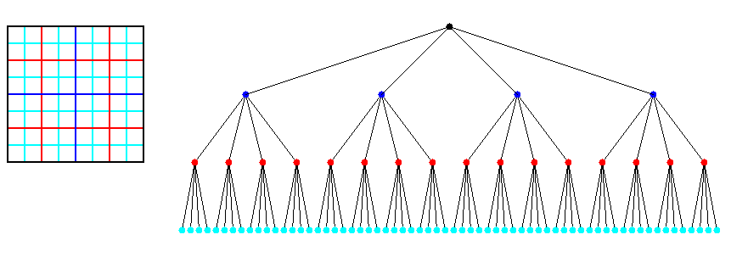
Figure 4: a complete quadtree with four levels
An example:

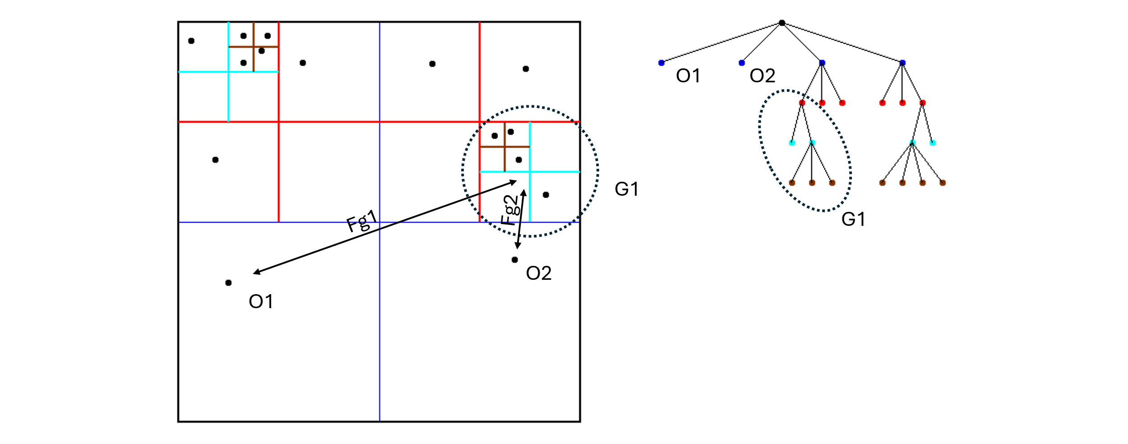
Figure 5: an example of a Barnes Hut algorithm calculation
In Figure 5 two specific examples of the algorithm are shown. For both objects (O1, O2) the algorithm calculates the necessary precision. It does this by checking the formula from above against the first node of the quadtree. If it applies, then said node will be used for the calculation of F_{g} if not then this process will be repeated for each of its children. If a leaf node is reached it is always used to calculate F_{g}. In this example the precision equation applies for O1 when interacting with Group 1 (G1) on its topmost node, since it is quite far away. For O2 the distance is much smaller and therefore the two nodes on the fourth level (turquoise) must be used.

References
Yury, M., Erich, S., & Sundaram, N. (02 2024). N-Body Methods. Abgerufen am 23. 06 2026 von UC Berkeley - Electrical Engineering & Computer Sciences: patterns.eecs.berkeley.edu/?page_id=193

(Yury, Erich, & Sundaram, 2024)
(Yury, Erich, & Sundaram, 2024)
(Yury, Erich, & Sundaram, 2024)
(Yury, Erich, & Sundaram, 2024)
(Yury, Erich, & Sundaram, 2024)

