Mike Audam
ERD | NoSQL Data Modeling

ERD
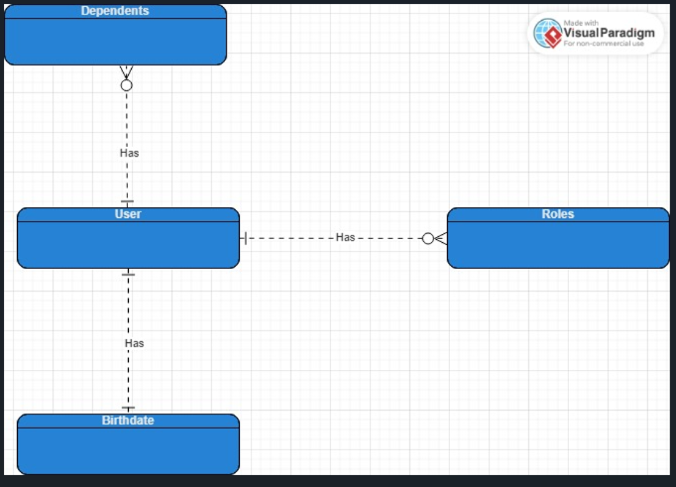

NoSQL
