Mike Audam
Module1 (CSD-310)
Github repository setup

Repo: https://github.com/mikaud/csd-310
Github
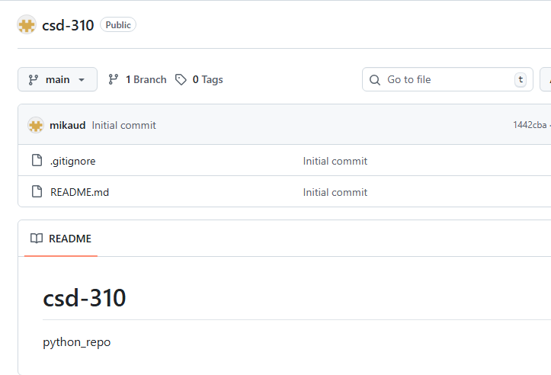
Local repo
