Mike Audam
Mod_6 | 1120

db_init_2022.sql script
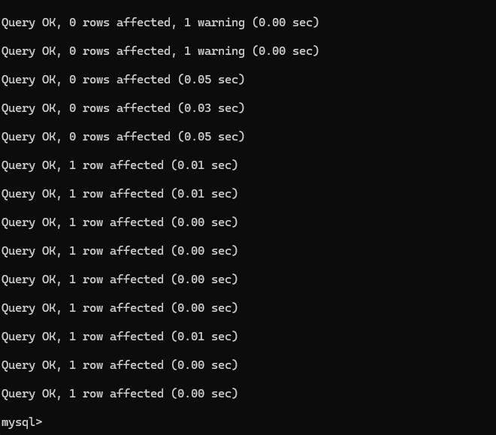

Tables_in_movies
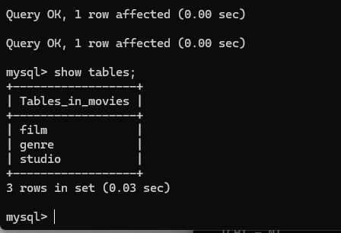

mysql-connector-python install
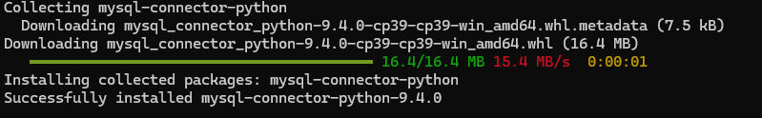

Python-dotenv install
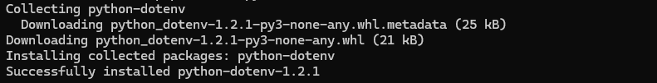

mysql_test.py
