Mike Audam
Advanced Python

Repo link: https://github.com/mikaud/csd-325
Github repo
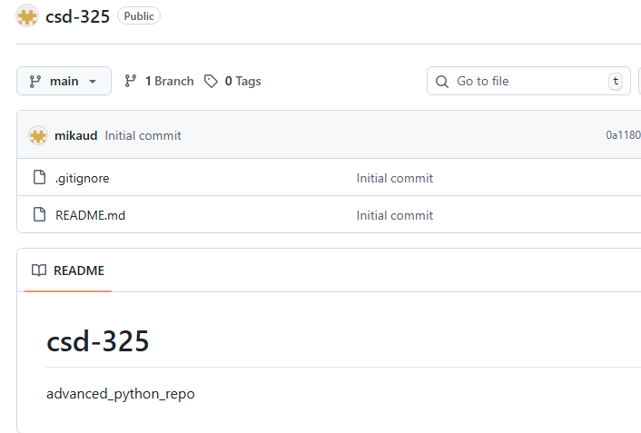

Local repo
