Mike Audam
Software Development
CSD-340: WebDev | Mod 1.2

Github: https://github.com/mikaud/csd-340/tree/main

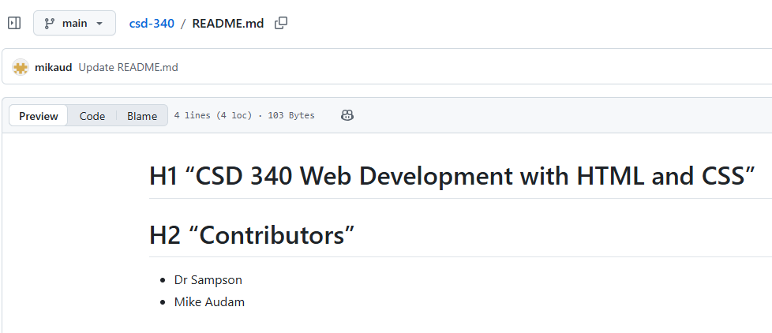

Local repo
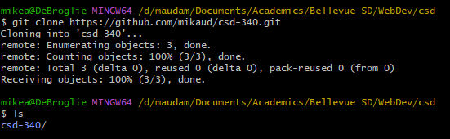

Local directory
