Mike Audam
Software Development
CSD-340: WebDev | Mod 1.3

Github: https://github.com/mikaud/csd-340/tree/main
Validation failures
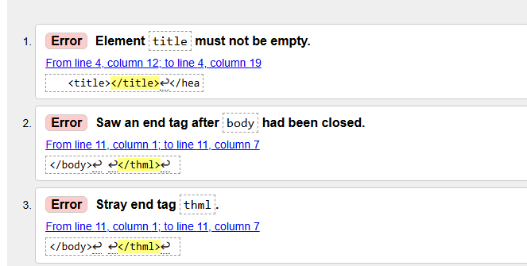

Subsequent validation
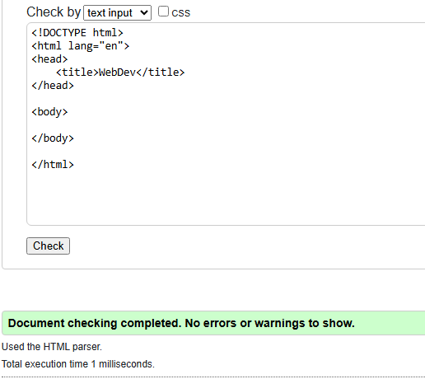

Updated doc
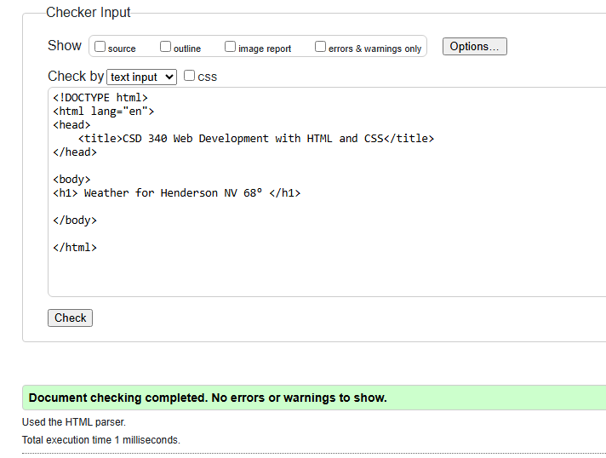

Output example
