MamaCare
Maternal Health Risk Classification Capstone Report
A reproducible data-science project using the UCI Maternal Health Risk dataset
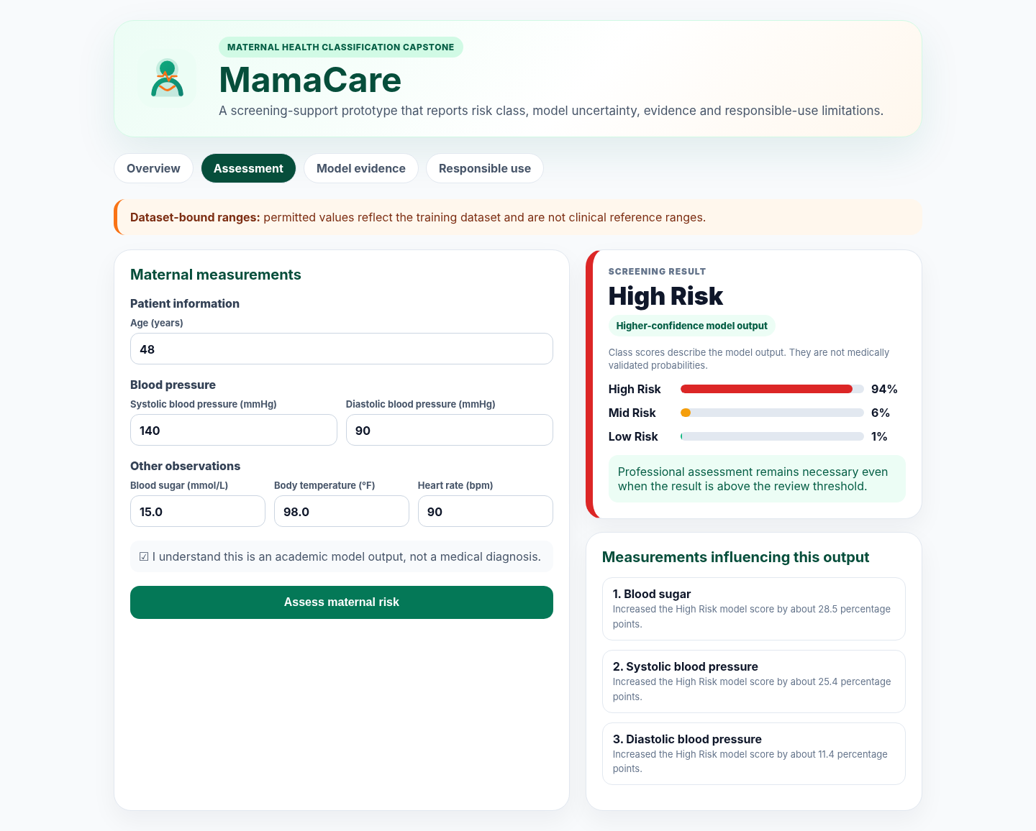
Prepared by Collins Mikaye
Computer Science Capstone Project
August 2026

Executive Summary
MamaCare is a three-class maternal-health risk classification capstone. It uses six routine measurements to assign records to Low Risk, Mid Risk or High Risk. The project was redesigned to follow the capstone mentor requirements: a precise problem statement, a no-learning baseline, a declared primary metric, disaggregated evaluation, structured error analysis, Responsible AI documentation, a public-repository structure and a presentation-ready frontend.
The selected model is ShallowMLP. On the untouched measurement-signature-separated test set it achieved Weighted F1 0.562, Macro F1 0.574, accuracy 0.601 and High Risk recall 0.818. It clearly outperformed the majority-class baseline, whose Weighted F1 was 0.228.
Central limitation: Mid Risk recall is only 14.9%. The model is therefore not suitable for clinical deployment. The interface is an academic demonstration and repeatedly warns against diagnostic, treatment, triage or emergency use.

The strongest methodological decision is the use of group-separated splits. The dataset contains 562 exact duplicate rows, and 35 identical measurement signatures have conflicting labels. Keeping identical signatures in one partition prevents duplicate leakage and produces a more honest estimate of generalization.

Capstone Deliverables
- Executed end-to-end Jupyter notebook with EDA, modelling, fairness and error analysis.
- Reusable Python backend with saved pipeline and metadata.
- Professional Streamlit frontend with uncertainty, explanations, what-if exploration and safety warnings.
- Responsible AI statement, model card, data dictionary and dataset-selection record.
- Five-slide presentation, speaker notes and submission checklist.

1. Problem Definition and Capstone Alignment

1.1 Final Problem Statement
MamaCare classifies maternal-health records represented in the UCI Maternal Health Risk dataset into Low Risk, Mid Risk or High Risk using age, systolic blood pressure, diastolic blood pressure, blood sugar, body temperature and heart rate. The primary evaluation metric is Weighted F1 on an untouched group-separated test set. Macro F1, High Risk recall, accuracy and log loss are secondary metrics, and High Risk recall is disaggregated by age group.

1.2 Scope
The project is limited to classification using the variables available in the public dataset. It does not diagnose a pregnancy complication, prescribe treatment, make an emergency decision or replace antenatal care guidelines. It demonstrates a complete data-science workflow and responsible communication of model limitations.

1.3 Research Questions
- Which measurements have the strongest association with the three risk labels?
- Do pulse pressure, mean arterial pressure and age band improve validation performance?
- How do baseline, traditional, boosting, neural-network and ensemble models compare?
- Where does the selected model fail, and are errors concentrated by class, age group or data-quality condition?
- How can the output be presented clearly without implying medical authority?

1.4 Mentor Requirements Addressed
The project uses one target variable and one declared primary metric. It includes a baseline, two secondary metrics, subgroup evaluation, structured error analysis, a 500-700 word Responsible AI statement, a clean GitHub structure and a five-slide presentation. The compliance matrix is included in docs/CAPSTONE_COMPLIANCE_CHECKLIST.md.

2. Dataset Selection and Data Quality

2.1 Dataset Source
Property | Value
Dataset | UCI Maternal Health Risk
DOI | 10.24432/C5DP5D
Licence | CC BY 4.0
Downloaded rows | 1,014
Target | RiskLevel
Inputs | Six numerical maternal-health measurements
Population context | Maternal-health facilities in rural Bangladesh, as documented by UCI

UCI metadata reports 1,013 instances, while the downloaded CSV used in this project contains 1,014 data rows. The exact file is preserved in data/raw and its SHA-256 checksum is recorded in model_metadata.json.

2.2 Dataset Selection
The Maternal Health Risk dataset was selected over the Financial Inclusion in Africa dataset because it matched the accepted MamaCare topic and allowed a complete classification, frontend and Responsible AI workflow. The alternative dataset was larger and offered richer demographic subgroups, but it did not match the maternal-health scope.

2.3 Data-quality Findings
- No source values are missing.
- 562 rows are exact duplicates.
- 35 identical measurement signatures carry more than one label.
- 215 rows belong to those contradictory signatures.
- Some observed values are implausible, including a heart rate of 7 beats per minute.
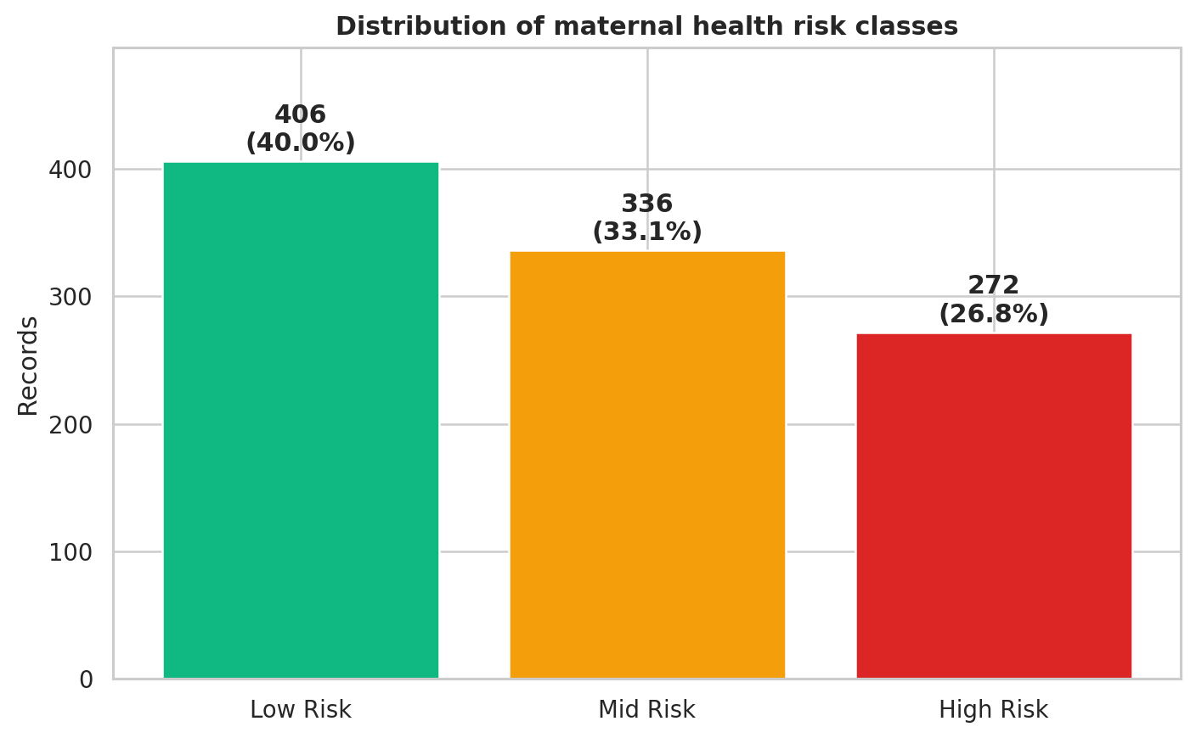
Figure 1. Target-class distribution with counts and percentages.
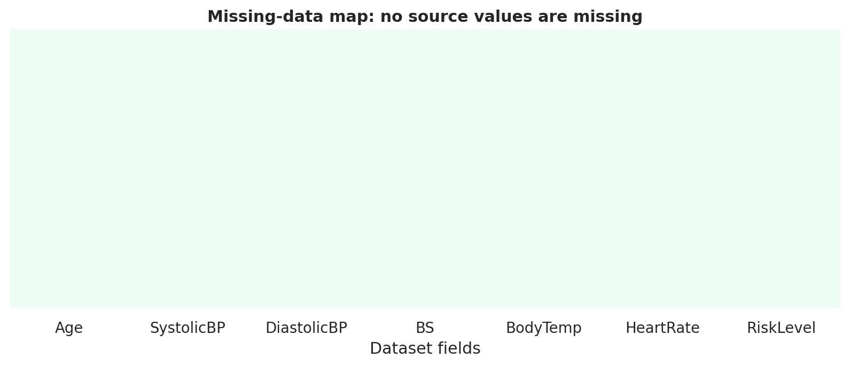
Figure 2. Source missingness audit.
Interpretation: The contradictory labels mean that identical inputs can map to different targets. A deterministic model cannot perfectly solve those records, so they must be reported rather than hidden.

3. Exploratory Data Analysis
EDA was used to test whether the classification problem is learnable and to identify data-quality limitations before modelling. The analysis covers target proportions, numerical distributions, outliers, measurement-by-class differences and correlations.
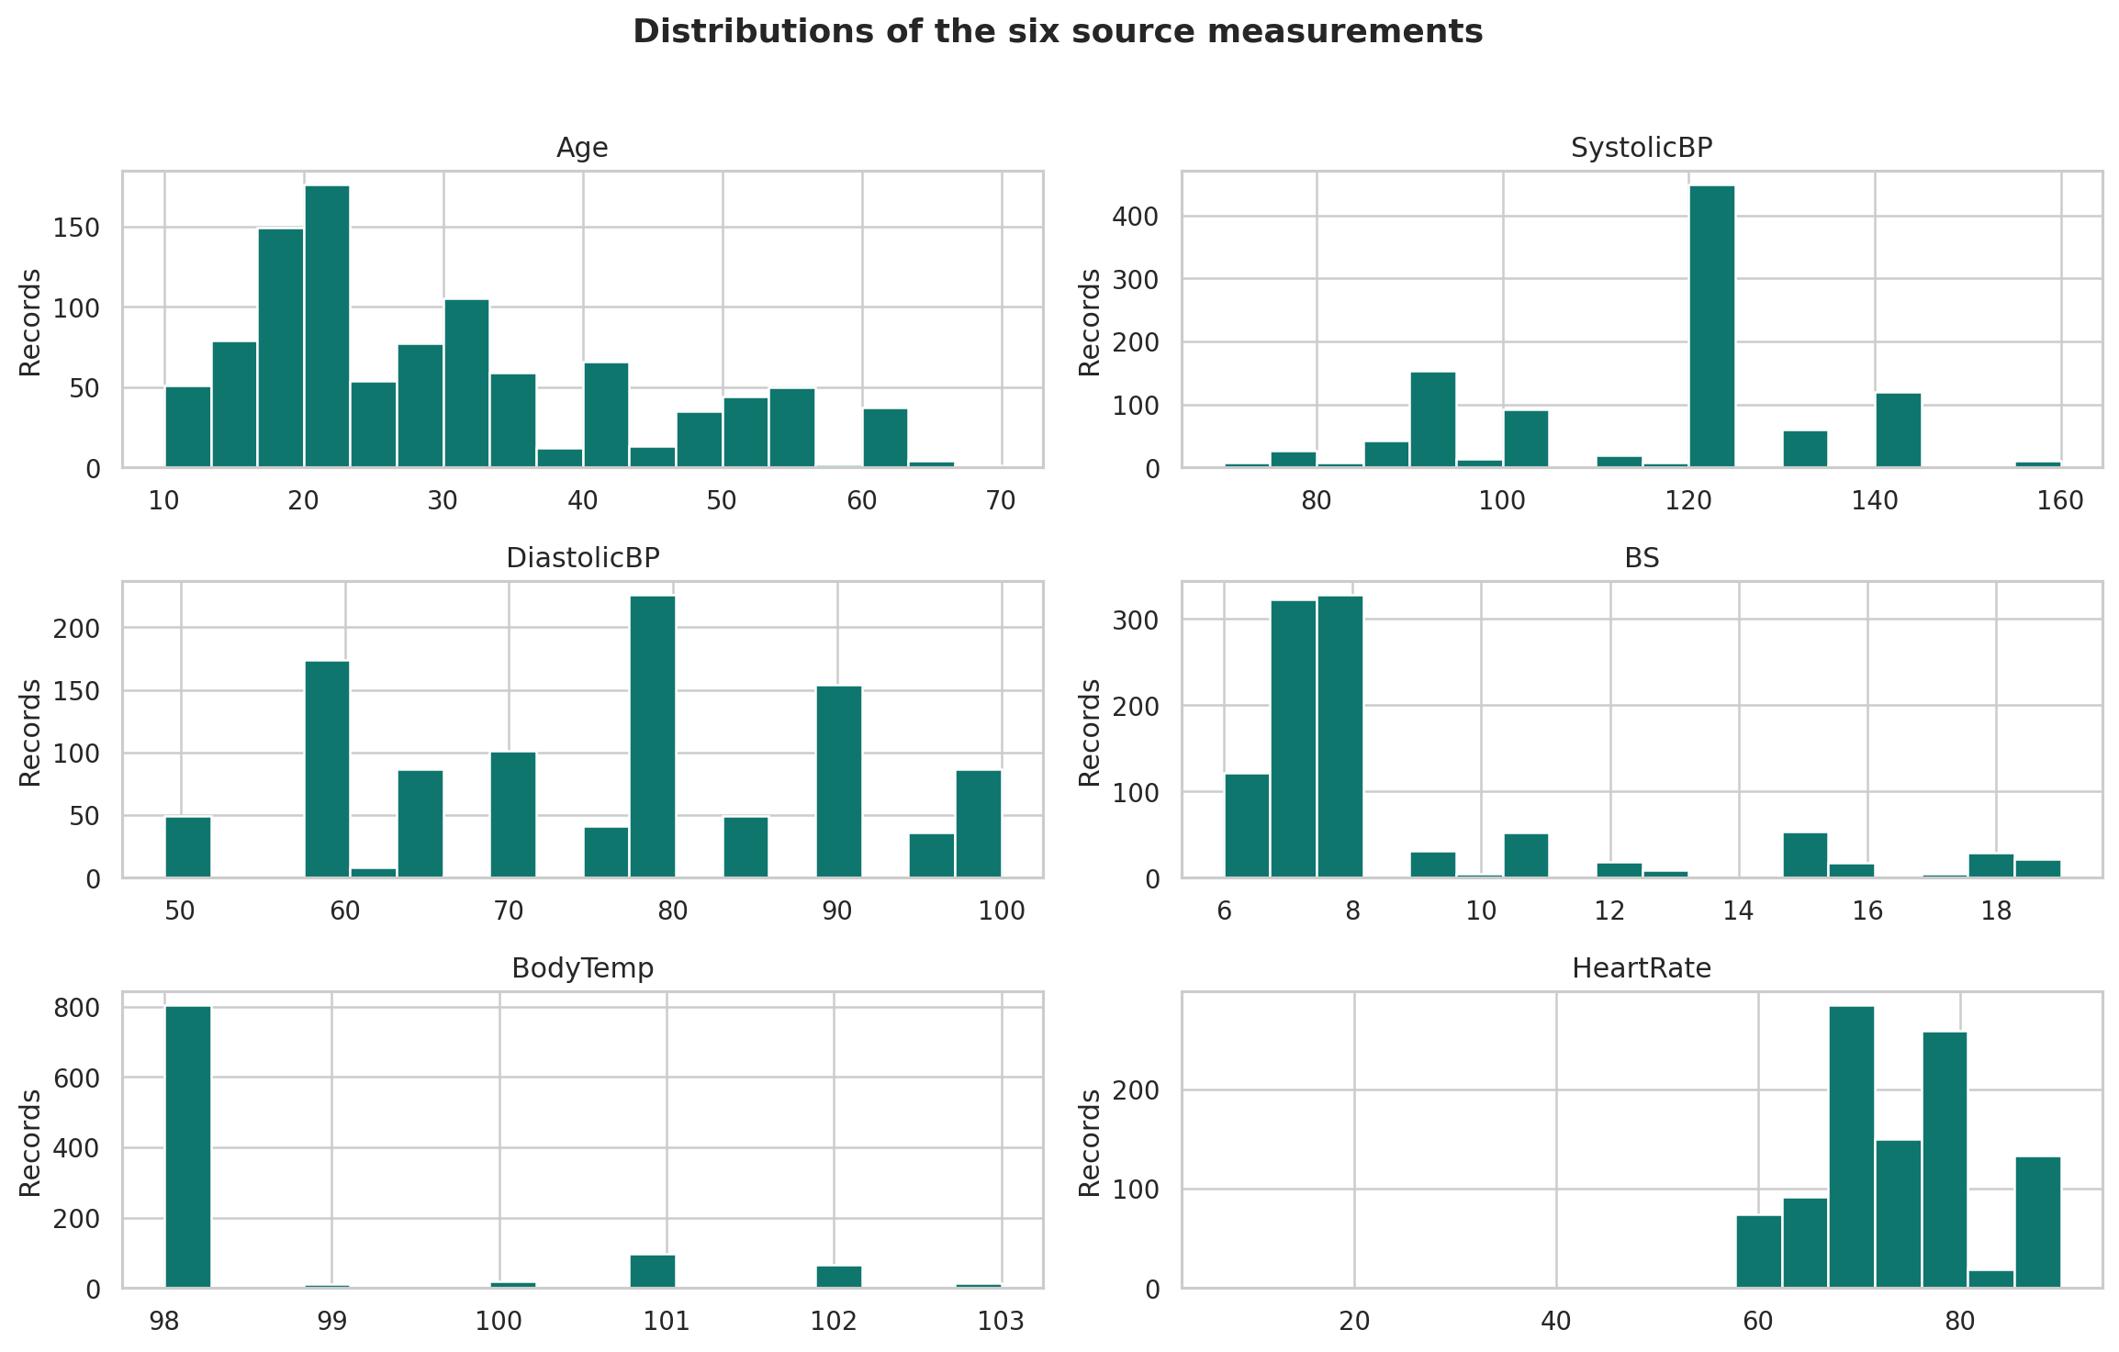
Figure 3. Distributions of the six source measurements.
The distributions contain repeated values, reflecting the extensive duplication in the source. Age, blood sugar and blood-pressure measurements show visible concentration at common values. The narrow support of some variables limits the complexity that can be learned.
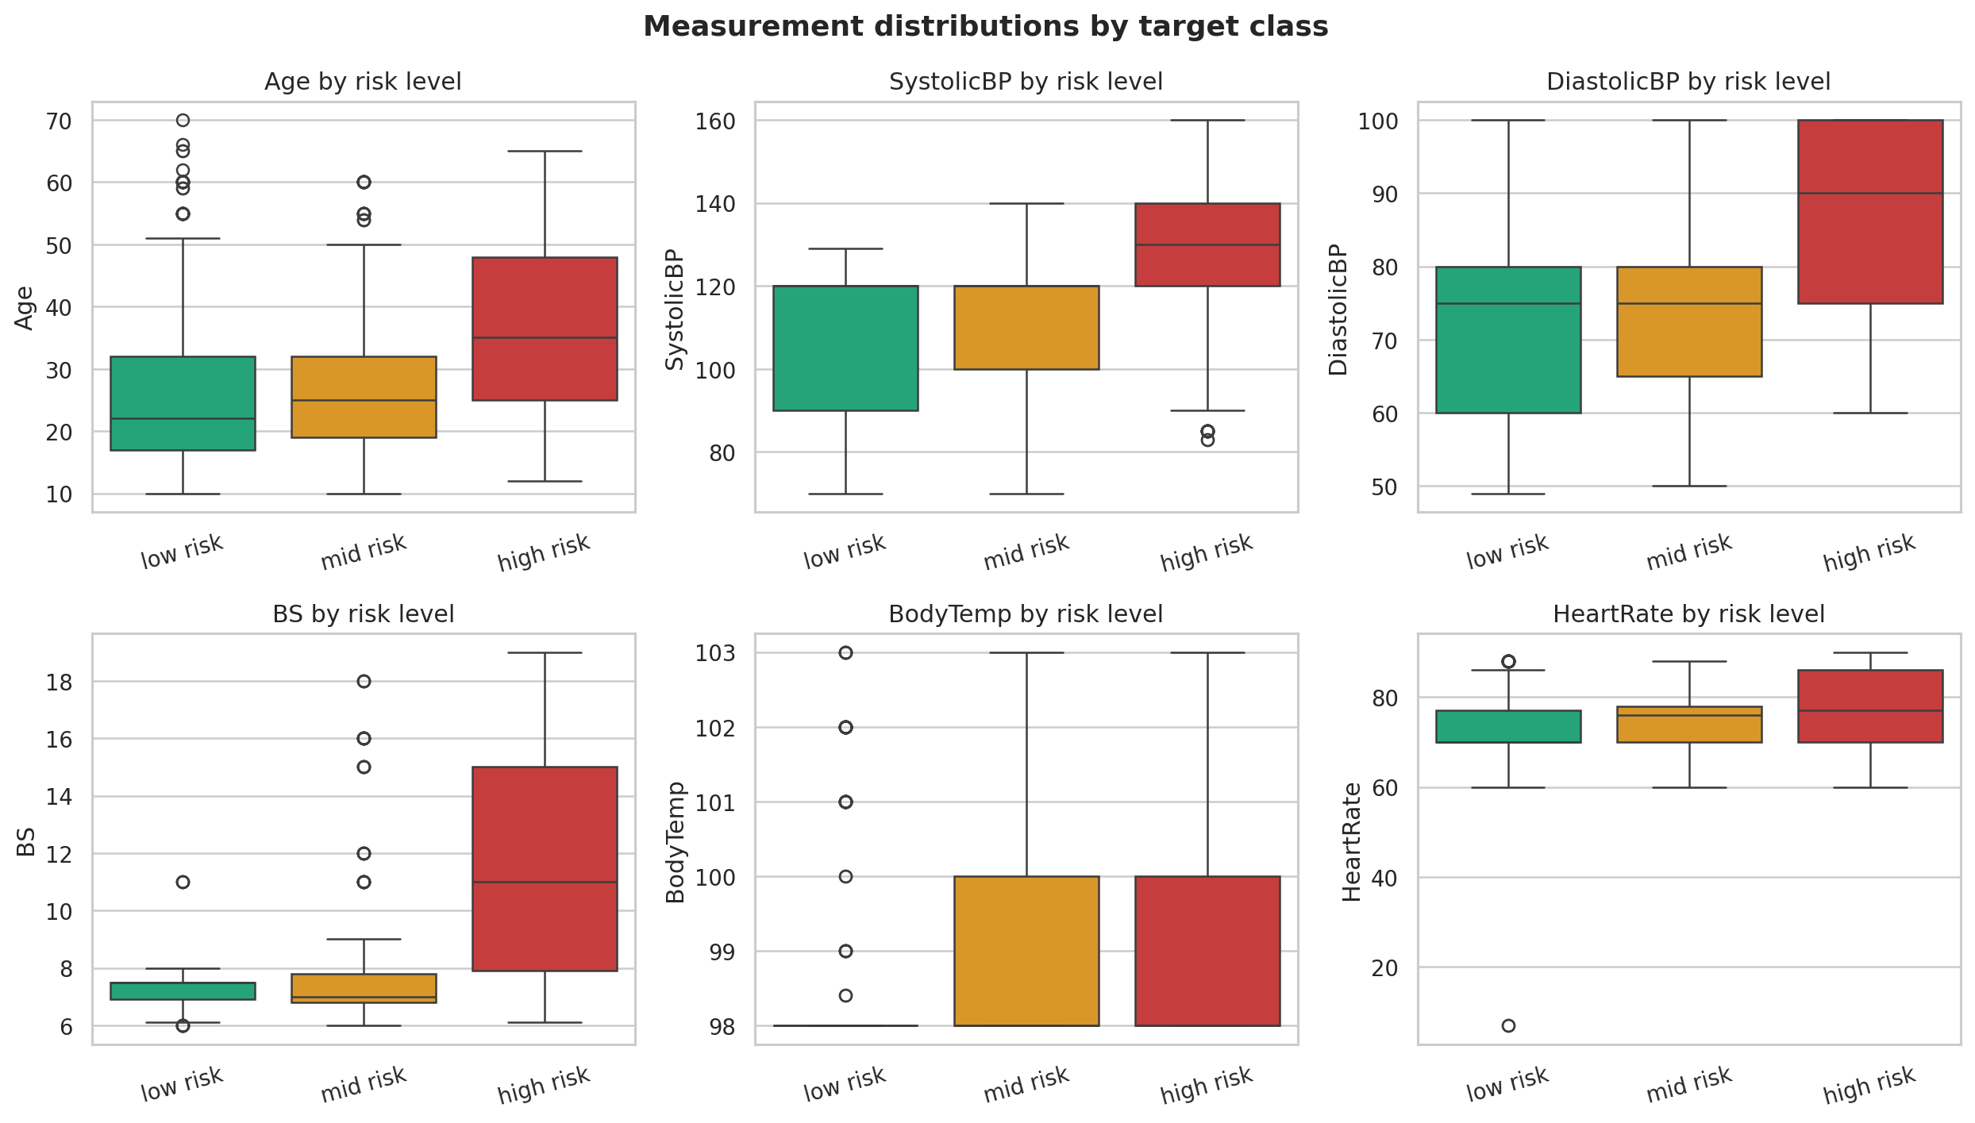
Figure 4. Measurement distributions split by target class.
High Risk records generally show higher blood sugar and blood-pressure values, but substantial overlap remains. Mid Risk overlaps strongly with Low Risk and High Risk, helping to explain the weak Mid Risk recall.
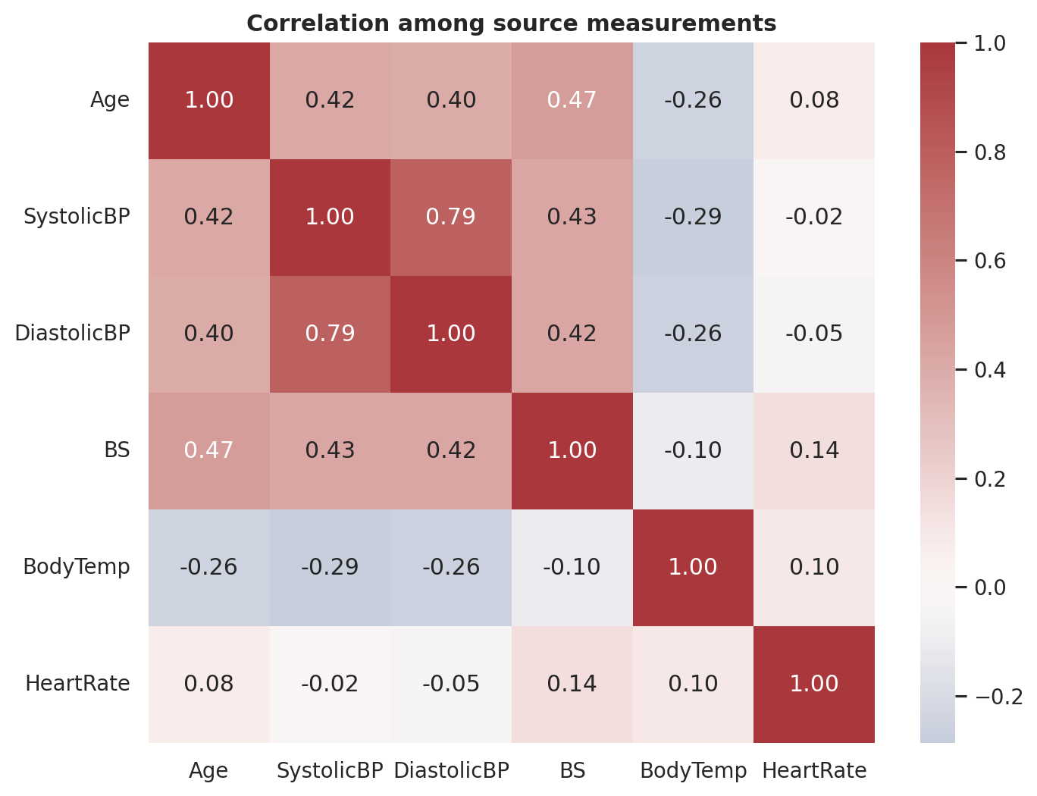
Figure 5. Correlation among source measurements.
Systolic and diastolic blood pressure are positively related. Correlation is treated as association only; it does not establish clinical causation or make the model medically valid.

4. Methodology and Reproducibility

4.1 End-to-end Workflow
Stage | Implementation | Output
Acquire | Preserve the UCI CSV and validate schema | Raw dataset and checksum
Audit | Missingness, duplicates, contradictory labels, outliers | Data-quality tables and figures
Split | StratifiedGroupKFold by six-measurement signature | Train, validation and untouched test sets
Engineer | PulsePressure, MeanArterialPressure, AgeBand | Pipeline features
Model | Ten baseline and candidate approaches | Validation comparison
Evaluate | Weighted F1, Macro F1, High Risk recall, accuracy, log loss | Final test metrics
Audit impact | Age-group Equal Opportunity and structured error analysis | Fairness and error tables
Deliver | Streamlit, notebook, report, slides and tests | Portfolio-ready repository

4.2 Leakage-resistant Splitting
Each record is assigned a signature based on all six input measurements. StratifiedGroupKFold keeps each signature in one partition while approximately preserving class proportions. The saved overlap audit reports zero signatures shared between train, validation and test sets.

4.3 Preprocessing Pipeline
- Median imputation permits at most one unavailable measurement.
- Feature engineering is fitted inside the pipeline to prevent training-serving inconsistency.
- StandardScaler normalizes numerical inputs before models that depend on scale.
- A fixed random seed supports reproducibility.

4.4 Model Selection Protocol
Candidate models are compared only on the group-separated validation set. The primary sorting key is Weighted F1, followed by Macro F1 and High Risk recall. The untouched test set is used once after model selection and retraining on the combined train and validation data.

5. Feature Engineering and Clustering

5.1 Engineered Features
Feature | Formula or rule | Purpose
PulsePressure | SystolicBP - DiastolicBP | Summarize the pressure difference
MeanArterialPressure | (SystolicBP + 2 x DiastolicBP) / 3 | Summarize average arterial pressure
AgeBand | <=19, 20-34, 35-49, >=50 | Represent non-linear age groups

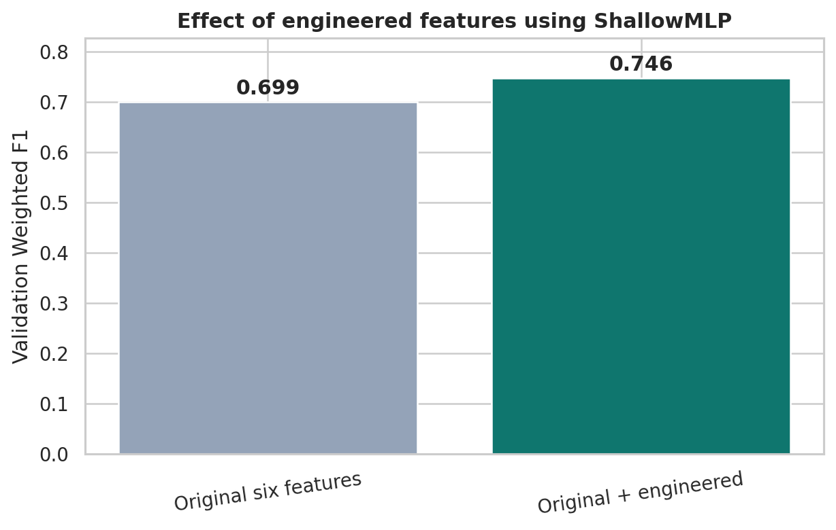
Figure 6. Validation performance with and without engineered features.
The ablation experiment compares the selected model using the original six features against the same model with the engineered variables. The final pipeline retains the engineered set because it produced the stronger validation result.

5.2 Exploratory Clustering
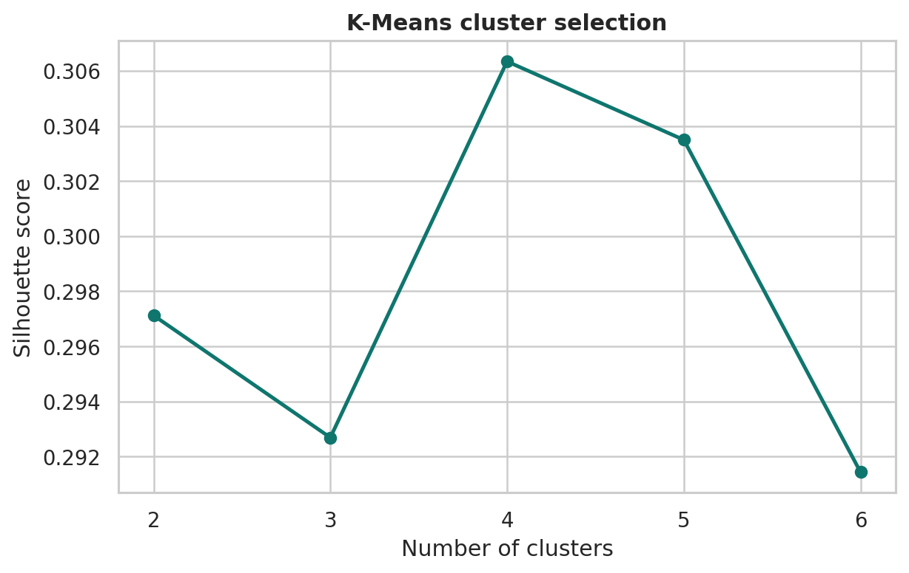
Figure 7. K-Means silhouette scores for two to six clusters.
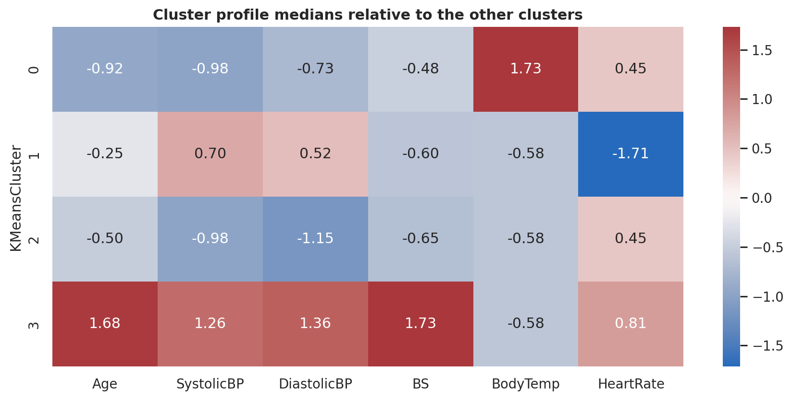
Figure 8. Median cluster profiles relative to the other clusters.
The best K-Means solution uses k=4. The silhouette score is moderate, so the profiles are exploratory rather than evidence of clinically distinct groups. K-Means and hierarchical clustering are compared through adjusted Rand agreement, recorded as 0.758.

6. Model Development and Selection
The project compares a majority-class baseline with linear, tree-based, kernel, boosting, neural-network and ensemble methods. XGBoost is included because it is the mentor-recommended upgrade model for classification. Two feed-forward neural-network architectures are also evaluated.
Model | Weighted F1 | Macro F1 | High Risk recall | Accuracy
ShallowMLP | 0.746 | 0.749 | 0.778 | 0.744
SoftVoting | 0.722 | 0.720 | 0.796 | 0.719
LogisticRegression | 0.690 | 0.691 | 0.778 | 0.685
RandomForest | 0.676 | 0.676 | 0.759 | 0.675
DecisionTree | 0.659 | 0.661 | 0.741 | 0.655
DeepMLP | 0.657 | 0.661 | 0.815 | 0.655
GradientBoosting | 0.652 | 0.650 | 0.759 | 0.670
SVC | 0.643 | 0.640 | 0.796 | 0.660
XGBoost | 0.608 | 0.608 | 0.741 | 0.631
MajorityBaseline | 0.232 | 0.192 | 0.000 | 0.404

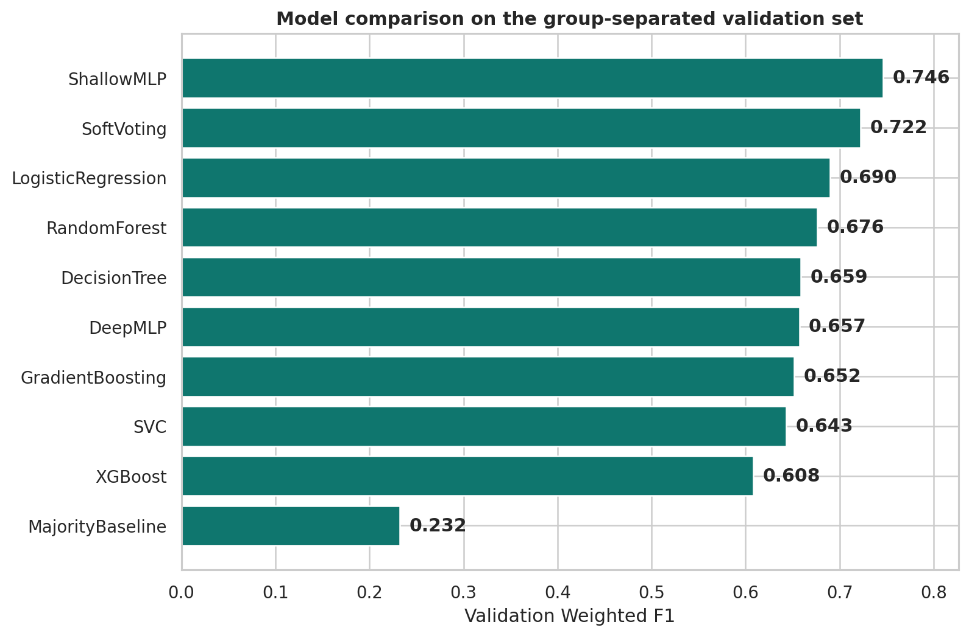
Figure 9. Candidate models ranked on validation Weighted F1.

6.1 Neural-network comparison
The shallow architecture uses one hidden layer, while the deeper architecture uses three hidden layers. Both use ReLU activation, L2 regularization and early stopping. The shallow model performed better, showing that additional depth did not help this small and noisy dataset.
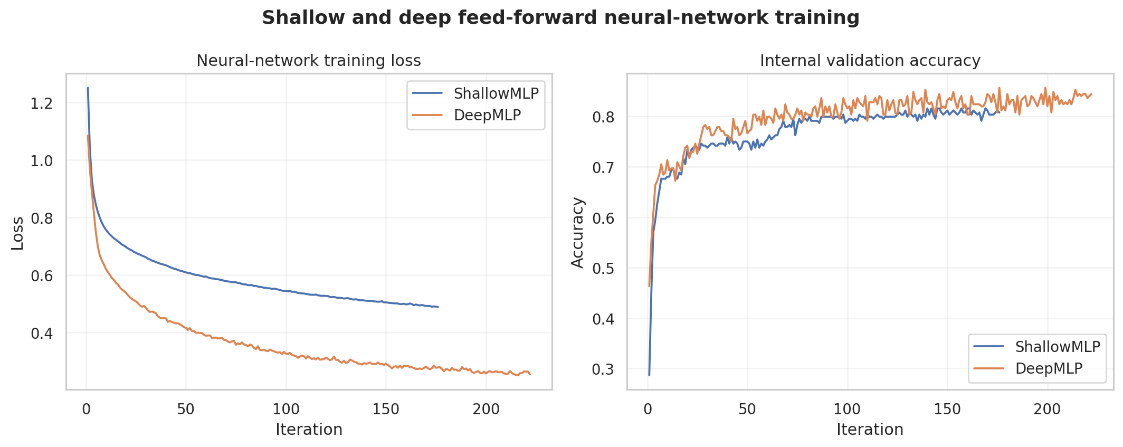
Figure 10. Training loss and internal validation accuracy for both MLP architectures.

7. Final Evaluation

7.1 Baseline Comparison
Metric | Majority baseline | ShallowMLP | Improvement
Accuracy | 0.399 | 0.601 | 0.202
Weighted F1 | 0.228 | 0.562 | 0.334
Macro F1 | 0.190 | 0.574 | 0.384
High Risk Recall | 0.000 | 0.818 | 0.818

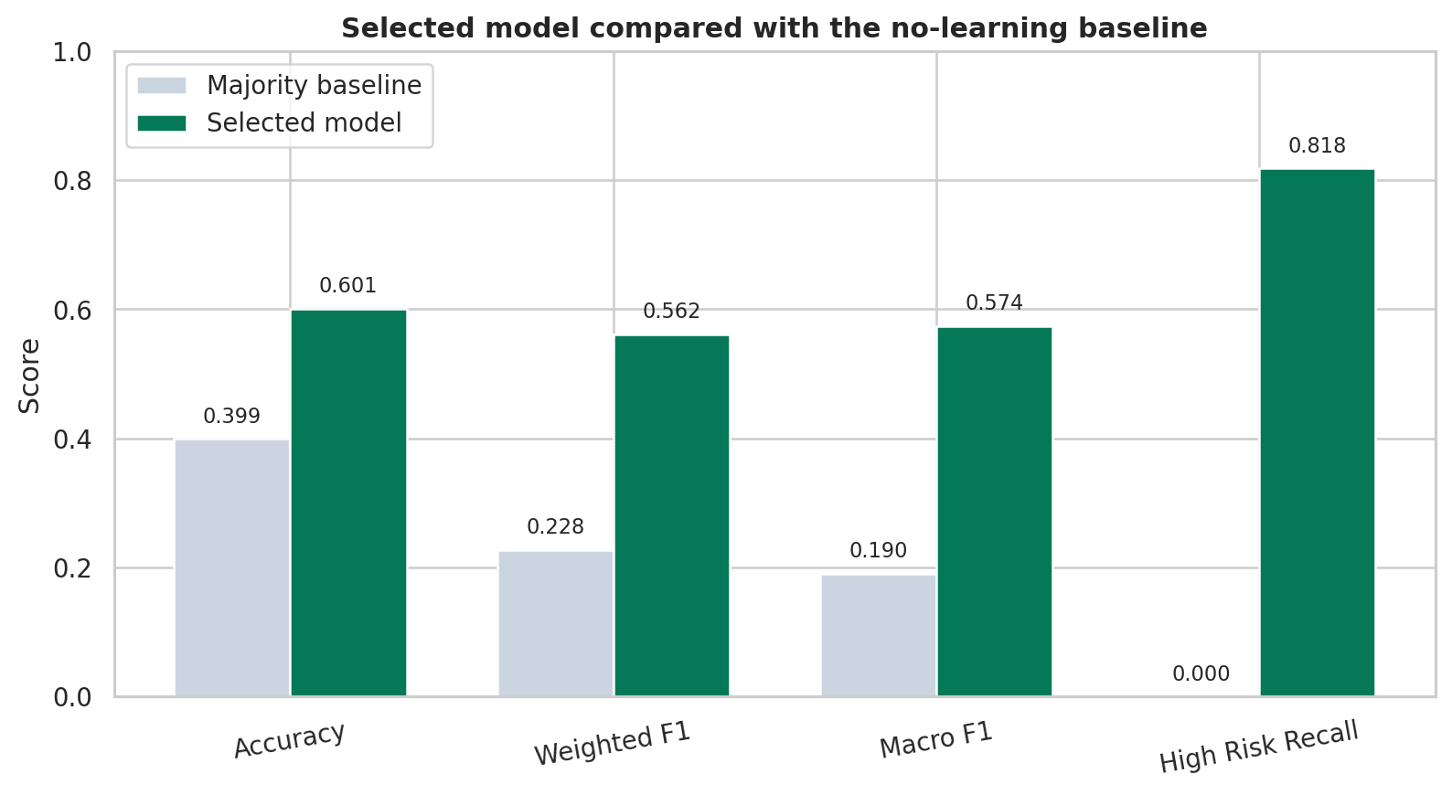
Figure 11. Selected model compared with the no-learning baseline.

7.2 Class-level Performance
Class | Precision | Recall | F1 | Support
High Risk | 0.918 | 0.818 | 0.865 | 55
Low Risk | 0.528 | 0.827 | 0.644 | 81
Mid Risk | 0.370 | 0.149 | 0.213 | 67

High Risk performance is the strongest: recall 0.818 and class F1 0.865. Mid Risk recall is only 0.149; most Mid Risk errors are predictions of Low Risk.
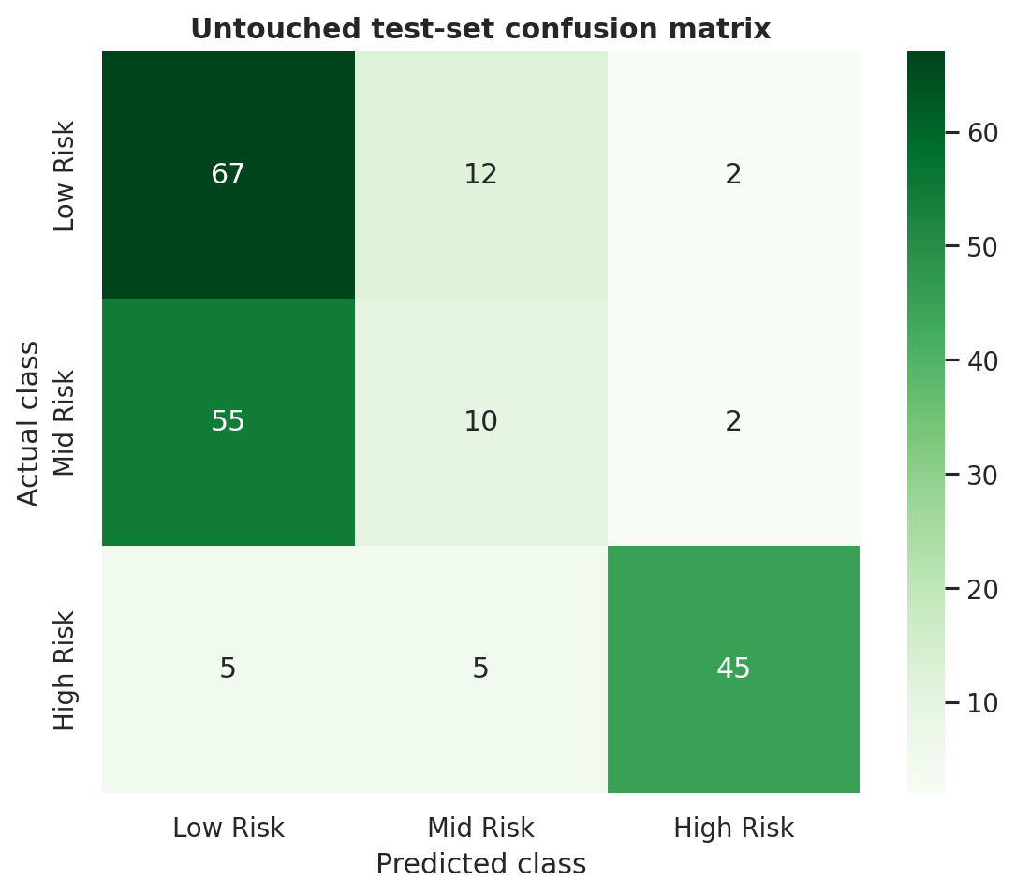
Figure 12. Untouched test-set confusion matrix.
Honest conclusion: The model has learned useful signal and beats the baseline, but it does not provide reliable three-class clinical classification. The weak Mid Risk result must be reported alongside the stronger High Risk recall.

8. Disaggregated Evaluation and Fairness
The fairness criterion is Equal Opportunity for High Risk identification across age groups. This asks whether actual High Risk cases are correctly identified at similar rates for different age categories.
Age group | N | High Risk N | Weighted F1 | Macro F1 | High Risk recall
<=19 | 77 | 8 | 0.350 | 0.372 | 0.375
20-34 | 58 | 10 | 0.556 | 0.596 | 0.700
35-49 | 40 | 22 | 0.855 | 0.608 | 0.955
>=50 | 28 | 15 | 0.751 | 0.564 | 0.933

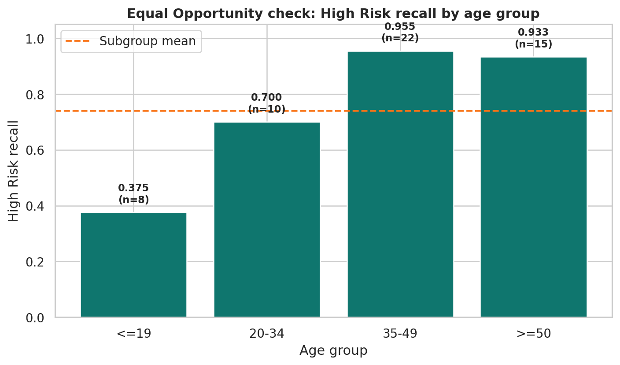
Figure 13. High Risk recall by age group.
High Risk recall ranges from 0.375 to 0.955, producing a gap of 0.580. The youngest group performs worst. The subgroup counts are limited, so the values have uncertainty, but the gap is too large to claim equal opportunity.
A responsible next phase would collect larger, locally validated data, predefine subgroup thresholds and repeat the analysis prospectively before any deployment decision.

9. Structured Error Analysis

9.1 Are the errors random?
No. Errors concentrate in Mid Risk records, the youngest age group and records whose identical measurement signatures have contradictory labels.

9.2 Are the errors concentrated?
Conflicting signature | Records | Accuracy | Error rate
No | 152 | 0.737 | 0.263
Yes | 51 | 0.196 | 0.804

Records with contradictory signatures have an error rate of 80.4%, compared with 26.3% for consistent signatures. This demonstrates a strong data-quality effect.

9.3 Are the errors consequential?
Yes. The most serious error is an actual High Risk record predicted as Low Risk because it could create false reassurance. False positive High Risk predictions can create anxiety, but missing a true High Risk case is treated as the greater safety concern.
Actual class | Predicted class | Records
Low Risk | Low Risk | 67
Mid Risk | Low Risk | 55
High Risk | High Risk | 45
Low Risk | Mid Risk | 12
Mid Risk | Mid Risk | 10
High Risk | Low Risk | 5
High Risk | Mid Risk | 5
Low Risk | High Risk | 2
Mid Risk | High Risk | 2

9.4 Most confidently wrong records
Age | Sys | Dia | BS | Temp | HR | Actual | Predicted | Confidence | Age group | Conflict
27 | 135 | 60 | 7.5 | 101.0 | 86 | high risk | mid risk | 0.823 | 20-34 | False
16 | 90 | 65 | 6.9 | 98.0 | 76 | mid risk | low risk | 0.817 | <=19 | False
16 | 90 | 65 | 6.9 | 98.0 | 76 | mid risk | low risk | 0.817 | <=19 | False
16 | 90 | 65 | 6.9 | 98.0 | 76 | mid risk | low risk | 0.817 | <=19 | False
21 | 90 | 65 | 6.9 | 98.0 | 76 | mid risk | low risk | 0.770 | 20-34 | True
21 | 90 | 65 | 6.9 | 98.0 | 76 | mid risk | low risk | 0.770 | 20-34 | True
21 | 90 | 65 | 6.9 | 98.0 | 76 | mid risk | low risk | 0.770 | 20-34 | True
45 | 120 | 80 | 6.9 | 103.0 | 70 | low risk | mid risk | 0.687 | 35-49 | False

10. Frontend and System Design
The Streamlit frontend is designed for a professional capstone demonstration. It uses plain-language labels, grouped measurements, an explicit acknowledgement, result-state clearing, model-score bars, uncertainty communication, local explanations, a one-variable what-if tool and downloadable summaries.

Figure 14. Desktop design preview of the MamaCare assessment screen.

10.1 Functional Controls
- Load a repeatable demonstration case.
- Select one unavailable measurement.
- Assess maternal risk only after acknowledging the academic-use warning.
- Reset measurements or start a new assessment.
- Compare original and adjusted model outputs.
- Download a text assessment summary.
- Download the Responsible AI statement from the application.

10.2 Safety and Accessibility Choices
- No names, phone numbers, identification numbers or addresses are collected.
- Risk is communicated with text, icons/borders and optional colour rather than colour alone.
- All measurements display units.
- Dataset input ranges are explicitly distinguished from clinical reference ranges.
- The model evidence tab exposes weak Mid Risk performance and subgroup differences.
Deployment status: The frontend is a demonstration interface. Public deployment would still require local clinical review, security assessment and a clearly owned monitoring process.

11. Responsible AI and Ethical Use
The Responsible AI statement identifies affected groups, the worst plausible harm, the distribution of error costs, the absence of a current redress mechanism and a monitoring plan. It also names Equal Opportunity as the fairness criterion and reports the age-group findings.

11.1 Who is affected?
Users interpreting the output, pregnant people whose records are classified, younger or underrepresented groups, and families affected by the communication of risk can all be influenced by the system.

11.2 Worst plausible outcome
False reassurance after a missed High Risk case is the main plausible harm. The application therefore avoids medical-authority language and requires professional review regardless of the model score.

11.3 Redress and monitoring
There is no formal redress mechanism in this academic prototype. A future study would need human review, a correction route, documented overrides and suspension thresholds based on High Risk recall, subgroup recall and data drift.
The complete 500-700 word statement is included as reports/responsible_ai_statement.pdf.

12. Limitations, Conclusions and Next Steps

12.1 Limitations
- Small public dataset with extensive duplication.
- Contradictory labels for identical input signatures.
- No pregnancy stage, clinical history, symptom context or facility metadata.
- No Kenyan clinical validation or prospective evaluation.
- Mid Risk recall of only 14.9%.
- Equal Opportunity gap of 58.0% across age groups.
- Model scores are not calibrated clinical probabilities.

12.2 Conclusions
MamaCare meets the capstone goal of producing a complete public-facing data-science artefact. The selected ShallowMLP clearly beats the no-learning baseline and identifies most High Risk records in the test split. The project also demonstrates professional integrity by exposing poor Mid Risk performance, subgroup gaps and contradictory labels rather than hiding them.

12.3 Next Steps
- Collect richer, clinically reviewed and locally representative maternal-health data.
- Add pregnancy stage, symptoms, medical history and facility context where ethically justified.
- Pre-register clinical and subgroup performance thresholds before model selection.
- Run prospective validation with health professionals and a formal governance process.
- Evaluate calibration and human-model interaction on new independent data.

13. Reproducibility and Submission
The repository separates raw data, processed data, reusable source code, the interface, tests, model artifacts, reports, slides and documentation. The training command regenerates splits, models, tables, figures and metadata from the raw CSV. The notebook reads the saved evidence and provides a complete narrative of the workflow.

13.1 Verification commands
python -m src.train
python -m pytest -q -p no:cacheprovider
python scripts/build_notebook.py
python -m nbconvert --execute --to notebook --inplace notebooks/MamaCare_End_to_End.ipynb
python -m streamlit run app/app.py
python scripts/clean_project.py
python scripts/verify_submission.py

13.2 Final package
The final ZIP contains the updated frontend, backend, model artifact, executed notebook, report, Responsible AI statement, presentation, speaker notes, tests, requirements, licences and the detailed VS Code Codex prompt.

References
Ahmed, M. (2020). Maternal Health Risk [Dataset]. UCI Machine Learning Repository. https://doi.org/10.24432/C5DP5D
NGAO Labs. (2026). Capstone project instructions and track-selection guidance.
MamaCare Maternal Health Risk Prediction System project proposal, July 2026.
Scikit-learn documentation for model selection, preprocessing, metrics and neural-network classifiers.

