**STT 811**

**In-Class Assignment 13**

This problem will use the Heart dataset, with AHD as the target.

1. Split the data into training and test datasets (with a 75/25 split).Text

   Description automatically generated
2. Build a decision tree model based on Thal, RestBP, and Age. 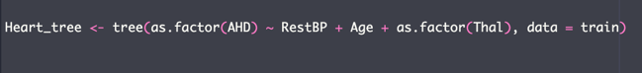
3. Plot the tree.

1. Create the confusion matrix and give the accuracy.

1. Try some other combinations of inputs. See if the new inputs appear in the tree. If so, calculate their confusion matrix.

