**STT 811**

**In-Class Assignment 6**

This problem will use the Heart dataset. The target is the AHD field.

1. Some of the fields are not clear. Find a website which describes the fields and read their description.
2. Determine whether the AHD target field is balanced or not.
   1. The field is relatively balanced (55% No, 45% Yes)
3. Ignoring the X field (just an id) determine which fields are truly numeric or categorical.
   1. Numeric: Age, RestBP, Chol, MaxHR, Oldpeak,
   2. Categorical: Sex, ChestPain, Fbs, RestECG, ExAng, Slope, Ca, Thal, AHD
4. Do some exploratory data analysis on a few of the variables:
   1. Age

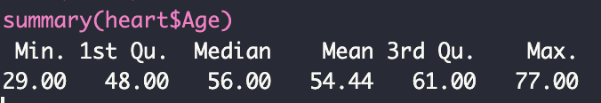

* 1. ChestPain

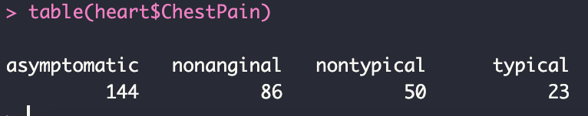

* 1. OldPeak

* 1. Thal

