**Basic CSS - Cascading Style Sheet**

**CSS Syntax**

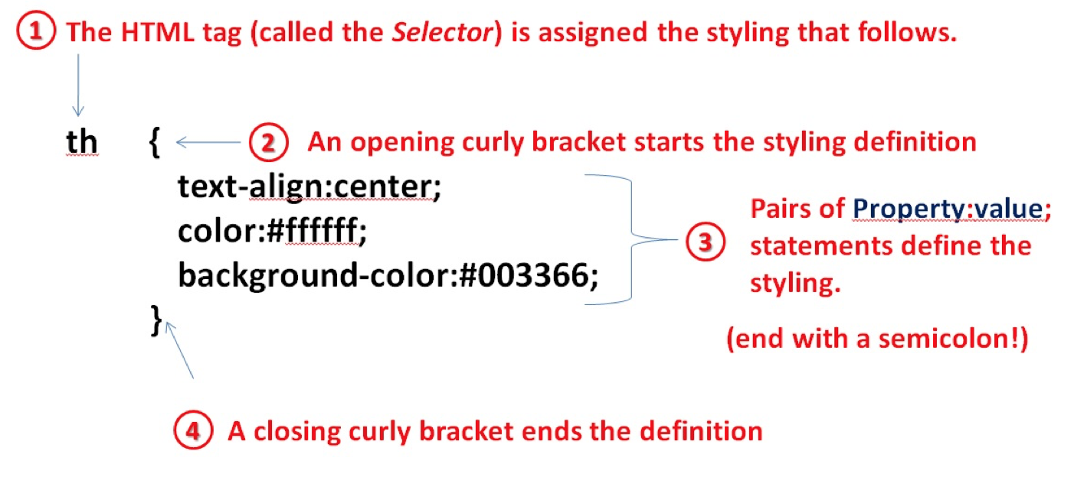

**For a single property-value pairing:**

selector { property:value; }

**For multiple property-value pairings:**

selector {

property:value;

property:value;

…

property:value;

}

**Style Sheet Priority**

*There are three levels of styling with CSS: External Style Sheets, Internal Style Sheets, and Inline Styling. When using multiple levels of style sheets, the one with the closest proximity will override the others. Inline styles have the highest priority, followed by internal style sheets. External style sheets have the lowest priority.*

**External Style Sheets:**

All style information is contained in a file separately from the HTML code. That file should end with a .css extension and be linked within the head tag of the html file using <link href=”mystyles.css” rel=”stylesheet” type=”text/css” /> .

**Internal Style Sheets:**

Place CSS code directly within the tag of an HTML document enclosed within a style tag:

<style type=”text/css” media=”all”>

selector { property:value; }

</style>

**Inline Styles:**

Place CSS code directly within another tag using the style attribute:

<tag style=”property:value;”>

**Selected CSS Properties and Values**

*Each of the CSS properties found in the reference below are shown in* **property: value pairs***.*

**For each property, give an example, and, if applicable, a list of possible values.**

**Example:**

**background-color: *color***

body {

background-color: yellow;

}

values: rgb(0-255,0-255,0-255), #hexadecimal, named, transparent

**background-image:*url(source)***

{ url(img_flwr.gif), url(paper.gif) }

**background-repeat: *value***

{ url(img_flwr.gif), url(paper.gif);

no-repeat, repeat; }

values: background

**border: *size style* *color***

{ }

styles: p.dotted {border-style: dotted;}

p.dashed {border-style: dashed;}

p.solid {border-style: solid;}

p.double {border-style: double;}

p.groove {border-style: groove;}

p.ridge {border-style: ridge;}

p.inset {border-style: inset;}

p.outset {border-style: outset;}

p.none {border-style: none;}

p.hidden {border-style: hidden;}

p.mix {border-style: dotted dashed solid double;}

**border-width: *top right bottom left***

{ }p.one {

border-style: solid;

border-width: 5px;

}

p.two {

border-style: solid;

border-width: medium;

}

p.three {

border-style: solid;

border-width: 2px 10px 4px 20px;

}

**color: *color***

{ }p.one {

border-style: solid;

border-color: red;

}

values: rgb(0-255,0-255,0-255), #hexadecimal, named

**font-family: *Family name* *by ordered preference*  (Family names having spaces must be in quotes.)**

{ font-family: "Times New Roman", Times, serif; }

**font-size: *value***

h1 {

font-size: 40px;

}

Values: setting the text size with pixels gives you full control over the text size

**font-style: *value***

h1 {

font-size: 2.5em; /* 40px/16=2.5em */

}

values:

**font-weight: *value***

{ p.normal {

font-weight: normal;

}

}

values: font-weight

**margin: *top, right, bottom, left***

{ p {

margin-top: 100px;

margin-bottom: 100px;

margin-right: 150px;

margin-left: 80px;

}}

values: margin

**padding: *top, right, bottom, left***

{ p {

padding-top: 50px;

padding-right: 30px;

padding-bottom: 50px;

padding-left: 80px;

}}

values: padding

**text-align: *value***

{ }img {

display: block;

margin: auto;

width: 40%;

}

values: The text-align property is used to set the horizontal alignment of a text.

A text can be left or right aligned, centered, or justified.

**text-indent: *value***

{ }p {

text-indent: 50px;

}

values: The text-indent property is used to specify the indentation of the first line of a tex