**Cookies & Search Queries**

**I. Your Digital Footprint**

What enduring bits are left behind by your activities on the Web?

Requesting a web page by its domain name causes chatter among name servers. What other network traffic is generated when you browse the Web? In this section, we look at cookies. What information about you gets stored, and by whom? This question reaches into issues of democracy, power, privacy, and more. In this section we consider cookies, a way that information about you is stored by web servers on your own machine.

1. A **Cookie** is a small amount of data stored on the computer(client machine). In order to view your cookies for one web page, turn on Firebug in Firefox by clicking its icon in the navigation bar shown below. Firebug is not built into Firefox; it is an Add-on. **Add-ons** are separate pieces of software that interact with another to extend its functionality. In this activity Firebug serves to allow us to examine websites in greater detail and provides some additional functionality beyond what is available in traditional browser-based tools.



Switch to the “Net” tab in Firebug and then select “HTML” as shown below.



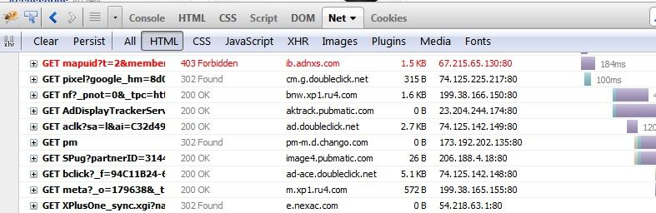

Direct your browser to ebay.com and do a search for something you are interested in buying. As you can see in Firebug, much of the HTML that your computer is viewing is provided by sources other than ebay.com.

1. Switch to the “Cookies” tab in Firebug as shown below.

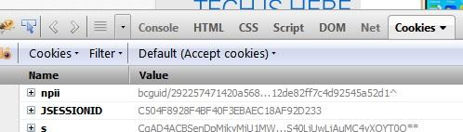

Web programmers use cookies to do things like remember your preferences, history, shopping cart, or login status. Each set of cookies is associated with a domain name and with a directory path on that host. So a cookie can be specific to one web page or can be shared across a web site. Cookies cannot be accessed by a server outside their domain, so a page at mail.google.com can access a cookie associated with google.com but not one associated with ebay.com. The cookies tab in Firebug lets you view the details of each cookie created or accessed when you visit a site. It provides the following information:

* 1. Cookie Name
  2. The value of the cookie, which is the actual information being accessed by the site
  3. The domain that is accessing the cookie
  4. The size of the cookie
  5. The expiry date and time among other details.

Choose one of the cookies that you can see and record its name, domain, size, and expiration date/time.

|  |  |  |  |
| --- | --- | --- | --- |
| cookie name | domain | size | expires |
| npii | .ebay.com | 99B | 09/18/2018 |

1. Now search for something on ebay and examine how the number and variety of cookies changes. Before your search, most if not all of the cookies should have belonged to the ebay domain. To whom do they belong now? List one or two different domains.

|  |
| --- |
| .ebay.com |

1. These cookies being accessed by domains other than ebay.com are called **Third-party cookies.** Use the Internet to find out more about the domains that are accessing your cookies when you searched for something on ebay. Who are the entities using these domains and what do they do? Choose at least one to examine at this level of detail.

|  |
| --- |
|  |

**II. Create Search Queries**

Search engines are one of the most powerful ways to quickly access the data you want on the web. Search engines typically use **Web crawlers** or spiders, autonomous softbots that examine the pages on the web by passing from link to link, aggregating all of the information that they discover into a massive database called a Web index. Search engines then use their own algorithms to determine relevance of the sites that they have indexed to a given query and return results back to the user. The words that you type into the search field of a search engine form the Query .

1. Use this information and optionally the video found at [**http://www.google.com/intl/en_us/insidesearch/howsearchworks/algorithms.html**](http://www.google.com/intl/en_us/insidesearch/howsearchworks/algorithms.html) to answer the question “What role do algorithms play in determining search results?”.   
   *Alternative link:* [*https://drive.google.com/open?id=0B---dT3GXSwYb3dzdUtMVUprZ1k*](https://drive.google.com/open?id=0B---dT3GXSwYb3dzdUtMVUprZ1k)

|  |
| --- |
| Algorithms makes it so its more convient and accessible to others. |

1. Watch the following video to understand how you get your search results. [**http://www.youtube.com/watch?v=BNHR6IQJGZs**](http://www.youtube.com/watch?v=BNHR6IQJGZs)

*Alternative link:* [*https://drive.google.com/open?id=0B---dT3GXSwYaFNheHlJX2lBRDA*](https://drive.google.com/open?id=0B---dT3GXSwYaFNheHlJX2lBRDA)  
Why might some web pages not be returned as search results even if they are relevant to your query?

|  |
| --- |
| Some web pages might not be returned as a search result if it is revelent. It might not contain the synonyms to the words you are searching or the key words. It wont pass the page rank. It might not pass the database. |

1. Even today one of the most important skills you can learn is how to effectively format your search queries. Higher quality queries get you better results in less time, leaving you more time for everything else. They help you conduct research, find images or videos, and locate communities for discussion of various topics. Some of the best tips for improving your searches are incredibly basic: be as specific as you can, consider the type of vocabulary that is likely to appear on sites that you want to see, and keep your queries simple. You can get a lot trickier if you have specific criteria for your search. Use this page provided by Google to answer the following questions: [**http://www.google.com/intl/en_us/insidesearch/tipstricks/all.html**](http://www.google.com/intl/en_us/insidesearch/tipstricks/all.html)
   1. You want to search for Mustangs but not the car, just the horse. What search operator would you use to ignore sites about cars?

|  |
| --- |
| animal mustangs |

* 1. You want to find PowerPoint slides about a given topic. How can you get results that contain only .ppt compatible documents?

|  |
| --- |
| filetype:ppt |

* 1. You saw a really interesting article about whales on cnn.com, but it’s been a few days and you can’t find it by searching for whales anymore. How can you narrow down your search and only get results from cnn.com?

|  |
| --- |
| whales site:cnn.com |

**GROUP WORK**

1. Google is certainly a popular search engine though by no means the only one. In your group of 3 or 4, brainstorm a total of 4 queries and use these search engines to test on those queries. Examine the first 10 results in each engine and record your comments and analysis here.

|  |  |  |  |
| --- | --- | --- | --- |
| Engine Names | A. www.google.com | B. www.duckduckgo.com | C. www.bing.com |
| Queries |  |  |  |
| 1  GAME OF THRONES | Google showed: top stories, hbo, wiki, fandom, facebook and other social media accounts, cast, theme song, episodes. | Articles, summary, Hbo, IMDB, wiki, game of thrones.com,Huffpost, etc. | News, pictures, social media, tweets on twitter, HBO, episode, cast, producers, also searched. |
| 2  SHAWN MENDES | twitter, shawn.com,  wiki, billboard | stubhub, shawn.com, wiki, facebook, | news, shawn.com, twitter, wiki, youtube, facebook |
| 3  corgis | social media  images  wiki  imformational site  breed | wiki  buying  welsch | images  videos  description |
| 4 | locations  descriptions  nutrition facts  top stories | recipes  taco ads  food network | taco locations with pie  map  news  food network |

1. In your opinion, which search engine’s algorithm do you think performed the best, and why?

|  |
| --- |
| In my opnion, I think google performed the best. Bing was the most compicated and too much information. Google was simple and it was easy to use, and duck duck go was confusing. |