Canadian Space Agency

NASA Space Apps Challenge 2020

|  |
| --- |
| README for 2019 LEAD Campaign Data  September 15, 2020 |

Table of Contents

1 Introduction 4

1.1 LEAD Campaign 4

1.2 Dataset 5

1.3 ROS (Robotic Operating System) 6

2 Telemetry and Telecommands 6

2.1 Localization Sub-System 7

2.2 3D Scanner 10

2.3 Rover Imagery 12

List of Figures

FIGURE PAGE

Figure 2.1‑1 base_link frame of reference 7

Figure 2.1‑2 Frame of Reference Tree 8

List of Tables

TABLE PAGE

Table 2‑1 Localization Topics and Services 9

Table 2‑3 3D Scanner Topics and Services 11

Table 2‑3 Rover Topics 12

Table 2‑4 TRT Camera Source IDs 12

**ACRONYMS**

|  |  |
| --- | --- |
| **AOS** | Absolute Orientation Sensor |
| **SCSCI** | Compute Software Configuration Item |
| **EVO** | Embedded Visual Odometer |
| **GN&C** | Guidance Navigation and Control |
| **LRSRS** | LEAD Rover Segment ROS Software |
| **PCL** | Point Cloud Library |
| **TRT** | Tele Robotics Testbed |

# 

# Introduction

This document provides a description of the format of the data collected during the Lunar Exploration Analogue Deployment (LEAD) Campaign conducted by the Canadian Space Agency in 2019.

## 2019 LEAD Campaign

For this simulated lunar deployment campaign, the Canadian Space Agency (CSA) partnered with the European Space Agency (ESA) to conduct a series of field tests to replicate scenarios of a lunar sample return mission using the CSA’s Juno Rover. The location, a Quebec quarry, was slightly modified to emulate the lunar surface. In addition, to recreate the difficulty of long-distance communications, the rover was operated by teams based in Longueuil (Quebec) and Germany.

When: June – September, 2019

Where: Montérégie, Quebec

For more information on the LEAD program: <https://www.asc-csa.gc.ca/eng/rovers/mission-simulations/lunar-exploration-analogue-deployment.asp>

For a video of the Juno lunar rover: <https://www.asc-csa.gc.ca/eng/search/video/watch.asp?v=1_pcweju8a&search=rover>

During these field tests, the rover navigated between various waypoints using a variety of operation modes (autonomous, manual mode, drive-by-distance and turn-by-angle, etc.) as per operator instructions. Operators used imagery data from Juno’s many cameras, as well as LiDAR scans to determine the rover’s position, attitude, and how best to command the rover (a.k.a. where to go and how to do it) in order to achieve mission goals (visiting waypoints).

## Dataset

This dataset collected during this campaign contains data in the form of rosbags. All data is stored in standard ROS messages that do not require the user to have custom ROS definitions.

The topics included in the rosbag LEAD_delayed_2019-09-25-19-00-01-filtered.bag are:

* + /delayed/artemisJr/centre/camera_info   
    1338 msgs : sensor_msgs/CameraInfo
  + /delayed/artemisJr/centre/image_rect_color/compressed   
    1338 msgs : sensor_msgs/CompressedImage
  + /delayed/artemisJr/imageData/centrePtzCam   
    7872 msgs : sensor_msgs/CompressedImage
  + /delayed/artemisJr/left/camera_info   
    1329 msgs : sensor_msgs/CameraInfo
  + /delayed/artemisJr/left/image_rect_color/compressed   
    1329 msgs : sensor_msgs/CompressedImage
  + /delayed/artemisJr/right/image_rect_color/compressed   
    1333 msgs : sensor_msgs/CompressedImage
  + /delayed/evo/left_polled/image_rect/compressed   
    18 msgs : sensor_msgs/CompressedImage
  + /delayed/evo/right_polled/image_rect/compressed   
    1 msg : sensor_msgs/CompressedImage
  + /delayed/lowrate_scanner/points   
    15 msgs : sensor_msgs/PointCloud2
  + /delayed/tf_static   
    1 msg : tf2_msgs/TFMessage
  + /delayed/trt/ws_left_polled/image_rect_color/compressed   
    14 msgs : sensor_msgs/CompressedImage
  + /delayed/trt/ws_right_polled/image_rect_color/compressed   
    9 msgs : sensor_msgs/CompressedImage
  + /delayed/trt_localization/pose   
    15951 msgs : geometry_msgs/PoseStamped
  + /delayed/trt_stitcher/pano/compressed   
    1 msg : sensor_msgs/CompressedImage

These topics provide imagery, LiDAR data, and the estimated pose of the rover. During the 2019 LEAD Campaign, this information was loaded into a graphical user interface which rover operators used to monitor telemetry, to achieve situational awareness (determine the rover’s position and attitude within the “lunar” terrain), and command the rover.

## ROS (Robotic Operating System)

This document presents part of the internal Robotic Operating System (ROS) interface on the rover segment. The ROS interface will present the different ROS topics and services residing on the rover segment. The ROS parameters are not presented in this document.

The following documents provide additional information or guidelines that either may clarify the contents or are pertinent to the history of this document.

|  |
| --- |
| Robot Operating System Homepage: <http://www.ros.org/> |
| Coordinate Frames for Mobile Platforms: <http://www.ros.org/reps/rep-0105.html> |
| sensor_msgs message definitions: <http://wiki.ros.org/sensor_msgs> |
| geometry_msgs message definitions: <http://wiki.ros.org/sensor_msgs> |
| tf2_msgs message definitions: <http://wiki.ros.org/sensor_msgs> |
| pcl_ros homepage: <http://wiki.ros.org/pcl_ros> |
| std_srvs message definitions: <http://wiki.ros.org/std_srvs> |
| tf2 library homepage: <http://wiki.ros.org/tf2> |
| std_msgs message definitions: <http://wiki.ros.org/std_msgs> |
| nav_msgs message definitions: <http://wiki.ros.org/nav_msgs> |
| ROS Parameter Server: <http://wiki.ros.org/Parameter%20Server> |

# Telemetry and Telecommands

The following sub-sections present some of the telemetry and commands exposed to the operator on the external interface of LEAD. The commands are implemented using the ROS service mechanism while the telemetry is implemented using ROS topics. The control scheme supports delayed and non-delayed command and telemetry.

The control scheme is implemented by prefixing each ROS topic and service by /nodelay, for the non-delayed version and /delayed, for the delayed version. Therefore, each ROS topic and service is prefixed by /{nodelay,delayed}/topicOrServiceName meaning that one would use /delayed/topicOrServiceName for the delayed version and /nodelay/topicOrServiceName for the delayed version. The delay is defined as the uplink and downlink delay. Note that the dataset only contains the delayed topics which are prefixed as delayed.

## Localization Sub-System

The Localization Sub System is in charge of providing localization to the rover. The transformation is expressed in the frame called map, which is the environment in which the rover is evolving. The rover frame is referred to as base_link. The current location of the rover in the map frame is available as a geometry_msgs/PoseStamped message, on the /trt_localization/pose topic, published at a rate of 1Hz by default. The rover frame of reference, base_link, has the x axis in the forward direction and the z axis in the zenith (up) direction, as presented in Figure 2.1‑1.

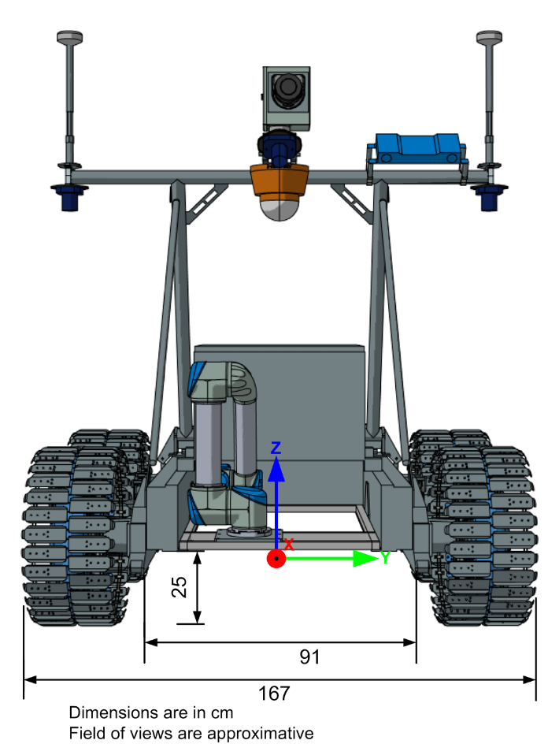

UR5 Manipulator

PTZ camera

Right camera

Left camera

evo

3D Scanner (corias)

Centre camera

Figure 2.1‑1 base_link frame of reference

Figure 2.1‑2 describes the different frames of reference.

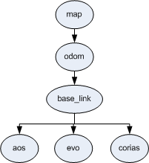

Figure 2.1‑2 Frame of Reference Tree

The frames of reference are defined as follows:

|  |  |
| --- | --- |
| map | The coordinate frame called map is a world fixed frame, with its Z-axis pointing upwards. The pose of a mobile platform, relative to the map frame, should not significantly drift over time. The map frame is not continuous, meaning the pose of a mobile platform in the map frame can change in discrete jumps at any time.  In a typical setup, a localization component constantly re-computes the robot pose in the map frame based on sensor observations, therefore eliminating drift, but causing discrete jumps when new sensor information arrives.  The map frame is useful as a long-term global reference, but discrete jumps in position estimators make it a poor reference frame for local sensing and acting. |
| odom | The coordinate frame called odom is a world-fixed frame. The pose of a mobile platform in the odom frame can drift over time, without any bounds. This drift makes the odom frame useless as a long-term global reference. However, the pose of a robot in the odom frame is guaranteed to be continuous, meaning that the pose of a mobile platform in the odom frame always evolves in a smooth way, without discrete jumps.  In a typical setup the odom frame is computed based on an odometry source, such as wheel odometry, visual odometry or an inertial measurement unit.  The odom frame is useful as an accurate, short-term local reference, but drift makes it a poor frame for long-term reference. |
| base_link | The coordinate frame called base_link is rigidly attached to the mobile robot base. The base_link is attached to the base as defined in Figure 2.1‑1. |
| evo | The static transformation, resulting from the calibration process, between base_link and the Embedded Visual Odometer (EVO) frame of reference. |
| corias | The static transformation, resulting from the calibration process, between base_link and corias (3D scanner) frame of reference. |
| aos | The static transformation, resulting from the calibration process, between base_link and the Absolute Orientation Sensor (AOS) frame of reference. |

The conversion between the rover reference frame and the LiDAR reference frame is:

|  |  |
| --- | --- |
| Translation (xyz) | 0.274, 0.012, 1.524 |
| Rotation (rpy), in radians | -0.003, -0.001, 1.58 |
| Rotation in Quaternion (xyzw) | 0 -0.001 0.710 0.704 |

Table 2‑1 presents a list of topics and services of the localization subsystem. Each topic or service is prefixed with /{nodelay,delayed} as detailed in Section 2.

Table 2‑1 Localization Topics and Services

|  |  |  |  |
| --- | --- | --- | --- |
| **Name** | **Type** | **Description** | **Rate** |
| **Published Topics** | | | |
| /tf _static | tf2_msgs/TFMessage | Provides the different transformations described in Figure 2.1‑2. | Async (latching) |
| /trt_localization/pose | geometry_msgs/PoseStamped | The current location of the rover (base_link), in the map frame. | 1 Hz (default) |

## 3D Scanner

The 3D Scanner currently installed on the Rover is called Continuous Range and Intensity Acquisition System (CORIAS), its location is presented in Figure 2.1‑1. The point cloud is expressed in the corias frame of reference. In order to transform the point cloud in the rover frame of reference, called base_link, one could use pcl_ros to perform the transformation:



It can also be done using the tf2 library, which does not require the Point Cloud Library (PCL), this can be an option when deploying the code to an embedded platform:



Table 2‑3 presents a list of topics and services related to the 3D scanner. Each topic or service is prefixed with /{nodelay,delayed} as detailed in Section 2.

Table 2‑3 3D Scanner Topics and Services

|  |  |  |  |
| --- | --- | --- | --- |
| **Name** | **Type** | **Description** | **Rate** |
| **Published Topics** | | | |
| /lowrate_scanner/points | sensor_msgs/PointCloud2 | The 3D point cloud from the 3D scanner, used for navigation (e.g., terrain assessment, path-planning). The resulting point cloud is voxelized and points that fall on the rover are removed. The point cloud is expressed in the corias frame of reference. | Async |

## Rover Imagery

Table 2‑3 presents the different topics published by the rover. Refer to Figure 2.1‑1 for details on the location of the different cameras. Each topic or service is prefixed with /{nodelay,delayed} as detailed in Section 2.

Table 2‑3 Rover Topics

| **Name** | **Type** | **Description** | **Rate** |
| --- | --- | --- | --- |
| /artemisJr/centre/camera_info | sensor_msgs/CameraInfo | Camera calibration information of the centre camera | Variable |
| /artemisJr/centre/image_rect_color/compressed | sensor_msgs/CompressedImage | Centre camera image (compressed) | Variable |
| /artemisJr/left/camera_info | sensor_msgs/CameraInfo | Camera calibration information of the centre camera | Variable |
| /artemisJr/left/image_rect_color/compressed | sensor_msgs/CompressedImage | Left camera image (compressed) | Variable |
| /artemisJr/right/camera_info | sensor_msgs/CameraInfo | Camera calibration information of the right camera | Variable |
| /artemisJr/right/image_rect_color/compressed | sensor_msgs/CompressedImage | Right camera image (compressed) | Variable |
| /artemisJr/imageData/centrePtzCam | sensor_msgs/CompressedImage | Centre PTZ image (compressed) | Variable |
| /trt_stitcher/pano/compressed | sensor_msgs/CompressedImage | Panorama image (compressed) | Async |