Histogram code

Mik Black

2 Jan 2018

library(ggplot2)  
library(magrittr)  
x <- rnorm(100)

Here is a histogram

histplot = x %>%   
 as.data.frame() %>%   
 ggplot(.,aes(x=.)) + geom_histogram()  
  
histplot

## `stat_bin()` using `bins = 30`. Pick better value with `binwidth`.

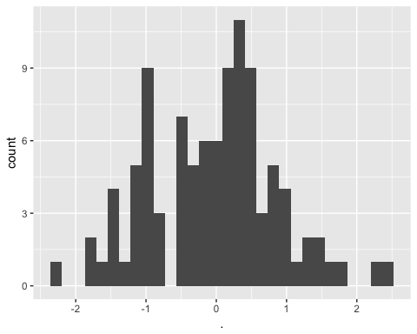

This is very cool:

## View(histplot)