Course One

Foundations of Data Science


Instructions
Use this PACE strategy document to record decisions and reflections as you work through this end-of-course project. You can use this document as a guide to consider your responses and reflections at different stages of the data analytical process. Additionally, the PACE strategy documents can be used as a resource when working on future projects.

Course Project Recap
Regardless of which track you have chosen to complete, your goals for this project are:
- Complete the PACE Strategy Document to plan your project while considering your audience members, teammates, key milestones, and overall project goal.
- Create a project proposal for the data team.

Relevant Interview Questions
Completing this end-of-course project will empower you to respond to the following interview topics:
- As a new member of a data analytics team, what steps could you take to get 'up to speed' with a current project? What steps would you take? Who would you like to meet with?
- How would you plan an analytics project?
- What steps would you take to translate a business question to an analytical solution?
- Why is actively managing data an important part of a data analytics team's responsibilities?
- What are some considerations you might need to be mindful of when reporting results?

Reference Guide
This project has three tasks; the following visual identifies how the stages of PACE are incorporated across those tasks.
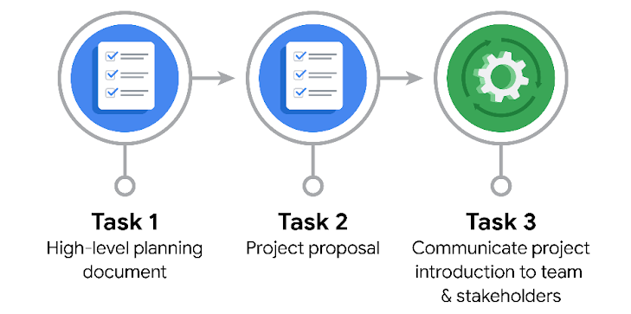

Data Project Questions & Considerations
PACE: Plan Stage

- Who is your audience for this project?

Deshawn Washington, Stakeholders of TLC (Titus Nelson and other TLC’s executives)

- What are you trying to solve or accomplish? And, what do you anticipate the impact of this work will be on the larger needs of the client?

We’ve been told to build a regression model that predicts taxi cab fares before each ride based on distance, time of day, and any additional variables we find necessary

- What questions need to be asked or answered?

Are there any faults/errors in the data? How to define ‘rush hours’? Do we have an access to all variables/deliverables?

- What resources are required to complete this project?

Team (Jesse, Deshawn), Tools (Python, mostly Pandas & SciKit-Learn), Details (data) from TLC for our regression models build
- What are the deliverables that will need to be created over the course of this project?

Correlation tables (distance/time of day/other variables we find necessary), graphs/visualizations, insights and other additional info from Customer, Business recommendations

THE PACE WORKFLOW
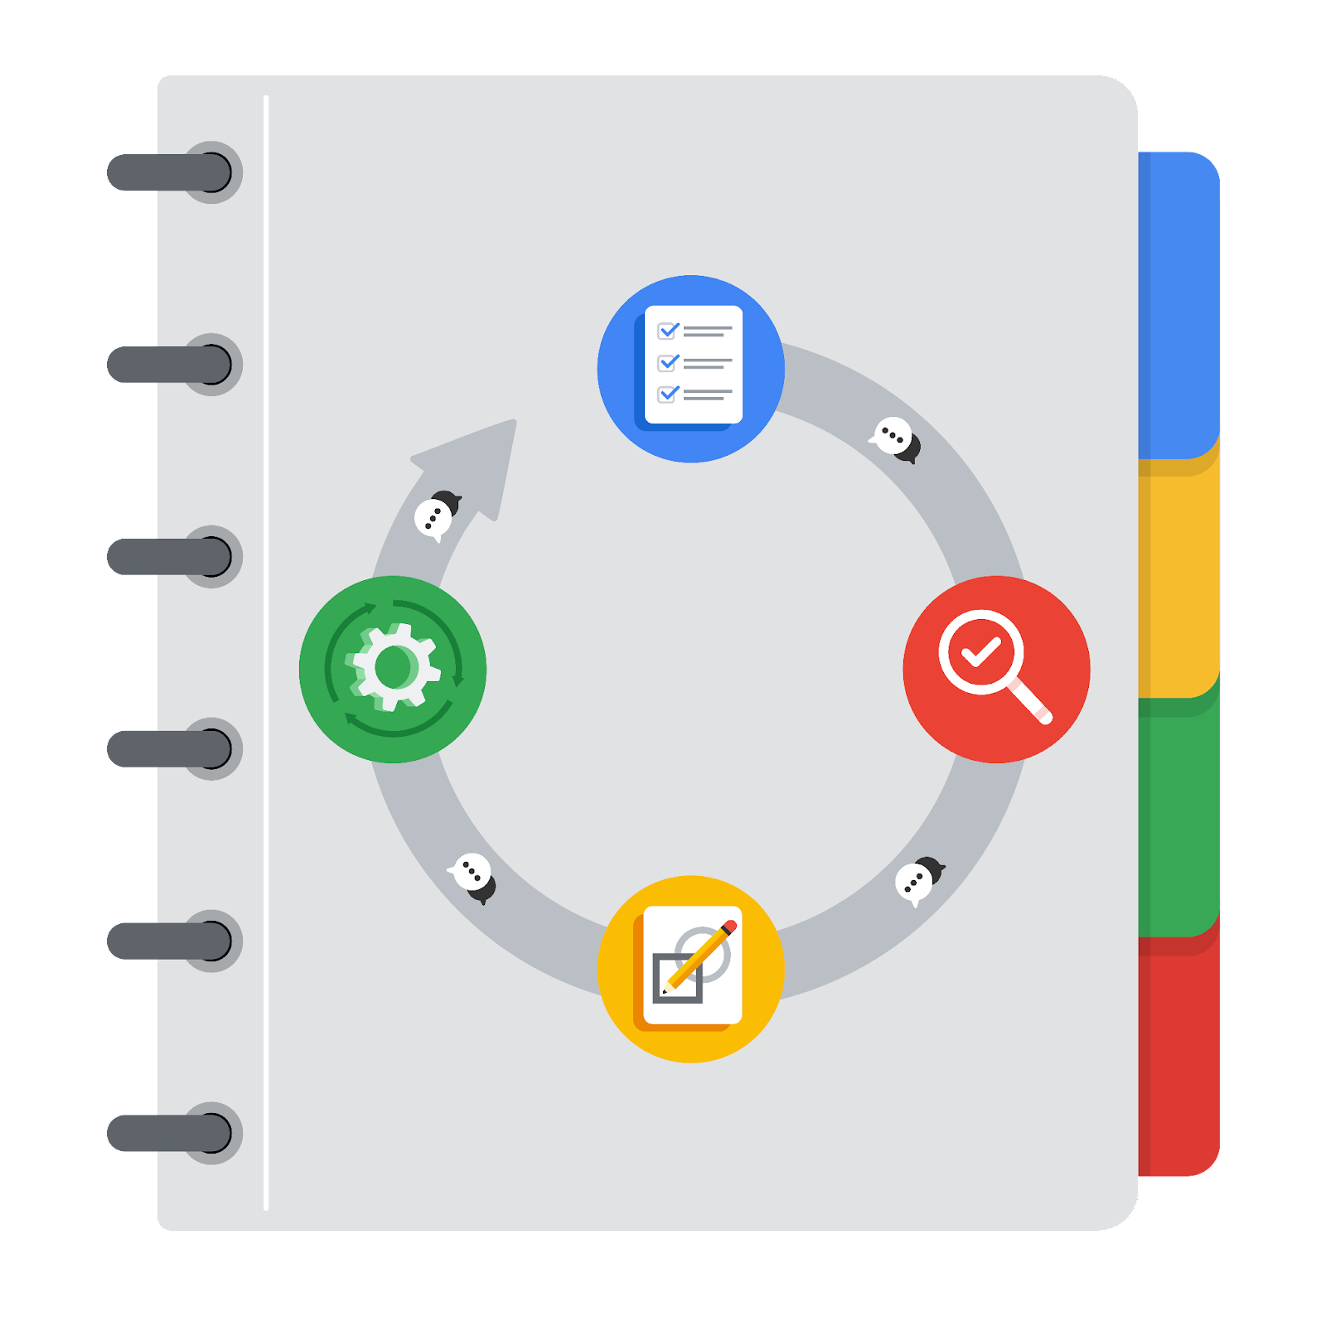
[Alt-text: The PACE Workflow with the four stages in a circle: plan, analyze, construct, and execute.]

You have been asked to demonstrate for the company's data team how you would use the PACE workflow to organize and classify tasks for the upcoming project. Select a PACE stage from the dropdown buttons. A few tasks involve more than one stage of the PACE workflow. Additionally, not every workplace scenario will require every task. Refer back to the Course 1 end-of-course portfolio project overview reading if you need more information about the tasks within the project.

Project tasks
Following are a group of tasks your company’s data team has determined need to be completed within this project. The data analysis manager has asked you to organize these tasks in preparation for the project proposal document. First, identify which stage of the PACE workflow each task would best fit under using the drop down menu. Next, give an explanation of why you selected the stage for each task. Review the following readings to help guide your selections and explanation: The PACE stages and Communicate objectives with a project proposal. You will later reorder these tasks within a project proposal.

- Evaluating the model: Execute
Why did you select this stage for this task?
Checking stage - whether the model works on our test data

- Conduct hypothesis testing: Construct and Execute
Why did you select these stages for this task?
Practical testing - has to be after we analyze the hypothesis

- Begin exploring the data: Analyze
Why did you select this stage for this task?
EDA - helps understand data relationships

- Data exploration and cleaning: Analyze and Construct
Why did you select these stages for this task?
Analyzing the data (EDA) & evaluating the main pinpoints after it has been cleaned

- Establish structure for project workflow (PACE): Plan
Why did you select this stage for this task?
Planning stage - we need to prepare the structure for the Project workflow

- Communicate final insights with stakeholders: Execute
Why did you select this stage for this task?
Business recommendations, our outcomes - presenting to the stakeholders

- Compute descriptive statistics: Analyze
Why did you select this stage for this task?
Analyzing the correlations, understanding what needs to be compared to make it clear

- Visualization building: Analyze and Construct
Why did you select these stages for this task?
We’re building the backend of the Final Insights for Stakeholders - prior to executing (showing) them

- Write a project proposal: Plan
Why did you select this stage for this task?
Our project preparation - we need to clarify what to do in the next steps

- Build a regression model: Analyze and Construct
Why did you select this stage for this task?
Understand (Analyze) and create/train the model (Construct)

- Compile summary information about the data: Execute
Why did you select this stage for this task?
Last step prior to the Results presentation to others

- Build machine learning model: Construct
Why did you select this stage for this task?
Practical step - building (constructing) the ML model

