Three Branding Strategies That Made Nutella A Business Success
Using the tagline “Spread the Happy,” Nutella has crossed the threshold from being a simple food product to national obsession, and its rise to the top could be a case study for entrepreneurs on how to run a business.
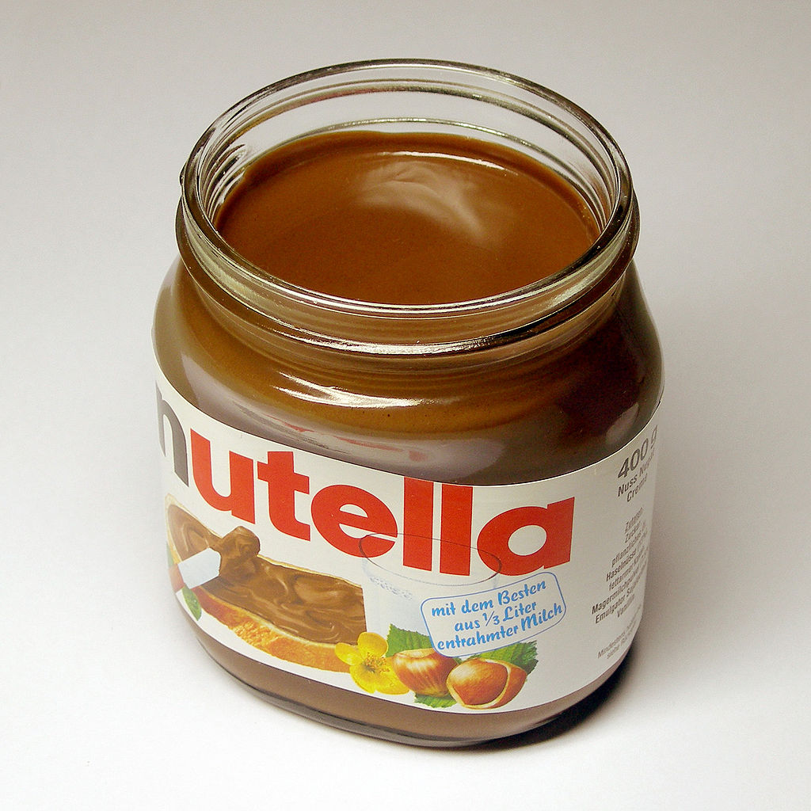

1. It focused on the breakfast market.
When Nutella came to the U.S., it branded itself as an alternative to several things, such as chocolate, jam and frosting, says Jason Biddle, branding expert and content developer for U.S. Imprints. Customers in other countries had already discovered its many uses, so Nutella assumed the U.S. market would quickly grasp the concept.
“But consumers just weren’t convinced that the signature spread was the miracle end-all-be-all type of product that it was claiming to be,” says Biddle. “Nutella was trying to be all things to all people and consequently became nothing to no one.”
In 2009, Nutella began focusing its branding almost purely on becoming a breakfast staple – something put on toast, waffles and bagels. This move helped consumers understand the product’s best use, says Biddle.
“It gave them a concise call-to-action of ‘eat this with your breakfast’ instead of its previous catch-all call-to-action of ‘eat this with everything,’” he says.

2. It tapped into a universal desire.

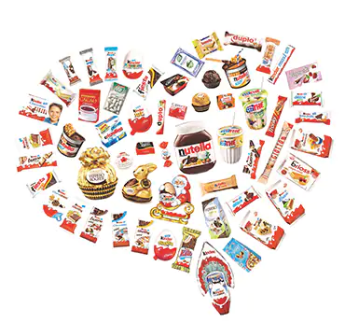
The second branding strategy proved to be controversial. Nutella was marketing itself as being part of a healthy diet. While the company never explicitly claimed the hazelnut spread was healthy in and of itself, it did cleverly branded the spread to be associated with a balanced diet, says Biddle.
“Nutella did this so well, that the parent company Ferrero had to change its advertising and settle a $3 million on a class-action lawsuit for deceptive advertising,” says Biddle. “It’s actually the healthiness aspect that led so many parents to incorporate the spread into their children’s diets, and Nutella managed to get a foot in the door in the homes of its target consumers.”

3. It capitalized on social proof.
Once the spread was in homes, curiosity led consumers to experiment with using it on other items, and soon people began sharing their creations on social media. This helped prove that Nutella was more than just a breakfast spread without Nutella having push that point (as they did unsuccessfully in the beginning), says Biddle.
“Social proof helps convince potential customers,” says Biddle. “It’s a case of, ‘If Susie is using Nutella, then maybe I should try it, too.’ Nutella’s strategy for growing this foundation of fans into a thrall of followers can be seen in its focused social media efforts.”
Nutella uses its social media pages to foster engagement with consumers. For example, in honor of its birthday, Nutella launched a “50 Years Full of Stories” global campaign, asking fans to share memories of using the spread. Those who shared stories via text, email or video received a personalized label and were eligible to win prizes. Nutella also focuses on visual-heavy platforms such as its Tumblr, Facebook and Pinterest pages.
“At this point, Nutella’s ability to grow its market share is based on the product itself,” says Biddle. “Consumers may justify purchasing Nutella by taking the stance that the spread may not be healthiest but there are worse things to eat, like donuts and cinnamon rolls. And when it tastes as good as it does, it’s hard to give it up.”
