'Best idea wins': how Pixar grew up
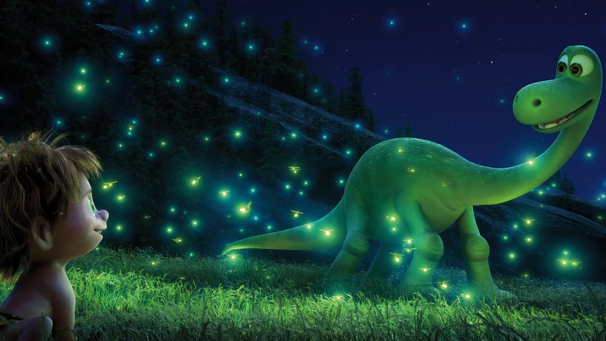
Pixar was founded in 1986 by computer scientist Ed Catmull, computer graphics pioneer Alvy Ray Smith and Steve Jobs, the Apple chief. Initially the company made computers; when that venture proved unsuccessful, it moved into creating CG animation for commercials, hiring ex-Disney animator John Lasseter. In the early Nineties Pixar began working on its first feature, Toy Story.
John Lasseter Pixar chief creative officer; director: Toy Story, A Bug’s Life, Toy Story 2, Cars, Cars 2, Toy Story 4: “It was a very small group [when I joined], but it was the smartest, most amazing computer researchers from around the world. They brought me in to work on the very first 3D computer animation of a character. It was [a short film] called The Adventures of André and Wally B. I was developing stuff at Disney with computers doing the backgrounds and the characters still animated by hand. But Ed challenged me and said, ‘Let’s try to do everything with the computer.’ ”
Ed Catmull co-founder and president: “John was the only animator here and we could never have made it to feature films with him alone, but by doing commercials we could bring in new talent.”
Lee Unkrich editor: Toy Story, A Bug’s Life, Finding Nemo; co-director: Toy Story 2, Monsters Inc., Finding Nemo; director: Toy Story 3: “When I first joined Pixar we were in rented office space in an industrial park and it was a very small operation. [Pixar] sold 3D software, it was making commercials and doing a lot of varied stuff. I joined at the time it was trying to get Toy Story made. It struck me as a company of mostly young people. I was in my 20s, like most of the people there. We had no idea if we were going to be able to pull off what we wanted to do, which was make the world’s first CG feature.”
Lasseter: “Disney kept trying to hire me back after each of the short films I had made. I kept saying, ‘Let me make a film for you up here [at Pixar]’. It always said, ‘No, a Disney animated film will always be made at Disney.’ It had no interest in doing an outside project. What changed their mind was Tim Burton. Tim and I went to college together and he had developed a feature idea [while employed by Disney] called The Nightmare Before Christmas. He went on to become a successful live-action director and was trying to buy Nightmare back from Disney. And it said, ‘Why don’t you just make it for us?’ That opened the door for Disney to think of these ‘niche’ animated films that could be done.”

