[1] 08/01: Vanilla GAN 16x16, g_conv_dim=64, d_conv_dim=64. Mode collapse to 2 outputs.

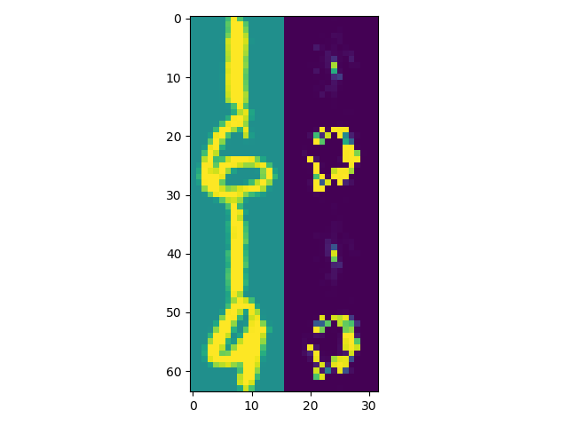

[2] 08/01: Vanilla GAN 28x28, g_conv_dim=64, d_conv_dim=64, niter=50, niter_decay=400, batch_size=64.

Observation: loss_D is already close to 0.5 from the first few iterations onwards. The more iterations, the less noisy the output but eventually ends up favouring certain digits (e.g. 8 -> 3, 7 -> 1)

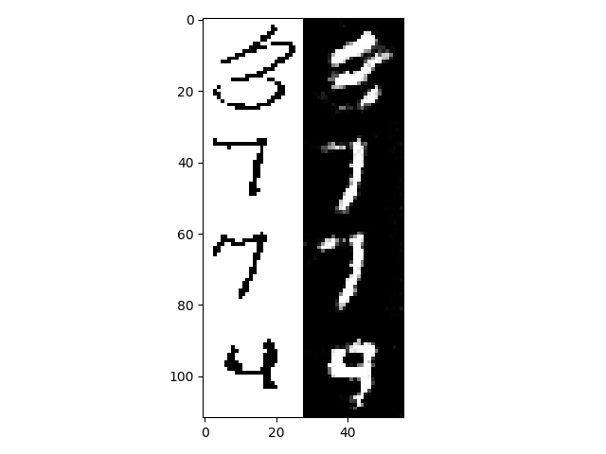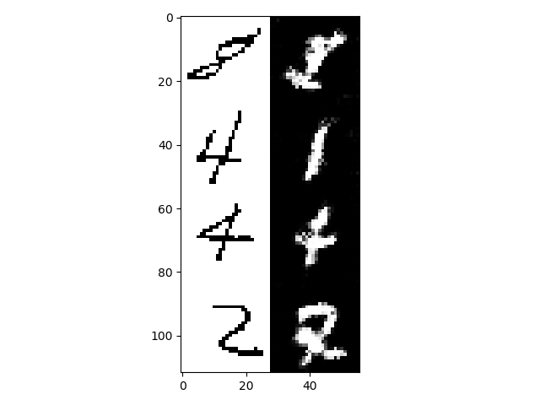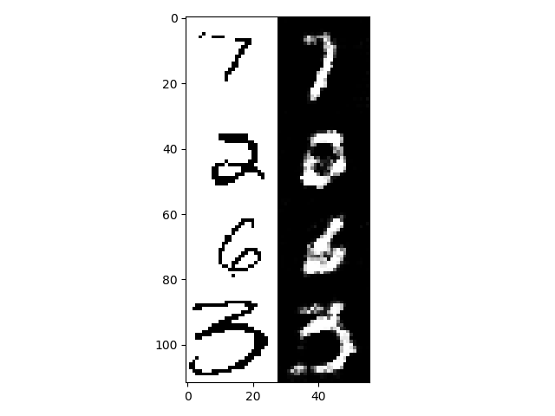

Maybe try tweaking g_conv_dim and d_conv_dim to find levels of sophistication of D and G that encourage fairer competition. Seeing that loss_D ~ 0.5 early on (it already cannot tell the difference between real and fake), try making it more sophisticated by setting d_conv_dim > g_conv_dim

[3] 09/01: Vanilla GAN 28x28, g_conv_dim=32, d_conv_dim=64, niter=50, niter_decay=400, batch_size=64.

Much better

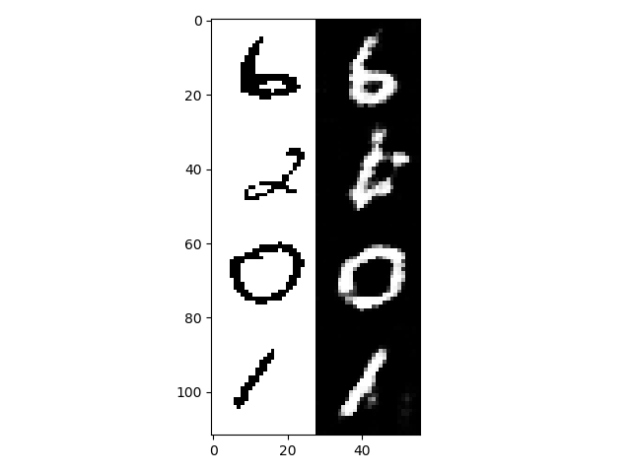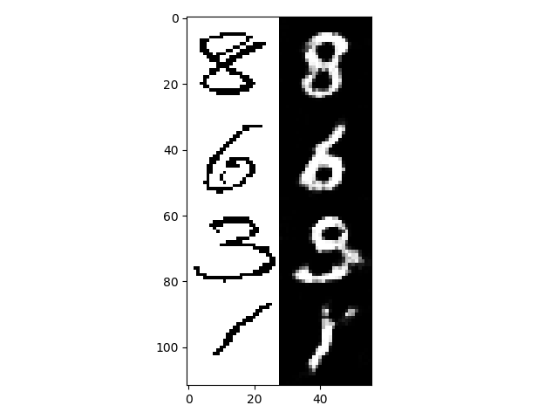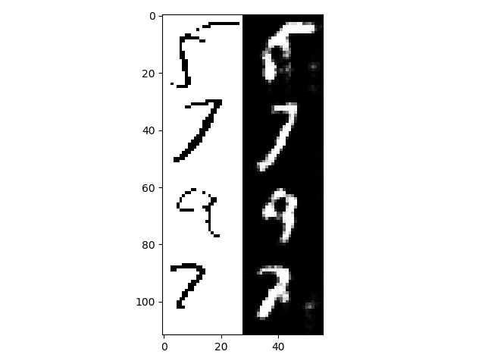

[4] 09/01: Vanilla GAN 28x28, g_conv_dim=20, d_conv_dim=64, niter=50, niter_decay=400, batch_size=64.

Poorer results possibly because G is not sophisticated enough to handle the variations in input

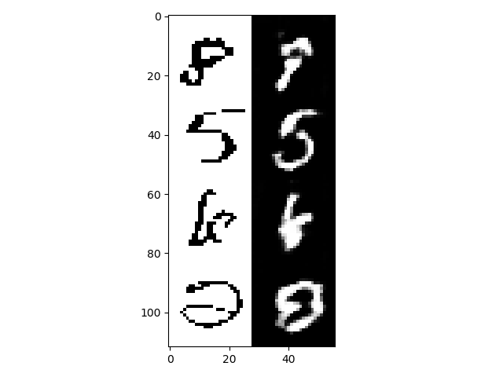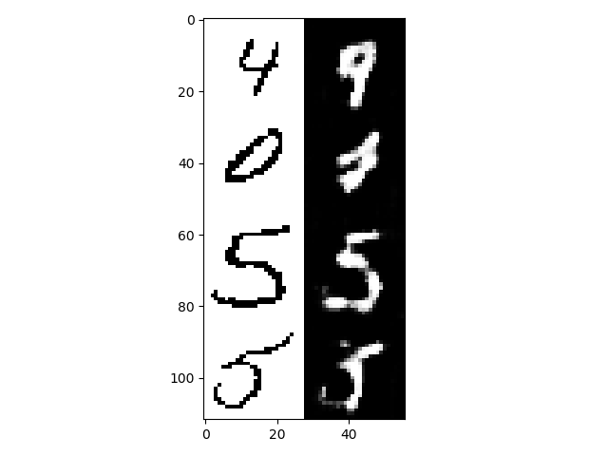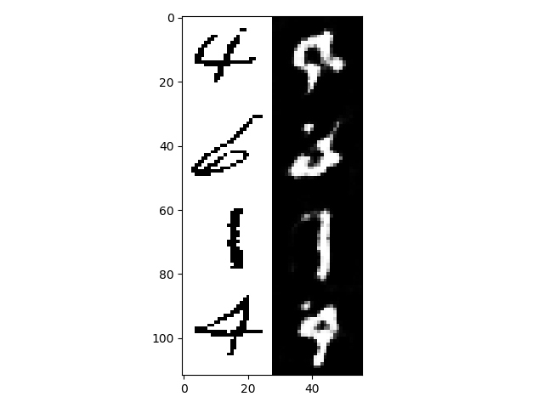

Still need d_conv_dim > g_conv_dim for the reason in [3] but concern about the network getting too large to train. Try decreasing d_conv_dim

[5] 09/01: Vanilla GAN 28x28, g_conv_dim=32, d_conv_dim=48, niter=50, niter_decay=400, batch_size=64.

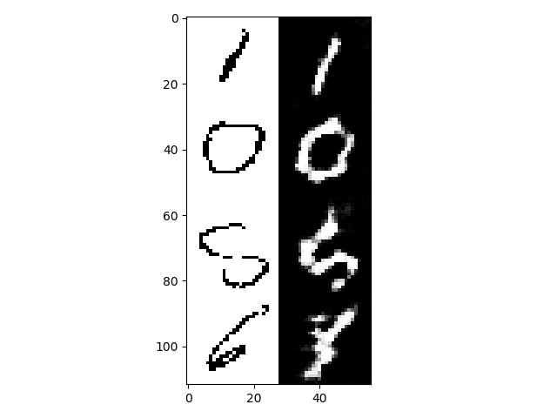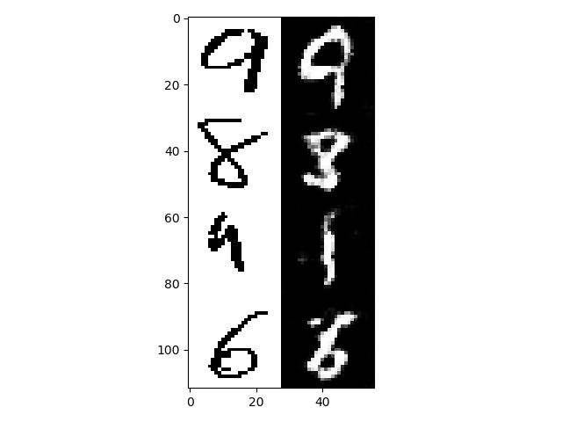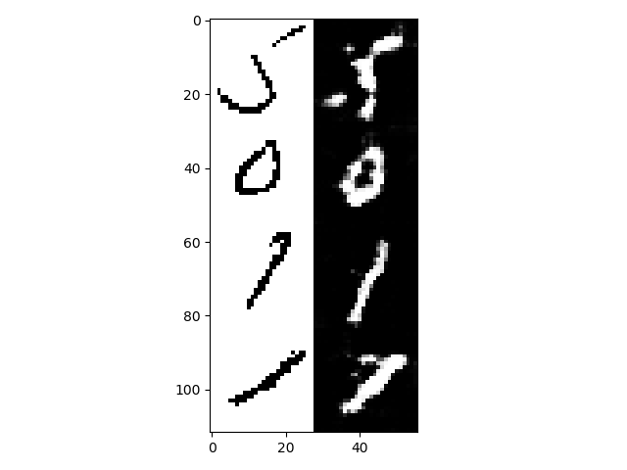

Same issues as [3] and arguably more pronounced. Will more iterations help?

[6] 09/01: Vanilla GAN 28x28, g_conv_dim=32, d_conv_dim=48, niter=70, niter_decay=700, batch_size=64.

Marginal improvements only. Also the images are noisy compared to [3]. Visually, [3] is still the best result.

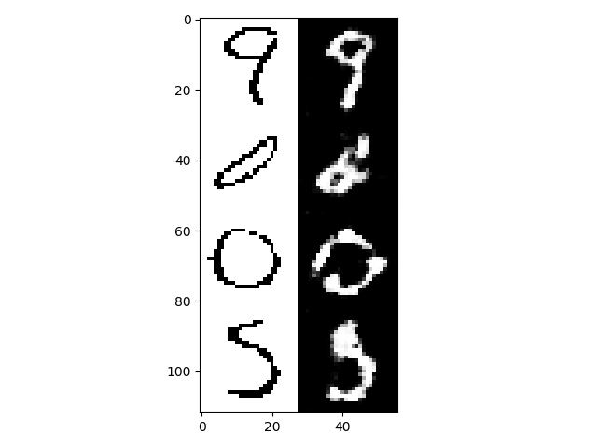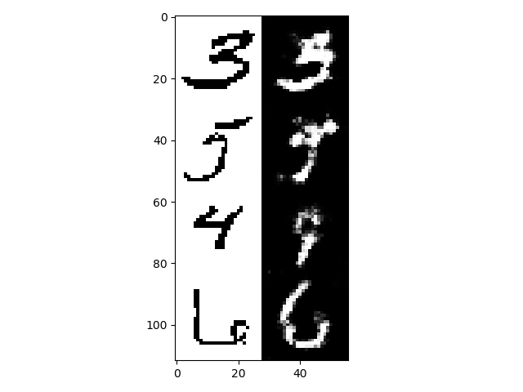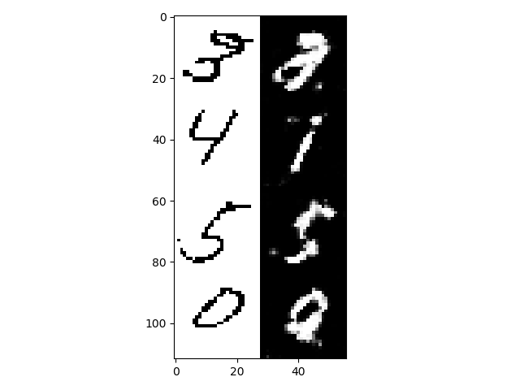

Let d_conv_dim remain at 64. Given that in [3] some numbers still fail to be rendered convincingly, try increase g_conv_dim to enable G to capture finer details in the image.

[7] 09/01: Vanilla GAN 28x28, g_conv_dim=36, d_conv_dim=64, niter=70, niter_decay=700, batch_size=64.

Same issues.

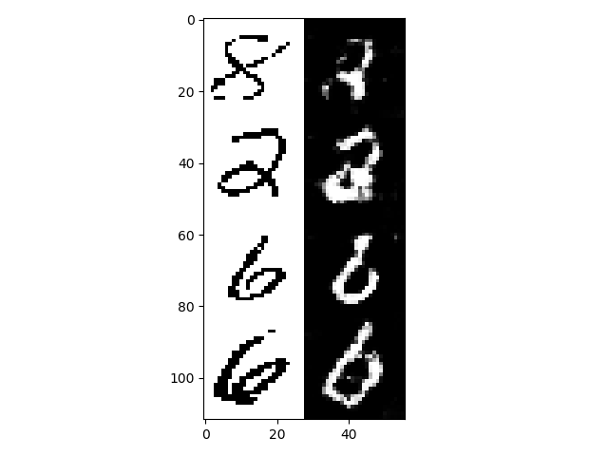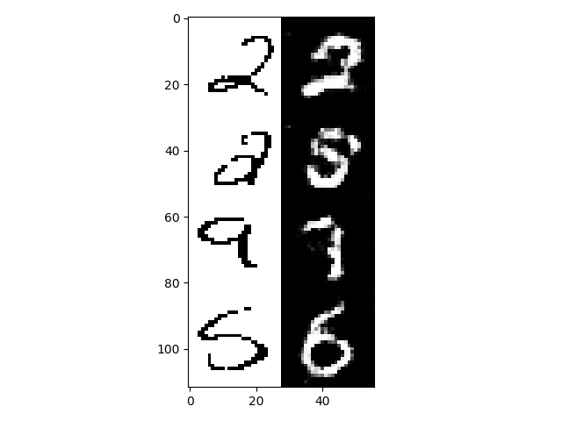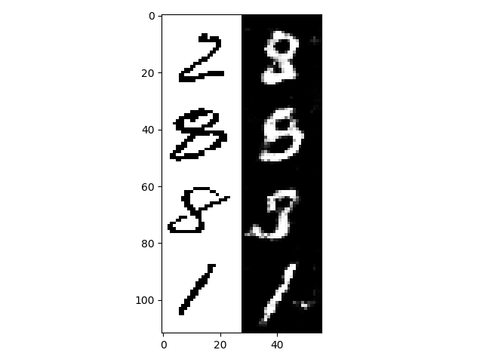

Even more iterations?

[8] 09/01: Vanilla GAN 28x28, g_conv_dim=36, d_conv_dim=64, niter=100, niter_decay=1200, batch_size=64.

Slightly better, but still suffers the same pitfalls of generating the wrong number as well as some noisiness.

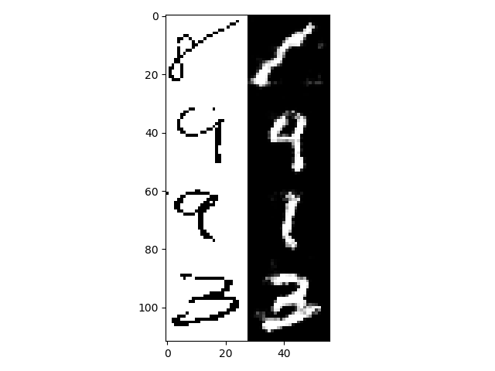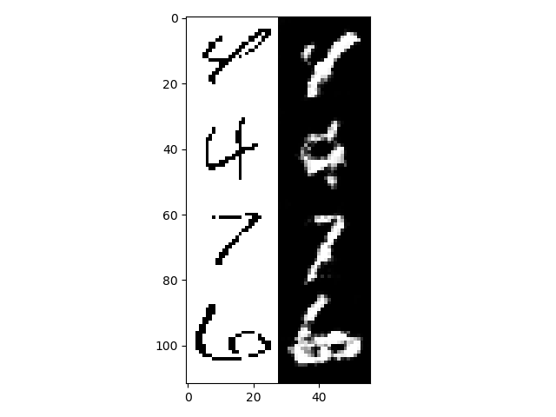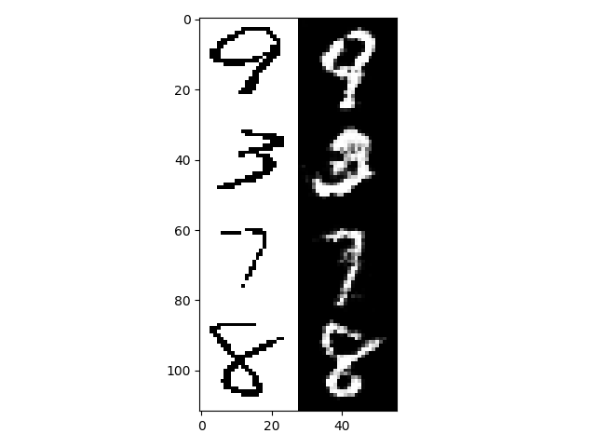

Everything above used 6 residual blocks as the network behind G. Try using which_model_netG=resnet_9blocks

[9] 09/01: Vanilla GAN 28x28, g_conv_dim=36, d_conv_dim=64, niter=60, niter_decay=600, batch_size=64, which_model_netG=resnet_9blocks.

Bad.

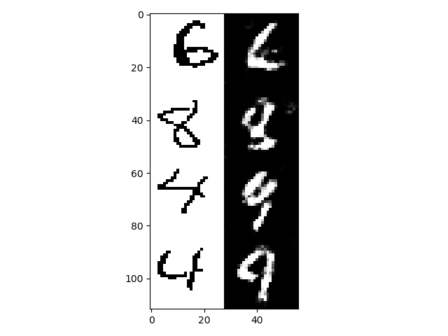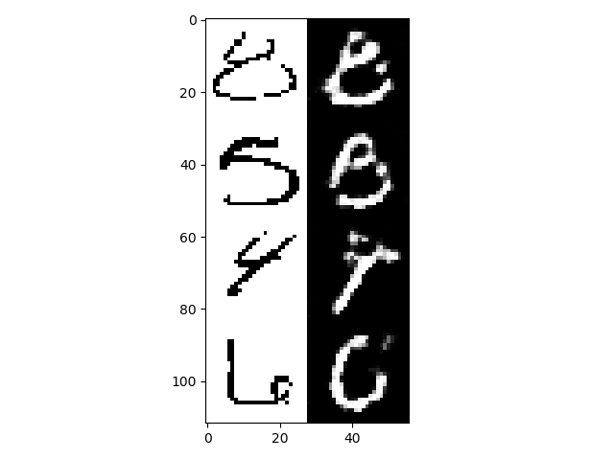

D is still too dumb.

[10] 09/01: Vanilla GAN 28x28, g_conv_dim=36, d_conv_dim=64, niter=60, niter_decay=600, batch_size=64, which_model_netG=resnet_9blocks

When the discriminator is not outsmarted by the generator, we see some rather good learning results. The output is quite convincing in some cases; however it is unstable in others.

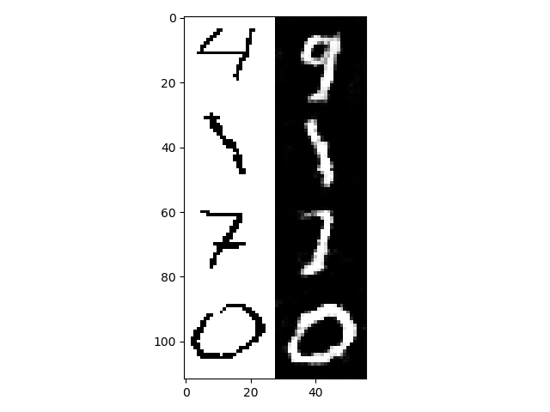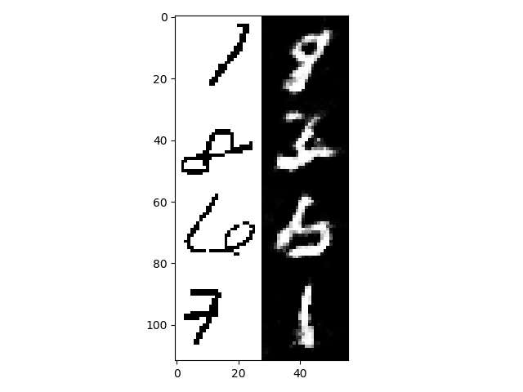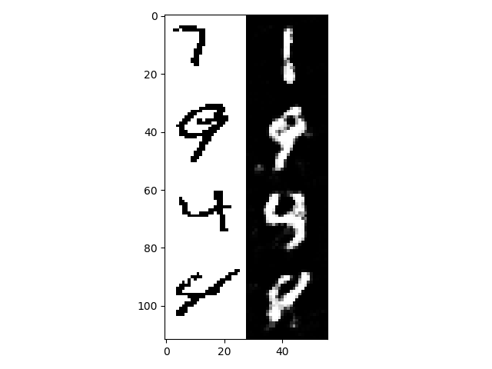

[11] 09/01: Vanilla GAN 28x28, g_conv_dim=64, d_conv_dim=64, niter=60, niter_decay=600, batch_size=32, which_model_netG=resnet_9blocks, D.use_sigmoid=True

Outputs are generally good but G is not mapping correct digits

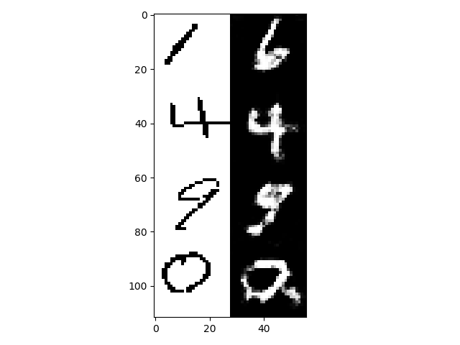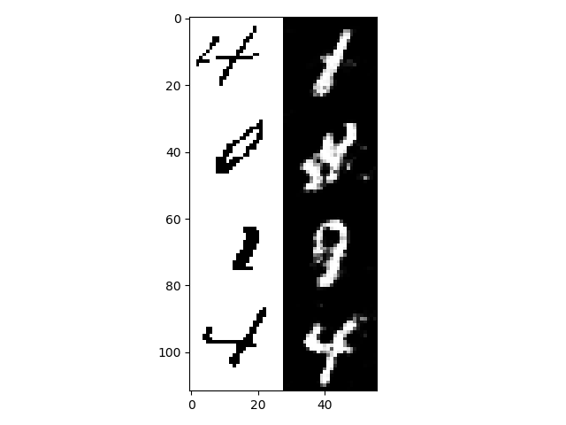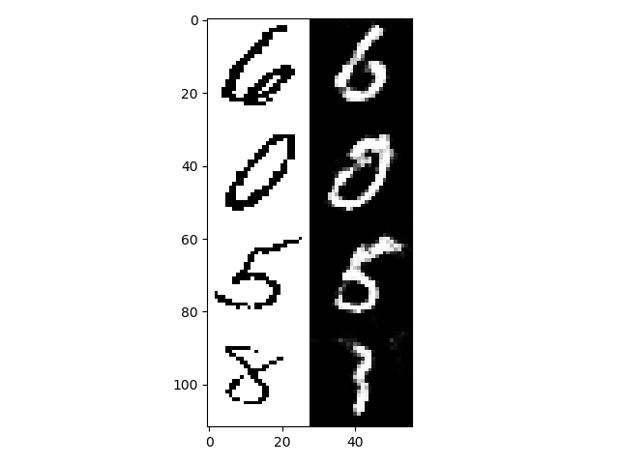

[12] 09/01: Vanilla GAN 28x28, g_conv_dim=64, d_conv_dim=64, niter=100, niter_decay=1400, batch_size=32, which_model_netG=resnet_9blocks, D.use_sigmoid=True, train G once every 2 iterations.

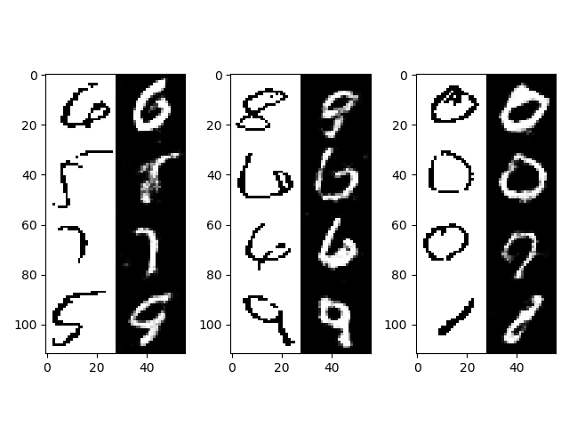

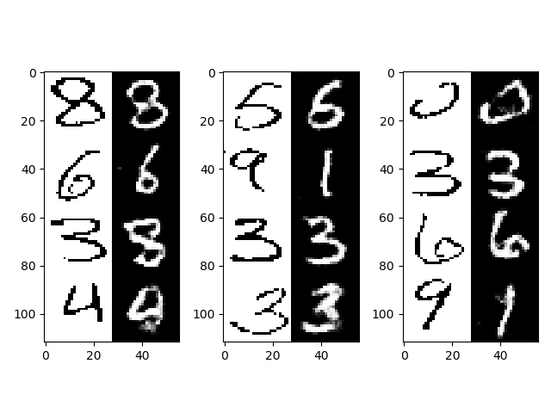

[13] 19/01: vanilla GAN. g_conv_dim=64, d_conv_dim=64, niter=1500, niter_decay=1500, batch_size=32, lr=0.0002, betas=(0.5, 0.999).

Result: 72.4% of test set classified correctly

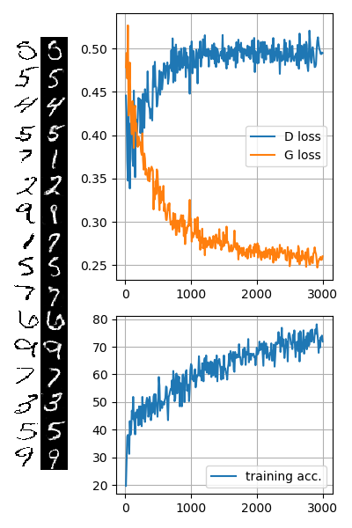

[14] 19/01: GcGAN. config same as [13] but with lambda_gc=1.0.

Result: 69.8%

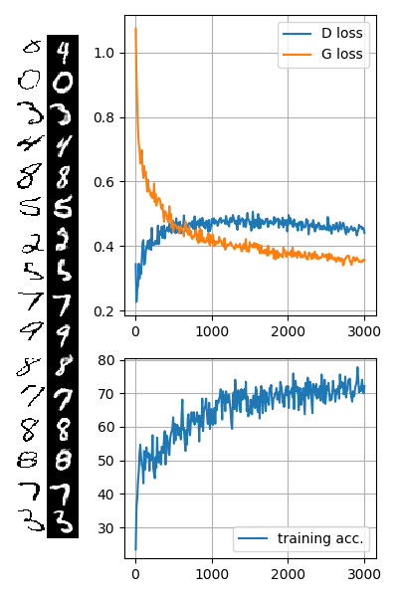

[15] 19/01: GcGAN. Same as [14] but with n_iter = n_iter_decay = 2000 to observe if performance plateaued

Result: 70.2%

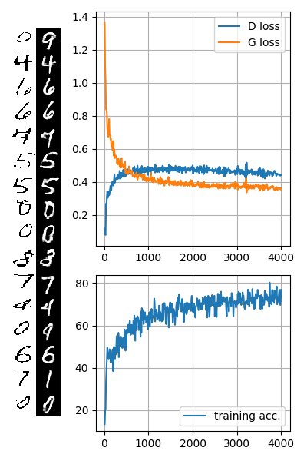

**Default settings**

Which_model_netD = ‘resnet_6blocks’

Which_model_netG = ‘basic’

G_conv_dim = d_conv_dim = 64

Niter = n_iter_decay = 1500

Batch_size = 32

Num_workers = 4

Lr = 0.0002

Beta1 = 0.5

Beta2 = 0.999

Lr_policy = ‘lambda’

Lambda_gan = 1.0

Use_lsgan = True

Lambda_cycle = 0.0

Lambda_gc = 0.0

Lambda_reconst = 0.0

Lambda_dist = 0.0

Begin_train = True

Geometry = 1

Pretrained_mnist_model = ‘models/MNISTClassifier/200115-172045-MNISTClassifier.pth’

[16] 25/01: default settings. (Vanilla GAN; lambda_gan = 1.0, all other criteria 0.0)

Result: 89.06% accuracy

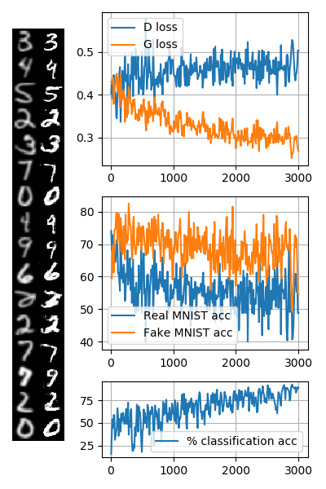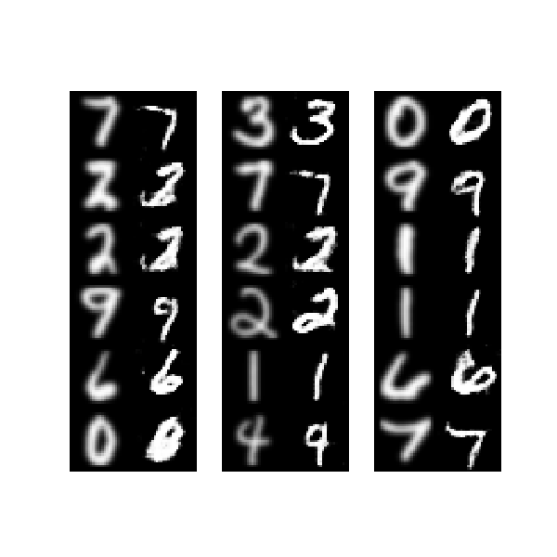

[17] 25/01: lambda_gan = 1.0, lambda_gc = 1.7

(model breaks when lambda_gc = 1.8. The highest it can go is 1.7. Even at 1.7 it occasionally fails)

Result: 94.06%

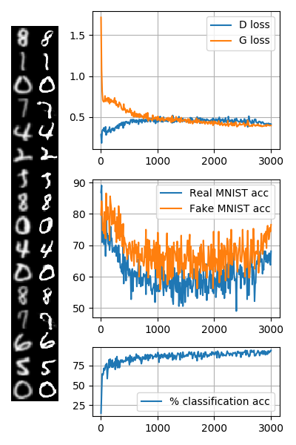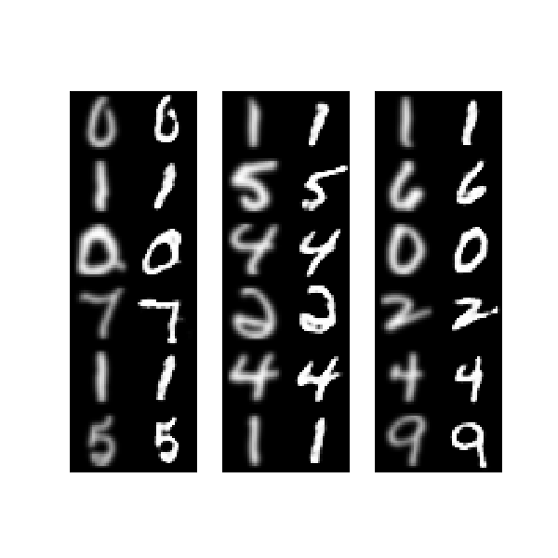

[18] 26/01: lambda_gan = 1.0, lambda_cycle = 20.0

Result:

Peak performance reached very quickly (after only about 200 iterations)

The transformation appears to be producing near-identity mappings, defeating the purpose of stylistic transfer. May be due to a large weighting given to the cycle consistency constraint

* Why is the discriminator so strong?

[19] 31/01: list of GcGAN tests to carry out

|  |  |  |
| --- | --- | --- |
| Rule | Lambda_gc | Result |
| Identity, one G (i.e. Vanilla GAN) |  |  |
| Identity, separate G |  |  |
| Rot90, one G |  |  |
| Rot90, separate G |  |  |
| Rot180, one G |  |  |
| Rot180, separate G |  |  |
| Identity + noise, one G |  |  |
| Identity + noise, separate G |  |  |
| Rot90 + noise, one G |  |  |
| Rot90 + noise, separate G |  |  |
| Rot180 + noise, one G |  |  |
| Rot180 + noise, separate G |  |  |