FASTTEXT.

Drawvecs to word2vec
- No sentence representation.
- Not exploiting morphology. (disastrous / disaster)

FastText
(1) Goal : Unified framework to “Text Representation and Text Classification”
(2) Core of the FastText : Given a set of indices, predict an index
(3) We can say that CBOW, SKip-gram are instances of this model.

Compare with “CBOW and Skip-gram”
- Both models are instances of a broader set of models
- Different input and output dictionaries.
- Common core but different pooling strategies.

Bag of Tricks for Efficient Text Classification

Model
- Model probability of a label given a paragraph
(1) feature for paragraph P : h_{p} = sum of word vectors
- Word vectors are latent and not useful for any task
- If scarce supervised data, Use pre-trained word vectors
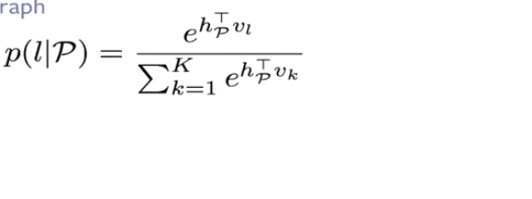
(2) Classifier for label l : v_{l}
N-Grams
- Possible to add higher-order features.
--) but avoid building n-gram dictionary (Too big)
--) Use Hashed dictionary

Tag prediction
- Using Flickr data
- Given an image caption, predict the most likely tag

Enriching Word Vectors with sub-word information.

- Exploiting sub-word information
(1) represent words as sum of its character n-grams.
(2) Grammatical variation
(3) Compound nouns are easy to model.

Model
(1) As in skip-gram, model probability of a context word given a word.
- classifier for word c : v_{c}
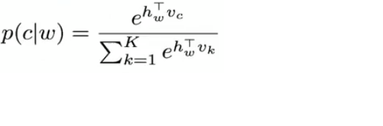
- feature for word w : h_{w,} It is computed using n-grams
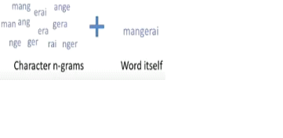
--) As for the previous model, Use hashing for n-grams
OOV words
- possible to build vectors for unseen words using n-grams.
** In word2vec, just use “UNK”
--) Through word similarity, works well for rare words and morphologically rich languages. ( Can use in sktproject. )

Word analogies : Also good in syntatic analogy.

