MELS Software component

User’s guide

Table of Contents

1. Introduction 2

2. Prerequisites 3

2.1 .NET framework 3

2.2 MELS source code 3

3. Run MELS software 5

3.1 Configuration files 5

3.2 Software execution 5

4. Input file preparation 7

4.1 Creating XML file 7

4.1.1 Crop Sequence 8

4.1.2 Livestock Sequence 11

4.2 End of the XML 13

# 1. Introduction

The following document describes the use of MELS software based on the adaptation made to meet the latest input parameters modifications.

The project source tree is organized as it can be seen in the following figure. Under the root directory the user can navigate into the **inputFiles** folder and modify any existing files. The calculated results of each execution are stored under the **outputFiles** folder.

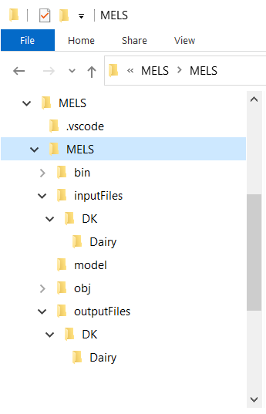

Figure 1: Source tree

The **bin** directory listed above include the executable file which is generated by the source files.

# 2. Prerequisites

## 2.1 .NET framework

MELS software is a C# based application. For this reason, the easiest way for a user to execute the program is to install .NET framework on his computer. The .NET framework can be downloaded from: <https://dotnet.microsoft.com/en-us/download>

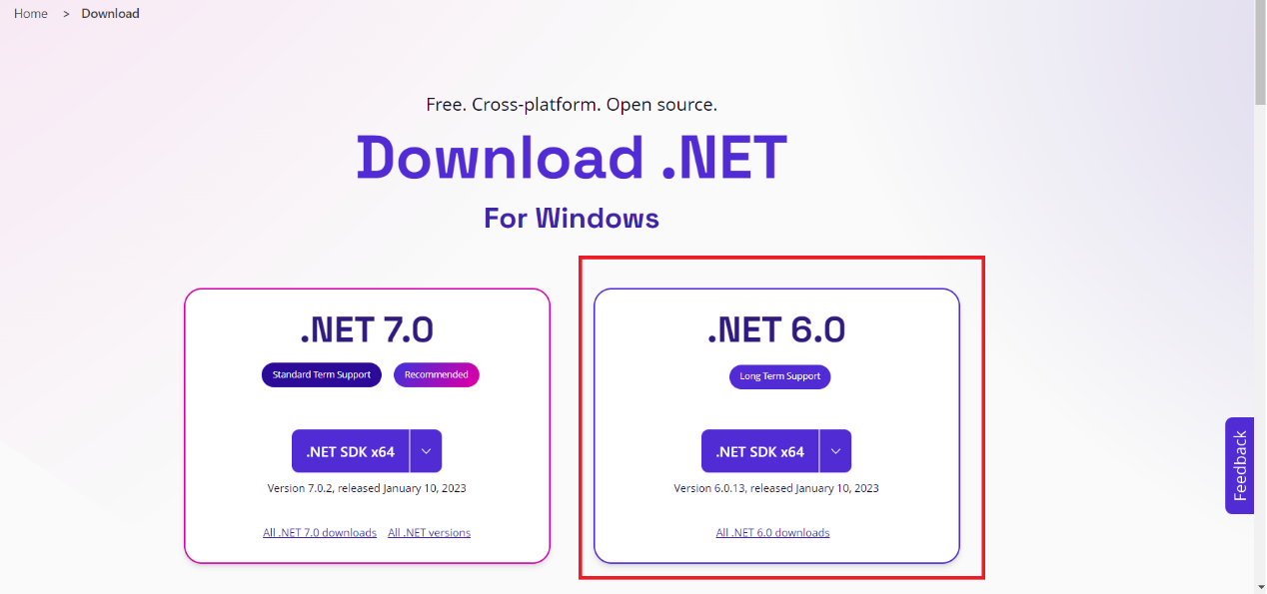

Figure 2 Download .NET 6.0

**Currently the software can run using .NET 6.0**. Upon selecting the download button, the user will be prompt to select the location to store the installation file. When download completes, the user shall install .NET framework by running the downloaded executable.

## 2.2 MELS source code

The MELS software component can be downloaded from GitHub by following the link below.

<https://github.com/mike1821/MELS/tree/master>

The user by pressing the <>Code button on the displayed webpage can download the source code, either by cloning the git repository or by downloading a .zip file (see **figure (3)** below).

Upon selecting to download the .zip file of the source code, the user can select were to store the file on his local hard drive. When download completes the user shall navigate to the destination folder and extract the downloaded .zip file.

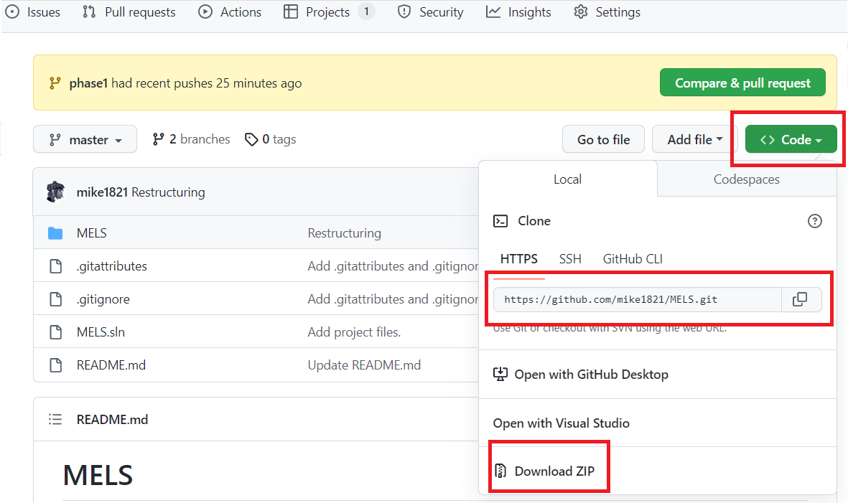

Figure 3: Software download

# 3. Run MELS software

## 3.1 Configuration files

**system**:

This system.xml file is the base file for running the MELS software. The file is located in the root directory of the MELS directory. The user shall edit the file and set the farm file name that he wants to process. The farm filename is located at line 7 of the system.xml file.

**farmfile**:

The farmfile is generated by the user, see instructions on section (4). The user shall place the file under the inputFiles/DK/Dairy directory and set the corresponding name in the system.xml file. The farmfile shall use the following naming convention: **farm_xxxx_y**

Were,

**xxxx**: is the farm number

**y**: is the selected scenario

## 3.2 Software execution

In order to run the software, the user shall use a command prompt. Run command prompt and navigate the project location directory.

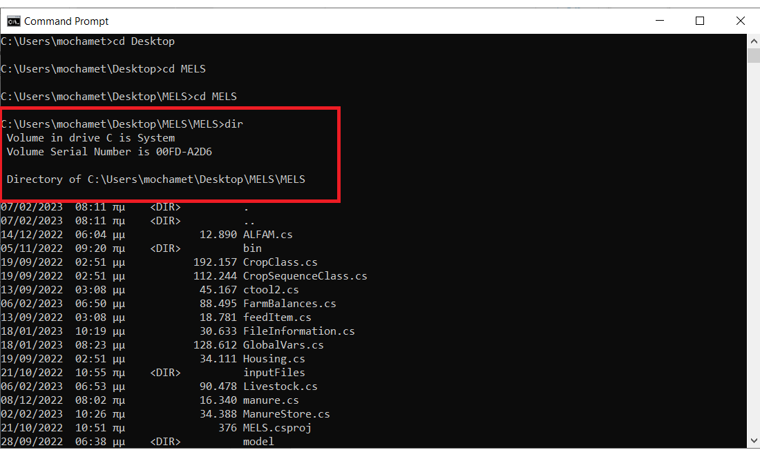

Figure 4: Command prompt

As soon as you enter the project directory type the command:

**dotnet run**

The above command will automatically build and run the downloaded software and post the calculated results in the outputFiles directory.

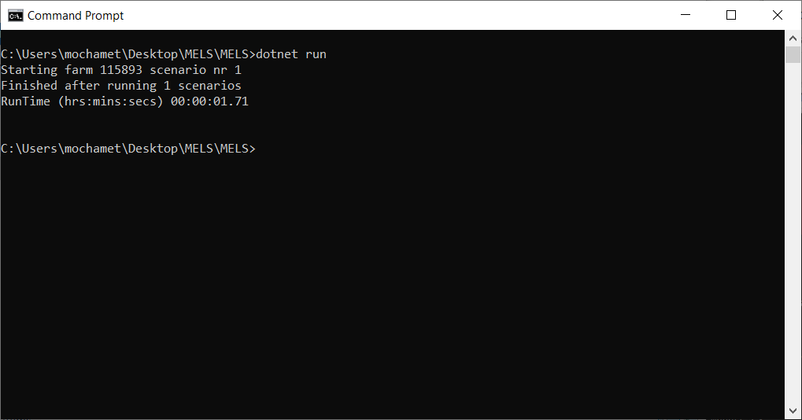

Figure 5 Sample output

# 4. Input file preparation

Input file is an essential part of MELS functionality. It is required so the program can simulate the created Farm and calculate results in the outputFiles. Farm file is an xml structured file that is created with 4 basic rules:

* XML must have a root element
* Tags must be properly nested
* Tags names are case sensitive
* Attribute values must be in quotes

## 4.1 Creating XML file

Given the aforementioned rules above, Input file(s) must follow the below structure. First of all, we will give the basic root elements:

<?xml version="1.0" standalone="yes"?>

<NewDataSet>

  <Farm>

  </Farm>

</NewDataSet>

Secondly, we need to provide some mandatory data segments for our Farm.

<NewDataSet>

  <Farm>

    <Identity>1</Identity>

    <FarmNumber>1</FarmNumber>

    <FarmOwnerName>Greece</FarmOwnerName>

    <FarmOwnerAddress />

    <FarmOwnerZipCode />

    <FarmOwnerTown />

    <FarmDescription />

    <AgroEcologicalZone>15</AgroEcologicalZone>

    <GeographicalZone>West</GeographicalZone>

    <FarmType>3</FarmType>

    <FarmTypeDescription>CaseStudy</FarmTypeDescription>

    <SelectedScenario>

    </SelectedScenario>  
 </Farm>  
</NewDataSet>

**<ArgoEcologicalZone>**: is one of the basic attributes since most of the values of our farm will be pulled from parameters file, which contains 15 different zones with different attributes for each one and acts as an offline database for our calculations.

**<GeographicalZone>:** will take values West or East depending on the user needs.

**<SelectedScenario>** will describe the selected scenario the user requires to process.

We add some basic info as in the Farm Attribute:

    <SelectedScenario>

      <Identity>1</Identity>

      <FarmNumber>1</FarmNumber>

      <Name>Scenario 1 - Baseline</Name>

      <NumberOfScenario>1</NumberOfScenario>

      <IS-ID>1</IS-ID>

      <ES-ID>1</ES-ID>

      <InventorySystem>

        <Name>IPCC 2019 </Name>

        <Value>1</Value>

      </InventorySystem>

And then MELS will take three categories:

1. Crop only option.
2. Livestock only option
3. Crop and Livestock (Crop always have to be first on the sequence of the xml.)

For the purposes of the manual, we will follow option (3) above, which contains both.

### 4.1.1 Crop Sequence

MELS needs Crop Sequence to follow some extra rules:

**1) Crop sequence must be 1 year:**

A crop sequence must last at least one year (365 days) and the day and month on which the last crop ends must be one day before the day and month of the start of the first crop. (e.g., if the first crop starts on 2.4.20xx then the last crop must end on 1.4.20yy). If the crop, we added is seasonal we have to add a bare soil on the remaining months to conclude the year.  
There can be no gaps in the cropping sequence.

**2) Fertilizers and Manure (Optional):**Fertilizers or Manure should be added on a month that the crop exists.  
A fertilizer or manure out of the crop months will result to an error on the MELS code.

**3) Product:**Every crop sequence that isn’t bare soil should have a product of the same family of the crop. (e.g Maize cannot produce corn).

**4) Rotation:**Every new Crop should be start with the <Rotation> element and raise the <identity> by 1.  
  
**Below I will show an example that follows all the four rules for crop sequence:**

      <Rotation>

        <Identity>1</Identity>

        <FarmNumber>2</FarmNumber>

        <ScenarioID>1</ScenarioID>

        <NameOfRotation>1</NameOfRotation>

        <Area>65</Area>

        <SoilType>Heavy Clayey Soil (&lt; 45% clay)</SoilType>

        <Crop>

          <Identity>1</Identity>

          <NameOfCrop>Maize</NameOfCrop>

          <RotationID>1</RotationID>

          <Start_day>29</Start_day>

          <Start_month>4</Start_month>

          <Start_year>2020</Start_year>

          <End_day>7</End_day>

          <End_month>10</End_month>

          <End_year>2020</End_year>

          <Irrigation>false</Irrigation>

          <Manure_applied>

            <Identity>1</Identity>

            <StorageType>1</StorageType>

            <Name>Cattle slurry</Name>

            <DeliveryID>1</DeliveryID>

            <Unit>kg N/ha</Unit>

            <Value>3298.37</Value>

            <N_Loss>72.56414</N_Loss>

            <Type>1</Type>

            <Kg_N_Utilized>0</Kg_N_Utilized>

            <Month_applied>4</Month_applied>

            <RotationID>1</RotationID>

            <SpeciesGroup>1</SpeciesGroup>

            <FieldPlanRotationID>1</FieldPlanRotationID>

            <MFId>0</MFId>

            <Applic_technique_Manure>

              <NameS>Injection</NameS>

              <NameI>1</NameI>

              <RotationID>1</RotationID>

              <FieldPlanRotationID>1</FieldPlanRotationID>

              <StorageID>1</StorageID>

              <MFId>0</MFId>

            </Applic_technique_Manure>

          </Manure_applied>

          <Fertilizer_applied>

            <Identity>1</Identity>

            <StorageID>40</StorageID>

            <Name>Urea</Name>

            <DeliveryID>5</DeliveryID>

            <Unit>kg N/ha</Unit>

            <Value>207</Value>

            <N_Loss>4.554</N_Loss>

            <Type>2</Type>

            <Kg_N_Utilized>0</Kg_N_Utilized>

            <Month_applied>4</Month_applied>

            <RotationID>1</RotationID>

            <FieldPlanRotationID>1</FieldPlanRotationID>

            <MFId>2</MFId>

            <Applic_technique_Fertilizer>

              <NameS>Fertilizer spreading</NameS>

              <NameI>5</NameI>

              <RotationID>1</RotationID>

              <FieldPlanRotationID>1</FieldPlanRotationID>

              <StorageID>40</StorageID>

              <MFId>2</MFId>

            </Applic_technique_Fertilizer>

          </Fertilizer_applied>

          <HarvestMethod>

            <Value>Grazing</Value>

            <Description>Grazing</Description>

            <Identity>1</Identity>

            <RotationID>1</RotationID>

          </HarvestMethod>

          <Product>

            <Identity>6</Identity>

            <Name>Maize</Name>

            <Amount>0</Amount>

            <FeedCode>204</FeedCode>

            <Harvested>Harvested</Harvested>

            <RotationID>1</RotationID>

            <FieldPlanRotationID>1</FieldPlanRotationID>

            <Grazed>false</Grazed>

            <Expected_yield>

              <Value>65000</Value>

              <Unit>kg DM/ha</Unit>

              <RotationID>1</RotationID>

              <FieldPlanRotationID>1</FieldPlanRotationID>

              <FeedstuffID>204</FeedstuffID>

            </Expected_yield>

            <Potential_yield>

              <Value>65000</Value>

              <Unit>kg DM/ha</Unit>

              <RotationID>1</RotationID>

              <FieldPlanRotationID>1</FieldPlanRotationID>

              <FeedstuffID>204</FeedstuffID>

            </Potential_yield>

          </Product>

        </Crop>

        <Crop>

          <Identity>2</Identity>

          <NameOfCrop>Bare soil</NameOfCrop>

          <RotationID>2</RotationID>

          <Start_day>8</Start_day>

          <Start_month>10</Start_month>

          <Start_year>2020</Start_year>

          <End_day>28</End_day>

          <End_month>4</End_month>

          <End_year>2021</End_year>

          <Irrigation>false</Irrigation>

        </Crop>

      </Rotation>

Bare soil crop is added since the Maize Crop isn’t an one year sequence.

### 4.1.2 Livestock Sequence

After we add the basic info of the livestock group we have, MELS needs livestock Sequence to follow these rules :

**1) ItemFed:**

Livestock should have at least 1 itemFed element in their sequence.  
  
**2) Housing:**

Housing element is needed also.

**3) Livestock:**

Every new livestock we add should start with <Livestock> element and increase element <identity> by 1.

Below is a simple example.

      <Livestock>

        <Identity>1</Identity>

        <Species_group>1</Species_group>

        <LivestockType>1</LivestockType>

        <NameOfAnimals>Holstein types - dairy</NameOfAnimals>

        <NumberOfAnimals>48.00</NumberOfAnimals>

        <avgProductionMilk>8500</avgProductionMilk>

        <avgProductionMeat>0</avgProductionMeat>

        <ProductionLevel3>0</ProductionLevel3>

        <ScenarioID>1</ScenarioID>

        <HerdID>1</HerdID>

        <itemFed>

          <Identity>2</Identity>

          <FeedCode>278</FeedCode>

          <Name>Cane molasses (treacle)</Name>

          <Amount>0.2555</Amount>

          <Grazed>false</Grazed>

          <LivestockType>1</LivestockType>

          <Species_group>1</Species_group>

          <HerdID>1</HerdID>

          <Unit>kg DM/day</Unit>

        </itemFed>

        <itemFed>

          <Identity>3</Identity>

          <FeedCode>930</FeedCode>

          <Name>DDGS (Corn and Wheat</Name>

          <Amount>1.347</Amount>

          <Grazed>false</Grazed>

          <LivestockType>1</LivestockType>

          <Species_group>1</Species_group>

          <HerdID>1</HerdID>

          <Unit>kg DM/day</Unit>

        </itemFed>

        <Housing>

          <Identity>1</Identity>

          <HousingType>6</HousingType>

          <NameOfHousing>Deep litter</NameOfHousing>

          <LivestockType>1</LivestockType>

          <Species_group>1</Species_group>

          <PropTime>1</PropTime>

          <HerdID>1</HerdID>

          <ManureRecipient>

            <Identity>3</Identity>

            <StorageType>3</StorageType>

            <StorageName>Dunghill without cover</StorageName>

            <Stable>6</Stable>

            <HerdID>1</HerdID>

            <LivestockType>1</LivestockType>

            <Species_group>1</Species_group>

          </ManureRecipient>

        </Housing>

      </Livestock>

## 4.2 End of the XML

After we add all the live stocks we need to terminate the root element of the xml file, using the following section.

      <EnergySystem>

        <Name>Metabolisable energy</Name>

        <Value>1</Value>

      </EnergySystem>

    </SelectedScenario>

    <NDepositionRate>

      <Description>Rate of deposition of N from the atmosphere</Description>

      <Value>15</Value>

      <Units>Kg N/ha/year</Units>

      <FarmNumber>1</FarmNumber>

    </NDepositionRate>