# MPC-MAP Week No. 3 - Report

## **Author:** Michal Miškolci

## **Date:** 5. 3. 2025

## Task 2

The goal of this task was to define a path in indoor_1 map, leading from point (2, 8.5) to the goal position. The defined path consists of straight lines and circular arcs, both sampled with a defined step and is visible in Figure 1 by green color. The straight lines were firstly defined by only beginning and end point, but for path following algorithm it was useful to sample them also.

Figure – Created path

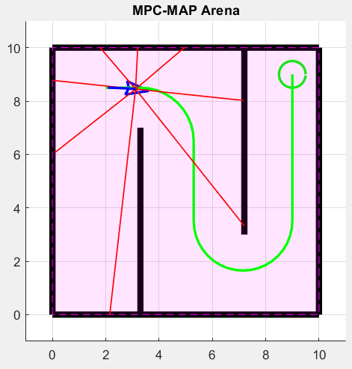

## Task 3

The purpose of this task was to choose any path-following algorithm and implement it to make the robot follow the path defined in the previous task. To achieve this, proportional regulator was used to regulate turning speed, which was then by a formula with a given wheelbase calculated to both motor speeds (with speed saturation). Proportional parameter was tuned empirically to achieve smooth drive. It was necessary to define a parameter lookahead distance which basically defines a point from where it calculates heading error. On Figure 1 and 2, can be seen the final path-following trajectory, when having larger lookahead distance, it cuts corners more and reaches the final point faster.

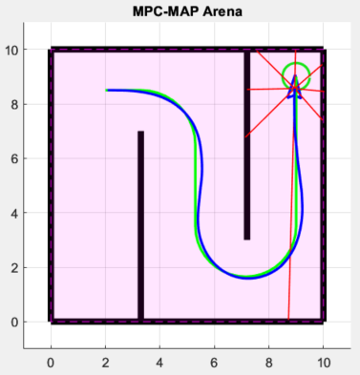

Figure 2 – Trajectory when   
lookahead distance = 1.5

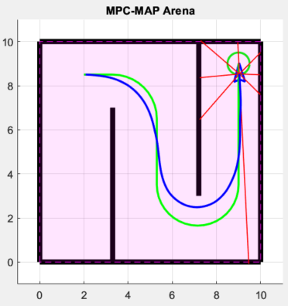

Figure 3 – Trajectory when   
lookahead distance = 2.5