# MPC-MAP Week No. 4 - Report

## **Author:** Michal Miškolci

## **Date:** 19. 3. 2025

## Task 4

The goal of this assignment is to implement a working localization algorithm based on the particle filter. The resemapling process is done using systematic resampling method. On the Figure 1, you can see the successful particle convergence on different maps, though on Figure 2 it wasn’t successful because of the different similar place on the map. The number of particles was important, when less than 100, it wasn’t converging almost at all. It also fails to converge sometimes, I am not sure why.

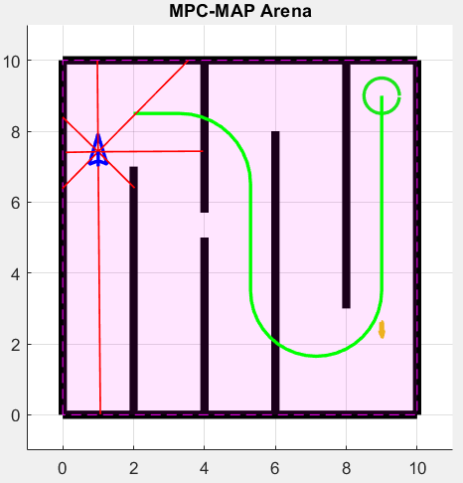

Figure 2 – Failed convergence on map with similar places

Figure – Convergence on map

