**Material, Culture and Consumer Society.**

**Introduction**

Consumer culture refers the kind of material culture which is promoted through the market, it therefore creates a certain connection between the consumers and the products or services the person is using. The relationship that comes up shows clearly that the consumer culture represent a crucial area that social changes occurs in everyday life. The way the sellers package their products influence how the members of the society view it and thus consumption of the product may rise or drop based on the judgment of the consumer. The goal of this research is to perform a critical comparative analysis based on the visual and textual data of a product. The visual and textual data comprises of things such as designs graphics and text. There are so many products in North America, however, this research will only compare and contrast brands of breakfast cereals and come up with a conclusion based on the observation. It will compare Raisin Bran from Kellogg Company and Honey Nut Cheerios from General Mills.

**Raisin Bran (Kellogg Company)**

Raisin bran is an example of a breakfast cereal made of wheat bran and raisins. The Kellogg’s raisin bran has a specific package that sends a specific impression to the customers. The outside packet is made of pink color with an emoji of a healthy body. At personal level, when I view the outside packet, it looks attractive due to arrangement of pictures and text on the packet[1]. For example, the Kellogg Company has written the name raisin bran in bold which an individual can identify from a far place. Secondly, the message on the packet tries to convince the consumer that the product is nutritious. For instance, the below sample of a packet have been written healthy heart. The message suggest that the consumer would enhance his or her health to a significant milestone when making use of this product every morning.

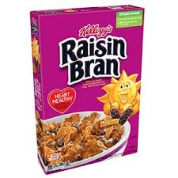

Consequently, what drives my impression in this product is the company’s choice of color[2]. For example considering the below packet, there are some issues that drives ones decision.

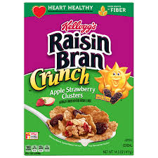

Both the two packets have pink color on the outside packet. The pink color is a gender sensitive color which is mostly identified by the ladies. However what makes this product stands out is how the company have made use of the texts and the graphics[3]. The texts are well positioned that it is easy for consumer to recognize from a far place. For example, there is an image of the heart where there is the text of heart healthy. The idea matches what the company sells. Then there is a graphic apple strawberry immediately after the same text. I try to understand there is a mixture of straw berry flavor to this product. The components of nutrients from this material is also not left out in the packet because there is the text of fiber on the far end.

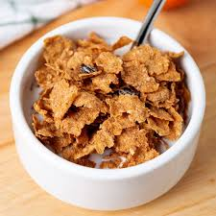

The above images is what one can see immediately or she opens the packet. These images look lie slices of meat. Each piece of the product is flat and that relate to the method of preparation. The Kellogg Company prepares this product from bran flakes and grapes. They apply steam during the rolling process to make the flakes straight.

**Honey Nut Cheerios from General Mills**

The honey nut cheerios is another brand of breakfast cereal from the General Mills Company. The packet of this brand of cereal has a slogan of be happy, be healthy. The company have made use of the orange color to appeal to the consumers concerning the product[4]. The following is an example of the packet:

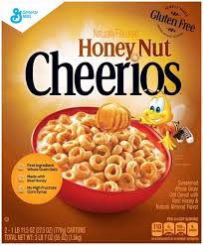

The arrangement of the text in this packet is organized in a way that make the name Cheerios to be visible from a far distance. Consequently, there is an impression that the user can create from a far distance. For example, the company have used the orange color on the text written on the lower part of the product[5]. The color of the text is not appealing since the background color is dark orange and the texts are a bit orange. There is another packet of the same product that reveal another impression to the consumers.

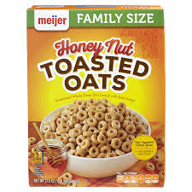

The above packet is well arranged and more appealing than the initial one. The choice of the color is appropriate and matching the graphics[6]. They are well centered with name toasted oats taking bigger font size. The idea of using the message family size may mean that the product increase in volume when cooked. The appearance of the product itself is as follows:

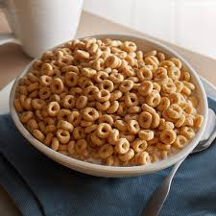

The company prepares this product by the use of corn starch, salt and sugar. These ingredients are mixed with some water to attain the shapes that are shown above. The special molds assist in shaping the product.

**Comparison between honey nut cheerios and raisin bran**

The names used in the packets have an implication on the culture. For example, the honey nut. Honey in the American people means that the product is made from the natural products[7], hence the flavor that comes from the product is natural as opposed to artificial flavors added from the company during the production process. From the closer look of the two packets, raisin bran have made use of the pink color in most of its packets while honey nut is packed in orange color packet. The perception that this difference in color brings to the consumer is that raisin bran is mainly used by the female population in North America. The honey nut packet color is general and it may not be easy to say which gender sides with it. However, an outstanding character that plays out in these two packets is the use of texts and graphics. In both brands of the cereals, the two companies have written the name of the product in a visible manner. The choice of the text color, which is black have matched with the background color in both the packets. Consequently, there is a feature of the graphics which raisin bran have applied that makes it outstanding than honey nut. In one of the packets of honey nuts it have used yellow text color on an orange background color. These two color are a bit similar hence making the texts invisible to some extent[8]. However the raisin bran packet have used black color text on a green background color. The choice is good and the consumer is able to read the information easily even from a far distance without straining.

**Conclusion**

The use of honey is production of honey nuts shows that the North American people love the natural products in their culture. The incorporation of honey is what drive most consumers towards these products. The difference that one can identify in these two cereal brands is that raisin brand is mainly from plant product while honey nut is from animal products. The graphics on these two packets are well arranged, however, the raisin bran color of pink is mostly for ladies while the honey nut color have used the orange color which is general color.

**List of Bibliography**

|  |
| --- |
|  |

1. Bartram, Lyn, Abhisekh Patra, and Maureen Stone. "Affective color in visualization." In *Proceedings of the 2017 CHI conference on human factors in computing systems*, pp. 1364-1374. ACM, 2017.
2. Creighton, Dean W., and Bryan Worwa. "Coated dried fruit and/or nuts and methods." U.S. Patent 8,999,412, issued April 7, 2015.
3. Firestone, Chaz, and Brian J. Scholl. "Cognition does not affect perception: Evaluating the evidence for “top-down” effects." *Behavioral and brain sciences* 39 (2016).
4. Fulgoni III, Victor L., James Painter, and Arianna Carughi. "Association of raisin and raisin‐containing food consumption with nutrient intake and diet quality in US children: NHANES 2001‐2012." *Food Science & Nutrition* 6, no. 8 (2018): 2162-2169.
5. Kim, Sook-Young, Ki Ju Kim, Hyun-Chae Chung, and Gi Dong Han. "Use of Rice Bran for Preparation of GABA (γ-aminobutyric acid)-rich Sourdough." *Food Science and Technology Research* 25, no. 3 (2019): 399-404.
6. Mesu, Gurbe Jelle. "Cereal bar having a crunchy texture." U.S. Patent 9,603,381, issued March 28, 2017.
7. Spiller, Mary Jane, Clare N. Jonas, Julia Simner, and Ashok Jansari. "Beyond visual imagery: How modality-specific is enhanced mental imagery in synesthesia?." *Consciousness and cognition* 31 (2015): 73-85.
8. Watts, Amanda Elizabeth. "Revitalization of the Cereal Category: Applying Brand Revival Techniques to Increase Sales of General Mills' Cereal." (2015).

1. Bartram, Lyn, Abhisekh Patra, and Maureen Stone (2017).
2. Creighton, Dean W., and Bryan Worwa, (2015).
3. Firestone, Chaz, and Brian Scholl,(2016)
4. Fulgoni III, Victor, James Painter, and Arianna Carughi,(2018).
5. Kim et al,(2019).
6. Spiller et al (2015),
7. Mesu, Gurbe Jelle, (2017).
8. Watts, Amanda Elizabeth, (2015).