# Project intro

In this portfolio, a group project will be discussed in detail with a focus on selection of the correct tools to build an artifact. The project will be hosted on a website via GitHub.

Github.com offers some very useful features for a collaborative project. One feature is the ability to host a website and display STL files to demonstrate a particular feature of the artifact to team members and embed them into websites or documentation.

The artifact our team aims to build is The artifact is inspired by the 1997 series of Men In Black(MIB), where Rosenberg is revealed as a Mechanical human controlled by an alien who is the keeper of Orion’s belt. The alien inside Rosenberg used the robot to hide amongst the Human population.

Figure -Rosenbergs head

Unfortunately, Our module budget doesn’t cover Hollywood level effects, so our artifact has some constraints. These are:

* Cost of materials.
* Availability of materials
* Scalability
* Time of production

These constraints will directly influence the method and size of the design.

# The Artifact

The artifact will be based on a full-sized human head. This head will be scaled down by roughly 50%.

The head will differ from the Rosenberg model as the method of opening a head from the front would be too complex for keeping the face as one piece. For this reason, the group agreed to build a method of accessing the internal head from the back.

The there are several software packages that will be crucial to the development of different parts of the project.

The artifact will consist of:

* A skin like material that forms the shape of the human tissue as seen used in the Rosenberg robot.
* A hinged mechanism to allow the back of the head to open.
* A rigid stand that will provide a structure to the head(like a skeleton).
* Method of adjusting the width to allow for scaling errors.

# Reverse Engineering

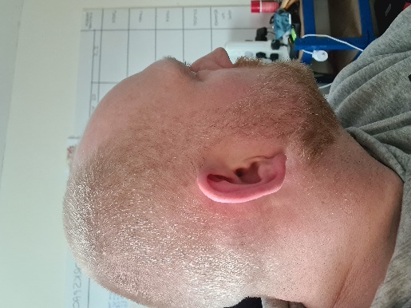The Head for the model will be Michael Alcock. Designing a head from scratch in a CAD or sculpting software would take a long time and potentially miss out features. For this reason a method of reverse engineering the object was required.

Two scanners were trialled for the task. The first is a HandySCAN 3D Black Series from creaform3d.com. This is a handheld unit that uses lasers to measure distance to the object and records the changes in shape as it moves across the surface. The measurement rate is incredibly fast at 1.3mil/s. and an accuracy of 0.025mm.

The HandySCAN requires the object to use a method of location. These are reflective markers that increase the accuracy and allow the laser to map an area. These markers are best placed in a random format. The main limitation of the HandySCAN is it cannot deal with hair. Which is an issue for modelling heads.

The Software used to process the scan is VXElements, supplied by creaform3d.com and the screen capture shows the outcome of a scan. The area of beard hair is unmapped in the software as the lasers couldn’t work out what the surface was.

The HandySCAN is more suited to scanning of manufactured parts with clear surfaces such as cars and aircraft.

The .stl viewer demonstrates the limitations of the HandySCAN but also the incredible detail of the areas where the laser can detect. Based on the results of this experiment, this device would be unsuitable for this project without a lot of editing in a sculpting package, such as Blender, due to the amount of surface detail that is missing.

In comparison to the HandySCAN, the Artec Eva 3D scanner, available from <https://www.artec3d.com/portable-3d-scanners/artec-eva>, is designed with modelling medium sized objects and is compatible with human skin. Unlike the HandySCAN using lasers to measure and map features, Artec Eva 3D uses light and photogrammetry to map the object. This method allows for software to use algorithms to “Stitch” the image together into a solid object and requires no markers to locate itself.

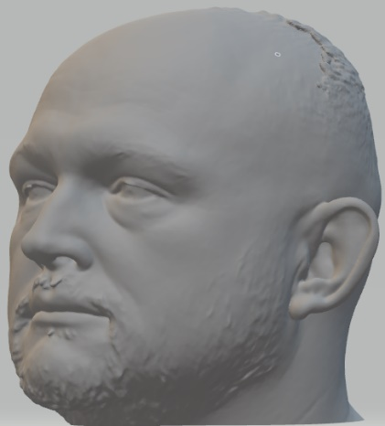The stl viewer shows the level of detail this method of scanning can achieve. The model handle areas of displacement such as hair well and reflects this in the overall model. The Artec Eva 3D is the best fit for the project. It will still require some adjustment in Blender to smoothen the hair and make holes for the eyes but will still be less work compared to the result of the HandySCAN.

Using a Computer Aided Design(CAD) package would benefit the design of a frame for the head to be modelled on. This frame will have to be strong enough to provide sufficient support and provide a method of attaching the skin to the head.

There are many CAD packages available online and some have strengths in certain areas. For example, Fusion 360 is a good fit for someone who is making small scale models due to its simplicity. This type of CAD package is more suited for rigid structures. CAD generally would not be useful for designing details or shapes of a face as CAD doesn’t handle 3D sculpting well. For 3D sculpting, a program like Blender or the haptic pen software.

Key features of this model are:

