**學號：B073040050**

**姓名：翁昌閔**

**Homework 5**

**nMOS I-V Curves and INV DC Transfer Curves**

Handout: 2021/06/01

Due: 2021/06/22

1. I-V curves for an nMOS transistor with Vdd=1 volt are shown below for both long-channel (large MOS length) and short-channel (small MOS length) transistors. Answer the following questions based on the CIC 0.18um process with Vdd=1.8 volts,



* 1. Plot the I-V curves for the nMOS width given in the following table.

→ [figure]：

Green: short channel 1.8V

Yellow: short channel 1.6V

Orange: long channel 1.8V

Blue: long channel 1.6V

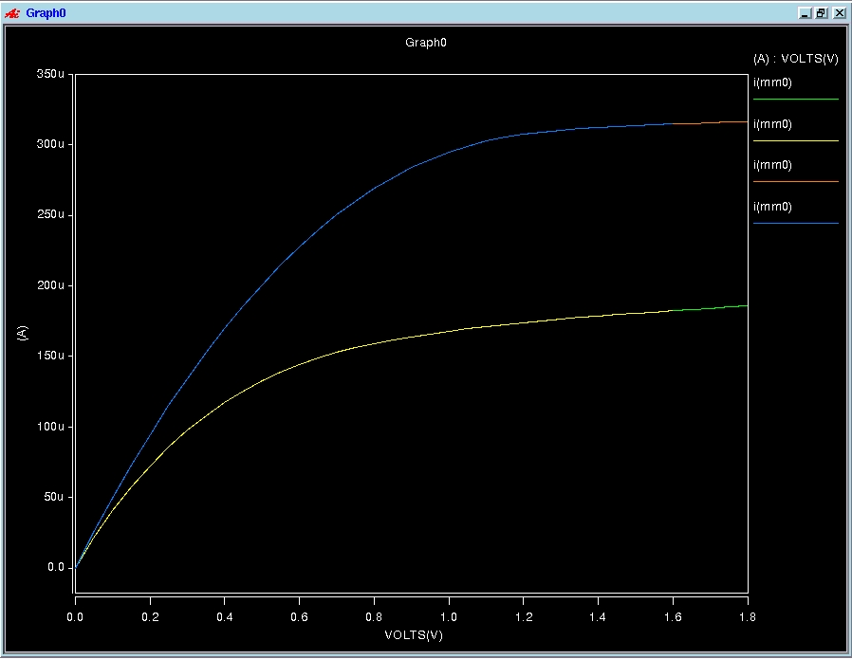

* 1. Fill in the values of Ids current for the specified Vds and Vgs.

[long_nMOS, Vds=1.8v, Vgs=1.8v]：



[long_nMOS, Vds=1.6v, Vgs=1.8v]：



[short_nMOS, Vds=1.8v, Vgs=1.8v]：



[short_nMOS, Vds=1.6v, Vgs=1.8v]：



* 1. What are the threshold voltages (in unit of volts) up to the second fractional position? Since threshold voltage Vth depends on Vds and Vgs, give the Vth for Vds=1.8V, Vgs=1.8V. Hint: use finer separation between two neighboring Vgs to observe the Vgs which causes a significant increase of Ids (at Vds=1.8volt & 1.6volts).

[long_nMOS, Vds=1.8v, Vgs=1.8v]：



[long_nMOS, Vds=1.6v, Vgs=1.8v]：



[short_nMOS, Vds=1.8v, Vgs=1.8v]：



[short_nMOS, Vds=1.6v, Vgs=1.8v]：



* 1. What are the channel-length modulation coefficients for short-channel nMOS transistors assuming the -power law model with ? Hint: you can calculate it based on the current values at different Vds which are in the saturation region. Use the following equation for nMOS with Vds=1.8V and 1.6V, and assume where the threshold voltage has been measured in the previous problem.



|  |  |  |  |  |  |  |  |  |
| --- | --- | --- | --- | --- | --- | --- | --- | --- |
| long/short channel | width W  (um) | length L  (um) | W/L | Vds  (V) | Vgs  (V) | Ids  (uA) | Vt  (V) |  |
| long | 2.5 | 1.8 | 1.39 | 1.8 | 1.8 | 316.4679u | 352.8049m | -0.00659 |
| 2.5 | 1.8 | 1.39 | 1.6 | 1.8 | 316.4679u | 352.8049m | -0.00659 |
| short | 0.25 | 0.18 | 1.39 | 1.8 | 1.8 | 185.7660u | 388.7968m | -0.21814 |
| 0.25 | 0.18 | 1.39 | 1.6 | 1.8 | 185.7660u | 388.7968m | -0.21814 |

1. DC transfer curve of a CMOS inverter with different pMOS/nMOS beta ratios  assuming the electron mobility is three times of the hole mobility, i.e., . Plot the DC transfer curves of the Inverter with seven different ratios:  given in the following table. Find the parameters VIH, VOH, VIL, VOL, NMH, NML related to noise margin for each ratio.

 

|  |  |  |  |  |  |  |  |  |  |
| --- | --- | --- | --- | --- | --- | --- | --- | --- | --- |
|  | Width Wp  (um) | Width Wn  (um) | Wp/Wn | VIH  (V) | VOH  (V) | VIL  (V) | VOL  (V) | NMH  (V) | NML  (V) |
| 10 | 75 | 2.5 | 30 | 1.30 | 1.70 | 1.10 | 0.05 | 0.4 | 1.05 |
| 5 | 37.5 | 2.5 | 15 | 1.25 | 1.68 | 1.02 | 0.06 | 0.43 | 0.96 |
| 2 | 15 | 2.5 | 6 | 1.15 | 1.66 | 0.88 | 0.08 | 0.51 | 0.80 |
| 1 | 7.5 | 2.5 | 3 | 1.05 | 1.68 | 0.75 | 0.10 | 0.63 | 0.65 |
| 1/2 | 3.75 | 2.5 | 3/2 | 0.93 | 1.71 | 0.62 | 0.11 | 0.78 | 0.51 |
| 1/5 | 1.5 | 2.5 | 3/5 | 0.80 | 1.74 | 0.52 | 0.10 | 0.94 | 0.42 |
| 1/10 | 0.75 | 2.5 | 3/10 | 0.72 | 1.74 | 0.48 | 0.09 | 1.02 | 0.39 |

[figure]：

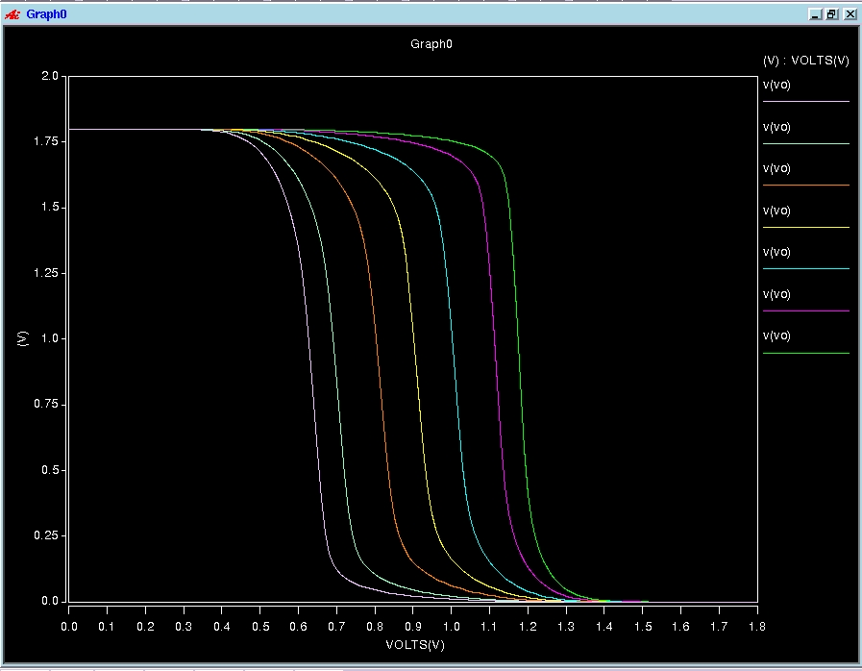

[75u]:

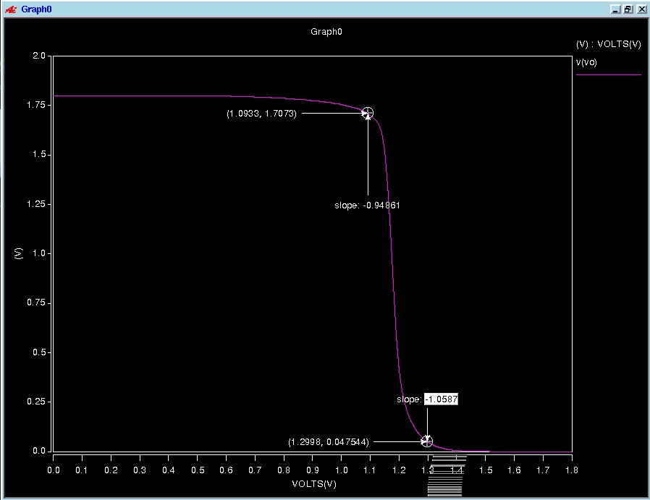

[37.5u]:

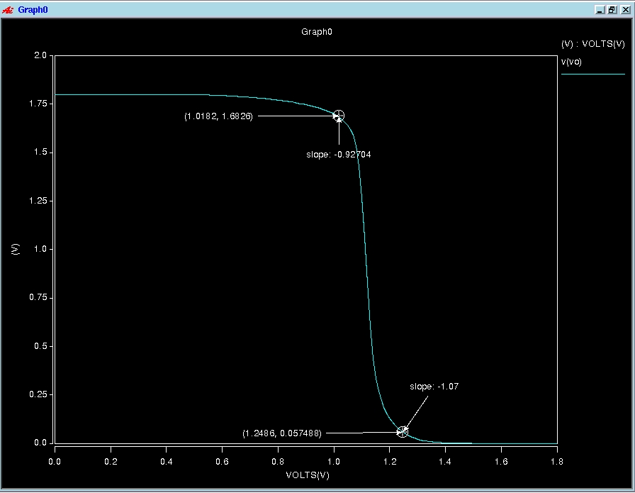

[15u]:

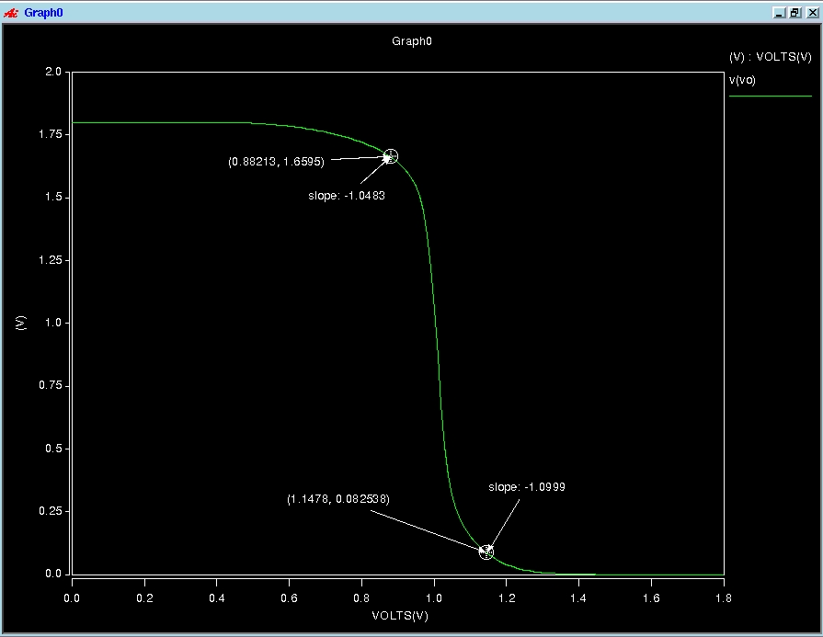

[7.5u]:

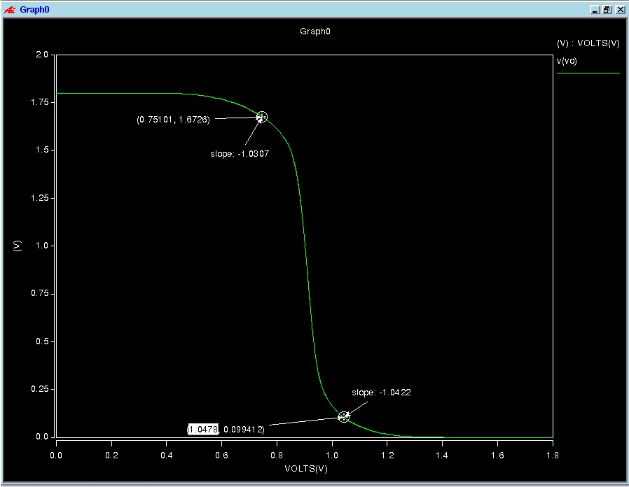

[3.75u]:

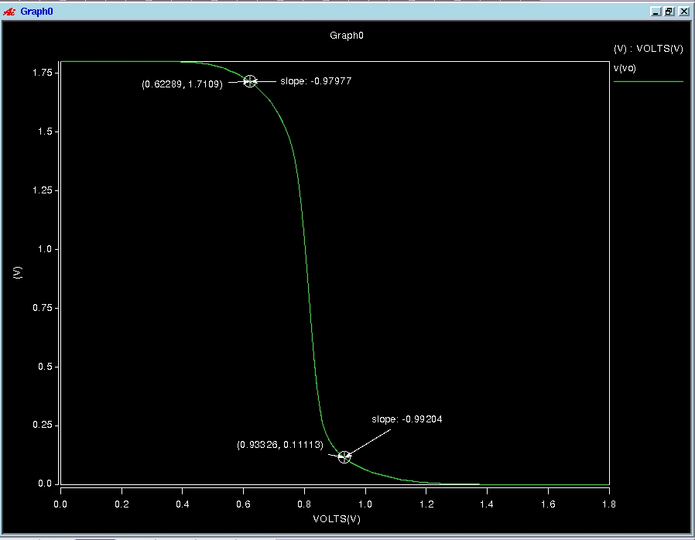

[1.5u]:

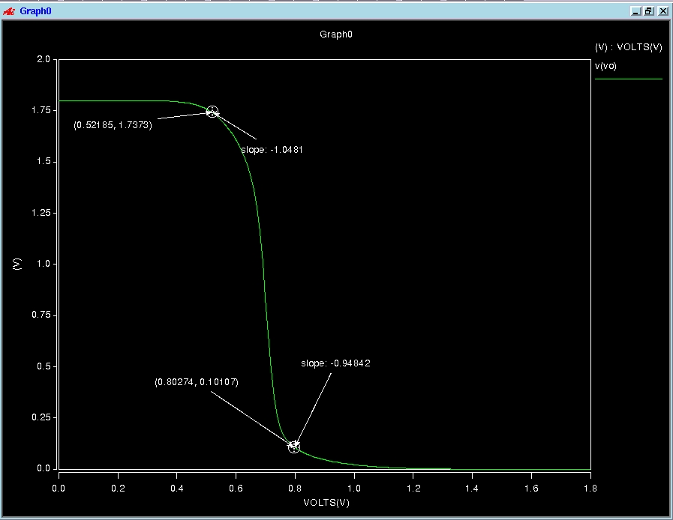

[0.75u]:

