**# Introduction**

**Hello Folks, my name is Michael - codename Opacite**

I am just a person who enthusiast in Cyber Security field, and try as much as I can about Cyber Security.

* Active student in Cyber Security major in one of Indonesian University,
* Actively doing Capture the Flag (CTF) to learn something new – mostly do OSINT Category,
* Currently learning from HackTheBox, TryHackMe, and [HackTheBox Academy](https://academy.hackthebox.eu).

Others Stuff I do :

[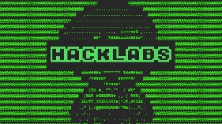](https://www.instagram.com/hacklabs.id/) Me and the boys trying to pull some new guys to the cyber world with a fun miniCTF challenges [Github](https://github.com/HackLabsId/HackLabsChall/).

One of active member and sometimes teach on CyberClass