I. Claim: Existing Metrics are Insufficient
Claim: "Existing studies show that simple static analysis metrics (like those from SonarQube) have a weak or inconsistent correlation with developer productivity metrics like lead time."
It's the primary motivation for proposing a new metric and is strongly supported by recent studies.
- Primary Source: TechnicalDebtPaper3.pdf (Paudel et al., "Towards Measuring the Impact of Technical Debt on Lead Time")
  - Evidence in Abstract: The authors state their core finding is a set of "mixed results." They found that TD had a moderate positive impact on lead time in two components, no meaningful impact in two others, and a moderate negative impact in the remaining two. This is the definition of an inconsistent correlation.
  - Evidence in Discussion (Section VI): They conclude, "Our findings suggest that the relationship between TDD and lead time... is either very weak or nonexistent if TD and lead time are aggregated monthly."
- Supporting Source: TechnicalDebtPaper9.pdf (Lenarduzzi et al., "A systematic literature review on Technical Debt prioritization")
  - Evidence in Related Work: The Paudel paper itself cites this SLR, noting that Lenarduzzi et al. also found that a previous study "did not find a meaningful correlation between lead time and violations."
Conclusion: These papers show that simply measuring static code issues isn't enough to reliably predict development slowdowns, justifying the need for a more holistic metric.

II. Claim: Prioritization is a Major Challenge
Claim: "Prioritization challenges... most approaches are complex, focus only on comparing TD items with each other, and often fail to include business value or resource constraints."
This claim comes directly from the findings of the systematic literature reviews (SLRs) which survey the entire field of TD prioritization research.
- Primary Source: TechnicalDebtPaper9.pdf (Lenarduzzi et al., SLR)
  - Evidence (TD vs. Features): In Section 5.2, the authors state, "...the papers investigated in this study commonly focus their prioritization approaches on prioritization among different TD items... None of the prioritization approaches described... explicitly addresses how the prioritization between implementing new features and spending time and effort on the refactoring of TD should be carried out." This is direct evidence that current methods fail to balance TD against new work.
- Supporting Source: TechnicalDebtPaper1.pdf (Alfayez et al., "A Systematic Literature Review of Technical Debt Prioritization")
  - Evidence (Resource Constraints): In the abstract, the authors find "a scarcity of approaches that account for cost, value, and resources constraint." Section 3.3 elaborates that only 16.67% of the approaches they studied consider resource constraints at all.
  - Evidence (Complexity): The "Impact Map" in the Lenarduzzi paper (Table 7) identifies 53 unique factors used for prioritization, highlighting the complexity and lack of consensus in the field.
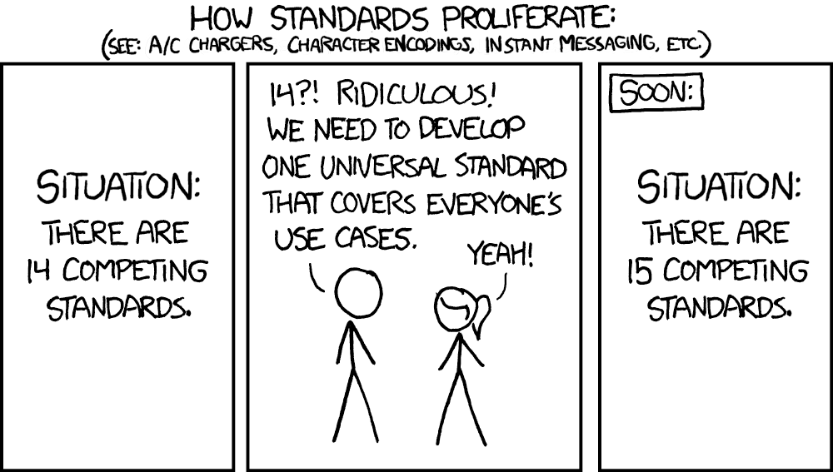
Conclusion: The literature shows a clear gap: there is no simple, widely accepted framework for prioritizing TD in the context of business goals and limited resources. This is the gap the prioritization matrix aims to fill.

III. Claim: Technical Debt is More Than Just Code
Claim: "TD is more than just messy code; it includes architectural coupling, build system complexity ('build debt'), and has a measurable negative impact on developer morale and wasted time."
This claim justifies the need for a holistic approach by showing that TD manifests in many ways beyond simple code smells. Each part of this claim is supported by a specific paper.
- Source for Architectural Coupling: TechnicalDebtPaper13.pdf (MacCormack & Sturtevant, "Technical debt and system architecture: The impact of coupling...")
  - Evidence: The entire paper is dedicated to this topic. It empirically demonstrates that highly-coupled "Core" components in a system cost significantly more to maintain and are responsible for a disproportionately large share of defect-related activity.
- Source for "Build Debt": TechnicalDebtPaper11.pdf (Morgenthaler et al., "Searching for Build Debt: Experiences Managing Technical Debt at Google")
  - Evidence: This paper coins the term "Build Debt" and details how issues in build files, dependencies, and dead code create significant maintenance overhead at Google.
- Source for "Wasted Time": TechnicalDebtPaper12.pdf (Besker et al., "Technical Debt Cripples Software Developer Productivity")
  - Evidence: This longitudinal study found that developers report wasting, on average, 23% of their total development time due to technical debt. The most common activities were additional testing and source code analysis.
- Source for "Developer Morale": TechnicalDebtPaper14.pdf (Besker et al., "The influence of Technical Debt on software developer morale")
  - Evidence: The study concludes that the occurrence of TD is associated with a lack of progress and wasted time, which has a negative influence on developers' morale. Conversely, managing TD has a positive influence.
Conclusion: These papers collectively argue that to effectively measure TD's impact, you must look beyond the code to architecture, process, and even human factors.
IV. Justification for the Novel "TDR Score"
Concept: The proposed TDR Score (Effort * (Commits + Bugs)) is a novel synthesis that addresses the weaknesses identified above. The papers do not propose this exact formula, but they provide the rationale for its components.
- Why include "Effort to Fix"? This is the "principal" of the debt, a standard concept found in most TD literature, including TechnicalDebtPaper7.pdf (Guo, "Measuring and Monitoring Technical Debt"). It's the baseline cost.
- Why include "Recent Commits" (Volatility)?
  - Source: TechnicalDebtPaper4.pdf (Gupta, "Measuring the Impact of Technical Debt on Development Effort...") proposes a study to link TD to "change-sets" from version control. The premise is that debt in frequently changed code is more painful.
- Why include "Recent Bugs" (Reliability)?
  - Source: TechnicalDebtPaper13.pdf (MacCormack & Sturtevant) provides the strongest evidence for this link. Their entire methodology is based on correlating architectural debt (coupling) with historical "defect-related activity" drawn from bug trackers. This proves that historical bug data is a powerful indicator of where architectural debt is causing pain.
Conclusion: The TDR score is an original contribution built directly upon the evidence in the papers. It combines the static cost of debt with dynamic, historical data on pain (change friction and bugs) to create a more predictive and practical metric.

