History of the Margarita

The truth is, no one really knows who invented the Margarita. A few interesting theories and coincidences, however, begin to paint an interesting tale.

• The Margarita is very similar to the Sidecar, a drink that was very popular at the same time the Margarita first appeared in the 1930s. The Sidecar is brandy, Cointreau and lemon juice, in the same proportions as the Margarita’s tequila, Cointreau and lime.
• The Café Royal Cocktail Book, published in 1937, lists a drink called a Picador, which contains tequila, Cointreau and lime juice. Could this be the precursor to the Margarita?
• A Dallas socialite named Margaret “Margarita” Sames claimed to have invented the drink at a party she threw in on vacation in Acupulco in 1948. One of her rich friends, Nick Hilton, loved it so much he put it on the menu at his hotels, furthering the legend. However, Cuervo had run an ad campaign featuring the Margarita in 1945, which discredits this particular story.
• Carlos “Danny” Herrera claimed to have invented the Margarita at his bar south of Tijuana, Rancho La Gloria, in 1938. He says he created it for a showgirl named Marjorie King, who wanted a palatable cocktail, but was allergic to all other spirits except tequila.
• It’s likely a Mexican did not invent the Margarita, as Mexico has never had much of a cocktail culture. More likely, it was an American visiting Mexico to escape the confines of American Prohibition.
• Regardless of who invented the Margarita, it didn’t gain widespread popularity in the U.S. until the 1970s, when tequila actually began to sell. Many bar books published before the 1960s barely mention tequila.
• Some think the drink is just a cocktail version of the classic tequila shot: tequila, salt and lime.
• Some cocktail geeks believe the Margarita may be descended from the Tequila Daisy, a formerly popular drink that fell out of favor. A basic daisy is made with a spirit, lemon juice, simple syrup and grenadine. If you trade out the Daisy’s grenadine for triple sec or Cointreau, you’ve got yourself a Margarita. Makes sense, as the Spanish word for “daisy” is, you guessed it, “margarita.”

Classic Margarita recipe:
1 ½ oz. tequila
1 oz. Cointreau or other triple sec
¾ - 1 oz. lime juice (or to taste, depending on tartness of limes)
Shake and serve up in a coupe with a rim of salt.

How to build the perfect Tex Mex cocktail list

Building the perfect cocktail menu is a total balancing act.

First, you want to try to balance the base spirit used in the cocktail (vodka, bourbon, tequila, gin, rum) so that you have a pretty even representation of each.

Second, you want to try to balance the style and taste of cocktails on the list (spirit forward and boozy, long drink/fruity, highballs, sparkling, etc.) so that there is something to appeal to everyone.

Next, you need to make sure to balance your glassware presentation (coupe, old fashioned, flute, martini) so that all of your cocktails won’t be coming in the same glass, which would be not only boring visually, but would cause a disaster on a busy night!

You also want to balance the method of your cocktails, so that aren’t too many muddled drinks, or two many egg white drinks, or all stirred drinks, or all shaken drinks. There need to be at least one or two easy pick-ups (highballs, batched cocktails), to keep the bar from getting bogged down during a rush.

Once you have all that down, you want to look at the cocktail names. Are they varied enough, none too similar, none of them taken already at another restaurant? Do the names chosen reflect the restaurant concept?

Next, cost everything out and look at the price points. Do you have at least one cocktail for the budget-conscious? Something on the high end for people who want to spend money? A few in-between?

Whew. That’s a lot to think about, on top of making sure that the cocktails themselves are actually GOOD!

For Tex Mex restaurants, almost all of this still applies, but with a few exceptions. Being Tex Mex, there will be a MUCH higher ratio of tequila and mezcal cocktails than on other restaurant menus. In fact, your menu may be 75% tequila and mezcal cocktails, with a vodka and a bourbon thrown in for good measure. That’s okay. But make sure to follow the rest of the rules! Glassware, names, price points… these things are still important. Even if your menu consists of 10 variations on the margarita.

Template for cocktail list

The list will be divided into two sections, one called Margaritas y Mas (made up of 8 margaritas or variations on the margarita) and one called Cocktails Y Classicos (made up of 8 original cocktails from the master and classic Tex Mex cocktails).

An ideal Margaritas y Mas section would consist of:
• Casa Margarita, a frozen or rocks house margarita
• The O.G., The ATL, or other classic build margarita
• Texas Star, a Ford Fry classic
• The Superita!, an Austin-style up margarita with olive
• A spicy margarita, such as jalapeno or habanero
• A simple or “skinny” style margarita, such as Tommy’s
• A seasonal fruit margarita or other cocktail
• Selection from the master list

An ideal Cocktails/ Classics menu would consist of:
• La Paloma, a Mexican classic
• A mezcal cocktail, such as Mezcal Mule or The Highwayman
• A vodka cocktail, such as Red Headed Stranger
• El Diablo
• Matador
• Vampire Weekend, a rum cocktail with housemade horchata
• Selection from the master list
• Selection from the master list

Also:
• Sangria
• Chelada/ Michelada, beer with lime or sangrita
• Brunch beverages such as Mimosa Fresca, Bloody Maria, Black and White
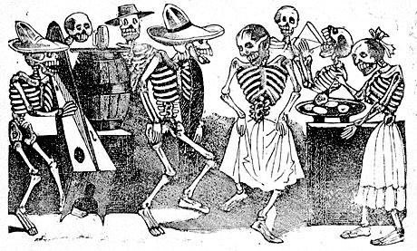

Superica/ El Felix Margarita Recipes

Margarita de la Casa (frozen version)
Batch recipe:
9 qt. (288 oz.) water
2.5 qt. (80 oz.) simple syrup
2 qt. (64 oz.) strained lime juice (pre-squeezed)
2.75 (750ml) bottles of Stirrings Triple Sec (about 69.75 oz.)
3 1L bottles El Jimador Blanco (about 101.5 oz.)
Yield: 603.25 ounces; about 54 (11 oz.) portions
To serve: Dispense 11 oz. portion into 12 oz. beer mug or similar sized glass.
Garnish: lime wedge, (optional) salt.

Margarita de la Casa (blender version)
Glass: Tall beverage
Garnish: Lime, duh
Recipe: To be batched only!
To make 3 gallons (96 servings):
4 1L bottles Stirrings Triple Sec
4.5 1L bottles El Jimador Reposado
72 oz. fresh lime juice with pulp (2 ¼ quart containers)
12 oz. white sugar (1 ½ cups)
4 teaspoons salt
Combine all in a Cambro and stir, stir, stir in order to fully dissolve sugar and salt. Divide into gallon store-and-pours and store in cooler.
For service, measure 4 oz. of batch into Vita Mix with ½ cup of cube ice (about 6 cubes). Pulse to blend, and until ice crushes but is not melted. Pour over mix of crushed and cube ice ¾ full in a tall Gibraltar glass. Drink should come to the top! Plenty of ice but with crushed ice visible on top. Garnish with lime wedge.

Single drink proportions:
1 ½ oz. El Jimador reposado
1 oz. triple sec
¾ oz. fresh lime juice
2 bar spoons white sugar
1 pinch salt
This recipe is to illustrate proportions only. See batch recipe.

The O.G.
Glass: Old-Fashioned glass
Garnish: Lime wedge
Recipe:
1 ½ oz. El Jimador Reposado, Goza Reposado, or other tequila
1 oz. triple sec
¾ oz. lime juice
¼ oz. simple syrup
Add all to mixing glass. Shake well with ice. Pour over FRESH ICE in an old-fashioned glass. Garnish with lime wedge. Salt rim if guest requests.

May be batched for speed of service:
Batched O.G.
To make 3 gallons (96 servings):
4 1L bottles Stirrings Triple Sec
6 750ml bottles Goza Reposado
72 oz. fresh lime juice with pulp (2 ¼ quart containers)
3 cups (24 oz.) simple syrup
4 teaspoons salt
Combine all in a Cambro and stir, stir, stir. Divide into gallon store-and-pours and store in cooler. To serve, measure out 3.5 oz and shake with ice. Strain over fresh ice. Do not serve on shaking ice!

The ATL: Atlanta’s hometown margarita, featuring Goza Reposado, 1821 charred lime/jalapeno/cilantro syrup, Stirrings triple sec and fresh lime, on the rocks
Glass: Footed Marg
Garnish: Cilantro leaf
Recipe:
1.5 oz. Goza Reposado
.5 oz. Stirrings triple sec
.25 oz. 1821 Charred lime/ jalapeno syrup
.75 oz. lime juice
Combine all ingredients in a cocktail shaker with ice. Shake and strain into a footed margarita glass over fresh ice. Garnish with a cilantro leaf.

Goza is an Atlanta-owned tequila company, and 1821 is an Atlanta-owned bitters and cordials company. The two combine to make Atlanta’s hometown margarita, which made its debut at the El Felix Braves Stadium location.

The BadA$$: Pasote Reposado, Gran Marnier, lime, orange, salt
Glass: Old Fashioned**
Garnish: jalapeno slice
Recipe:
1.5 oz. Pasoto Blanco
.75 oz. Gran Marnier
.75 oz. Lime juice
.25 oz. simple syrup
Combine all ingredients in a cocktail shaker with ice. Shake and strain into an OF glass over fresh ice. Garnish with a slice of jalapeno.

Pasote is a Mexican slang term that basically means “badass mother-f#@&ker.” The Pasote tequilas were made in honor of the Aztec warriors that ruled Mexico before the Spanish arrived. This margarita is made to honor the badass, with not only Pasote tequila, but also Gran Marnier, the top shelf of orange liqueurs. The jalapeno garnish builds a slow heat, and can be omitted upon request.

Blood Orange Margarita: El Jimador reposado, Solerno Blood Orange, Ancho Reyes, lime, orange
Glass: Footed marg
Garnish: very thin blood orange slice, or blood orange crisp
Recipe:
1 oz. El Jimador reposado
1 oz. Solerno blood orange
.75 oz. lime juice
.25 oz. orange juice
.5 oz. Ancho Reyes original
Combine all in a cocktail shaker with ice. Shake and strain into a footed margarita glass over fresh ice. Garnish with a blood orange crisp**
** Blood orange crisps may be oven dried, or purchased commercially from www.dressthedrink.com

Habanero Margarita: Tanteo habanero tequila, Brovo Curacao, fresh lime, jalapeños
Glass: OF
Garnish: jalapeno slice
Recipe:
1.5 oz. Tanteo Habanero
.75 oz. Brovo Curacao
.75 oz. lime juice
Combine all ingredients in a cocktail shaker with ice. Shake and strain into a footed margarita glass over fresh ice. Garnish with a slice of jalapeno.

Jalapeno Margarita: Tanteo jalapeno tequila, Ancho Reyes Verde, triple sec, lime
Glass: Footed Marg
Garnish: jalapeno slice
Recipe:
1.5 oz. Tanteo jalapeno
.5 oz. Ancho Verde
.5 oz. Stirrings triple sec
.75 oz. lime
Combine all ingredients in a cocktail shaker with ice. Shake and strain into a footed margarita glass over fresh ice. Garnish with a slice of jalapeno.

Mezcal margarita: Bahnez mezcal, Stirrings triple sec, fresh lime, agave
Glass: Footed marg
Garnish: lime wedge
Recipe:
1.5 oz. Banhez mezcal
1 oz. stirrings triple sec
.75 oz. lime juice
.25 oz. simple syrup
Combine all in a cocktail shaker with ice. Shake and strain into an OF glass over fresh ice. Garnish with a lime wedge, salt optional.

Perfect Margarita
Glass: Old Fashioned
Garnish: lime wedge
Recipe:
¼ oz. agave nectar
½ oz. lime juice
½ oz. triple sec
2 oz. blanco tequila
Build in mixing glass and shake with ice. Strain over fresh ice into old-fashioned glass.

Superita!
Glass: Coupe
Garnish: Citrus Marinated olive
Recipe:
1 ½ oz. Herradura Double Reposado
1 oz. Combier
¾ oz. fresh lime juice
½ oz. orange juice
Dash olive brine
Combine ingredients in a mixing glass. Shake well with ice and strain into a chilled coupe. Garnish with a citrus-marinated olive.
To make citrus-marinated olives:
Drain olive brine from olive jar and reserve for drink use. Zest 2 lemons, 2 limes and 2 oranges. Marinate olives in a mixture of lemon, lime and orange juices with a little water and the citrus zest.
The Superita! is based on the so-called “Mexican Martini” that is insanely popular in Austin, TX: essentially a margarita, served up with olives on the side. We take ours a step further. We use the tequila from the barrel we selected especially for Superica. We marinate our olives in citrus juices. And we put a dash of brine in the margarita, which is like having salt on the rim, but not. It’s all very delicious.

Tommy’s Margarita: Lunazul blanco, agave nectar, fresh lime
Glass: Footed marg
Garnish: lime wedge
Recipe:
2 oz. Lunazul blanco
1 oz. fresh lime juice
½ oz. agave nectar
Combine all in a cocktail shaker with ice. Shake and strain into an OF glass over fresh ice. Garnish with a lime wedge, salt optional.
Tommy’s Margarita was created in the early 1990s at Tommy’s Mexican Restaurant in San Francisco, by bartender Julio Bermejo. Bermejo omitted the orange liqueur, which is standard in all margaritas, in favor of using only agave nectar. In the process, he helped forward the style of West Coast bartending that uses only fresh, natural ingredients. He also inadvertantly created a craze for “skinny margaritas” that has never died.

Guidelines for adding new margaritas

While many Tex Mex restaurants use pre-packaged mixes or flavorings for their margaritas, this is never something that we will do at Superica or The El Felix.
We are proud to offer only fresh juices at our bar, and only the best quality hand-crafted ingredients. With that in mind, always make choices based on the quality of the ingredients when adding any beverage to the menu.

The margarita is a classic SOUR build, which means it has a base spirit, a citrus juice and a balancing amount of sweetener.

The recipe we use as our standard is:
1 ½ oz. tequila
1 oz. triple sec/ curacao/ orange liqueur/ orange brandy
¾ oz. lime juice
¼ oz. simple syrup

When experimenting with adding new margarita recipes, this classic build should always be the starting point.
Any “flavors” should be naturally occurring in the original margarita (orange, lime, other citrus) or in tequila (herbs, flavors imparted by oak such as coconut, baking spices, vanilla, brown sugar), or should be naturally complementary of the flavors in the original margarita (seasonal fruits, hot peppers, spices).

Flavors should only be added in the form of:
• Quality spirits (all natural cordials, infused tequila)
• Fresh juice or fruit/fruit puree
• Bitters or tinctures
Do not make ever margaritas with ANY sub-standard product such as:
• Bottled “Margarita Mixes”
• Flavored spirits made with artificial flavorings
• Products with high-fructose corn syrup as an ingredient

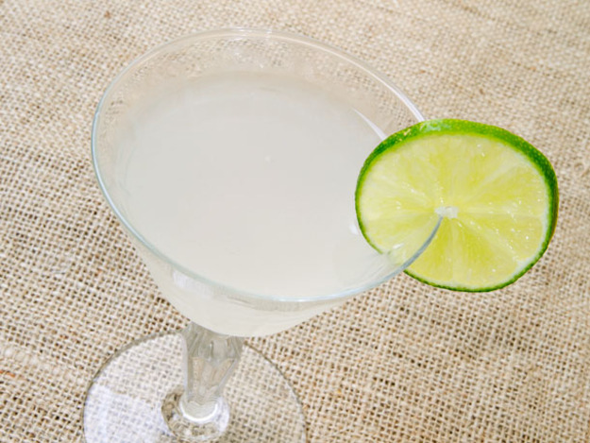

COCKTAILS!
TEX-MEX MASTER RECIPES

Apache (Jump on it)
Glass: Collins
Garnish: Fresh pineapple
Recipe:
1 ½ oz. Puerto Angel Aged Oaxacan rum
½ oz. Giffard Banana de Bresil
1 oz. housemade tepache
¼ oz. lemon juice
2 oz. Cigar City Florida Cracker
Build all but beer in a mixing glass, fill with ice and shake. Strain into a Collins glass filled with ice. Add beer last to fill. Toss briefly to combine and top up with ice if needed.

Tepache is a fermented pineapple drink, popular in Mexico. It is sometimes drank by itself, and sometimes mixed with tequila or beer. We make our tepache in house. The tepache originally featured at the Krog Street Superica was featured on Tales of the Cocktail’s website.
https://talesofthecocktail.com/techniques/diy-tepache

Ancho Sour
Glass: OF
Garnish: lemon wedge
Recipe:
2 oz. Ancho Reyes
1 oz. lemon juice
¾ oz. simple syrup
Combine all in a cocktail shaker with ice. Shake and strain into an OF glass over fresh ice. Garnish with a lemon wedge. (Courtesy of Bryan Griggs)

Batanga
Glass: Tall beverage
Garnish: Lime, salt rim
Recipe:
1 ½ oz. El Jimador blanco
½ oz. fresh lime juice
Salt rim of a tall beverage glass. Build tequila and lime juice over ice. Serve bottle of Mexican Coke on the side.

Briar Patch
Glass: Coupe
Garnish: lemon peel
Recipe:
¾ oz. lemon juice
1 oz. blackberry puree
¾ oz. St. Germain
1 ½ oz. Tito’s vodka
Build in mixing glass. Shake with ice and strain into coupe. Express lemon peel over glass and drop in.

Bulevar
Glass: Old-fashioned
Garnish: flamed orange peel
Recipe:
1 oz. El Jimador reposado tequila
1 oz. Campari
1 oz. Cocchi Vermouth di Torino
Combine all in a mixing glass with ice and stir well. Strain into a rocks glass, neat. Garnish with a flamed orange peel.

This cocktail is a riff on the Negroni, using tequila instead of gin. There is another classic cocktail called Boulevardier, which is a Negroni variation that uses bourbon instead of gin. “Bulevar” is the Spanish word for Boulevard.

Crossfire
Glass: Coupe
Garnish: lemon wedge
Recipe:
¾ oz. Rittenhouse rye
¾ oz. Novo Fogo cachaca
¾ oz. Aperol
½ oz. lemon juice
¼ oz. simple syrup
Combine all in a cocktail shaker with ice and shake well. Pour into a chilled coupe and garnish with a lemon wedge. (Courtesy of Bryan Griggs)

Desert Rose/ Christmas Cactus
Blanco Tequila, Hibiscus Liqueur, rosemary syrup, Dolin Blanc, lemon
Glass: Old fashioned
Garnish: rosemary spear
Recipe:
1 oz. blanco tequila
½ oz. hibiscus liqueur
1 oz. rosemary syrup
½ oz. Dolin blanc
½ oz. lemon juice
Combine all in cocktail shaker with ice and shake well. Pour into rocks glass over fresh ice. Garnish with rosemary spear.
**Christmas Cactus is for the holiday menu only. Other times of the year, please use Desert Rose as the name.

The Dahlia
Glass: Coupe
Garnish: Morita chili salt rim; grilled pineapple
Recipe:
1 oz Tanteo jalapeno tequila
1 oz Aperol
1 oz lime juice
1 oz pineapple juice
¼ oz crème de cassis
Rim a chilled coupe with Morita chili salt. Build ingredients in a cocktail shaker. Shake with ice and strain into glass. Garnish with grilled pineapple.

El Chapo
Glass: Coupe
Garnish: Coffee salt
Recipe:
1 oz. Peleton de la Muerte
½ oz. Ancho Reyes
½ oz. Caffe Mokka
¼ oz. Kahlua Especial
1 ½ oz. strong coffee
Combine all in a shaker with ice and shake. Strain into a chilled coupe garnished with a half rim of coffee salt.

If you want to batch:
1 liter bottle of Peleton
16 oz. Ancho Reyes
16 oz. Caffe Mokka
8 oz. Kahula Especial
Shake 1 ½ oz. cold brew coffee with 2 ¼ oz. batched spirits. Strain into coupe.

El Chapo is the most notorious drug trafficker to ever come out of Mexico. He has escaped from prison twice, once from maximum security prison in Guatamala, and mostly recently from a prison in Mexico. His henchmen dug a mile-long tunnel under the prison to bust him free. He would seem to be an unstoppable force, much like this cocktail.

El Diablo
Glass: Old-fashioned
Garnish: fresh blackberries, if in season; if not, lime wheel
Recipe:
1 ½ oz. El Jimador
½ oz. Crème de Cassis
½ oz. lime juice
2-3 oz. ginger beer, or to fill
Build tequila, lime and cassis in a tall beverage glass. Add crushed/cube mixed ice and top with ginger beer. Roll to combine.

Extra Fresca
Glass: Tall beverage
Garnish: lime
Recipe:
1 ½ oz. Denizen white rum
½ oz. honey syrup
½ oz. lime juice
Jamaica agua fresca to fill (about 2 oz.)
Build in a tall beverage glass over ice. Roll to combine. Garnish with fresh fruit to match.

Fresa Fresca
1 ½ oz. spirit (choice of: Jack Daniels or Blackwell Rum)
4 oz. strawberry agua fresca
Shake with ice and strain over fresh cube ice into a Collins glass. The drink should be a little short from the top of glass. Top with a cap of crushed ice, and garnish with a tall straw, a half strawberry and a LARGE, FRESH sprig of mint. The garnish should be beautiful and dramatic.

Strawberry/ Mint Agua Fresca
3 cups strawberries, chopped
2 cups water
½ cup lime juice
¾ cup sugar
handful mint leaves
Combine all in a VitaMix and puree well until blended as smooth as possible. Refrigerate. Yields about 1 ½ quarts or 12 servings.

Frosé
Glass: Coupe
Garnish:
Recipe:
1.5 3-liter boxes rosé (La Nevera from Olé Imports is recommended)
30 oz strawberry puree (1 container Perfect Puree)
24 oz lemon juice
1 liter bottle Fris vodka
64 oz simple syrup
192 oz water (6 quarts)
Yield: 496 ounces, 58 servings (8.5 ounces each)

Grapefruit Mojito
Glass: Collins
Garnish: Grapefruit peel
Recipe:
1.5 oz. Myers platinum
½ oz. lime juice
1 oz. grapefruit cordial
muddle 3-4 pieces mint
Muddle mint in mixing glass. Add other ingredients, and shake with ice. Strain over fresh ice into a collins glass, top with splash of soda. Garnish is thin slice of grapefruit and large mint sprig. Slap mint to release oil, and curve grapefruit around inside rim of glass.

Grapefruit cordial:
Zest of 6 grapefruits
Juice of 6 grapefruits
3 cups of sugar
2 bar spoons of citric acid
1 barspoon rosewater
Put grapefruit juice, zest and sugar into a saucepan and bring just up to a simmer. Cool and store overnight in the cooler. Strain out solids and add citric acid and rosewater. Store in cooler for up to a week.
Perfect!! Yields about 2 quarts.

Heat Miser 2
Glass: Old fashioned
Garnish: Lemon twist
Recipe:
1.5 oz. pure sugar can rum
¾ oz. Nux alpina walnut liqueur
¼ oz. Eddie’s mole syrup
Shake all in a cocktail shaker with ice. Strain over fresh ice into an old-fashioned glass. Garnish with a lemon twist.
To make Eduardo’s syrup:
6 Arbol chilies, bar spoon cumin, bar spoon black pepper, 6 bay leaves, 2 slices garlic, 1 cup sugar, 1 cup water. Bring to a boil. Cool and strain.
** This cocktail is for the holiday menu only.

The Highwayman
Glass: Old-fashioned
Garnish: Orange peel and 3 coffee beans
Recipe:
2 oz. mezcal (try Banhez, Del Maguey Vida or Sombra)
½ oz. agave/honey syrup
4 dashes Bitter End Mexican Mole bitters
Combine bitters, agave nectar and mezcal in an old-fashioned glass. Stir to dissolve nectar. Add ice and stir briefly to chill. Garnish with orange peel expressed over glass, and 3 coffee beans.

Agave/honey syrup:
2 cups agave nectar
1 cup honey
1 cup boiling water
8 coffee beans
Stir to combine. Allow beans to steep over night.

“The Highwayman” is a country and western song originally recorded by Glen Campbell, and again by country super-group The Highwaymen. The unbelievable group of country legends was made up of Johnny Cash, Kris Kristofferson, Willie Nelson and Waylon Jennings (all of them, except Johnny Cash, were Texans!). The song is about a soul incarnated through various times and places in history.
“The bastards hung me in the spring of ’25, but I am still alive…”

The Highwayman is essentially an Old-Fashioned at its core. An Old-Fashioned cocktail is one of the earliest and simplest cocktails around. It’s generally made up of only 3 things: spirit, sugar and bitters. Originally created in the early 1800s, it was modified a bit during Prohibition, when spirits were less palatable than they are now, and fruit was added along with the sugar and bitters to disguish the harsh flavors. Today, a citrus peel is the only fruit most Old-Fashioneds need.

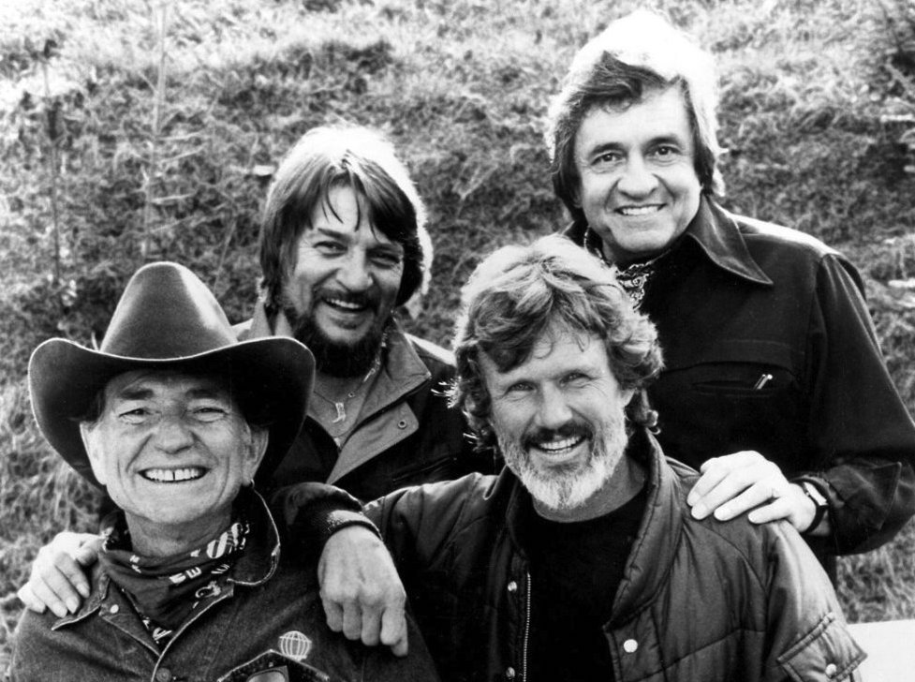

Hot House
Glass: Wine glass
Garnish: thin cucumber slice
Recipe:
2 cucumber slices
1 oz. Herradura Silver
½ oz. lime juice
¼ oz. simple syrup
3 oz. Cava
Muddle cucumber slices in the bottom of a mixing glass. Add tequila, lime, simple syrup and ice and shake well. Double strain through a fine mesh strainer into a wine glass, and top with Cava. (Please note where 5 oz. fill is on wine glass, and do not over fill with Cava!!)

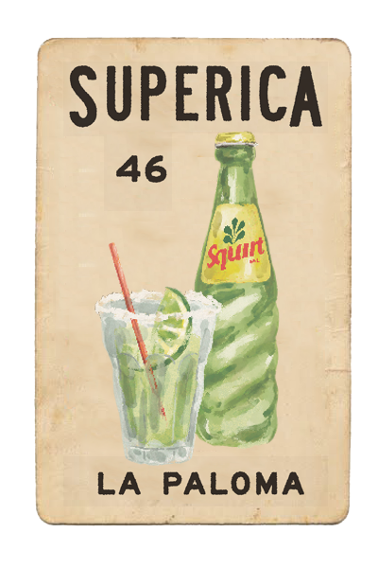
La Paloma
Glass: Tall beverage glass
Garnish: Lime, salt rim
Recipe:
1 ½ oz. El Jimador blanco
½ oz. lime juice
Salt rim of a tall beverage glass. Build tequila and lime juice over ice. Serve bottle of Squirt on the side.
Despite the fact that many American cocktail purists think a Paloma should be made with fresh grapefruit juice and served up, this is a true, authentic Paloma. Go into any bar in Mexico, and your Paloma will be made exactly this way: with a glass bottle of grapefruit soda. No point messing with a good thing.

La Parilla
Glass: Old Fashioned
Garnish: Grilled lime wheel
Recipe:
1 ½ oz. El Jimador Reposado, infused with charred serrano
1 oz. triple sec
1 oz. grilled lime juice
Combine in a mixing glass with ice. Shake and strain into an old-fashioned glass, filled with ice and garnished with a rim of smoked salt. Float about ¼ oz. of Vida Mezcal on top of the cocktail. Grilled lime wheel garnish.
Char serrano on grill or flat top until it blisters. Cut a slit in the pepper longways and drop into a bottle of El Jimador Reposado. Allow to infuse for at least 24 hours. Longer makes it hotter!

This cocktail utilizes our wonderful wood-burning grill. Why not? The limes are grilled before juicing so that the juice itself has a smoked/charred flavor. The tequila is infused with a blistered serrano pepper for heat. The build is a classic margarita. The garnish continues the smoke, with a floater of mezcal and also a rim of smoked salt. Delicious.
The name “La Parilla” means “the grill” in Spanish.
(Originally from the menu at State of Grace, Houston)

Little Brown Sour
Glass: Old-fashioned
Garnish: lime
Recipe:
1 ½ oz. Old Forester bourbon
1 oz. brown sugar syrup
¾ oz. lime juice
2 oz. Fresh tamarind juice
Build in mixing glass. Add ice and shake well. Strain into old-fashioned glass over fresh ice.

Little Havana (single)
Glass: Old fashioned
Garnish: Fresh mint sprig
Recipe:
1 ½ oz. platinum rum
1 oz. fresh lime juice
1 oz. simple syrup
1 bar spoon Luxardo maraschino
Fresh stawberries.
Muddle two fresh strawberries in a cocktail shaker. Add other ingredients, fill with ice and shake well. Strain over crushed ice and garnish with sprig of fresh mint.

The Little Havana is a classic from the menu at JCT Kitchen. It reappears on the menu there every spring when strawberries come in season. It is based on the classic rum cocktail, the Daiquiri, which is made of just rum, lime and sugar. The name “Little Havana” is for the neighborhood in Miami where many Cuban immigrants live.
The version below is frozen, so a frozen fruit puree will be used to make the freezing process more efficient. Nevertheless, all ingredients will be natural and good quality.

Little Havana (frozen)
Glass: Collins
Garnish: big mint sprig
Recipe for batch:
2-1L bottles Myers Platinum
2-30 oz. containers of strawberry puree
48 oz. strained lime juice
1-750ml bottle Luxardo Maraschino
2-3 quarts simple syrup (depending on lime tartness)
6 quarts water
Yield: 455 ounces; 38 portions

The Lucky One (Superica version)
Glass: Coupe
Garnish: very thin jalapeño slice
Recipe:
1 ¼ oz. Tanteo jalapeno
¾ oz. white crème de cocoa
¾ oz. fresh lemon juice
Combine all in a mixing glass and shake well with ice to combine. Strain into a chilled coupe, and garnish with a thin slice of jalapeno, floated on top of cocktail.

This cocktail was originally used at The El Felix location at Avalon (see below). The first version used the Herradura Double Reposado tequila selected specifically for the El Felix.
The El Felix loosely translates to mean “The Lucky One” in a weird, poor grammatical combination of Latin and Spanish.
The cocktail is based on the 20th Century Cocktail, which is typically made of gin, crème de cocoa, lemon and Kina Lillet.

The Lucky One (original version)
Glass: Coupe
Garnish: Lemon twist
Recipe:
1 ½ oz.- 2 oz. Herradura double reposado, El Felix barrel
¾ oz. white crème de cocoa
½-¾ oz. lemon juice
¼ oz. Herbsaint rinse
Spritz coupe with Herbsaint using atomizer if available. Build other ingredients in mixing glass with ice and shake. Strain into coupe and garnish with lemon peel, expressed over glass.

Matador (El Felix version)
Glass: Coupe
Garnish: Paper thin lime wheel
Recipe:
5 cilantro leaves
2 slices jalapeno
½ oz. lime juice
½ oz. simple syrup
2 oz. pineapple juice
1 ½ oz. blanco tequila
Muddle cilantro and jalapenos, add other ingredients and shake with ice. Strain into chilled coupe and drop an extra thin lime wheel onto surface of cocktail.

Matador (Superica version)
Glass: Coupe
Garnish: Cilantro leaf
Recipe:
1 ½ oz. El Jimador blanco
2 oz. pineapple juice
½ - 1 oz. lime juice
4 or 5 cilantro leaves
Muddle cilantro in bottom of mixing glass. Add other ingredients. Add ice and shake, then strain into a chilled coupe.

This is truly the classic cocktail that nobody knows. It was a question asked to the person being tested next to our menu creator, Lara Creasy, at the Certified Sommelier exam, and she had no idea what it was. Luckily Lara got “Dark and Stormy.” But she knows the Matador now! And we are sharing it with the world.

Mexican Hot Chocolate
Glass: glass mug
Garnish: sea salt, cinnamon
Recipe:
1 oz. Hangar One Chipotle
½ oz. Kahlua
Hot chocolate from dessert station
Serve in pre-warmed glass punch mug. Garnish with sea salt and a pinch of cinnamon.

Mezcal Mule
Glass: Collins
Garnish: cucumber slices with Tajin salt sprinkled on top
Recipe:
½ oz. mezcal
1 oz. Sparkle Donkey Reposado
½ oz. lime juice
drop agave nectar
3-4 very thin slices of cucumber, peel on
2 oz. Q ginger beer
Pinch Tajin/salt (perhaps sal de gusan?)
Muddle cucumber in a mixing glass. Pour tequila, mezcal, agave nectar and lime on top and shake with ice. Strain into Collins glass. Fill glass with crushed ice so that it is very full. Top with ginger beer and top up with ice if necessary. Garnish with 3 thin cucumber slices and a sprinkling of Tajin salt.
We’re taking the ubiquitous Moscow Mule trend and running with it. Why not make it a mezcal mule? It’s spicy, it’s earthy, it goes well with lime. Seems like a good idea...

Mezcal Smash
Glass: Old-fashioned
Garnish: mint leaf
Recipe:
2 oz. Sombra joven mezcal
2 orange slices
4 mint leaves
Muddle 4 mint leaves and two orange slices in the bottom of a mixing. Add ½ oz. agave nectar and 2 oz. mezcal, plus ice. Shake well to combine and bruise mint. Strain over crushed ice into old-fashioned glass. Allow bits of mint through. Garnish with a sprig of fresh mint, smacked to relase aroma.

Pear Caiprinha
Glass: OF
Garnish: limes
Recipe:
2 oz. Leblon Cacacha
½ oz. Velvet Falernum
2 oz. pear nectar (Looza or Goya please! Not Jumex)
4 small lime pieces
Squeeze/muddle lime quarters in the bottom of a mixing glass. Add cacacha, pear nectar, velvet falernum and ice to the mixing tin. Shake briefly, then pour entire thing into an Old-Fashioned glass. Top up with ice if needed. The limes are the garnish, but add a sprinkle of cinnamon or nutmeg to the top as well.
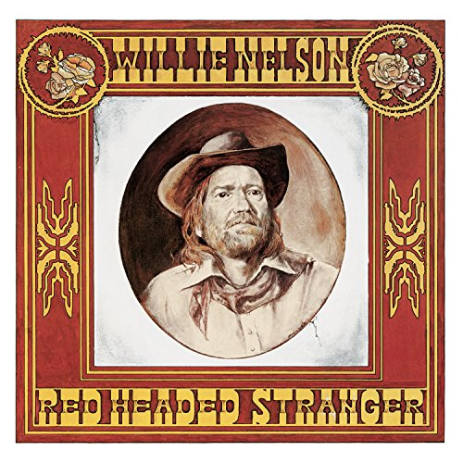
Red Headed Stranger
Glass: Old-fashioned
Garnish: lime
Recipe:
1 ½ oz. Deep Eddy Ruby Red vodka
½ oz. Campari
2 oz. fresh ruby red grapefuit juice
Combine ingredients in a mixing glass and add ice. Shake and strain over fresh ice into an old-fashioned glass.

The Red Headed Stranger was an album recorded by native Texan Willie Nelson in 1975.
Deep Eddy is a Texas-made vodka, corn-based like Tito’s, but currently of more reliable quality than Tito’s. It’s a great product to turn your guests onto! If they love Tito’s, they will love Deep Eddy.

Return of the Swamp Thing
Glass: Coupe
Garnish: Pickled shrimp or cilantro leaf
Recipe:
2 cucumber slices
pinch of salt
1 ½ oz. Sombra joven mezcal
1 ½ oz. avocado puree (Yucatan brand Avocado pulp)
½ oz. lemon juice
½ oz. simple syrup
IF BLENDED, use 2 ½ oz. of blended avocado, lemon, simple mix.
Combine all in mixing glass. Add ice and shake well. Double strain into a coupe. Garnish with shrimp over edge of glass, and leaf floated on top.

For ease of mixing, blend avocado puree, lemon juice and simple syrup together and stir well to combine. Store in a squeeze bottle for service.

To pickle shrimp, bring a blend of water and citrus juices to a simmer. Poach shrimp for about 2 minutes. Remove from poaching liquid, squeeze with fresh lime and chill.

Revolver
Glass: Wine glass
Garnish: Flamed orange peel
Recipe:
2 oz. Bulleit Bourbon (or Bulleit Rye)
½ oz. Kahlua
2 dashes Regan’s Orange bitters
Combine ingredients in a mixing glass. Add ice and stir for 20 seconds. Strain with a julep strainer into a wine glass with no ice. Garnish with flamed orange peel.

The Revolver cocktail was created by San Francisco bartender Jon Santer in 2004 to welcome Bulleit Bourbon to the market. It’s a pretty simple twist on the classic Manhattan, featuring Bulleit and coffee liqueur.

Rough Rider
Glass: Tall beverage glass
Garnish: Lime wheel/ circle
Recipe:
1 ½ oz. vanilla-infused Havana Club rum (infuse bottle of Havana Club with ½ vanilla bean, sliced open length-wise to expose seeds)
4 dashes velvet falernum
Fill glass with lots of ice, add rum and falernum. Serve bottle of Mexican Coca-Cola on side. Pour Coke at table or in front of guest and leave bottle.

“Cuba Libré” means “free Cuba,” and it was the battle cry of Teddy Roosevelt’s Rough Riders, the cavalry that drove the Spanish out of Cuba during the Spanish American War. Coca-Cola had only been available for about 4 years when the Rough Riders took off on their mission. They brought some Coke with them to Cuba and mixed it with the local rum and lime. This simple cocktail became a sensation, and remains one of the most popular drinks in the world today.
The Rough Rider is a variation on the popular Cuba Libré cocktail, featuring vanilla-infused rum and the deep flavors of the classic tiki ingredient velvet falernum. Consider it an upgrade on a classic.

Sangria (classic)
2 bottles unoaked red wine
1 cup Brandy
1 cup orange juice
1 cup sugar
1 cup water
1 cup triple sec
1 each diced orange, apple and lemon
Dice fruit and marinate in brandy and triple sec while preparing other ingredients. Make a simple syrup of sugar and water. Add to batch along with orange juice. Add wine last. If possible, chill for at least 6 to 8 hours before serving. Serve over ice with fruit for garnish. Add seasonal fruits when serving as garnish.

Sangria (frozen)
2 bottles red wine (Spanish garnacha is a good choice)
2 cups Torres Orange brandy
1 cup orange juice
½ cup lime juice
1 quart simple syrup
3 quarts water
Yield: 206 ounces; 17 portions

Or if you use boxed wine:
1 box La Nevera (3L)
4 cups Torres Orange brandy
2 cups orange juice
1 cup lime juice
2 quarts simple syrup
6 quarts water
Yield: 412 ounces; 34 portions

Sour Lake Springs
Glass: Coupe
Garnish: Celery leaf
Recipe:
1 egg white
1 ½ oz. El Jimador blanco tequila
¾ oz. pineapple juice
½ oz. lemon juice
½ oz. simple syrup
3-4 drops celery tincture (small bar spoon)
Crack egg white into mixing glass. Add other ingredients. Dry shake. Add ice and shake again. Double strain into a coupe. Garnish with a few celery seeds floating on top of foam.

To make celery tincture:
Use one pint 80-100 proof vodka to cover about 4 oz. celery seeds and a few celery leaves in a sealed container. Shake daily for about 2 weeks to allow tincture to fully infuse. Strain through cheesecloth before using.

Southern Hospitality
Glass: Tall beverage glass
Garnish: Grapefruit peel, Fresh pineapple
Recipe:
1 oz. El Jimador reposado
2 oz. tepache
2 oz. IPA
Build over ice in a tall beverage glass. Roll to mix. Express a grapefruit peel over top and drop in. Garnish with fresh pineapple.

Strawberry Caiprinha
4 Lime quarters
2 strawberries, cut into pieces
2 barspoons Sugar in the Raw
2 oz. Leblon Cacacha
Squeeze/muddle lime quarters in the bottom of an Old-Fashioned glass. Add ice to glass to fill. Separately, muddle strawberry pieces really well in a mixing glass or small tin with the Sugar in the Raw. Add cacacha and ice to the mixing tin. Shake well, then strain into glass, trying to hold back as many strawberry bits as possible. The limes are the garnish, so nothing extra is needed. Just make sure ice is enough in glass.

Tahona Sundown
Glass: OF
Garnish: lime wedge
Recipe:
1.5 oz. Banhez mezcal
.75 oz. grapefruit juice
1 oz. Stirrings triple sec
.5 oz. honey syrup (1:1 ratio)
1 slice muddled jalapeño
4 dashes Angostura’s bitters
Combine all in a cocktail shaker with ice. Shake and strain into an OF glass over fresh ice. Garnish with a lime wedge. (Courtesy of Bryan Griggs)

Tea-Juana Punch
4 cups tequila (well)
4 cups unsweet ice tea
3 cups pineapple juice
½ cup honey
½ cup hot water
½ cup lime juice
½ cup lemon juice
½ t. cinnamon
1 t. Angostura’s bitters
Mix honey and hot water to dilute. Mix with all other ingredients and refrigerate. Serve a 6 to 8 oz. portion on rocks with lemon garnish.

This fun party punch, adapted from a home cookbook, is a perfect example of a classic punch. It has all 5 elements that a traditional punch would have: spirit, sugar, citrus, tea, spice. The name reflects the party spirit of Tijuana, a place where fun-seeking Americans have gone since Prohibition days to enjoy the loose laws South of the Border, where no type of fun is illegal!

Tequila Sunrise
Glass: Coupe
Garnish: Brandied cherry
Recipe:
1 ½ oz. El Jimador reposado
2 oz. fresh orange juice
½ oz. housemade grenadine
Shake tequila and orange juice and strain into coupe. Pour grenadine so it settles at bottom of glass, and garnish with a brandied cherry.

Americans, especially those from Hollywood, used to travel to Tijuana during Prohibition, because Tijuana didn’t outlaw any type of fun! The Tequila Sunrise was originally conceived at the Agua Caliente racetrack in Tijuana in the 1920s, and it was quite different than it is today. It was once made with lemonade, French crème de cassis, and soda water. Once Prohibition ended, and the drink found its way north of the border, it became something quite different.
The Eagles wrote a song about it in the 1970s, probably at the height of its popularity.

Tequila y Tonic
Glass: Snifter
Garnish: Rosemary
Recipe:
1 ½ oz. El Jimador Blanco
lime, orange wedges
Fever Tree Mediterranean Tonic to fill
Pour tequila into snifter. Squeeze lime wedge and orange wedge into glass. Fill with ice. Garnish with rosemary sprig. Send to table with tonic bottle.

Though it seems like a no-brainer, I would say the average person has never considered ordering a tequila and tonic without someone suggesting it to them. Too bad, because it’s actually delicious!
We are using Fever Tree’s Mediterranean tonic, which has notes of flowers, fruits and herbs, and it mixes really well with the herbal notes of the tequila and the fruit garnishes.
This presentation is based on the popularity of Gin and Tonic in Spain. Serving the cocktail in a wine glass or snifter is a popular presentation in Spain, as is garnishing with lots of fruit squeezed right in the glass. Sadly, what is not popular in Spain is tequila!

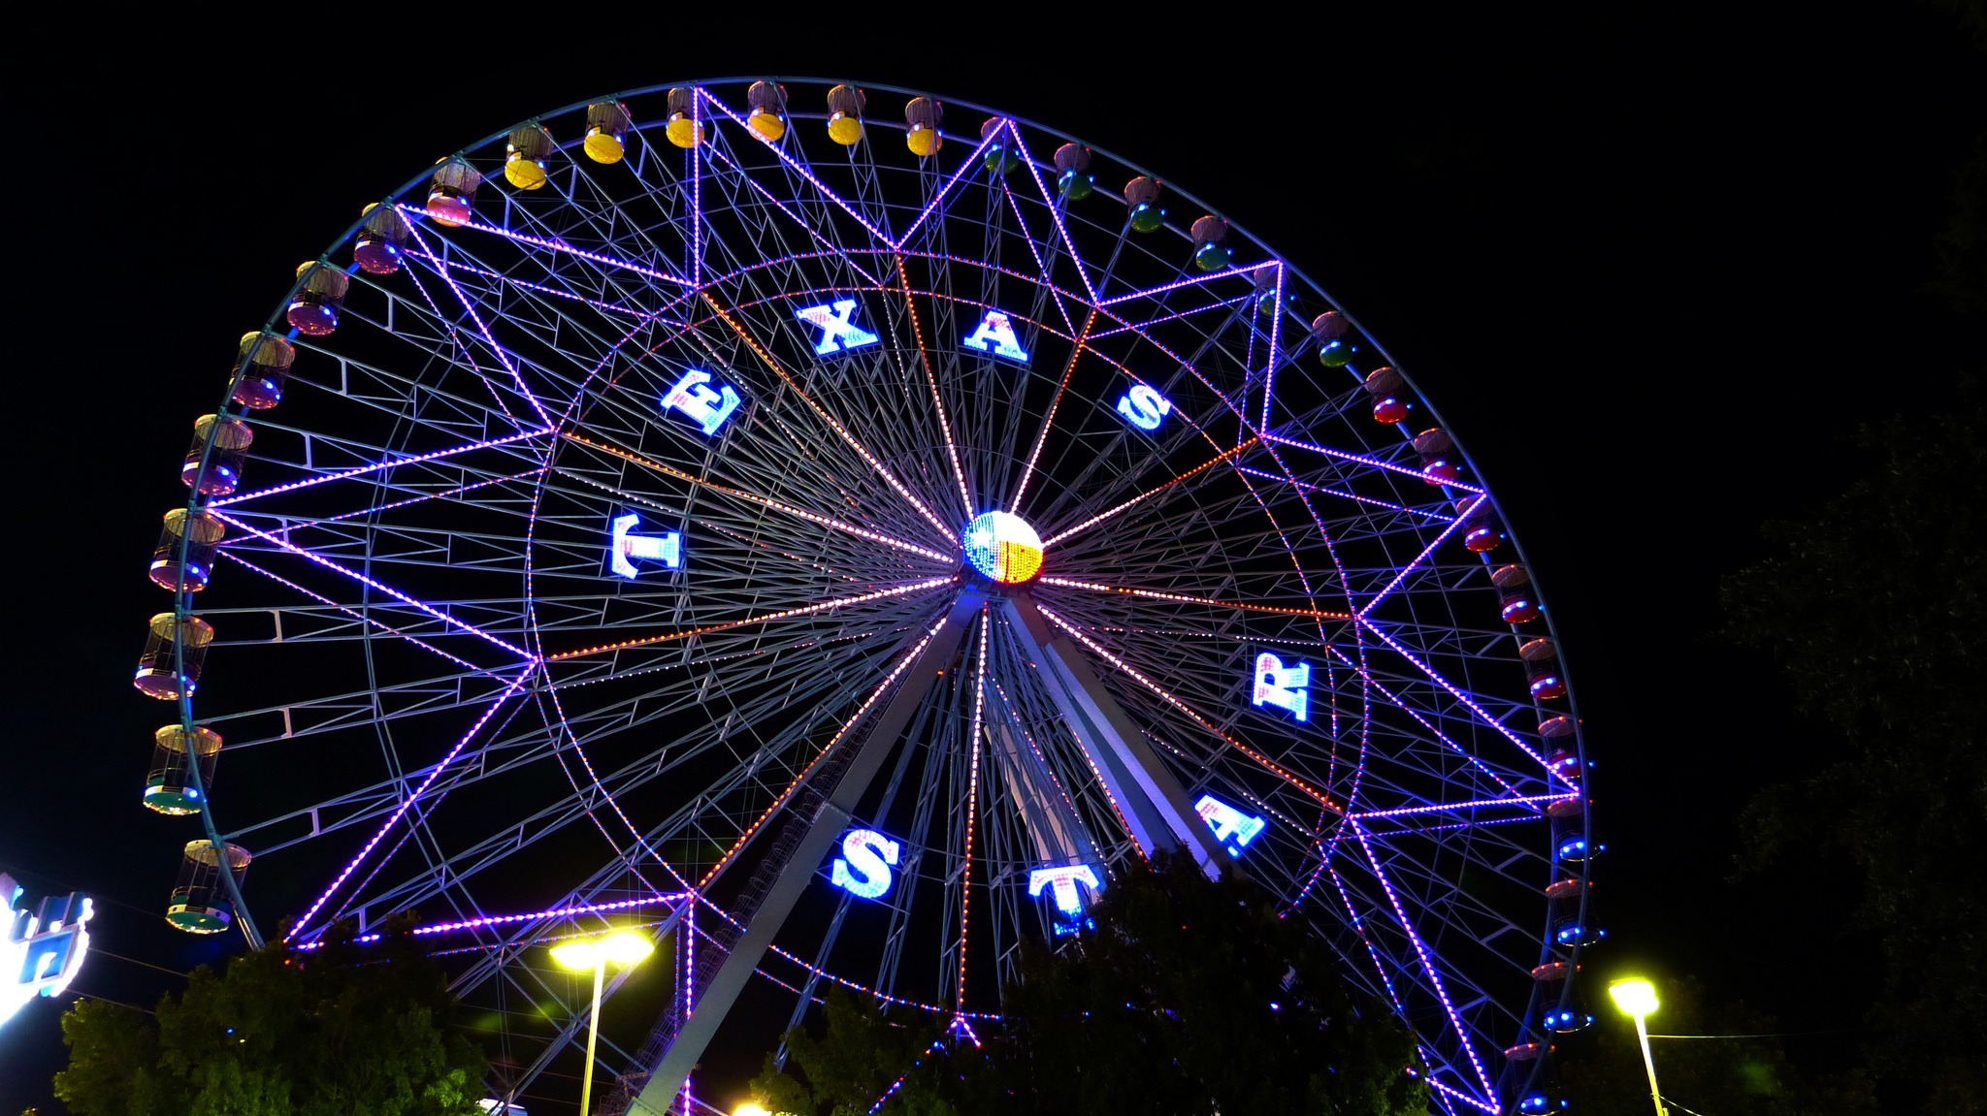

Texas Star
Glass: Old-Fashioned
Garnish: Lime
Recipe:
1 ½ oz. Centenario Rosangel
½ oz. St. Germaine
1 oz. fresh grapefruit juice
½ oz. fresh lime juice
½ oz. simple syrup
Build in a mixing glass, shake briefly. Pour over fresh ice to serve.

This is another cocktail originally from the menu at JCT Kitchen. It was originally created in honor of Ford Fry, our own Texas star. Ford loves margaritas, and this cocktail is based on the classic margarita build. The name of the cocktail comes from the giant Ferris Wheel in Dallas that operates at the Texas State Fair, and is its most popular ride. It’s also in honor of the Rio Star variety of ruby red grapefruit from Texas, which is one of the most delicious grapefruits out there.

Última Palabra
Glass: Coupe
Garnish: none
Recipe:
¾ oz. mezcal
¾ oz. Luxardo maraschino
¾ oz. Arrogante Damiana
¾ oz. fresh lime juice
Combine all in a mixing glass and shake well with ice. Strain into a chilled coupe.

This cocktail is a variation on the classic cocktail known as “The Last Word,” which is typically made with gin as th base spirit. We have used mezcal instead, and therefore changed the name to Ultima Palabra, which means “last word” in Spanish.

Under the Volcano
Glass: Coupe
Garnish: grapefruit peel
Recipe:
1.5 oz Sombra mezcal
.75 oz grapefruit
.5 oz lime
.25 oz Luxardo
.25 oz simple
¼ eye dropper of habañero tincture
Shake with ice, and serve up in coupe with grapefruit twist.

Vampire Weekend
Glass: Tall beverage glass
Garnish: fresh pineapple, grated nutmeg
Recipe:
1 ½ oz. The Kraken Spiced Rum
4 oz. housemade Horchata (see recipe in NABev)
Build over ice in a tumbler, roll to mix, and garnish with fresh pineapple chunk and grated spice on top.
Horchata is a wonderful “rice milk” type beverage popular in Mexico and other parts of Latin America. It is typically seasoned with cinnamon and nutmeg, as is ours.
We named this cocktail “Vampire Weekend” in honor of the band, which has a song about Horchata on its Contra album.

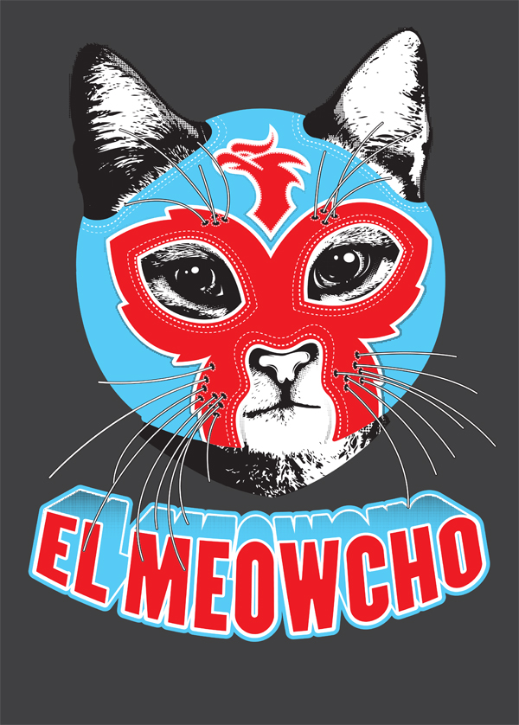

Brunch beverages

The ideal brunch beverage menu should consist of at least three brunch-specific beverages.
The following are approved for all locations:
• Black and White: housemade horchata mixed with cold brew coffee
• Sangria: red or white (see recipe below)
• Classic Mimosa: fresh squeezed orange juice mixed with Cava
• Mimosa Fresca: housemade agua fresca of the day mixed with Cava
• Extra Fresca: agua fresca of the day mixed with platinum rum and lime
• Bloody Maria: housemade or quality bottled bloody mix mixed with tequila
• Tomatillo Bloody Maria/Mary (see recipe below)
• Cava Punch (see recipe below)
• Hot House (see recipe below)

Standard Bloody Maria mix
Recipe:
1 #10 can of tomatoes with juice
12 oz. lemon juice
¾ oz. Worcestershire sauce
¾ oz. hot sauce
2 oz. Prepared horseradish, to taste
2 oz. brine from pickled jalapeno jar
1 teaspoon Celery salt (or ½ t. celery seed and ½ t. salt)
1 teaspoon Ground black pepper
(add one morita chile, softened with boiling water)
(add one quart water)
Combine all in Vitamix and puree. Store in cooler. Yields about 160 ounces, or 40 servings.
To serve: Combine 4 oz. mix with 1.5 oz. El Jimador tequila in a Collins glass. Roll to combine. Garnish with lime, pickled jalapeno ring, etc.

Tomatillo Bloody Mix
Recipe:
7 ½ lbs tomatillos, roughly chopped
7 ½ garlic cloves, peeled
4 ½ cucumbers, rough chopped
4 ½ jalapeños, seeded
1 T celery seed
3 bunches of cilantro leaves, no stems
1 ½ yellow onion, peeled and rough chopped
3 cups water
3 cups fresh lime juice
Kosher salt, to taste
Combine ingredients in a VitaMix and process until smooth. Serve chilled. Yields about 7 quarts. Add about 4 oz. mix to Collins glass with 1.5 oz. El Jimador blanco and roll to combine. Garnish with cucumber or lime.

Sangria (classic)
2 bottles unoaked red wine
1 cup Brandy
1 cup orange juice
1 cup sugar
1 cup water
1 cup triple sec
1 each diced orange, apple and lemon
Dice fruit and marinate in brandy and triple sec while preparing other ingredients. Make a simple syrup of sugar and water. Add to batch along with orange juice. Add wine last. If possible, chill for at least 6 to 8 hours before serving. Serve over ice with fruit for garnish. Add seasonal fruits when serving as garnish.

Cava punch
½ cup lemon juice
½ cup lime juice
½ cup grapefruit juice
½ cup orange juice
½ cup Torres Brandy
½ cup Torres Orange
Grapefruit bitters to taste
2 bottles chilled Cava
Chopped fruit and fresh berries
Dice an orange, a lemon and add some fresh blueberries or blackberries. Mix all other ingredients and add to diced fruit. Chill as long as possible before serving. Add Cava last and chill until service. Serve over ice with fruit included as garnish. Yields 12-14 servings.

Hot House
Recipe (to be used for single portion):
2 cucumber slices
1 oz. Herradura Silver
½ oz. lime juice
¼ oz. simple syrup
3 oz. Cava
Muddle cucumber slices in the bottom of a mixing glass. Add tequila, lime, simple syrup and ice and shake well. Double strain through a fine mesh strainer into a wine glass, and top with Cava. (Please note where 5 oz. fill is on wine glass, and do not over fill with Cava!!)

** Carafe recipe (4 portions):
4 oz. Herradura Silver, infused with sliced cucumbers
2 oz. lime juice
1 oz. simple syrup
12 oz. Cava
Shake tequila, lime and simple. Add to carafe with ice, fresh slices of cucumber, lime wheels and Cava. Serve with bar spoon. Send out glasses of ice with cucumber garnish and cilantro sprig
** The cucumber infusion eliminates the muddling and saves a step overall.
Seasonal menu changes

Menu reprints happen infrequently at Superica and the El Felix, so cocktail menu changes will also happen infrequently.
The best idea is to get into the mindset of changing with the seasons. This might mean changing 4 times per year: for winter, spring, summer and fall. It could also mean changing just 2 times per year, once for spring/summer and once for fall/winter.
However, you should always be several months ahead of the season when planning menu changes, to allow adequate time for planning, obtaining product, staff training and PR/promotions. (Magazine and other media outlets work on deadlines several month before publication, so the PR department may ask you for fall cocktails in June!)

Always keep the season’s temperature, business levels and available produce in mind when making season menu changes. If you are only going to change your menu twice a year, think twice about adding a hot cocktail to the fall/winter menu, which might only be relevant for 3 of the 6 months the menu will be presented. If you are only going to change the menu twice per year, think about the availability of seasonal fruits, like strawberries and blackberries, and don’t add them to the menu if availability might be a challenge halfway through the menu print cycle.
** Be aware that certain fruits have come to be viewed as “year round,” such as apples and citrus, but these fruits still have a season when they are at their best. Though we all love lemonade in the summer, citrus is a WINTER fruit, so be aware of this when sourcing less typical fruits, such as kumquats, blood oranges or tangerines.

The following are some good suggestions for seasonal produce and flavors when planning your upcoming menus.
Spring: Strawberries, rhubarb, pineapple, apricots
Summer: Blackberries, peaches, raspberries, cucumber, hot peppers, plums
Fall: cinnamon, apples, pears, nuts, pumpkin, grapes/ muscadines, figs, cranberries
Winter: all citrus fruits, baking spices, rosemary, sage, pomegranate

Guidelines for adding staff-created cocktails

It’s possible—probable even!—that your bar may attract talented bar staff that have their own cocktail ideas to contribute to the menu. This is great! We always encourage staff submissions, as nothing encourages a bar team to take ownership of prep and quality like having their own drinks on the menu.

Here are some guidelines and suggestions for incorporating staff submissions into your beverage program.
• Superica vs. El Felix
The in-town bars of Superica are better suited to staff-created craft cocktails. One way to encourage staff creativity is by listing a “Wild Card” feature, which rotates weekly (see below).
The suburban bars of The El Felix are better suited to a more streamlined, traditional menu. For this reason, we discourage The El Felix from putting staff-created cocktails on the menu.
• Incorporate Tex Mex appropriate themes and ingredients
When qualifying staff cocktails for menu inclusion, always take into account the appropriate use of agave spirits or Tex Mex ingredients. While there are many wonderful styles of cocktails in the world, from martinis to Manhattans to tiki style layered rum drinks, many of them are not appropriate to the concept of Superica or The El Felix. However, with some adaptation or swapping of ingredients, they can be made into something entirely new.
• Build on the classics
Building on classic cocktails is the best way to create new menu items. This gives the bar staff a solid foundation, with tried and true proportions to build on. Adapting the classic Old Fashioned by using mezcal (The Highwayman) makes it immediately Tex Mex. Taking a cocktail like the 20th Century and using tequila instead of gin (The Lucky One) is an easy adaptation for the menu. And swapping out the vodka in the ubiquitous Moscow Mule to make a Mezcal Mule is a no brainer. Many more ideas exist in this regard!
• Ease of execution
Always take into account the prep load, number of ingredients, and ease of execution during volume periods before considering a cocktail for the menu.
• Name appropriately
Make sure to choose names for staff-submitted cocktails that are not offensive, fit the Tex Mex theme, and encourage guest curiosity.
• Keep in mind the same guidelines for quality outlined in the margarita section.
• Wild Card
An easy way to get staff cocktails on the menu without having to reprint constantly is by running a rotating feature, which we have called “The Wild Card” at other Superica locations. Take staff submissions each season, do a tasting with the management staff/chefs or other bar staff, and decide which cocktails will be featured. Then create a calendar for when the cocktails will run. This gives the bar a chance to be prepared, and also gives PR a chance to promote on social media! (See below for best practices for cocktail rollouts.)
• Follow best practices for cocktail menu changes (next section).

Guidelines for creating frozen cocktails

Taking a successful single cocktail, scaling it up and dumping the batch in the frozen machine is NOT a guarantee of success! Not all regular cocktails should be frozen, and not all frozen cocktails would be good as a single, non-frozen cocktail.
Note that successful frozen cocktails are often fruitier in flavor profile, more intensely acidic and generally sweeter. This is because freezing tends to dull flavors, so recipes will typically need a higher ratio of sugar and acid to not taste over-diluted once frozen (see notes below on adding water).
“Just as ice cream makers add a ton of sugar to compensate for the taste-dulling effect of the treat's frozen state, frozen drinks need intense flavors to make up not only for our numbed tongues but for all that blended ice, which melts much more quickly than bigger cubes. If the drink isn't a flavor punch on delivery, it's going to be a vague, watery mess by the time you're done drinking it.”
http://www.chicagotribune.com/dining/drink/ct-frozen-cocktails-20170802-story.html

Classic frozen drinks, like the daiquiri, are frozen classics because of their built-in high citrus and sugar ratio.
Unlike in most other cocktails, using frozen fruit instead of fresh fruit is actually better, because the flavors and juices are concentrated in the frozen fruit, which gives you more pop on the palate. Plus, it will already be cold when you add it to your batch, so freezing will be much quicker. All-natural fruit purees are also a good way to go. Perfect Puree is a trusted brand.
www.perfectpuree.com
Generally, spirit-driven cocktails don’t translate well into the frozen or blended format unless there’s an opportunity to temper bitter or sour elements with sugar. Negronis can be made in a slushy machine, for example, but not without the addition of a little grapefruit juice and sugar.
When experimenting, the best way to know if a cocktail will translate well to the drink machine is to make a small batch and freeze it! Most frozen drink machines allow you to add ingredients to the hopper continuously, just make sure the ingredients you add are stirred in well. And keep track of the exact amounts you add! You’ll eventually need a recipe you can replicate.

Some more articles to read:
http://punchdrink.com/articles/reconsidering-the-virtues-of-the-blended-cocktail/

http://www.bonappetit.com/test-kitchen/common-mistakes/article/frozen-cocktails-common-mistakes

An important note about frozen batches:
All cocktails contain a certain amount of water. Normally this is integrated during the shaking or stirring process, or by pouring the cocktail over ice. However, with frozen cocktails, the water must be incorporated into the batch recipe, as it is frozen into the cocktail and served straight out of the machine.
How much water to incorporate will vary by recipe, but a good test is to measure out a few ounces of product and shake it with ice to proper dilution, then measure it again.
A good rule of thumb is to plan for water to be 1/5 to 2/5 of your total cocktail volume, just like you were shaking 3 oz. of cocktail with ice, and wound up with 5 oz. of diluted cocktail to serve.

Best practices for menu rollouts

The following general guidelines will make introducing new cocktails (or beers, or wines) to the menu virtually painless.
• Allow yourself about a two week lead time. Introduce new cocktails to the menu on a Monday or Tuesday, if possible, to allow all staff to get comfortable with the item before the weekend.
• Two weeks out/ Monday or Tuesday: Schedule a tasting for at least 3 restaurant leaders to sample the cocktail (including managers, chefs or VPs). Work on incorporating any suggestions/ changes to the cocktail.
• 12 days out/ Wednesday: Establish an agreed upon recipe. Cost out your menu item based on COGS guidelines. Email recipe to bar staff so they can begin to learn it.
• 11 days out/ Thursday: Add any new ingredients to the order guide. Have them added to Compeat if they are not in the master. Receive all product into inventory.
• 9 days out/ Saturday: Train bar staff on the new menu item. Edit prep list and establish protocol for producing any housemade ingredients.
• 7-5 days out/ Monday-Wednesday: Hold line-ups for service staff to train on new item.
• 4 days out/ Thursday: Program Micros with new menu item. Add item to menu template and have menu proofread by another manager. Make sure all product is in house, in case of out-of-stock issues.
• 2 days out/ Saturday: Hold another line up for service staff. Make sure all bar staff is ready to go for Monday with new prep list, glassware and the proper recipe.
• Monday: Reprint menus, have hosts stuff before service, start selling new cocktail!

Sample Opening Cocktail Menu
Superica Buckhead

Cocktails

Little Havana $9: (frozen) Myers Platinum rum, strawberries, lime, Luxardo Maraschino, fresh mint

The Lucky One $9: Tanteo Jalapeno, crème de cocoa, lemon, served up

Red Headed Stranger $10: Deep Eddy Ruby Red vodka, Campari, grapefruit juice, lime, on the rocks

Mezcal Mule $12: Peloton de la Muerte mezcal, Sparkle Donkey Reposado, spicy ginger beer, cucumber, lime, Tajin salt, crushed ice

Vampire Weekend $10: Housemade horchata, The Kraken spiced rum, grated cinnamon and nutmeg, pineapple garnish

El Chapo $12: Peleton de la Muerte mezcal, Ancho Reyes, Caffe Mokka, Kahlua Especial, strong coffee, coffee salt, served up

Bulevar $12: El Jimador Reposado, Campari, Cocchi Vermouth di Torino, neat

The Highwayman $11: A mezcal old-fashioned with agave nectar and The Bitter End Mexican Mole bitters

Margs y Classicos

Margarita de la Casa $8: El Jimador Reposado, Stirrings triple sec, fresh lime, sugar, frozen

The O.G. $10: Goza Reposado, Stirrings triple sec, fresh lime, short and strong, up or on the rocks

Superita! $15: Herradura Double Reposado, Combier, lime juice, orange, brine, citrus-marinated olives, served up Austin-style

Texas Star $12: Centennario Rosangel, St. Germaine, ruby red grapefruit, lime

Tequila y Tonic $10: El Jimador blanco with orange, lime, rosemary and a bottle of Fever Tree Mediterranean tonic

Matador $9: El Jimador Blanco, pineapple, lime, served up

La Paloma $9: El Jimador Blanco, fresh lime, Squirt soda, salt

El Diablo $10: El Jimador Reposado, crème de cassis, lime, ginger beer, crushed ice

(listed with beers)
Chelada $6: Negro Modelo over ice, with fresh lime juice and salt
(listed with wines)
Sangria $9: Temprenillo, Torres 5-Year Brandy, triple sec, citrus

