

|  |
| --- |
| **Selling on Amazon** |
| CS669 – Database Design and Implementation for Business. Boston University, Spring 2018 |
| The purpose of this document is to illustrate the complete lifecycle of database design; from conception to implementation to application. The key concepts include structural business rules, conceptual & logical entity relationship diagrams, and demonstration of SQL code. |
|  |





Table of Contents

Business Rules……………………………………………………………………………………………. 2

Conceptual ERD……………………………………………………………………………………...... 3

Logical ERD……………………………………………………………………………………………… 4

Use Cases………………………………………………………………………………………………... 5

New Product …………………………………………………………………………...……… 5

Product Delivery …………………………………………………………………………...…. 8

New Customer …………………………………………………………………………...…… 10

Product Purchase …………………………………………………………………………..... 12

Product Shipment …………………………………………………………………………..... 15

Index………………………………………………………………………………………………........... 17

**Business Rules:**

1. A seller may sell many products. A product must be sold by one or many sellers.
2. A seller must have one and only one vendor account. A vendor account is linked to one and only one seller.
3. A product must belong to one product category. A product category may contain many products.
4. A product is linked to one and only one customer order. A customer order may contain many products.
5. A customer must have one and only one customer account. A customer account must be owned by one or more customers.
6. A customer may buy many products. A product may be purchased by many customers.
7. A customer may complete many orders. Each order is linked to one customer.
8. A product must be assigned to one or many packages. A package must contain one or more products.
9. A package may ship via many shipping methods. A shipping method applies to many packages
10. A package must be assigned one and only one tracker. A tracker must be attached to one and only one package.

**Conceptual ERD:**

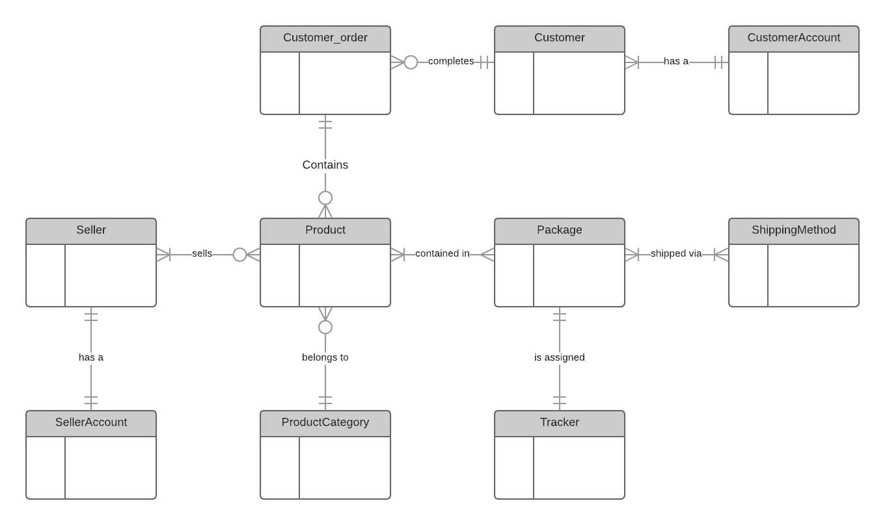

**Logical ERD:**

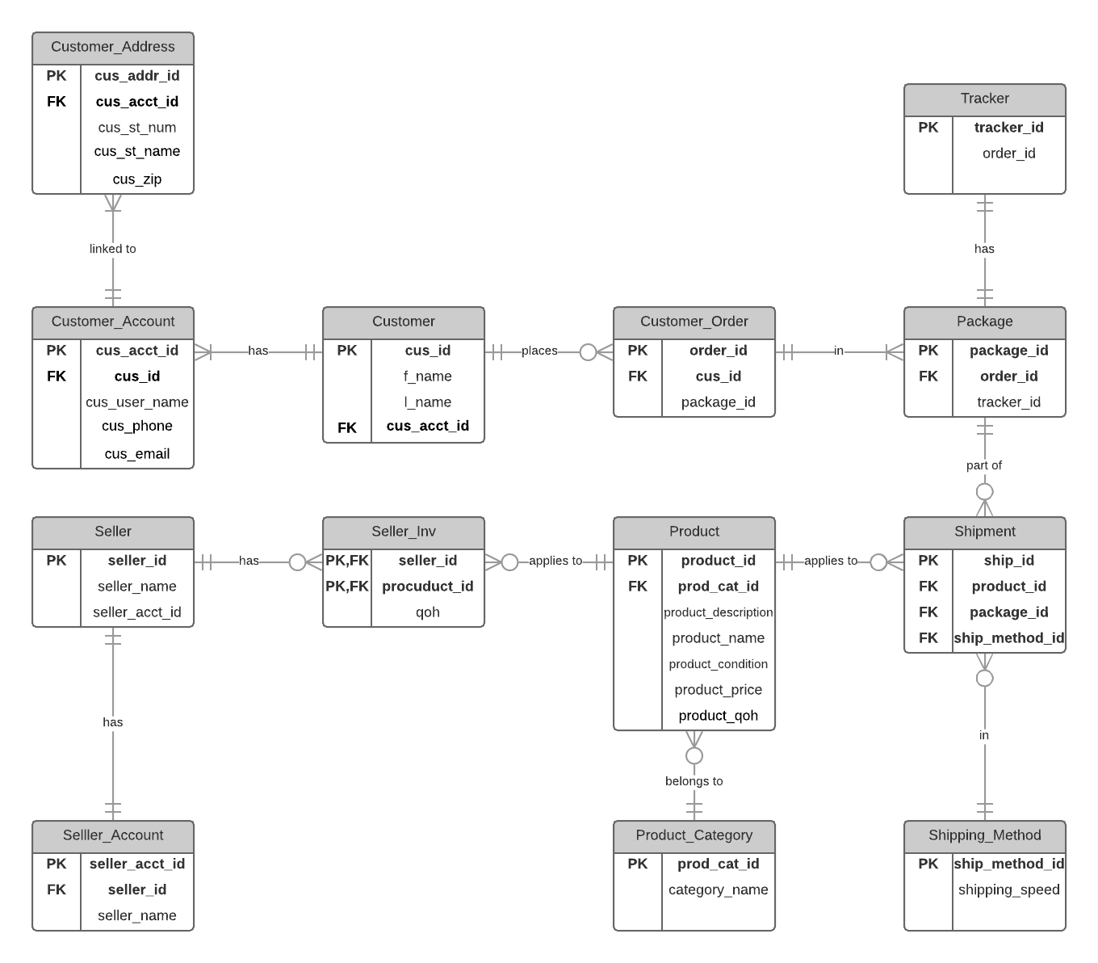

**USE CASE 1: New Products**

1.1 Develop a parameterized stored procedure that is used when a seller needs to add any new product.

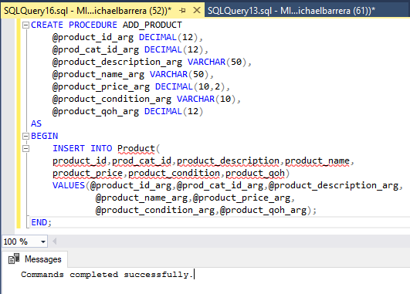

1.2 A seller adds two new products. The first is a self‐driving video camera which automatically follows a subject that is being recorded. The second is a holographic keyboard that emits a three‐dimensional projection of a keyboard and recognizes virtual key presses from the typist. Invoke the stored procedure twice to add these products, keeping in mind that products have at a minimum a name, description, price, and category.

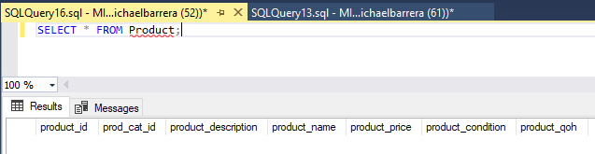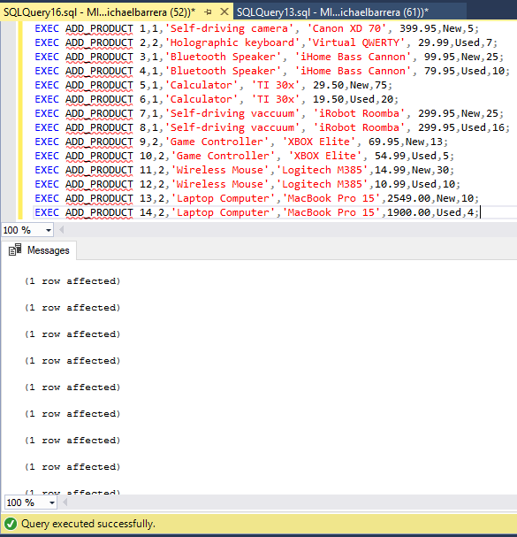

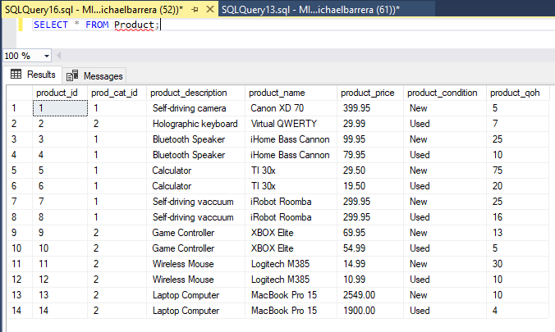

1.3 A seller is considering developing a new electronic product and requests a list of existing products in the “Computers” or “Electronics” categories that cost $30 or less. Develop and execute a single query that provides this information.

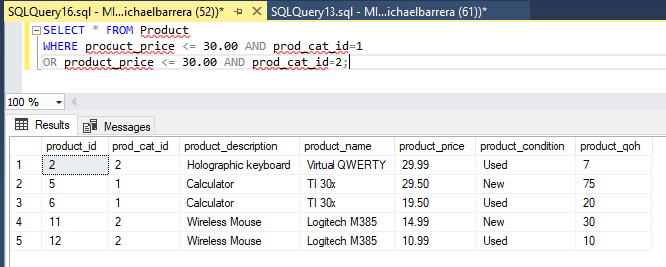

ASPECT 2: Product Delivery

2.1 Develop a parameterized stored procedure that is used when any seller delivers any product to Amazon’s warehouse.

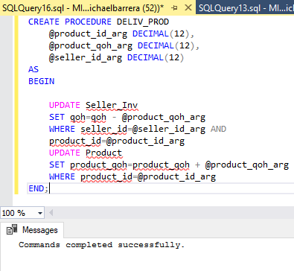

2.2 A seller delivers four each of the two new products added in Aspect 1 (the self‐driving video camera and the holographic keyboard). Invoke the stored procedure twice to update the inventory of these products for a seller of your choosing.

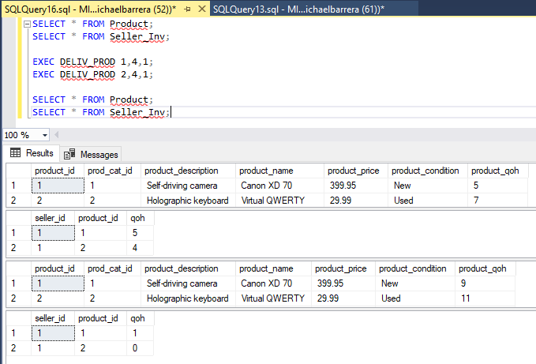

2.3 The seller from b above requests a listing of all of its products that have an inventory of 11 or less. Develop and execute a single query that provides this information (the self‐driving video camera and holographic keyboard should be among those listed).

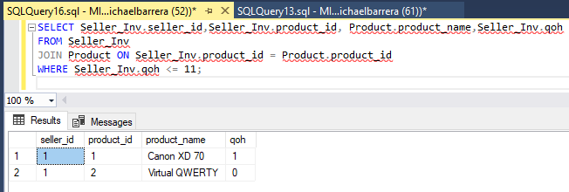

**ASPECT 3: New Customer Accounts**

3.1 Develop a parameterized stored procedure that is used when any new customer signs up for a new account on Amazon.

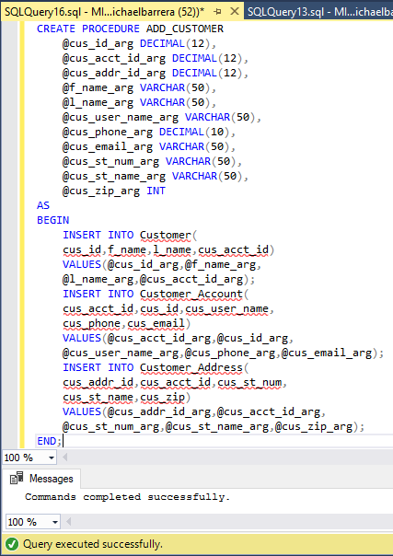

3.2 You and your facilitator sign up for new accounts on Amazon. Invoke the stored procedure twice to add you and your facilitator as customers.

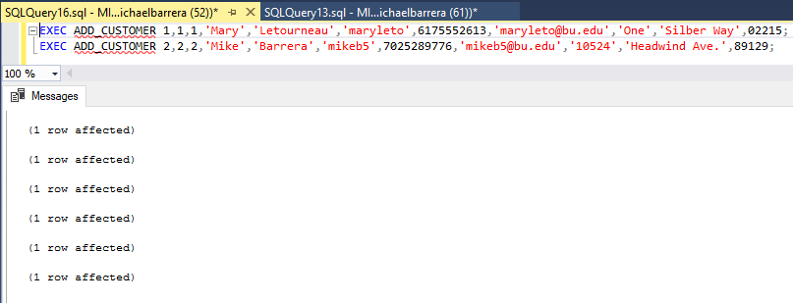

3.3 For research purposes, Amazon requests the last names of customers where there are least 4 accounts associated with the last name. Amazon would like to see the actual number of accounts associated with those last names. Develop and execute a single query that provides this information.

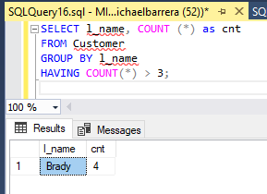

**ASPECT 4: Product Purchases**

4.1 Develop a parameterized stored procedure that is used when any customer purchases any product.

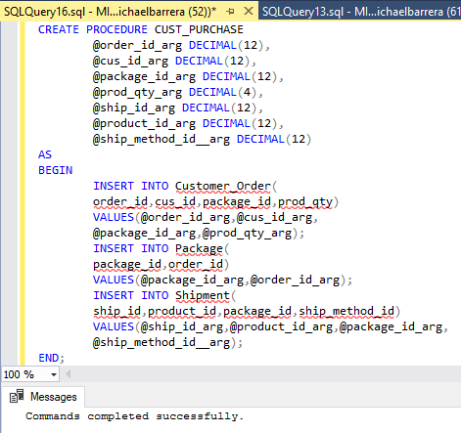

4.2 You purchase a self‐driving video camera (from Aspect 1), and your facilitator purchases three holographic keyboards. Invoke the stored procedure twice, once for each purchase.

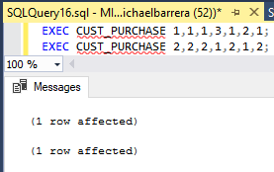

4.3 The marketing department at Amazon wants to reach out to customers who buy popular products. The department requests the names and addresses of all customers who bought any product that was purchased by at least three different people. Develop and execute a single query that provides this information.

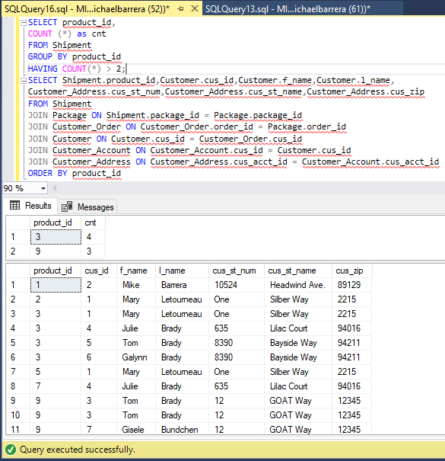

**ASPECT 5: Product Shipment:**

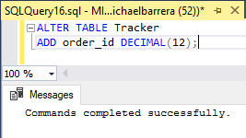

5.1 Develop a parameterized stored procedure that is used when Amazon ships any order.

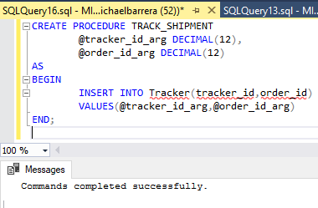

5.2 Amazon ships the orders listed in Aspect 4, one to you and the other to your facilitator. Invoke the stored procedure twice, once for each order.

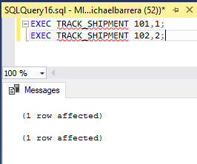

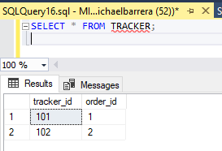

**INDEX CREATION:**

