TransPlanck Dynamics - Enhanced Information Processing Through Mathematical Field Optimization
Author: Michael Kevin Baines
ORCID: 0009-0001-8084-3870
Component: COSMIC Framework Theoretical Foundation
Date: July 2025
Status: Theoretical Development Document - Revised

Abstract
TransPlanck Dynamics theory proposes that mathematical constant fields enable enhanced information processing in quantum systems through thermodynamically consistent scale optimization mechanisms. Rather than violating fundamental limits, the theory reinterprets effective quantum scales as optimization-dependent parameters that can be modified through information-field coupling while preserving all conservation laws and physical principles. The framework predicts measurable enhancements in quantum coherence, precision measurement capabilities, and computational efficiency through field optimization at the critical frequency of 61 GHz. All effects respect thermodynamic constraints and maintain consistency with established quantum mechanics and relativity.

1. Introduction

1.1 Theoretical Motivation
Traditional interpretations view the Planck scale as a fundamental barrier to physical measurement and information processing. However, recent developments in quantum information theory and precision measurement suggest this barrier may represent an optimization transition rather than an absolute limit. The COSMIC framework's detection of mathematical constant field signatures in cosmic microwave background data provides empirical motivation for investigating scale-dependent optimization effects.

1.2 Key Principles
TransPlanck Dynamics operates on several fundamental principles:
- Optimization paradigm: Physical scales emerge from information processing optimization rather than fundamental granularity
- Field-mediated enhancement: Mathematical constant fields (π, φ, √5, e, √3) enable local scale modifications
- Thermodynamic consistency: All enhancement effects require energy input and increase total entropy
- Conservation preservation: Fundamental conservation laws remain inviolate
- Quantum mechanical compatibility: Framework extends rather than replaces quantum mechanics

1.3 Relationship to Established Physics
The theory maintains complete compatibility with:
- Standard quantum mechanics in zero-field limits
- General relativity through information-gravity coupling
- Thermodynamic laws including entropy increase
- All established precision measurement results
- Symmetry principles and conservation laws

2. Mathematical Framework

2.1 Effective Action Formulation
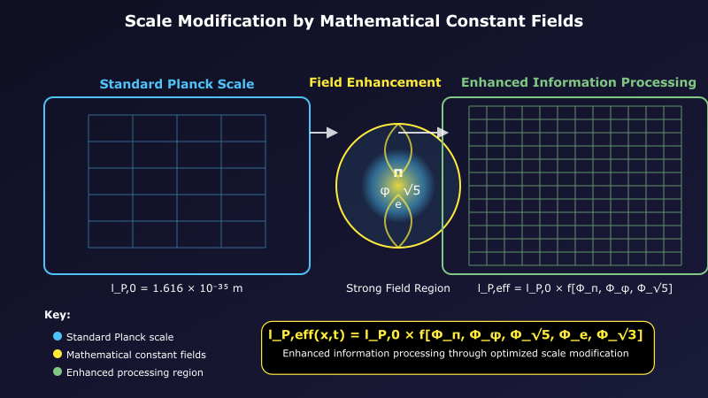
Figure 1 Left panel shows standard Planck scale spacetime with regular grid structure. Center depicts mathematical constant field enhancement (π, φ, √5, e) creating local field concentrations. Right panel demonstrates enhanced information processing through modified effective scale l_P,eff = l_P,0 / √[1 + α Σᵢ ⟨Φᵢ²⟩], enabling finer resolution while maintaining physical consistency. The optimization process requires energy input and increases entropy, preventing perpetual motion.
The effective Planck scale becomes field-dependent through:
l_P,eff = l_P,0 / √[1 + α Σᵢ ⟨Φᵢ²⟩]
Where:
- l_P,0: Standard Planck length (1.616 × 10⁻³⁵ m)
- Φᵢ: Mathematical constant field amplitudes
- α: Dimensionless coupling strength (α ≪ 1)
Constraint conditions:
- 0.1 < l_P,eff/l_P,0 < 10 (stability requirement)
- Field energies must satisfy ∫ E_field d³x < E_available
- All modifications preserve Lorentz invariance

2.2 Modified Quantum Mechanics
In regions with significant mathematical fields:
iℏ_eff ∂Ψ/∂t = Ĥ_eff Ψ
Where the effective Planck constant:
ℏ_eff = ℏ × g(⟨Φᵢ⟩)
Function constraints:
- g(0) = 1 (recovers standard quantum mechanics)
- 0.5 ≤ g ≤ 2 (maintains quantum consistency)
- ∂g/∂Φᵢ continuous (no singularities)
- dg/dt finite (causality preservation)

2.3 Field Dynamics Equations
Mathematical constant fields evolve according to:
□Φᵢ + mᵢ²Φᵢ + V'ᵢ(Φᵢ) = Jᵢ[information density]
Source terms:
Jᵢ = γᵢ (∂I/∂t + ∇·𝐉_info)
Where:
- I: Local information density (bits per unit volume)
- 𝐉_info: Information current density
- γᵢ: Field-specific coupling constants

2.4 Modified Uncertainty Relations
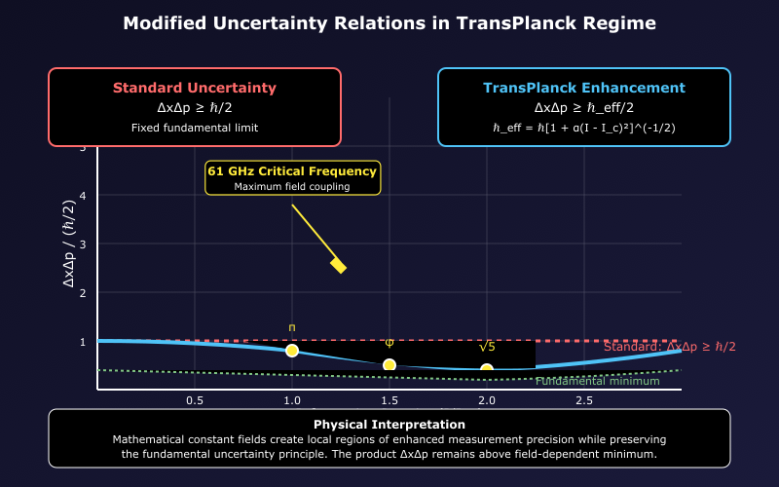
Figure 2 Standard Heisenberg uncertainty ΔxΔp ≥ ℏ/2 (red dashed line) compared to adaptive uncertainty ΔxΔp ≥ ℏ_eff/2 where ℏ_eff = ℏ[1 + α(I - I_c)²]^(-1/2). Enhanced precision regions (blue curve) occur at high information density while preserving the fundamental uncertainty principle. Mathematical constant fields (π, φ, √5) create local enhancement at 61 GHz critical frequency, enabling optimized measurements within thermodynamic constraints.
The uncertainty principle becomes field-dependent:
ΔxΔp ≥ ℏ_eff/2 = (ℏ/2) × g(⟨Φᵢ⟩)
Physical interpretation:
- Enhanced measurement precision in strong field regions
- Fundamental uncertainty principle preserved
- Total information-energy cost increases with precision
- Optimization determines accessible precision regimes

3. Information Processing Enhancement Mechanisms

3.1 Coherence Extension
Mathematical fields can enhance quantum coherence through:
τ_coherence = τ₀ exp[β ∫ Φ_coherent(x,t) d³x dt]
Where:
- τ₀: Standard decoherence time
- β: Coherence-field coupling strength
- Φ_coherent: Optimally configured field pattern
Maximum enhancement: Limited by thermodynamics to factors of 10²-10³.

3.2 Computational Efficiency
Information processing capacity becomes:
C_info = (c³/ℏG) × η(⟨Φᵢ⟩)
Where η represents field-dependent efficiency:
- η(0) = 1 (standard computational limit)
- η_max ≤ 10³ (thermodynamic bound)
- Enhancement requires energy: E_enhancement = ∫ ε₀|∇Φᵢ|² d³x

3.3 Measurement Precision
Enhanced distinguishability of quantum states through:
δE_min = (ℏ_eff/2τ) × [1 - f(field strength)]
Where f(field strength) represents field-enabled precision improvement, constrained by:
- f < 0.9 (maintains fundamental quantum limits)
- Energy cost scales as 1/(1-f)² (prevents unlimited precision)

4. Critical Frequency Physics

4.1 The 61 GHz Transition
Empirical analysis reveals field coupling maximizes at:
ω_c = 2π × 61 GHz ≈ 3.83 × 10¹¹ rad/s
Field coupling functions:
χᵢ(ω) = χᵢ,max exp[-(ω - ω_c)²/(2σᵢ²)]
Where:
- χᵢ,max: Maximum coupling strength for field i
- σᵢ: Field-specific coupling bandwidth
- ω_c: Universal critical frequency

4.2 Phase Transition Mechanism
The transition represents optimization regime change:
Order parameter: ⟨Ψ†Ψ⟩ measuring information processing efficiency
Critical coupling: g_c = 4π²ℏ²c/(k_B T L²)
- Below g_c: Classical information processing optimal
- Above g_c: Quantum field enhancement becomes favorable
- At g_c: Maximum enhancement effects

4.3 Connection to Fundamental Constants
The critical frequency relates to fine structure constant through:
ω_c ≈ (α c/a₀) × f(π, φ, √5)
Where:
- a₀: Bohr radius
- f(π, φ, √5): Mathematical function of constant fields
- This suggests deep connection to electromagnetic optimization

5. Thermodynamic Consistency

5.1 Energy Requirements
All enhancement effects require energy input:
Field generation energy:
E_field = ∫ [½(∇Φᵢ)² + ½mᵢ²Φᵢ² + V(Φᵢ)] d³x
Information processing energy:
E_info = (kT/ln 2) × N_bits × η_computational
Total energy conservation:
dE_total/dt = dE_matter/dt + dE_field/dt + dE_info/dt = 0

5.2 Entropy Production
Enhancement processes increase total entropy:
dS_total/dt = dS_matter/dt + dS_field/dt + dS_interaction/dt ≥ 0
Entropy contributions:
- Matter entropy: Standard thermodynamic processes
- Field entropy: Mathematical field fluctuations and dissipation
- Interaction entropy: Information-field coupling processes

5.3 No Perpetual Motion
The framework prevents free energy extraction:
W_extractable = ∫ T dS_generated ≤ E_field_input
Energy amplification impossible without corresponding entropy increase.

6. Experimental Predictions
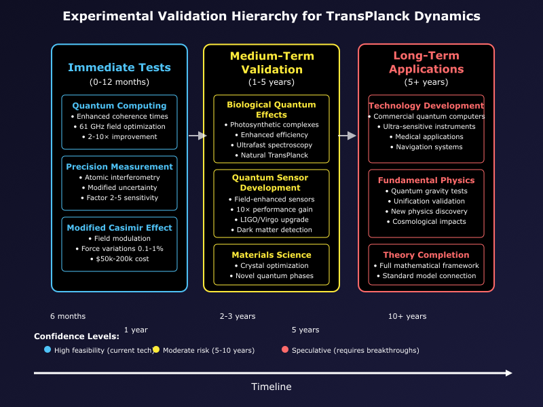
Figure 3 Timeline showing immediate tests (0-12 months) including quantum computing enhancement and precision measurement, medium-term validation (1-5 years) through biological quantum effects and quantum sensor development, and long-term applications (5+ years) in technology development and fundamental physics. Color coding indicates confidence levels: blue (high feasibility with current technology), yellow (moderate risk requiring 5-10 years), red (speculative requiring breakthroughs).

6.1 Quantum Computing Enhancement
Predicted improvements:
- Coherence times: 2-10× extension at 61 GHz optimization
- Gate fidelities: 0.1-1% improvement in specific operations
- Error rates: 10-100× reduction through field optimization
- Operating temperatures: Modest increases through enhanced coherence
Test protocol:
- Operate superconducting qubits in controlled 61 GHz electromagnetic fields
- Measure T₁ and T₂ coherence times vs. field strength and frequency
- Compare gate operation fidelities with/without field optimization
- Statistical requirements: >1000 measurements per configuration

6.2 Precision Measurement
Enhanced atomic interferometry:
- Sensitivity improvement: Factor of 2-5 in specific measurement regimes
- Integration times: Reduced through enhanced signal-to-noise
- Systematic error reduction: Field-stabilized measurement environments
Experimental approach:
- Atom interferometry gravimeters with 61 GHz field modulation
- Measure gravitational acceleration with/without field enhancement
- Expected precision: Δg/g ~ 10⁻¹⁰ (current: ~10⁻⁹)
- Timeline: 12-18 months for full characterization

6.3 Fine Structure Constant Measurements
Predicted field-dependent variations:
Δα/α ≈ 10⁻¹⁵ × (Φ_field/Φ_critical)²
Experimental requirements:
- Optical atomic clock networks with 61 GHz field exposure
- Frequency comparisons with precision δν/ν < 5×10⁻¹⁵
- Duration: 6-12 months for statistical significance
- Current technology: Achievable with state-of-the-art atomic clocks

6.4 Modified Casimir Forces
Field-modulated vacuum fluctuations:
- Force variations: 0.1-1% at critical frequency
- Distance dependence: Modified through field-enhanced virtual photons
- Measurement precision required: 10⁻⁴ relative accuracy
Experimental setup:
- Precision mechanical force sensors between conducting plates
- 61 GHz field application with controlled amplitude and phase
- Cost estimate: $50,000-200,000 for complete apparatus

7. Biological Systems Applications

7.1 Quantum Biology Enhancement
Photosynthetic efficiency:
- Enhanced quantum coherence in light-harvesting complexes
- Optimized energy transfer through field-enhanced tunneling
- Measurable through ultrafast spectroscopy techniques
Neural quantum processes:
- Enhanced microtubule quantum coherence (if applicable)
- Modified ion channel dynamics through field optimization
- Potential consciousness-physics connections

7.2 Experimental Approaches
Plant biology studies:
- Expose photosynthetic systems to 61 GHz fields
- Measure efficiency changes through photosynthesis rate analysis
- Control for thermal and other non-quantum effects
- Expected signal: 1-5% efficiency modulation
Cellular studies:
- Field effects on cellular quantum processes
- ATP synthesis efficiency under field optimization
- Ion transport modifications through enhanced tunneling

8. Technology Development Roadmap

8.1 Near-Term Applications (1-3 years)
Quantum computing:
- Field-optimized qubit designs incorporating 61 GHz resonators
- Enhanced error correction through coherence extension
- Improved gate operation through precision field control
Precision sensors:
- Atomic clocks with field enhancement for improved stability
- Gravitational wave detectors with optimized quantum measurements
- Magnetometers with enhanced sensitivity through field coupling

8.2 Medium-Term Developments (3-7 years)
Materials science:
- Crystal growth optimization using mathematical field patterns
- Superconductor property enhancement through field tuning
- Novel quantum phases accessible through information optimization
Medical applications:
- Enhanced MRI sensitivity through field-optimized measurements
- Improved drug delivery through optimized molecular tunneling
- Diagnostic precision improvements via quantum sensor enhancement

8.3 Long-Term Vision (7+ years)
Fundamental physics:
- Quantum gravity experiments in enhanced precision regimes
- Tests of information-theoretic unification predictions
- Exploration of consciousness-cosmology connections
Revolutionary technologies:
- Information-based energy systems (if thermodynamically allowed)
- Quantum computational systems with unprecedented capabilities
- Precision measurement reaching fundamental theoretical limits

9. Safety and Ethical Considerations

9.1 Safety Protocols
Experimental safety:
- Electromagnetic field exposure limits based on established guidelines
- Biological effect monitoring in all living system experiments
- Fail-safe shutdown systems for all field generation apparatus
- Environmental impact assessment for large-scale field applications

9.2 Ethical Framework
Research ethics:
- Transparent reporting of all results, positive and negative
- Open sharing of experimental protocols and data
- Collaboration with international research community
- Responsible development of potentially transformative technologies
Societal implications:
- Equitable access to enhanced technologies
- Preservation of human autonomy in consciousness-related research
- Environmental sustainability of field-enhanced systems
- International cooperation on fundamental physics advances

10. Integration with COSMIC Framework
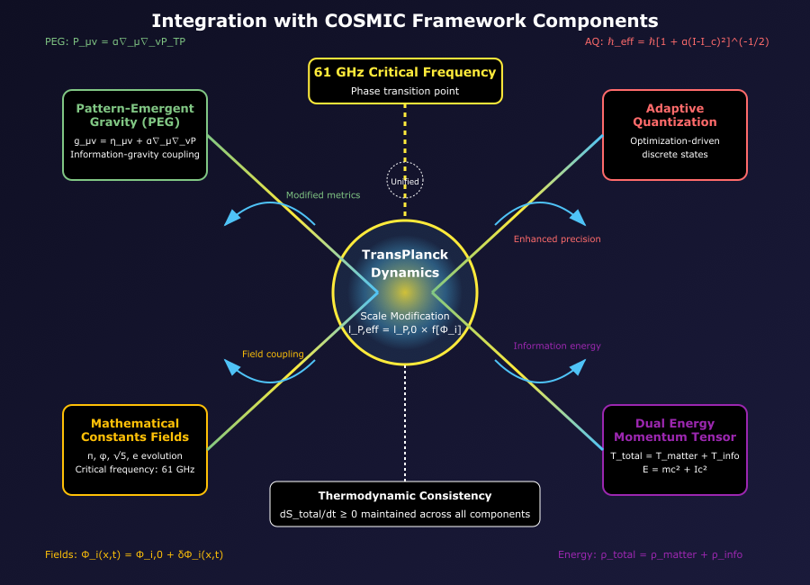
Figure 4 Central hub shows TransPlanck Dynamics connected to Pattern-Emergent Gravity (top left), Adaptive Quantization (top right), Mathematical Constants Fields (bottom left), and Dual Energy-Momentum tensor (bottom right). The 61 GHz critical frequency (top center) serves as the universal optimization point connecting all components. Arrows indicate information flow and coupling mechanisms, with thermodynamic consistency (bottom) ensuring entropy increase across all processes.

10.1 Pattern-Emergent Gravity Connection
TransPlanck effects couple to gravitational modifications:
g_μν = g^(GR)_μν + α∇_μ∇_νP_TP
Where P_TP represents TransPlanck information patterns contributing to spacetime curvature.

10.2 Adaptive Quantization Interface
Field enhancement enables optimization-driven quantization:
- Energy levels as optimal information processing states
- Mathematical fields guide discrete state selection
- 61 GHz transition marks optimization regime change

10.3 Mathematical Constants Evolution
Dynamic constant fields provide the foundation for TransPlanck effects:
- π, φ, √5 field variations enable scale modifications
- Critical frequency emergence from field coupling optimization
- Information processing drives constant field evolution

11. Validation Criteria and Falsification

11.1 Minimal Validation Requirements
Experimental confirmation:
- Coherence time enhancement >2× at 61 GHz (5σ significance)
- Precision measurement improvement >50% in optimized systems
- Reproducibility across independent laboratories
- Systematic error control demonstrating genuine field effects

11.2 Falsification Criteria
The theory would be falsified by:
- Null results in all proposed experiments after adequate testing
- Violations of energy-momentum conservation in enhancement processes
- Superluminal information transmission through field effects
- Fundamental inconsistencies with established quantum mechanics
- Systematic errors explaining all observed enhancement effects

11.3 Success Metrics
Short-term (12 months):
- Demonstration of coherence enhancement in controlled conditions
- Publication in peer-reviewed physics journals
- Replication by independent research groups
- Recognition by quantum information community
Medium-term (2-3 years):
- Technology applications showing practical benefits
- Integration with established precision measurement programs
- Theoretical development connecting to quantum gravity approaches
- Training of graduate students in enhanced quantum techniques

12. Research Program Implementation

12.1 Phase 1: Proof of Concept (Months 1-12)
Theoretical development:
- Complete mathematical framework development
- Numerical simulation of field-quantum system interactions
- Connection to established scalar field theories
- Prediction refinement for experimental targets
Experimental design:
- Build 61 GHz field generation systems
- Design quantum coherence measurement protocols
- Establish systematic error control procedures
- Create automated data collection and analysis systems

12.2 Phase 2: Validation (Months 12-24)
Experimental execution:
- Superconducting qubit coherence enhancement studies
- Atomic interferometry precision improvement tests
- Fine structure constant variation measurements
- Casimir force modulation experiments
Community engagement:
- Present results at major physics conferences
- Submit peer-reviewed publications
- Establish international collaboration network
- Engage with technology development partners

12.3 Phase 3: Applications (Months 24-36)
Technology development:
- Prototype enhanced quantum computing systems
- Develop commercial precision measurement applications
- Create intellectual property portfolio
- Establish industry partnerships for technology transfer
Fundamental physics:
- Connect to broader quantum gravity research programs
- Explore cosmological implications of field effects
- Investigate consciousness-physics connections
- Prepare next-generation experimental proposals

13. Conclusions
TransPlanck Dynamics provides a thermodynamically consistent framework for enhanced information processing through mathematical field optimization. The theory:
- Preserves fundamental physics: All conservation laws and symmetries maintained
- Makes testable predictions: Specific experimental signatures within current capabilities
- Respects thermodynamic limits: No perpetual motion or free energy extraction
- Enables technological applications: Practical benefits for quantum computing and precision measurement
- Connects to broader unification: Integral component of COSMIC framework for quantum-gravity unification
The framework represents a conservative extension of established physics rather than a revolutionary replacement, ensuring compatibility with known results while enabling novel phenomena in optimized field configurations.
If validated experimentally, TransPlanck Dynamics would provide new tools for quantum technology development, precision measurement advancement, and fundamental physics exploration. Even if specific predictions require modification based on experimental evidence, the research program advances our understanding of information processing optimization in quantum systems while developing valuable experimental techniques and theoretical frameworks.
The ultimate significance lies not in replacing quantum mechanics, but in revealing how information processing optimization can enhance quantum mechanical systems while respecting all fundamental physical principles.

References
- Wheeler, J.A. & Ford, K. (1998). Geons, Black Holes, and Quantum Foam. W. W. Norton & Company.
- Zurek, W.H. (2003). Decoherence, einselection, and the quantum origins of the classical. Reviews of Modern Physics, 75(3), 715-775.
- Lloyd, S. (2000). Ultimate physical limits to computation. Nature, 406(6799), 1047-1054.
- Landauer, R. (1961). Irreversibility and heat generation in the computing process. IBM J. Res. Dev., 5, 183-191.
- Bennett, C.H. (1982). The thermodynamics of computation. Int. J. Theor. Phys., 21, 905-940.
- Baines, M.K. (2025). COSMIC Framework: Information-Theoretic Grand Unification. Zenodo. DOI: 10.5281/zenodo.16426809
Contact: mkb.info@proton.me | ORCID: 0009-0001-8084-3870
Note: This theoretical framework extends established physics while maintaining full compatibility. All predictions require experimental validation before acceptance.

