Jenkins lab 1

Part 1 – Explore IDE and create a Jenkin job

Objectives
- In this part you will install Jenkins using Docker technology.
- Investigate the Jenkins IDE.
- Create a basic Job and explore its options

Install Jenkins using Docker
For a simple method, type the following command and skip to step 8 (docker exec -it …).
docker run -d -p 8080:8080 -p 50000:50000 -v jenkins_home:/var/jenkins_home jenkins/jenkins:lts-jdk11
Alternatively, for more flexibility, use the following method:
- Create a folder
- Open the folder in VS-Code
- Create a file called compose.yaml
- Copy the following to the yaml file
services:
jenkins:
container_name: jenkins-docker-container
image: jenkins/jenkins:lts
ports:
- "8080:8080"
networks:
- ecommerce-network
networks:
ecommerce-network:
name: ecommerce-network
external: true

Here is a picture showing the correct indentation
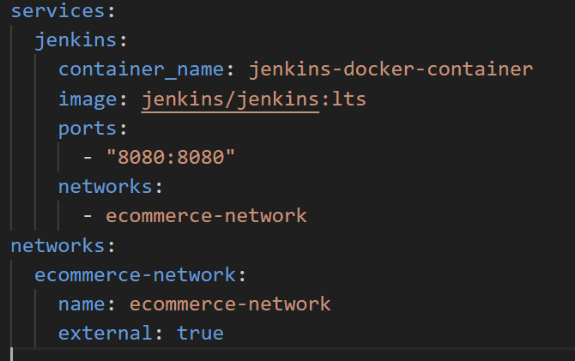
- Test your file by typing the following command in a Terminal window: docker compose config
This command will type the contents of the file if it is valid.
- Run the command: docker compose up -d
And then wait for a minute. This command will install Jenkins in detached and will not echo the secret password which you need to start Jenkins.
- Get the Jenkin’s docker ID (docker ps).
In this example we assume the ID starts with e7b
- Run the following command to get the Jenkins secret password:
docker exec -it e7b cat /var/jenkins_home/secrets/initialAdminPassword
copy the secret password
- In a browser type: localhost:8080
Copy the secret Administrator password from the previous step and paste here:
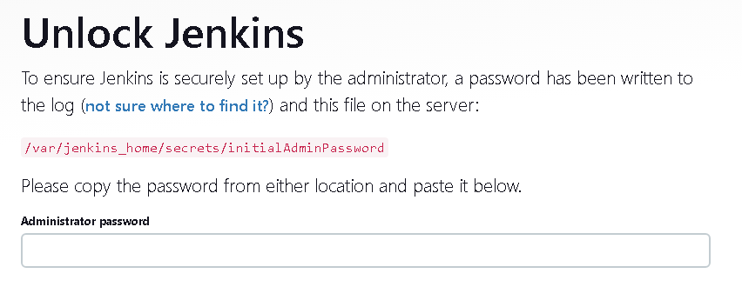
- Install the suggested plugins
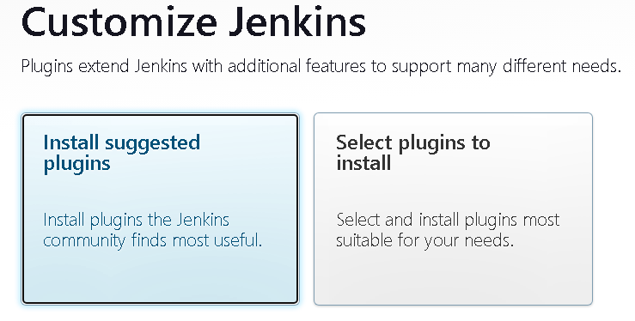
- Create the admin user (any name and password will do. The email is not checked)
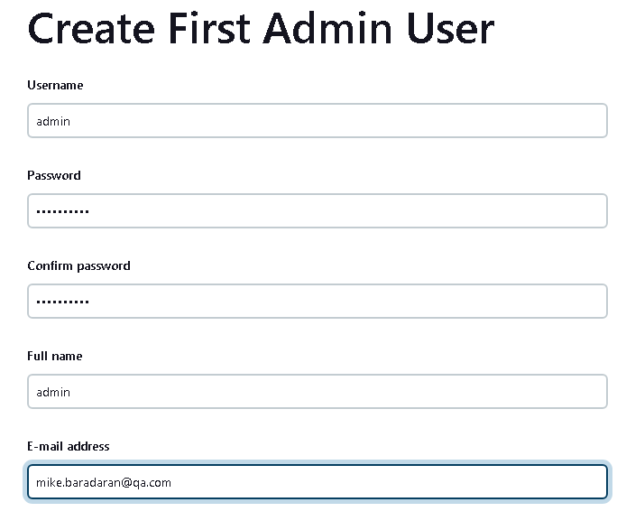
- Follow the rest of the dialogs
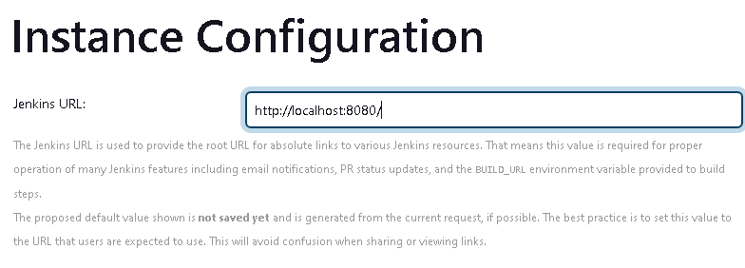
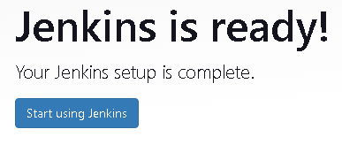
- Create a new job by clicking [+ New Item]
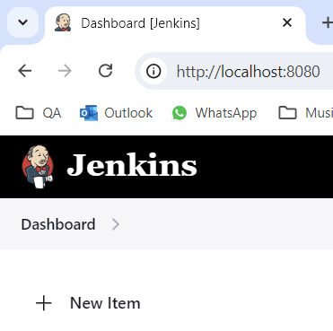

- Choose a name for this job
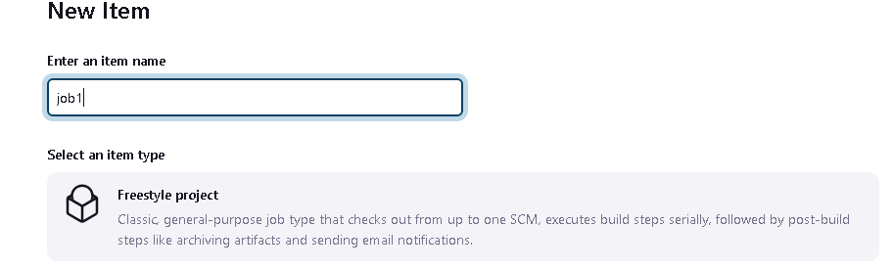
- Scroll down and find the Buil Step section and then select these options:
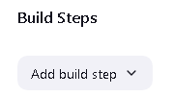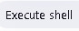
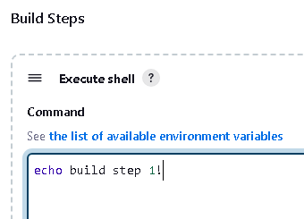
We will not deploy an application, only a simple script to get to know this tool.
- Click Save and then 
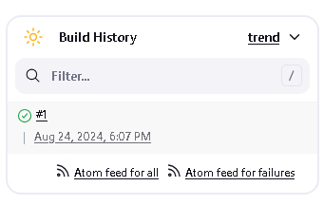
- Click on #1 (build number) and then click
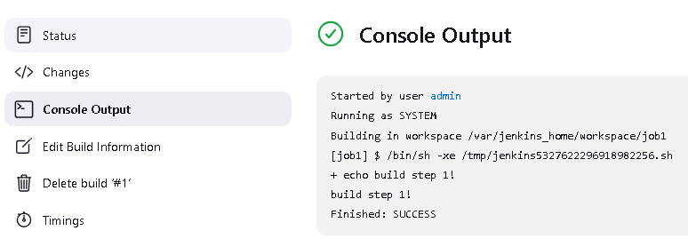
- Jenkins provides many environmental variables. We will have a look at a few. View these by clicking on the link.
- Click on job1 title and then select the configure option
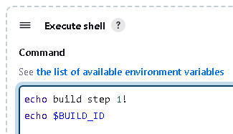
- Click
- View the Console log and note the BUILD_ID value.
- Modify Job1 by adding a few more lines
(Execute shell) 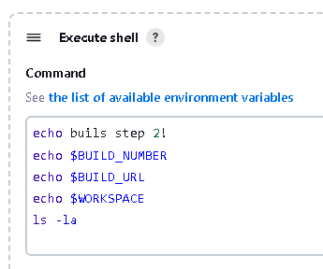

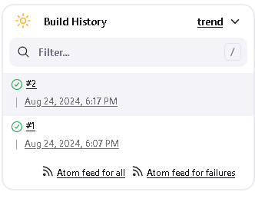
- View the console log
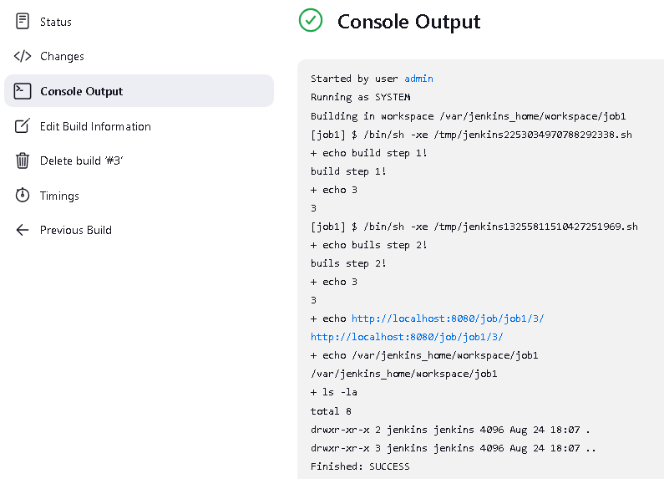
- Add another step to the build to execute a shell command to reference Jenkin’s Workspace
which is a directory on the Jenkins server where the files related to a specific job are stored during the build process. The following command create a file called file.txt with content of “QA Training”.
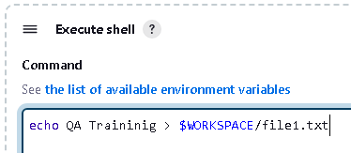
- Lokk for the Job 1’s Workspace menu and display the content of file.txt
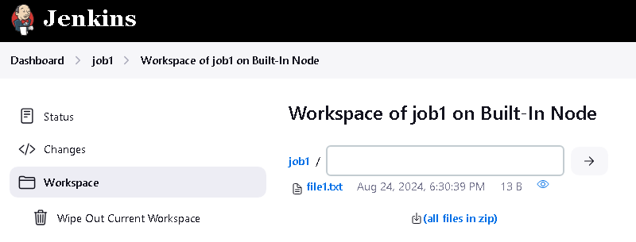

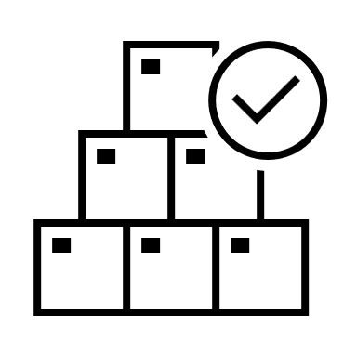Congratulations, you have successfully created a job using Jenkins and explored it’s various IDE options.
Please continue to Part 2 below.

Part 2- Triggers

Objectives
In this part you will create a Jenkin trigger, and explore other forms of triggers in other labs.
Trigger is an event or action that initiates the execution of a job or pipeline (we will explore pipelines later).

Create a Remote build trigger

- Configure Job1 and find the Buil Triggers section
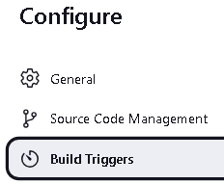
- Create a token for invoking and API end point for triggering a build (any secret token word will do)
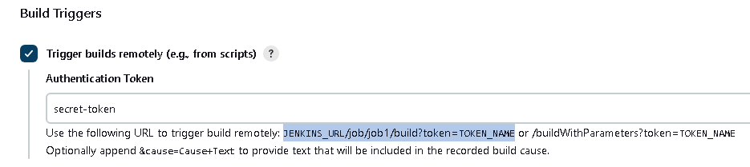


- Make a change to the last build and then save.
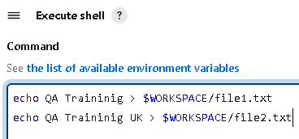

- Type the following text in a browser and click the Proceed button to trigger the build.
Please note, this will result in a blank screen and will only shows errors if there are any.
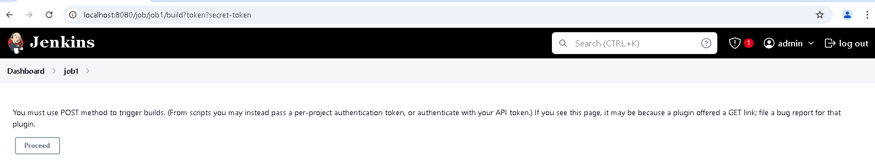
http://localhost:8080/job/job1/build?token?secret-token

- As mentioned, the screen will go blank but a new build is triggered (please wait a moment until it does)
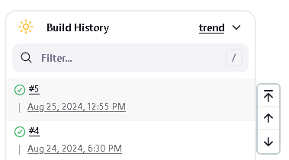

Congratulations, you have successfully created a Jenkins trigger. This is an important concept and you will explore other forms of Jenkin’s Triggers in other labs.
Please continue to Part 3 below.

Part 3 - Chaining project builds

Objectives
In this part you will chain 2 or more builds together.
Build chaining in Jenkins automatically triggers one or more jobs after another job completes. This enables multi-step automation pipelines, where one job’s output becomes the next job’s input.
- Create a new Job called job2
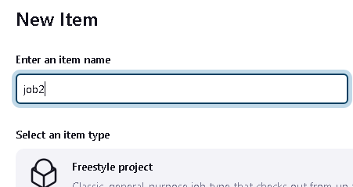
- Assign a build step like
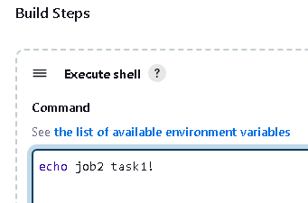

- Configure Job1’s post-build action to trigger building Job2
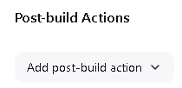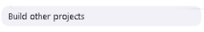
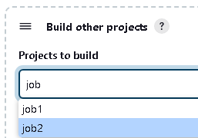

- Build Job1  and note that both jobs get built
View the console output of Job1 and Job2 for proof
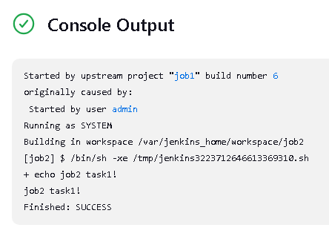
- View Job1’s status for the Downstream project (Job2)
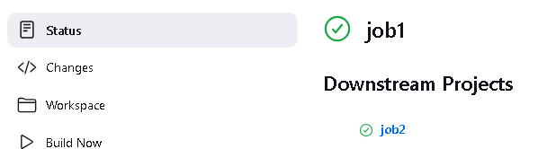

Congratulations, you have successfully created a Jenkins build chain.
Please continue to Lab2 to explore building and deploying a Maven app stored on GIT.

