**Networking and Parallel Computation**

October 4, 2013

**A HTTP Proxy Server**

**BY:**

**Bayle Michael**

**Kumar Ankit**

* **Setting the browser as proxy server:**

For example, here we used Google chrome and went to advance network settings and go to change proxy settings to set the browser as proxy server.

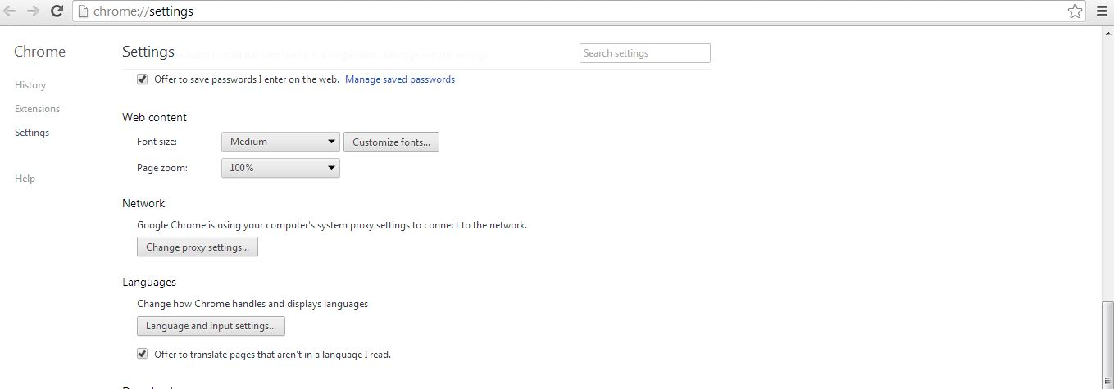

After you click on change proxy setting, the internet options will open up. Go to settings from internet options, Once the settings tab open up check mark for use as proxy server for this connection and type in for address: localhost and PORT: 80. The figure is shown on the next page. For us it was PORT: 98.

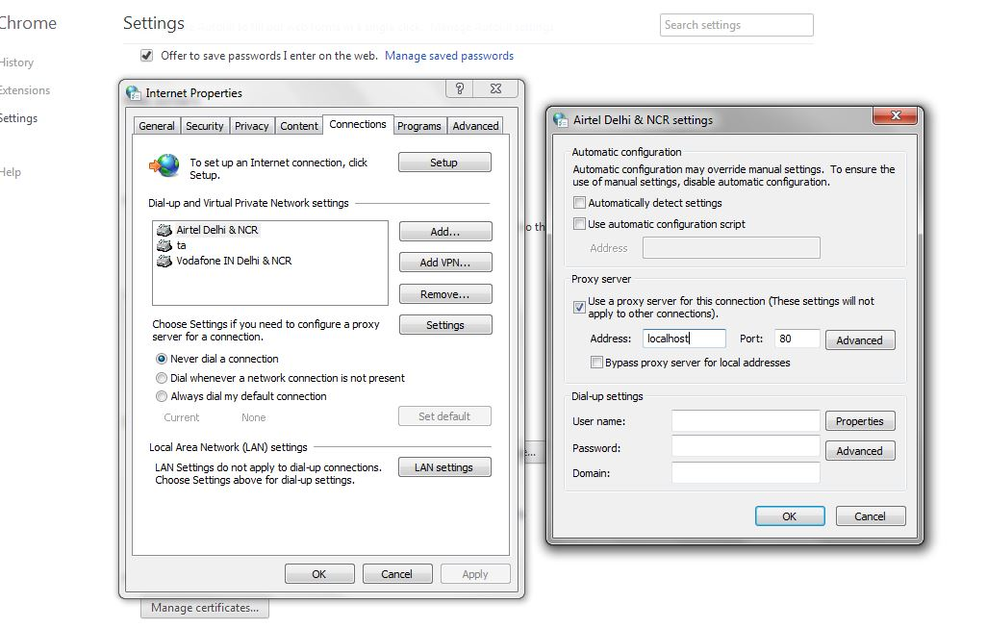

The main concept of http proxy server goes like this. We set up our browser as proxy server and we use the browser from our local machine to request pages. The responses that we get in turn are stored in cache as text files. If the file exists, next time the user requests the same page then it will just open it up from the cached text file, instead of getting the response from the server. The working model of the program can be seen in the next page.

* **Running Java Program**

Here the output window of the java program says that the proxy server is running.

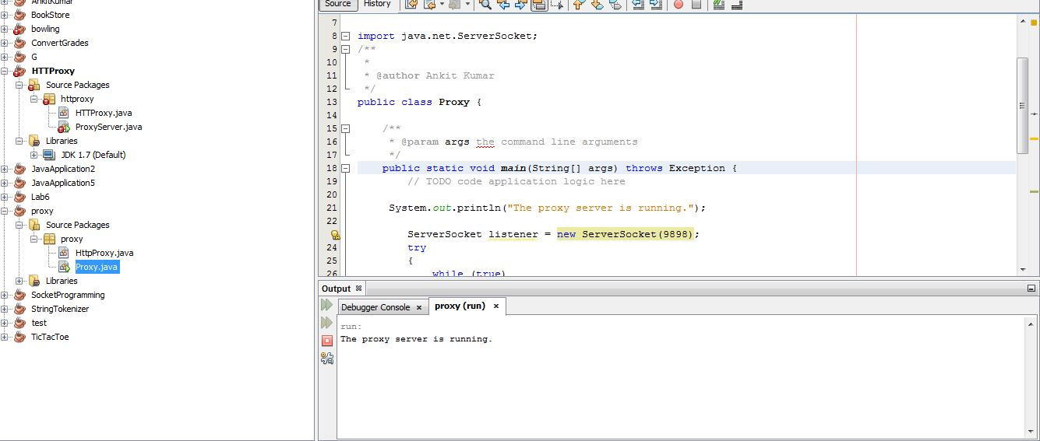

Once the proxy server is running, go to the browser and browse the website you want to browse and you will see the responses in the output window and the cached text file if the page has not been requested before. In case the file has been requested before, the page would be just opened from the cached text file. The figure below shows all the cached files.



* **Response between the server and the proxy server in the output window of java**

The clip below shows the responses between the server and the proxy server.