**HW5 CSCD320**

**This homework does NOT require programming.**

**To Turn in: please submit the questions and your answers below them in a pdf file on canvas.** Turn in your solution on the **EWU Canvas** by going to CSCD320-01 course page on Canvas, then clicking Assignments🡪hw5->submit. Please name your pdf file with your last name, followed by the first initial of your first name, followed by hw5. For example, if you are John Smith, name you file as smithjhw5.pdf

**Question to solve**

**Give an array of integers {0, 1, 2, 3, 4, 5, 6, 7, 8, 9, 10, 11}, which represents a complete binary tree in memory.**

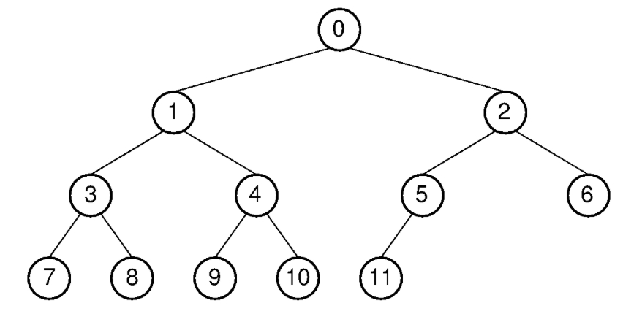

**As we learned in class, please explain how to construct a Max-heap with this input array by repeatedly calling siftdown procedure. Please include step by step explanations. After each step of swapping values, please show the intermediate resultant tree diagram to guarantee partial credits.**