**HW6 CSCD320**

**This homework requires coding.**

**To turn in: please wrap up all your java source files into a zip file, then** turn in the single zip file on the **EWU Canvas** by going to CSCD320-01 course page on Canvas, then clicking Assignments🡪HW6->submit. Please name your zip file with your last name, followed by the first initial of your first name, followed by hw6. For example, if you are John Smith, name you file as smithjhw6.zip

**Specifics**

**Give an input weighted and undirected graph as shown in the diagram below, with the weight being labeled on each edge.**

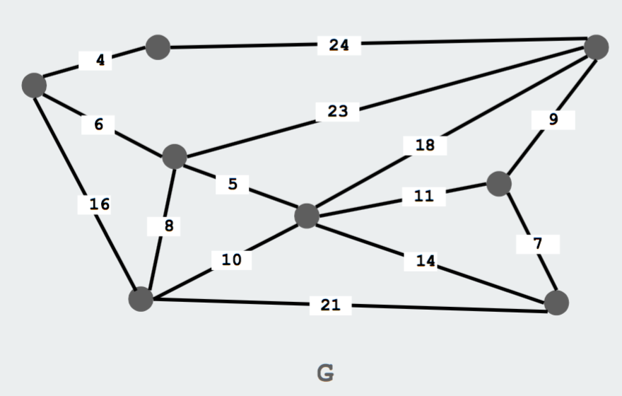

1. Please implement the Adjacency List representation to construct the graph in the main memory of your computer.
2. Please implement **either** the Kruskal’s algorithm **or** the Prim’s algorithm to output the Minimum Spanning Tree for the graph above, as we learned in classroom. You are allowed to use any Java build-in classes or data structures, such as HashSet, PriorityQueue or TreeMap. On the top of your Java source files, please clearly document which one of the two algorithms you are implementing.
3. Please invoke the method of your Kruskal’s algorithm implementation OR your Prim’s algorithm implementation on the input graph above in a separate java file **Tester.java**.
4. When running your program, please print out on the **standard output** explicitly the Minimum Spanning Tree that your program finds in the input graph. Please follow the output format shown in the below. Note: the **order** of the edges displayed by your program may be different, depending on which algorithm you implement.

*The MST contains the following edges:*

*0🡪1*

*0🡪2*

*2🡪5*

*2🡪3*

*5🡪6*

*4🡪6*

*6🡪7*

1. Please organize your source code so that I can compile **all** your source files in **one** folder using command, **javac *.java**, and run your program using command on command line, **java Tester.**
2. **You can have your own design for any details that have NOT been specified in this document.**