CSCD467 Lab 8

Michael Peterson

1)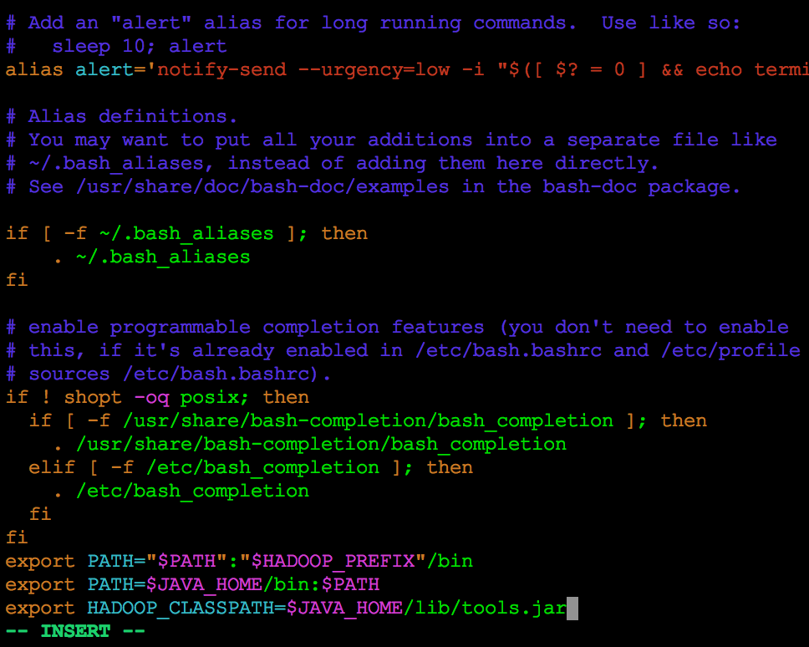

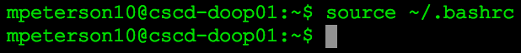

2)

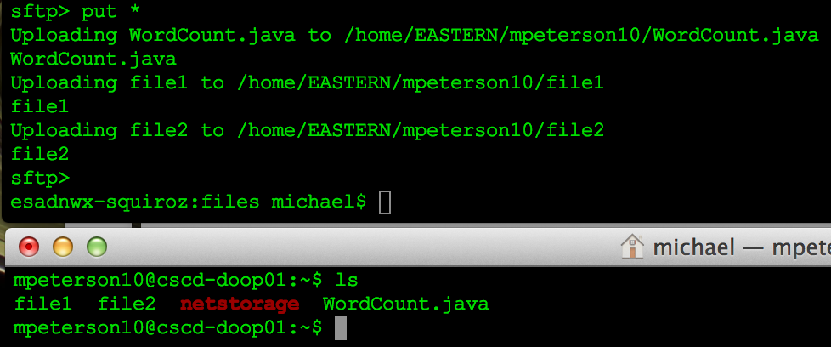

3.1)



3.2)

Macintosh HD:Users:michael:Desktop:Screen Shot 2016-02-22 at 2.53.07 PM.png

3.3)



3.4)



3.5)

Macintosh HD:Users:michael:Desktop:Screen Shot 2016-02-22 at 2.57.32 PM.png

3.6)

Macintosh HD:Users:michael:Desktop:Screen Shot 2016-02-22 at 2.58.12 PM.png

3.7)

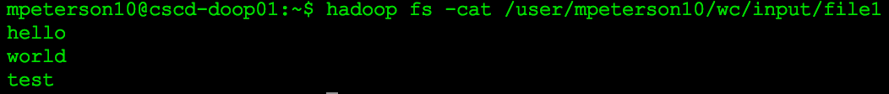

3.8)

