**BUtiful Schedule: A Schedule Optimization App for the Busy BU Student**

**Our mission:**

We, as BU students, know what it’s like to try to cram all five of your required classes into one schedule every semester and still make time for work, clubs, or even electives. We know the headaches you get staring at the screen, trying to juggle all the conflicting lecture and discussion sections in your head until they somehow come out as a single schedule. And our app, BUtiful Schedule, is here to save you the headache and trouble. Just input your desired classes, and your preferences for time, professor and more, and BUtiful schedule will output your five most optimal schedules in moments! You’ll never have to pull out the graph paper and markers again.

**Our app:**

BUtiful Schedule allows you to choose courses from the BU course catalog by simply typing in the College, Department, and Course Code, then supplies you with the possible times, days, and professors for each chosen course. No long, confusing lists, just simple drop-down menus where you can rank your preferences for each category. Once you’ve told us what you want out of your schedule, our algorithm will determine which possible schedules match your preferences best! If there are a few options you want to consider further, you can save schedules for later and access them at any time.

Let us walk you through how it works:

Our homepage welcomes you to the app. Since you probably don’t have any saved schedules yet, you’ll want to click the “Create Schedule” button.

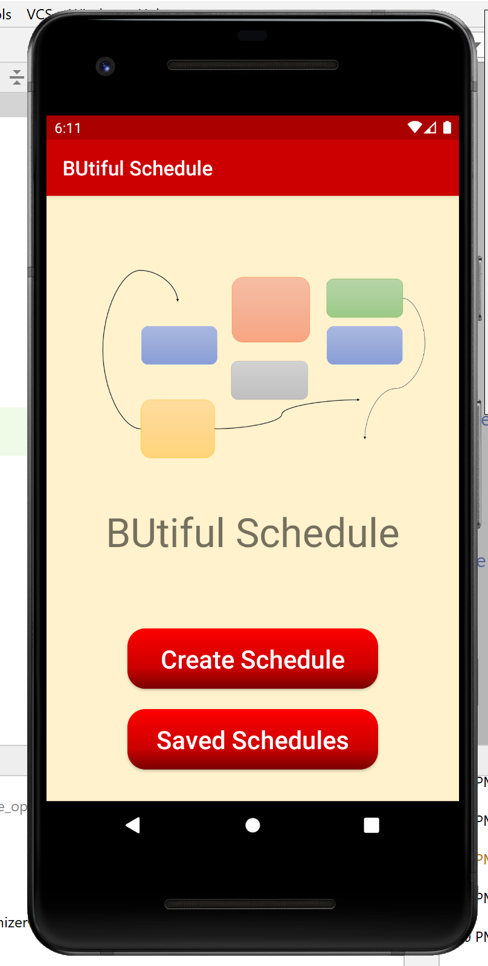

First, you choose your courses (below):

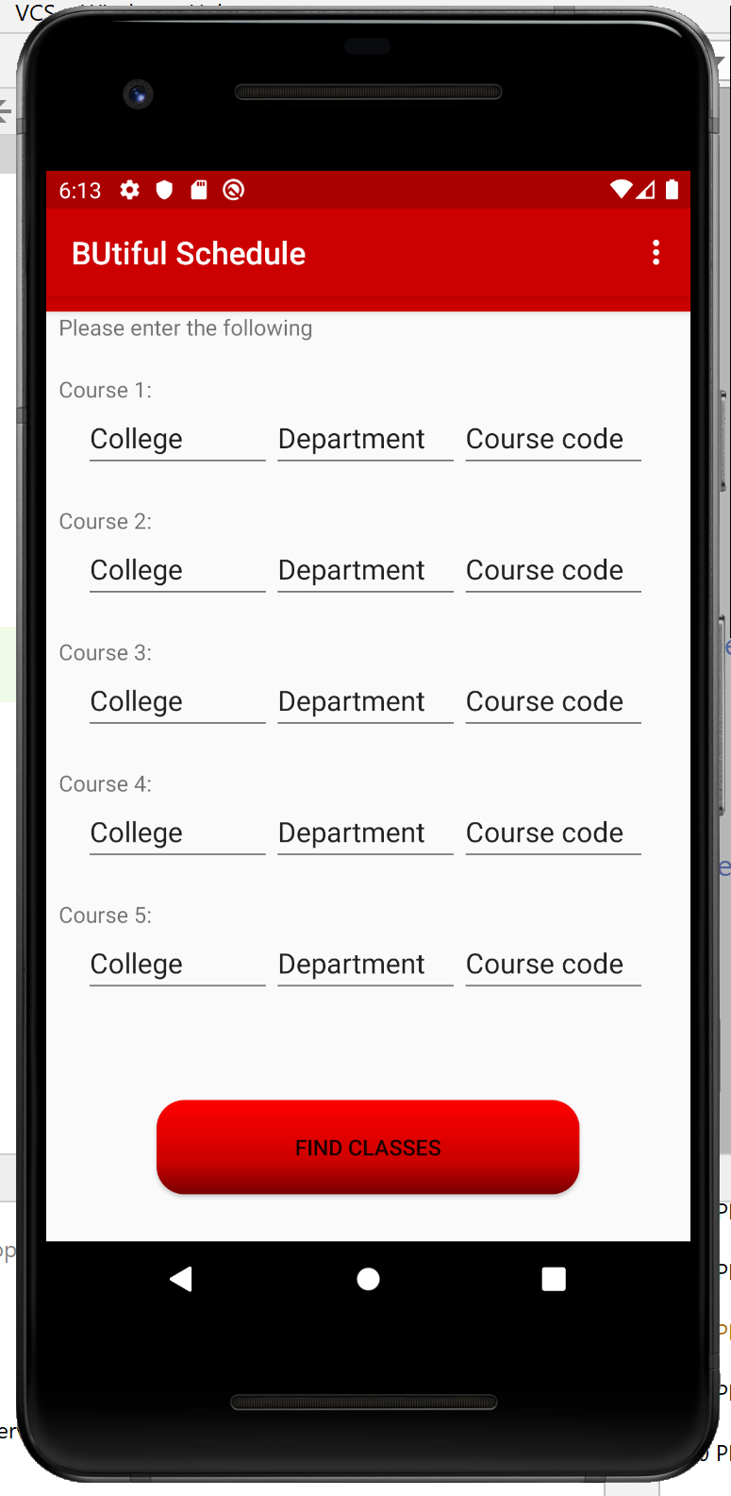 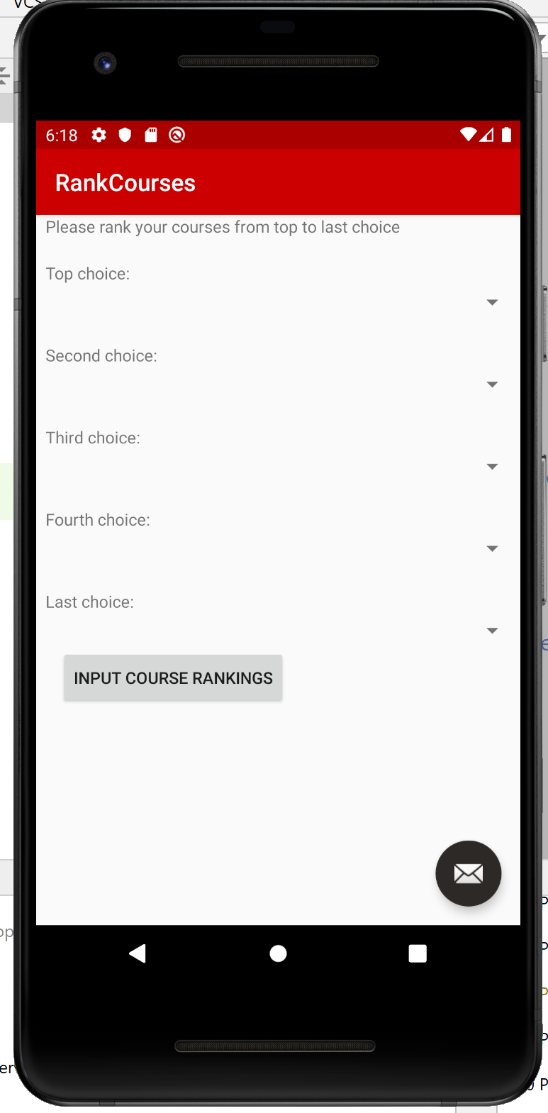

Once you’ve entered those, the Choose Courses button will find them in the catalog and let you rank which are most important to you with five drop-down menus (above right):

Next, you have to input preferences for each course. The first menu (below left) will show you all the courses you can edit your preferences for. Discussion sections will be included here too, if required for the class:

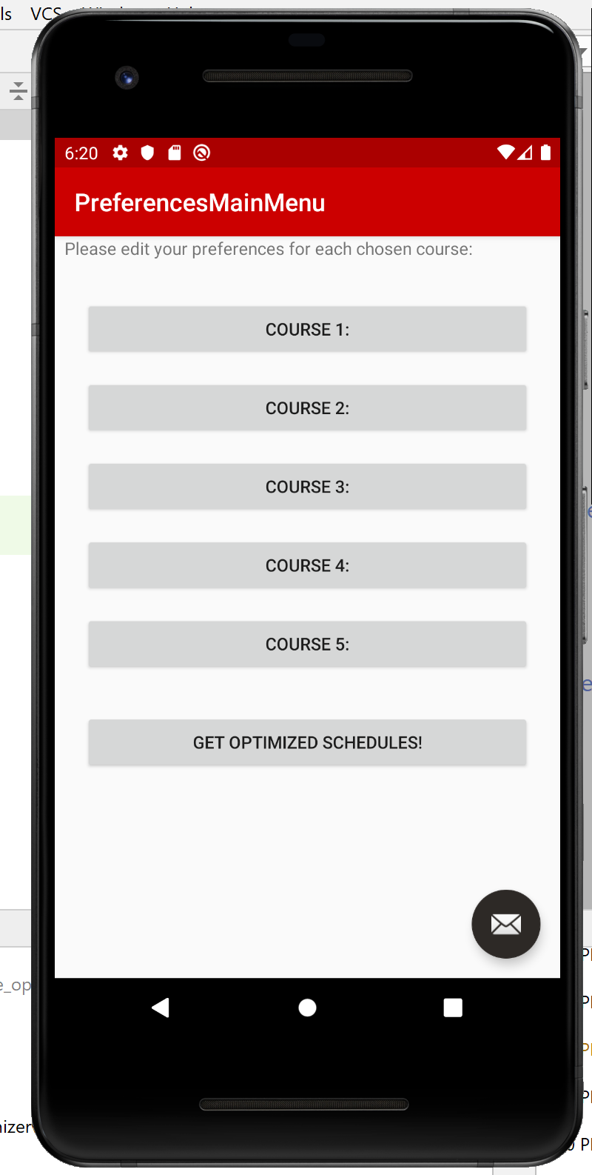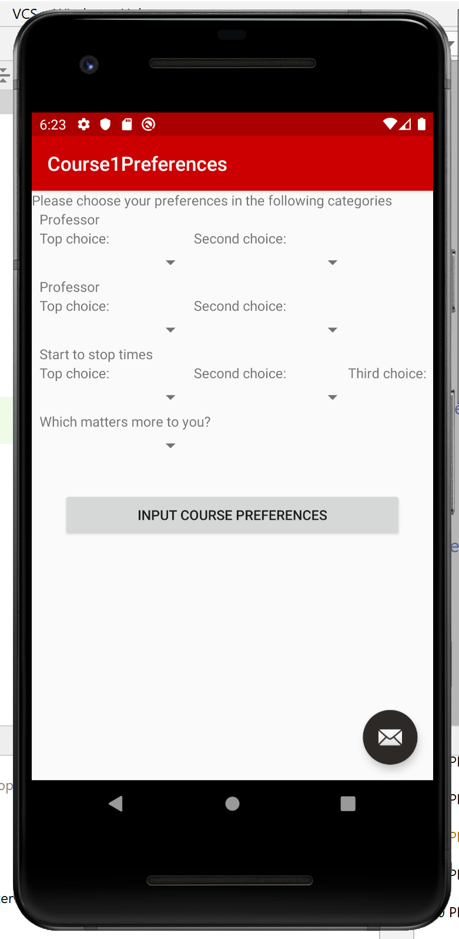

The next page (above right) lets you edit your preferences. It will look slightly different for each course, depending on the number of available professors, times, and days you can choose from. Once you’re done, click “Input Course Preferences” to go back to your list of courses.

Once you’ve edited your preferences for all your courses, just click on the “Get Optimized Schedules!” button at the bottom of the page to get your optimized schedules! But careful! If you haven’t entered preferences for every class, our app won’t let you move past this page. Make sure you haven’t missed any courses before moving on.

Finally, you can choose schedules to save. You can access saved schedules again from our homepage:



Troubleshooting: We hope that our app will be easy to use and that you won’t need any of these tips! But just in case, here are some problems you might run into.

* Your course can’t be found in the BU catalog. That’s okay, we’ll have a page where you can input the days, times and professors of different sections manually, so that our course optimizer can still work it into your schedule!
* There are time conflicts keeping you from taking all the courses you’ve selected, no matter what sections the optimizer chooses. Don’t worry, we can help you decide which course to sacrifice! We’ll let you know the time conflicts, and give you a few schedules with different combinations of four out of your five chosen courses.
* There are extra drop-down menus! Say there are only two possible professors for the lecture, but the Edit Preferences page shows asks you to pick a top choice, second choice, and third choice. This shouldn’t happen, but if it does, just enter your second choice again for the third choice, and our optimization algorithm will ignore it.
* If you run into any other unexpected problems, just contact our customer service!