Statistics, merging other data, and other resources

Mike Blazanin

Table of Contents

# Where are we so far?

1. Introduction: vignette("gcplyr")
2. Importing and transforming data: vignette("import_transform")
3. Incorporating design information: vignette("incorporate_designs")
4. Pre-processing and plotting your data: vignette("preprocess_plot")
5. Processing your data: vignette("process")
6. Analyzing your data: vignette("analyze")
7. **Statistics, merging other data, and other resources:** vignette("conclusion")

So far, we’ve imported and transformed our measures, combined them with our design information, pre-processed, processed, plotted, and analyzed our data. The only things left are a few notes on best practices for running statistics, merging growth curve analyses with other data, and additional resources for analyzing growth curves.

If you haven’t already, load the necessary packages.

library(gcplyr)  
  
library(dplyr)  
library(ggplot2)

#This code was explained in sections 2 through 6  
#Here we're re-running it so it's available for us to work with  
example_tidydata <- trans_wide_to_tidy(example_widedata,  
 id_cols = "Time")  
example_design <- make_design(  
 pattern_split = ",", nrows = 8, ncols = 12,  
 "Bacteria_strain" = make_designpattern(  
 values = paste("Strain", 1:48),  
 rows = 1:8, cols = 1:6,  
 pattern = 1:48,  
 byrow = TRUE),  
 "Bacteria_strain" = make_designpattern(  
 values = paste("Strain", 1:48),  
 rows = 1:8, cols = 7:12,  
 pattern = 1:48,  
 byrow = TRUE),  
 "Phage" = make_designpattern(  
 values = c("No Phage"),  
 rows = 1:8, cols = 1:6,  
 pattern = "1"),  
 "Phage" = make_designpattern(  
 values = c("Phage Added"),  
 rows = 1:8, cols = 7:12,  
 pattern = "1"))  
ex_dat_mrg <- merge_dfs(example_tidydata, example_design)  
#> Joining, by = "Well"  
ex_dat_mrg$Well <-   
 factor(ex_dat_mrg$Well,  
 levels = paste(rep(LETTERS[1:8], each = 12), 1:12, sep = ""))  
ex_dat_mrg <- group_by(ex_dat_mrg, Well, Bacteria_strain, Phage)  
  
ex_dat_mrg <-  
 mutate(ex_dat_mrg,  
 smoothed_med3 =   
 smooth_data(x = Time, y = Measurements,  
 sm_method = "moving-median", window_width_n = 3),  
 #Note that for the second round, we're using the   
 #first smoothing as the input y  
 smoothed =   
 smooth_data(x = Time, y = smoothed_med3,  
 sm_method = "moving-average", window_width_n = 3))

# Statistical analyses of growth curves data

At this point, we’ve now summarized our growth curves data into some metrics. How can we best go about drawing statistical conclusions from these data?

## When should we average replicates?

Before we dig into what we to do next, I want to emphasize something we did *not* do in this workflow: averaging different wells together *before* summarization. In my opinion, averaging should only occur after summarization, not before. Why is that? Even wells that have the same contents (i.e. are technical replicates) can still differ in their growth due to biological variation (e.g. stochastic growth dynamics). If we average our density values at the beginning, we may introduce bias and we will not have the ability to visualize or assess the biological variation present in our data.

Let’s look at a simple example to demonstrate this point. I’m going to simulate bacterial growth using the Baranyi-Roberts mathematical model of growth, which is logistic growth but with a period of acclimation at the beginning:

$$\frac{dN}{dt}=\frac{q_{0}}{q_{0}+e^{−mt}}*rN\left(1−\frac{N}{k}\right)$$

Where $N$ is the population size, $q_{0}$ is a parameter controlling the initial acclimatization state of the population, $m$ is the rate of acclimation, $r$ is the rate of growth, and $k$ is the carrying capacity of the population.

In the code below, I simulate the growth of 96 different wells of bacteria. All the bacteria are identical, except that they differ in the rate at which they acclimate.

#Define the function that calculates density according to Baranyi-Roberts eq  
baranyi_gr <- function(r, k, q0, m, init_dens, times) {  
 #Note: these eqs are the integral of the dN/dt eq in the text above  
 #Acclimation function  
 a <- times + 1/m*log((exp(-m*times)+q0)/(1+q0))  
 #Density function  
 return(k/(1-(1-(k/init_dens))*exp(-r*a)))  
}  
  
#Set up our wide-shaped data frame  
times <- seq(from = 0, to = 24*60, by = 15)  
sim_dat <- as.data.frame(matrix(NA, nrow = length(times), ncol = 98))  
sim_dat[, 1] <- times  
colnames(sim_dat) <- c("time", "averaged", paste("Well", 1:96, sep = ""))  
  
#Simulate growth  
for (i in 3:ncol(sim_dat)) {  
 sim_dat[, i] <- baranyi_gr(times = sim_dat$time,   
 r = 0.02, k = 1, q0 = 0.5,  
 m = rgamma(n = 1, shape = 2, scale = 0.02/2),  
 init_dens = 0.001)  
}  
  
#Calculate the "average well"  
sim_dat[, "averaged"] <- rowMeans(sim_dat[, 3:ncol(sim_dat)])  
  
#Transform to tidy and calculate per-capita growth rate   
sim_dat_tdy <- trans_wide_to_tidy(sim_dat, id_cols = "time")  
sim_dat_tdy <- mutate(group_by(sim_dat_tdy, Well),  
 percap_deriv = calc_deriv(y = Measurements, x = time,  
 percapita = TRUE, blank = 0))  
  
#Plot the growth in our wells  
ggplot(data = filter(sim_dat_tdy, Well != "averaged"),   
 aes(x = time, y = Measurements, group = Well)) +  
 geom_line(alpha = 0.1) +  
 geom_line(data = filter(sim_dat_tdy, Well == "averaged"), color = "red") +  
 scale_y_continuous(trans = "log10")

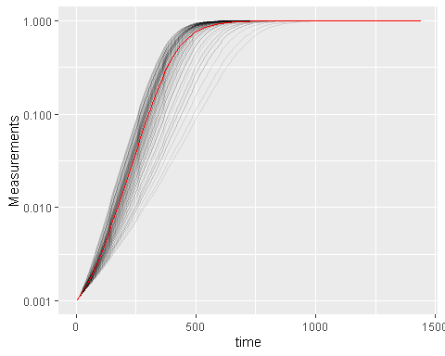

Here we’ve plotted each individual well in black, with the “average well” plotted in red. We can clearly see that our different wells are varying in how quickly they’re acclimating. Our average well appears to reflect the data pretty well, does it give a good measure for our average maximum per-capita growth rate?

#Summarize our data  
sim_dat_sum <- summarize(group_by(sim_dat_tdy, Well),  
 max_growth_rate = max(percap_deriv, na.rm = TRUE))  
  
#Plot the maximum per-capita growth rates of each well  
# Add a red line for the max growth rate of the "average well"  
# Add a dashed line for the true average growth rate of all the wells  
ggplot(data = filter(sim_dat_sum, Well != "averaged"),   
 aes(x = max_growth_rate)) +  
 geom_histogram() +  
 geom_vline(data = filter(sim_dat_sum, Well == "averaged"),   
 aes(xintercept = max_growth_rate), color = "red") +  
 geom_vline(xintercept =   
 mean(filter(sim_dat_sum, Well != "averaged")$max_growth_rate),  
 lty = 2)  
#> `stat_bin()` using `bins = 30`. Pick better value with `binwidth`.

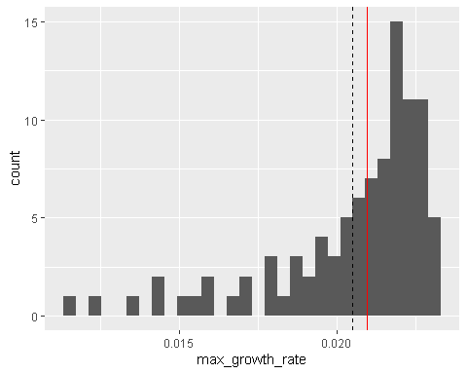

Here we can see that the maximum per-capita growth rate of the “average well” (red line) is not the same as the true average maximum per-capita growth rate of all the wells (dashed line). While this bias in the “average well” might seem small, it is in fact very consistent: if you ran this simulation many more times, the “average well” growth rate would nearly always be higher than the true average growth rate. Moreover, **the “average well” is often biased in many summarized statistics**, not just growth rate.

Additionally, calculating the “average well” means that we would not have the ability to plot this distribution of growth rates between wells; we would only have the single value of the red line, with no way to directly visualize how biased or not it is. By visualizing the distribution directly, we can see that it is skewed and that perhaps we should use a transformed metric (e.g. the log growth rate) for any analyses that assume normality.

## Carrying out statistical testing

With that aside on when to average done, how do you go about running statistics on individual wells? Typically, growth curves experiments will have a highly nested structure. You probably have multiple wells with the same contents (i.e. technical replicates) in each plate. You may also have multiple plates from different runs (creating the possibility of batch effects).

In order to pull apart these effects and test for differences between your treatments, you’ll need to do mixed-effects modeling. Unfortunately, it’s beyond the scope of this vignette to provide a sufficient explanation of how to do mixed-effects statistics. However, I can provide some guidance:

For frequentist statistics, the R package lme4 is one of the most-popular implementations of mixed-effects modeling.

For Bayesian statistics, the R packages brms or rstanarm are popular implementations that can incorporate mixed-effects modeling.

Regardless of your approach, you should:

* use your your summarized statistics (e.g. auc, max_growth_rate, lag_time, etc.) as your response variable
* use your design elements (e.g. Bacteria_strain, Phage) as your explanatory variables
* incorporate random effects for any technical replicates you have
* incorporate random effects for any potential batch effects in-play

There are a number of excellent resources out there to learn how to do this sort of mixed-effects modeling, including what I think is [**a good introductory guide to the process by Michael Clark**](https://m-clark.github.io/mixed-models-with-R/).

# Combining growth curves data with other data

As you approach the end of your growth curves analyses, you have summarized the dynamics of your growth curves into one or a few metrics. At this point, you may wish to pull in other sources of data to compare to your growth curves metrics. Just like merging multiple growth curves data frames together, this can be achieved with merge_dfs.

Let’s use the ex_dat_mrg_sum from an earlier section, where we’ve summarized our growth curves using area-under-the-curve (although this approach would work with any number of summarized metrics).

ex_dat_mrg_sum <-  
 summarize(ex_dat_mrg, auc = auc(x = Time, y = smoothed))  
#> `summarise()` has grouped output by 'Well', 'Bacteria_strain'. You can override using the  
#> `.groups` argument.

Now imagine that, separately, we’ve measured the resistance of each of these bacteria to antibiotics, and we want to know if there’s any relationship between the antibiotic resistance of the bacteria and their growth.

We’re just going to focus on the bacterial growth in the absence of phage, so let’s use dplyr::filter to remove the phage added rows.

ex_dat_mrg_sum <- dplyr::filter(ex_dat_mrg_sum, Phage == "No Phage")  
head(ex_dat_mrg_sum)  
#> # A tibble: 6 × 4  
#> # Groups: Well, Bacteria_strain [6]  
#> Well Bacteria_strain Phage auc  
#> <fct> <chr> <chr> <dbl>  
#> 1 A1 Strain 1 No Phage 55223.  
#> 2 A2 Strain 2 No Phage 67262.  
#> 3 A3 Strain 3 No Phage 52592.  
#> 4 A4 Strain 4 No Phage 70159.  
#> 5 A5 Strain 5 No Phage 71007.  
#> 6 A6 Strain 6 No Phage 44141.

Now, let’s generate some mock antibiotic resistance data. The file containing the antibiotic resistance data should have the bacterial strain names under the same header Bacterial_strain, so that merge_dfs knows to match those two columns. We’ll put whether or not the strain is resistant to the antibiotic under the Antibiotic_resis column, with a TRUE for resistance, and FALSE for sensitivity. **Don’t worry exactly how this code works**, since it’s just simulating data that you would have collected in the lab.

set.seed(123)  
antibiotic_dat <-   
 data.frame(Bacteria_strain = paste("Strain", 1:48),  
 Antibiotic_resis =   
 ex_dat_mrg_sum$auc[  
 match(paste("Strain", 1:48),   
 ex_dat_mrg_sum$Bacteria_strain)] *   
 runif(48, 0.5, 1.5) < mean(ex_dat_mrg_sum$auc))  
  
head(antibiotic_dat)  
#> Bacteria_strain Antibiotic_resis  
#> 1 Strain 1 TRUE  
#> 2 Strain 2 FALSE  
#> 3 Strain 3 TRUE  
#> 4 Strain 4 FALSE  
#> 5 Strain 5 FALSE  
#> 6 Strain 6 TRUE

Great, now we merge our two data frames.

growth_and_antibiotics <-   
 merge_dfs(ex_dat_mrg_sum, antibiotic_dat)  
#> Joining, by = "Bacteria_strain"  
head(growth_and_antibiotics)  
#> # A tibble: 6 × 5  
#> # Groups: Well, Bacteria_strain [6]  
#> Well Bacteria_strain Phage auc Antibiotic_resis  
#> <fct> <chr> <chr> <dbl> <lgl>   
#> 1 A1 Strain 1 No Phage 55223. TRUE   
#> 2 A2 Strain 2 No Phage 67262. FALSE   
#> 3 A3 Strain 3 No Phage 52592. TRUE   
#> 4 A4 Strain 4 No Phage 70159. FALSE   
#> 5 A5 Strain 5 No Phage 71007. FALSE   
#> 6 A6 Strain 6 No Phage 44141. TRUE

And now let’s see if there’s a relationship!

ggplot(data = growth_and_antibiotics,   
 aes(x = Antibiotic_resis, y = auc)) +  
 geom_point()

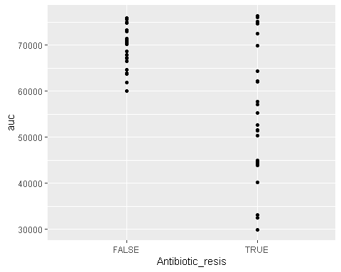

There is! We can see that the antibiotic resistant strains (TRUE) have a smaller area-under-the-curve than the antibiotic sensitive strains (FALSE) (although, to be fair, I did simulate the data so we’d get that result).

# Other growth curve analysis packages

A number of other R packages besides gcplyr facilitate analysis of growth curves data.

There are, broadly speaking, two ways to analyze growth curves data:

1. directly quantify attributes of the growth dynamics
2. fit the growth dynamics with a mathematical model, then extract parameters from the fitted model

While gcplyr focuses on manipulation of growth curves data and the first analysis approach (direct quantification of growth curves dynamics), many other R packages focus on fitting growth dynamics with a mathematical model.

Generally, fitting growth dynamics with a model has greater power to accurately quantify the underlying traits. However, it also takes much more effort to be rigorous when fitting data with a model. You have to carefully choose a model whose assumptions your data meet. You also have to evaluate the fits to ensure that the optimization algorithms arrived on reasonable solutions.

A number of R packages implement fitting-style approaches, which I list here for readers to explore on their own. At some point in the future, I hope to incorporate more direct examples of how to use tidy-shaped data imported and manipulated by gcplyr with these packages.

* [growthcurver](https://github.com/sprouffske/growthcurver)
* [QurvE](https://nicwir.github.io/QurvE/)
* AUDIT (including growr and mtpview1)
* growthrates
* drc
* opm
* grofit
* R-Biolog
* growthmodels
* cellGrowth
* grofit
* GCAT
* CarboLogR
* biogrowth

Additionally, one R package doesn’t implement fitting-style approaches, but does contain useful functionality for plate-reader data analysis:

* plater

# What’s next?

You’ve finished all the documentation that I’ve written (so far). Congratulations! gcplyr is a powerful framework to build additional analyses on, since the data is nicely organized. Feel free to reach out to me with any questions, comments, or concerns you might have. I’d love to continue making gcplyr as useful for others in the scientific community as it has been for me. You can reach me at mikeblazanin [at] gmail [dot] com.

1. Introduction: vignette("gcplyr")
2. Importing and transforming data: vignette("import_transform")
3. Incorporating design information: vignette("incorporate_designs")
4. Pre-processing and plotting your data: vignette("preprocess_plot")
5. Processing your data: vignette("process")
6. Analyzing your data: vignette("analyze")
7. Statistics, merging other data, and other resources: vignette("conclusion")