Assignment 5: GUI

# Question 1

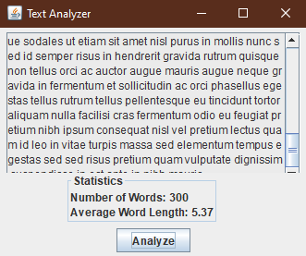

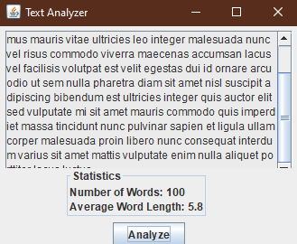

# Question 2

Start

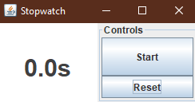\

Running: Press Button | Press Space Key | Press S Key while **not** running.

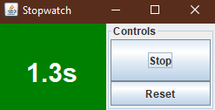

Stopped: Press Button | Press Space Key | Press S Key while running.

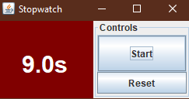

Reset: Press Button | Press ESC Key | Press R Key

