Table of Contents

Abstract 2
Artificial Intelligence 3
Types of Intelligence 3
Types of Utility Functions 4
Analysis 4
Conclusions 5
User’s Guide 6
Installation in Linux 6
Installation in Windows 95/98/NT/2000 6
Execution in Linux 6
Execution in Windows 95/98/NT/2000 6
User Options 6
Program Execution 7
Implementation 8
Class Overview 8
Appendix 10
A. Generating Random Numbers 10
B. Example Options File 11
References 12

Abstract

The main motivation of this project was the fascination of the idea of pooled intelligence. Pooled intelligence refers to the idea of having several units with limited individual intelligence, but superior intelligence when their knowledge is combined. These ideas have been implemented in this project to some extent. However, even early in the implementation stage, the realization has been made that simple decision making skills are fairly tedious to implement.

In a nutshell, the program is a simulation of two types of units fighting with each other. There are only two types of units, blue dinosaurs and green lizards. It is important to note that the concept of fighting is not essential to this program, but was chosen because virtually everyone is familiar with real-time strategy games such as Warcraft. In other words, the units may well be engaging in some activity other then fighting. Thus, the purpose of the simulation is to have one set of units defeat the other set of units.

The playing field consists of an array of squares, 20 squares in each column and 30 squares in each row for a total of 600 squares. The simulation has several settings, which can be changed during initialization of the program, and one of them is the number of units of each type. Each unit of each type is entitled to making a single move at each epoch; north, south, east, west. Optionally, the unit may choose to remain in its current position. Because each square can only contain a single unit, it is possible to “trap” a unit by placing four units around the unit that is to be trapped. Therefore, the goal is to design an engine that will instruct the units to move around such that the units will achieve their purpose of defeating the other set of units.

The fighting has been implemented as follows, each unit starts with 100 power points, and when it comes in contact with an enemy unit, it will engage the unit, this is indicated by the unit turning red on the screen. During engagement, both sides will lose an equal amount of power points. Therefore, the obvious way (and the only way) to win is to engage each enemy unit with a larger number of friendly units. Napoleon Bonaparte first demonstrated this tactic with astounding success during the Napoleonic Wars.

The algorithm designed to implement this is fairly straightforward. Basically, the idea is to unify units of the same type in a group. And only if the number of units in this group is larger than the number of units in the opposing group, should the units attempt to engage the enemy (note that the opposing group may consist of a single unit). Thus the units need to collectively decide if they should form a group and where to form a group. And in fact, the most difficult part turned out to be deciding where the group should be formed.

This algorithm has been successfully implemented in the program, but there are limitless modifications that can be made to the algorithm. For example, rather than comparing the number of units in the two opposing groups, it is probably a better idea to compare the total power of the two opposing groups. Because the original algorithm did not yield satisfactory results, the latter improvement has indeed been implemented.

It is interesting to note that this simple change of tactic has yielded a 54% performance increase in the simulation (where performance is the number of surviving units after all enemy units have been eliminated).

Artificial Intelligence

Types of Intelligence

Five types of behavior were implemented for each unit.

Behavior Number (used in the options file) | Behavior Name | Description
0 | None | - Move EAST (or WEST) until a collision occurs and then change direction to SOUTH/NORTH (decided randomly).  - Move NORTH (or SOUTH) until a collision occurs and then change direction to EAST/WEST (decided randomly).
1 | Random | - Move in direction D, where D is determined randomly before each move.
2 | Aggressive | - Look for an enemy unit and then move towards that unit and engage/attack.  - If there is an obstacle in the way, then the unit will attempt to move around the obstacle in the direction of the enemy unit. In this simulation, the only possible obstacle is a friendly unit.  - If no enemy unit can bee located, then move in direction D, where D is determined randomly before each move.
3 | Defensive | - Look for an enemy unit and then move away from that unit.  - If there is an obstacle in the way, then the unit will attempt to move around the obstacle in a direction that takes the unit away from the enemy unit(s).  - If the unit is cornered between four enemy/friendly units, nothing can be done until one of the units moves away.  - If no enemy unit can bee located, then move in direction D, where D is determined randomly before each move.
4 | Unify | - Each unit will transmit a message that evaluates its situation, such that the value is high when there is a lot of friendly units around and the value is low when there is a lot of enemy units around.  - Each unit will listen to messages from friendly units and it will move toward a location that is safest, where the safest location is one where there are many friendly units, and few enemy units. Note that,  - If there is an obstacle in the way, then the unit will attempt to move around the obstacle in the direction of the safe location.  - Move in direction D, where D is determined randomly before each move.

Types of Utility Functions

Due to time constrains, only three simple types of utility functions were implemented:

Utility Function Number  (used in the options file) | Utility Function Name | Description
0 | UtilityFunctionA | This is the most interesting utility function and it was in fact used for practically all the simulations.  - The value of the function is highest when power is above some level N and the unit is engaged/attacking an enemy unit. In this simulation this value was 10.  - The value of the function is second highest when the power is below some level N and the unit is engaged/attacking an enemy unit. This value was 5.  - When the unit’s power was above level N and the unit was NOT engaged/attacking an enemy unit, the value was 2.  - When the unit’s power was below level N and the unit was NOT engaged/attacking an enemy unit, the value was 1.
1 | UtilityFunctionB | This utility function is inversely related to the power of a unit.  The function’s value is high when the power of a unit is low, and low when the power of the unit is high.
2 | UtilityFunctionC | This utility function’s value is high when the power of a unit is high, and low when the power of the unit is low.

Analysis

Each test was performed five times because the results of individual tests were fairly close (within 5% to 10%). The following results were obtained when running the program with the option files provided (demoX.dat):

Filename | Settings | Results
Filename | Settings | Epoch | Lizards | Lizard Utility | Dinosaur | Dinosaur Utility
demo1.dat | lizard = aggressive,  dinosaur = unify | 4000 | 3.2 | 13563 | 0 | 0
demo2.dat | lizard = random,  dinosaur = unify | 3000 | 4.6 | 15197 | 0 | 0
demo3.dat | lizard = random,  dinosaur = unify | 3000 | 19.2 | 62467 | 0 | 0
demo4.dat | lizard = unify,  dinosaur = aggressive | 4000 | 6.0 | 24718 | 0 | 0
demo5.dat | lizard = unify,  dinosaur = random | 3000 | 6.4 | 27890 | 0 | 0
demo6.dat | lizard = unify,  dinosaur = random | 3000 | 26.6 | 79735 | 0 | 0

Conclusions

A major shortcoming was discovered during simulation. The simulation is biased towards the lizard type units. This bias occurs because the lizard type units are allowed to make the very first move in the simulation. Randomizing which type of unit will make the very first move may result in a wider range of test results. Instead, the test cases were designed to eliminate this bias.

In the first three test cases the dinosaur units had their intelligence set to “unify” and the intelligence of the lizard units was varied. The solid bars in the graphs below show the result of these tests.

In the other set of tests, namely the last three test cases, the lizard units had their intelligence set to “unify” and the intelligence of the dinosaur units was varied. The bars with the checkered pattern in the graphs below show the results of these tests.

Both graphs show the superior performance of the lizard units when they had their intelligence set to “unify”. The average number of units remaining was 54% higher when their intelligence was set to “unify”. Also, the average total utility of remaining units was 64% higher when their intelligence was set to “unify”. (Informal testing has shown that the performance of dinosaur units also increases when their intelligence is set to “unify”, but these results are not shown).

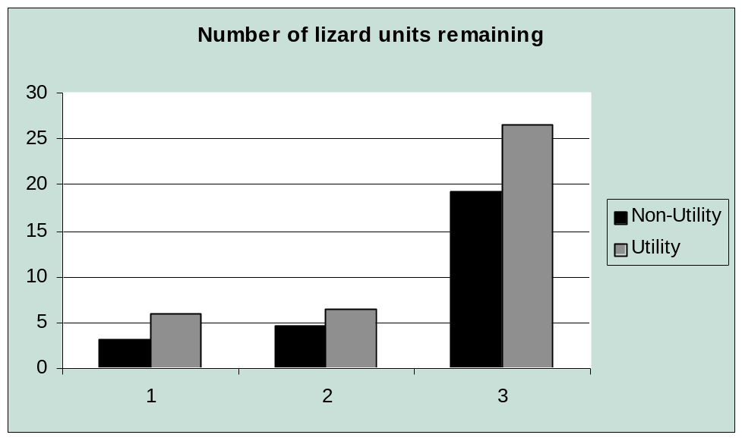

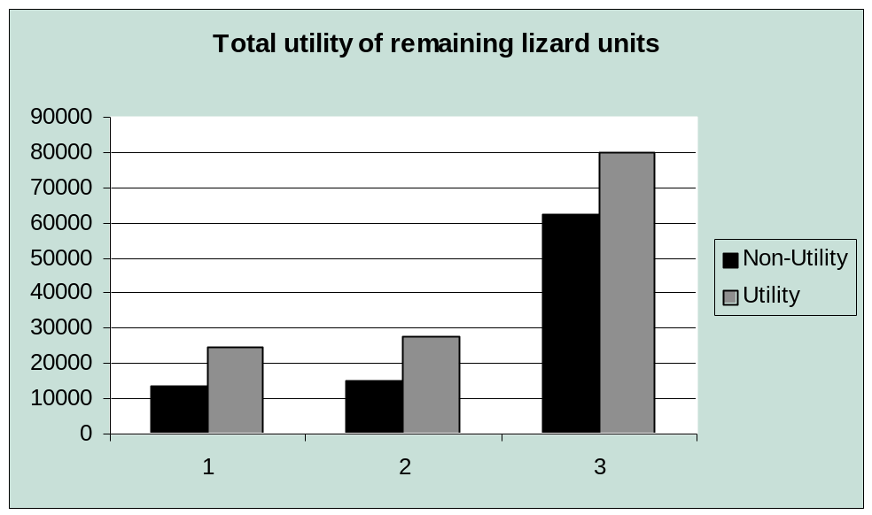

User’s Guide

Installation in Linux

To install the package, type:
- gunzip pro.tgz
- tar xvf pro.tar
- make

Installation in Windows 95/98/NT/2000

On a MS Windows system, the package can be installed by unzipping the package to a directory and then by typing from the command prompt:
- javac *.java

Execution in Linux

To run the program, type:
- run
(Make sure that current directory is the directory where the package has been installed.)

Optionally, the user can type:
- run filename
Where filename is the name of the file that contains the user specified options

Execution in Windows 95/98/NT/2000

On a MS Windows system, typing from the command prompt can start the program:
- java Program
Similarly, the user can type:
- java Program filename
Where filename is the name of the file that contains the user specified options

User Options

There are several options that the user can specify to fine-tune the execution of the program. Since there are so many, the preferred method of input is in an input file that can be saved and modified easily. An example options file is provided in Appendix B. The table below highlights the most significant options (Note: the value for each attribute is specified by a non-negative integer).

Option | Description
speed | The number of milliseconds between each epoch (1000 milliseconds = 1 second).
gridlines | Turns gridlines on/off (1 for on, and 0 for off).
display | Turns dynamic display on/off (1 for on, and 0 for off). This can be used to run simulation quicker, since redrawing the game field is computationally intensive.
firepower | The number of power that is lost each time the unit is engaged/attacked by another unit.
dinoUnits | Number of dinosaur units to the simulation with.
dinoRandom | Turns random number of dinosaur units on/off (1 for on, and 0 for off). If on, the dinoUnits will be set to a random integer between 1 and the original value of dinoUnits. If off, dinoUnits will remain unchanged.
dinoAI | Type of intelligence that each dinosaur will have (1, 2, 3, 4, or 5).
dinoFun | Which utility function to use (1, 2, or 3).
dinoVisibility | This integer specifies the number of squares across which each dinosaur can see.
dinoCom | This integer specifies the number of squares across which each dinosaur can communicate with the other dinosaurs.

A small number of example option files are also provided with the system. These files were used in the analysis of the system.

Filename | Description
Filename | Lizard behavior | Dinosaur behavior | Number of units of each type
demo1.dat | aggressive | unify | 20
demo2.dat | random | unify | 20
demo3.dat | random | unify | 100
demo4.dat | unify | aggressive | 20
demo5.dat | unify | random | 20
demo6.dat | unify | random | 100

Program Execution

When running the simulation (with display on), there are several actions that the user can perform:
- Pause: At any time the user can click anywhere on the game field to pause the simulation. To continue the simulation, the user must click on the game field once again.
- Information: At any time the user can click on any of the units to see the attributes of that particular unit.

Additionally, the program will print a summary to the screen. An example output might look like this:
Epoch = 125
Number of Lizards = 25 Total Utility of Lizards = 172
Number of Dinosaurs = 25 Total Utility of Dinosaurs = 2388
(This output can be piped to a file or directly to a printer, see the documentation for your operating system).

When a unit is engaged/attacking another unit, both units will turn red to indicate this state. Clicking on either unit will reveal that indeed the state is engaged (Engaged=true), and the power will decrease by the specified amount.

Implementation

Class Overview

More detailed documentation of the source code is available at: http://www.uoguelph.ca/~mboche01/475Project/doc/index.html

Class Const
Const()

Class DrawArea
 | DrawArea(Option op, java.util.Vector unitIn, javax.swing.Timer cl)
void | mouseClicked(java.awt.event.MouseEvent e)
void | mouseEntered(java.awt.event.MouseEvent e)
void | mouseExited(java.awt.event.MouseEvent e)
void | mousePressed(java.awt.event.MouseEvent e)
void | mouseReleased(java.awt.event.MouseEvent e)
void | paint(java.awt.Graphics g)
void | setU(java.util.Vector u)

Class GraphicalUnit
 | GraphicalUnit()
protected boolean | attemptMove(int direction)
protected int | evalSituation(java.util.Vector units, int meID, Unit me)
int | getColumn()
protected int | getRandomDir()
int | getRow()
int | getUnitType()
protected Boolean | isTouching(Unit u)
protected boolean | isVisible(Unit u, int range)
protected void | move(int direction)
protected int | moveAwayFrom(Unit u, java.util.Vector units, int myID)
protected int | moveTowards(Unit u, java.util.Vector units, int myID)
void | paint(java.awt.Graphics g, DrawArea area)
protected void | setLocation(int r, int c)
protected Boolean | squareEmpty(java.util.Vector units, int meID, int newRow, int newColumn)

Class Main
 | Main(Option options)
void | actionPerformed(java.awt.event.ActionEvent evt)
void | windowActivated(java.awt.event.WindowEvent event)
void | windowClosed(java.awt.event.WindowEvent event)
void | windowClosing(java.awt.event.WindowEvent event)
void | windowDeactivated(java.awt.event.WindowEvent event)
void | windowDeiconified(java.awt.event.WindowEvent event)
void | windowIconified(java.awt.event.WindowEvent event)
void | windowOpened(java.awt.event.WindowEvent event)

Class Option
 | Option()
 | Option(java.lang.String filename)
void | readOptions()

Class OptionInterface
 | OptionInterface(Option o)
 | OptionInterface(Option o, java.lang.String databaseFilename)
int | getInteger(java.lang.String s)
void | parse(java.lang.String s)
void | printAll()
int | readDatabase()
int | readDatabase(java.lang.String databaseFilename)

Class Program
 | Program()
static void | main(java.lang.String[] args)

Class Unit
 | Unit()
 | Unit(int id, int uType, int ai)
void | checkContact(int uID, Option op, java.util.Vector units)
void | evaluateUtility(java.util.Vector units)
int | getID()
java.lang.String | getInfo()
int | getPower()
int | getSituation()
int | getTotalUtility()
int | getUtility()
void | go(int random, int uID, Option op, java.util.Vector units)
void | kill(Unit enemy)

Appendix

A. Generating Random Numbers

There are several instances in this project were random number generators were used, and each time the Java Random Class was used. Creating an instance of this object will by default generate a stream of pseudorandom numbers using the current time as a seed (Where the current time is 4-bit integer representing the number of milliseconds between the current time and midnight, January 1, 1970).

Therefore this instantiation,
Random r = new Random ();
is identical to:
Random r = new Random (System.currentTimeMillis());

Optionally, the Random Class can be instantiated be manually providing a 4-bit integer to use as a seed, however this was virtually never done since this integer would have to be random as well.

As mentioned above, the Random Class uses a linear congruential random number generator. For a more detailed discussion of this topic see Donald Knuth, The Art of Computer Programming, Volume 2, Section 3.2.1.
The general form of a linear congruential random number generator is:
SEED = (A * SEED + C) mod M
The initial integer value for SEED is provided as explained above. On each call nextInt() to the random number generator, a new value of SEED is calculated by taking the current value of SEED, multiplying by A, adding C, and taking the remainder MOD M of the result.

Some obvious properties of sequences generated by this method are:
- The integer returned by nextInt() will be between 0 and M – 1.
- If the integer returned by nextInt() has already been returned before, the sequence of random numbers will repeat itself starting at that integer.
- The maximum number of different integers that nextInt() will return is M.
- Since M is a finite integer, all sequences of integers that the generator produces will eventually enter a cycle which repeats itself endlessly. Ideally, this sequence will be as long as possible.

A linear congruential formula will generate a sequence of maximum length M if and only if:
- C is relatively prime to M;
- B = (A - 1) is a multiple of P, for every prime P dividing M;
- B = (A - 1) is a multiple of 4, if M is a multiple of 4.

In conclusion, the random number generator implemented in the Java Random Class produces random numbers to our satisfaction. Producing and evaluating random number generators is a task beyond the scope of this paper.

B. Example Options File

#
# This is the DEFAULT options file for the program.
#

# simulation speed
speed=500

# show grid lines or not (1 = yes, 0 = no)
gridlines=1

# redisplay everything every epoch (1 = yes, 0 = no)
display=1

# the amount of power lost when an enemy is engaged
# should be between 1 and 100, since each unit starts with 100.
firepower=1

# number of units of DINO
dinoUnits=20
dinoRandom=0

# number of units of LIZZARD type
lizUnits=20
lizRandom=0

# behaviour of units of DINO type
dinoAI=4

# behaviour of units of LIZZARD type
lizAI=2

# utility function for units of DINO type
dinoFun=0

# utility function for units of LIZZARD type
lizFun=0

# visibility range for units of DINO type
dinoVisibility=2

# visibility range for units of LIZZARD type
lizVisibility=2

# communication range (0 for disabled) for units of DINO type
dinoCom=10

# communication range (0 for disabled) for units of LIZZARD type
lizCom=10

References

Artificial Intelligence: a modern approach, by Stuart Russell and Peter Norvig

Java(TM) 2 Platform, Standard Edition, v1.2.2 API Specification
http://java.sun.com/products/jdk/1.2/docs/api/index.html

Computer Generated Random Numbers, by David W. Deley
http://world.std.com/~franl/crypto/random-numbers.html

Course Website for CIS*4750
http://www.crle.uoguelph.ca/dswayne/ftpstuff/CIS475

