#** An Analysis of Kickstarter Campaigns**
## Overview of Project
The project involves giving assistance to our client, “Louise”, an up and coming play right who has mounted a fundraising campaign in order to finance her play "Fever”. While she has come close to her fundraising goals in a short period of time, she would like to study how other campaigns, including those outside of the theatre industry performed. Data from projects around the world since 2009 is provided.
### Purpose
By the use of Microsoft Excel spreadsheets, pivot tables and charting techniques, the purpose of the project is to:

- Provide spreadsheet data concerning a wide array of worldwide productions including those of television, film and video among others
- Within that effort, focus on productions within the theatre industry.
- Create visual charting methods emphasizing launch dates and funding goals and pledge efforts
Use of these tools will provide the ability to make informed decisions on future fundraising efforts.
## Analysis and Challenges
Analysis: Specific metrics involved within our spreadsheet and charting analysis focus on the following:
- Fundraising goals
- Pledged amounts/percentage funded
- Successful/Failure rates
- Launch dates of past fundraising efforts in relation to the success of the project
- Number of backers
- Average donation amounts of those backers

The following charts have been placed in the Resources folder

### Analysis of Outcomes Based on Launch Date

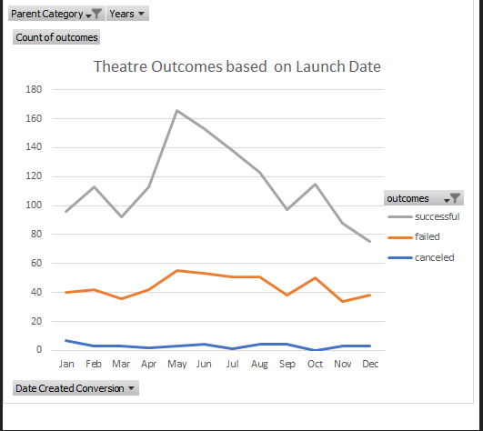

Conclusions based on the “Outcomes Based on Launch Date” chart:
1. The optimum time for launch of fundraising efforts is in early May and declines steadily over the remainder of the year with a slight rise in October
2. Failed projects peak in early May as well but remain somewhat constant throughout the year although at a much lower level than successful projects.

### Analysis of Outcomes Based on Goals
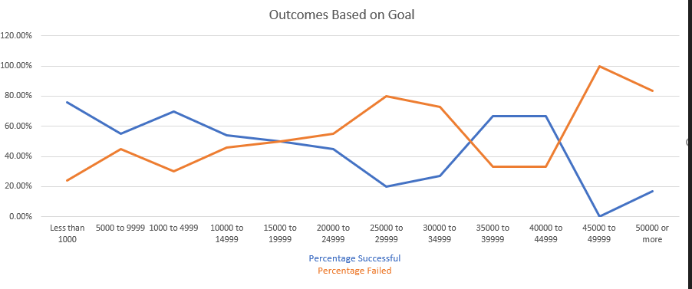
Conclusions based on the “Analysis of Outcomes Based on Goals” chart:

- The failure rates of failed projects peak at 100% with goal amounts in the $45,000-$49,000 range. Secondary failure rates of 80% are in the $25,000 goal range.
- The reasons for this failure may be related:
- Goal amounts being set to an unrealistic level
- The perceived risk of the failure of the project by backers (investors)
### Challenges and Difficulties Encountered
Challenge:

The success or failure of fundraising efforts depends on the formulation of realistic goals of each individual project. The goals of each project may be dependent on the perceived marketability of the project itself by donors. Donors may be reluctant to invest in projects that they feel would not be successful or do not have an interest in.
## Limitations of Dataset
While this initial analysis does provide an understanding of the success or failure of “Kickstarter” campaigns it is only a starting point.
For more of an in-depth analysis, additional data would need to be gathered on the backers (investors) themselves. This data should provide an insight into the following questions:
1. What other projects have previous backers been involved with?
2. How much have they invested?
3. What types of projects (subject matter) would backers
consider to be viable or have an interest in seeing produced?

Additional charts or graphs could be produced concerning the above points.

