Game of Thrones Analysis by Critic Review

CS 498H - Deep Learning

Austin Westfall and Michael Brady

5/8/16

Our goal for this project was to create a binary classifier that would rank how well liked each season of the television show Game of Thrones was based off critic reviews. We obtained these reviews from the popular film and television review website “Rotten Tomatoes”. We took two top critic reviews from each season and saved them as text files which we would later alter.

The network we used to create our classifier was created and trained using data from the IMDB database. IMDB is an online database of information related to films, television programs, and other types of media. We specifically used only the top 50,000 high reviews and split it into two to use half for training and half for testing. Each set comprised of 50% negative and 50% positive reviews. Once we loaded this data, we created a constraint that would only use the top 10,000 most frequently used words for the training data. This would remove any rare words allowing the vector size to be more easily managed.

To prepare the data to be processed we turned the lists of words into strings, eliminated any punctuation replacing them with a space, and turned every character into lower case character. We then turned the string of text we had into an integer array using a hashing function which then allowed us to vectorize the integer array. This is necessary because the model parameters are to only take in a vectorized array of integers of text. Finally, we created our model and fit it using the training data that we just processed and ran it for four epochs with a batch size of 512. We then tested our model using the test data that we just processed. The final training and validation accuracy can be seen in the graph below.

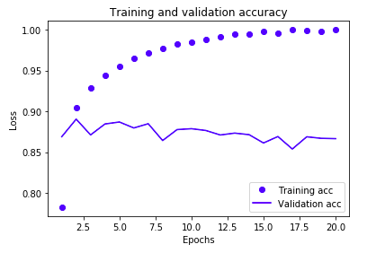

Nowthat our network has been built, trained, and tested, it is ready for us to generate predictions using our own new data. This new data will be the text files of the critic reviews from Rotten Tomatoes. This process can be seen in the screenshot of code below.

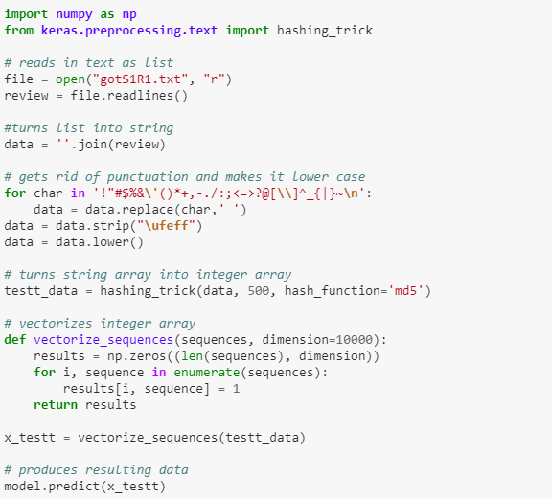

It can be seen that we took the same approach to prepare the data as before. After we read in the file we turned the list of words into a string, replaced all punctuation with spaces, turned every character into a lower case character, turned the new string into an integer array using a hashing function, and finally vectorized the integer array. We then were able to produce results using the predict method from our model.

We received very mixed results from our network. Overall, as we see from the training and loss accuracy, the network is fairly confident in its predictions. This however produced results that were far from the actual values given from the reviews. Most reviews for Game of Thrones are in the mid nineties. Our came out mostly between .45 and .55. These are very mediocre scores that do not necessarily reflect the rave reviews that most critics left. Our average scores can be seen in the graph below.

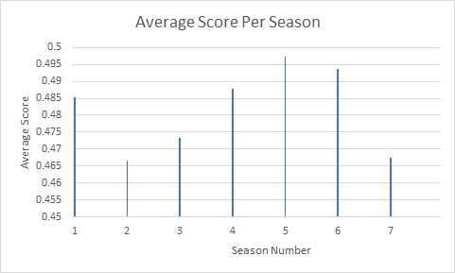

With These results we feel there could be a few adjustments to the network. It is possible the network may need to be trained more or less to give more accurate ratings. We could also use more dense layers in the network to identify. The reviews could also be difficult to classify because of the wording used by the critic. Since the show is dramatic, so of the language is difficult to decide if the review is positive or negative. There are also better ways to encode the data that would increase accuracy for the data we chose to run. Finally since the data was difficult to classify, we could use a different set of training data with more dramatic terminology. Overall the project was successful to show us that there are difficulties coming from using already created datasets.