I’ve gotten a few questions about channels and aquifers. Here is some guidance:

**Open Channels:**

Many of you have been asking me what to use for the dimensions of the open channels. Its hard to say because a) we have no real field data and b) they are not all the same. That said, I’d like to be consistent in what we are doing. So I’m going to suggest that for the open channels and ditches under existing conditions, first try to scale them off of google earth images of the location. If you can’t make it out from there then use 2 ft x 2 ft in the uphill regions of the carenage, and 2ft (deep) x 4 ft (wide) for the Carenage ditches down near the coast and for all the Grande Anse ditches.

**Aquifers:**

I have asked you all to put aquifers in the coastal regions of your model. The only reason for doing this is to constrain infiltration based on the groundwater table. Lets use the following properties for your aquifers:

* Porosity, wilting point, field capacity, conductivity – select based on soil properties. Pick properties from table A.2 on page 178 of the users manual:

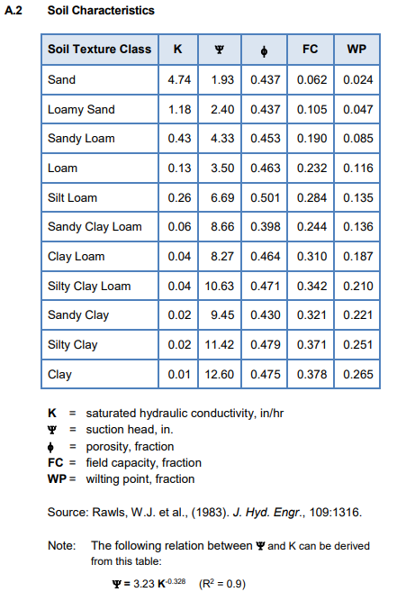

* Conductivity slope and tension slope, upper evaporation fraction, lower evaporation depth, lower GW loss rate, unsat zone moisture1 – keep default values
* Bottom elevation: set equal to -10 ft
* Water table elevation: set equal to 2.74 ft

Then when you put the aquifer into the subcatchment, set the following:

* Receiving node: outfall
* Surface elevation: from the topo map
* A1=0.5
* B1=1.0
* A2=B2=A3=0