GitHub Issues Gateway
UI Walkthrough with Screenshots
CMPE 272 — Homework 2

Service | FastAPI gateway over the GitHub Issues REST API
Interface shown | Swagger UI at /docs, rendered from openapi.yaml
Source repository | github.com/mikechau1/CMPE272-HW2
Issues operated on | github.com/mikechau1/cmpe272-issues-gw
Commit | f6754ea
Captured | 2026-09-07
Runtime | Python 3.14.5, uvicorn, macOS
Captured with | Playwright driving headless Google Chrome
Screenshots | 18, all from live calls against real GitHub

What this document shows
Every screenshot below is a real interaction with a running instance of the service, driven through its own web interface. The gateway serves its hand-written OpenAPI 3.1 contract at /docs, so that page is not a description of the code — it is the contract itself, and Swagger UI's "Try it out" issues genuine HTTP requests against the running process, which in turn calls the real GitHub API.
Nothing here is mocked, staged, or edited. Issues really were created, renamed, closed, reopened and commented on in the test repository while these screenshots were taken; the webhook deliveries really were signed, verified and stored. The HTTP status shown in the summary table was read off the page during capture rather than typed in afterwards.
Webhook secret: the signatures visible in these screenshots were produced with a throwaway secret used only for this document, so that no material derived from the real WEBHOOK_SECRET is committed alongside the images.

How to reproduce it
1. ./scripts/run.sh — start the service on port 8000.
2. pip install -r docs/requirements.txt — Playwright and python-docx.
3. python docs/capture_ui.py — drive the UI, write the screenshots.
4. python docs/build_walkthrough.py — rebuild this document.

Summary of verified interactions
Each row is one screenshot in this document. The status column is what the service actually returned during the capture run.
Interaction | Status | What it demonstrates
Creating an issue: 201 Created | 201 | 201 + Location header; rate-limit headers forwarded
The same call, rejected: 400 Bad Request | 400 | Invalid input rejected as 400 before any GitHub call
Listing issues, with pagination headers | 200 | Link header rewritten to this service; ETag; X-Page
Reading a single issue | 200 | Read-after-write through the gateway
Closing an issue: this API's DELETE | 200 | Close models DELETE (GitHub has no delete-issue)
Reopening the same issue | 200 | The close is reversible; closed_at returns to null
Commenting on an issue | 201 | 201 + Location for a comment
Reading the comment back | 200 | The comment is readable back from GitHub
A correctly signed webhook delivery: 204 | 204 | HMAC verified, delivery stored, fast 204 ack
A tampered delivery: 401 Unauthorized | 401 | Signature mismatch rejected: 401 invalid_signature
The delivery log | 200 | Accepted delivery stored; the rejected one absent
Health, without depending on GitHub | 200 | Liveness independent of the upstream

Walkthrough

1. The contract, served as the UI
The service serves its hand-written openapi.yaml at /docs, so this page is the contract itself, not a description generated from the code. The server dropdown lists both spellings of localhost, because Try it out sends requests to the selected server URL.
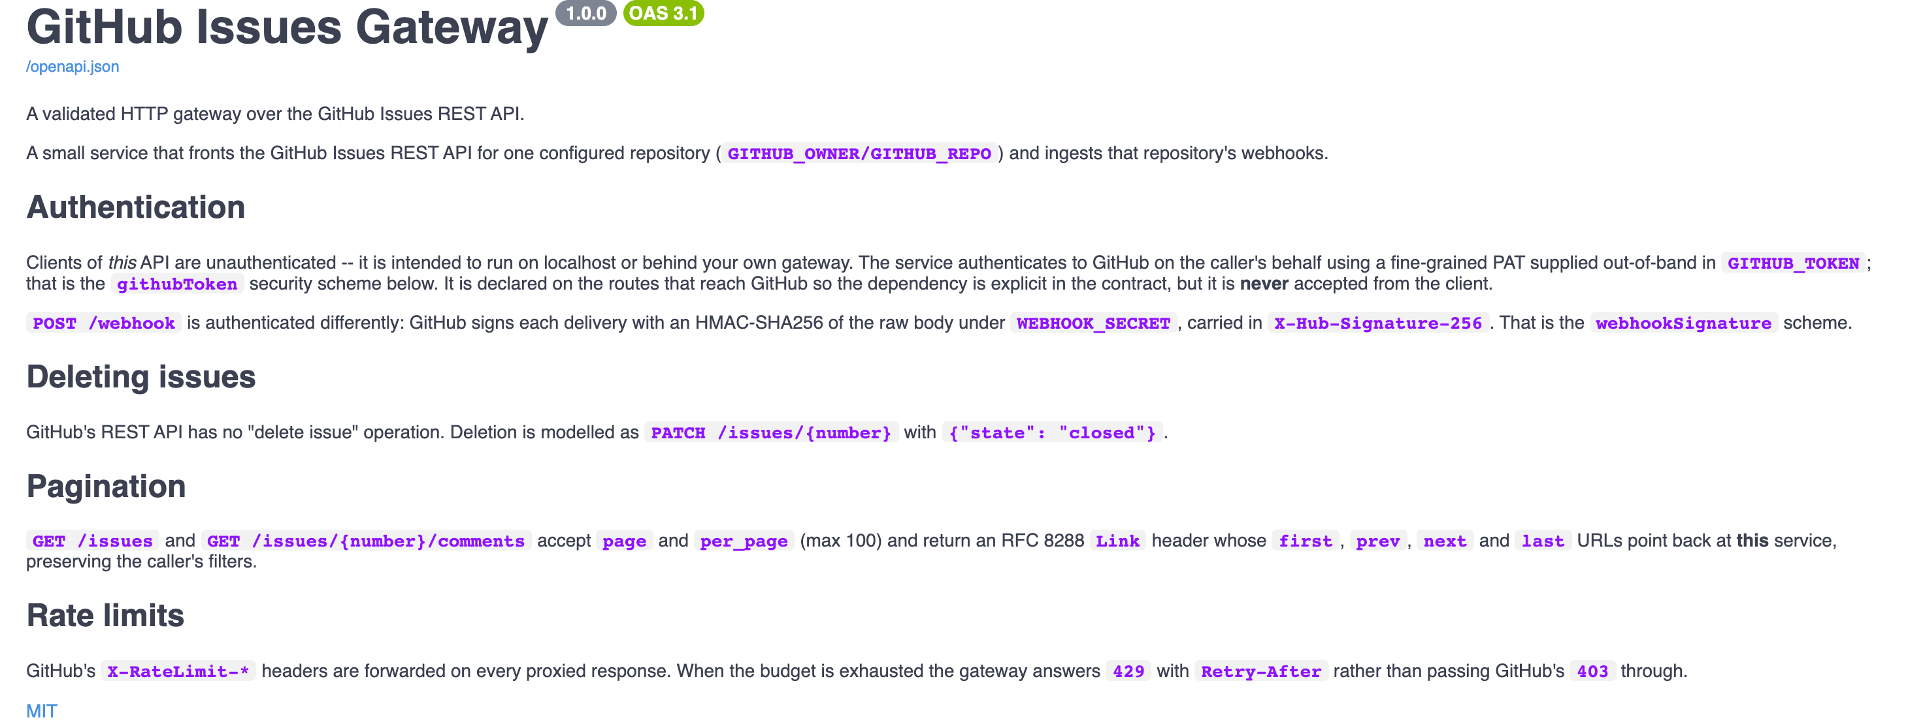

2. The operations this API exposes
Ten operations in three groups. There is deliberately no DELETE: GitHub's REST API has no delete-issue endpoint, so removal is PATCH /issues/{number} with state=closed.
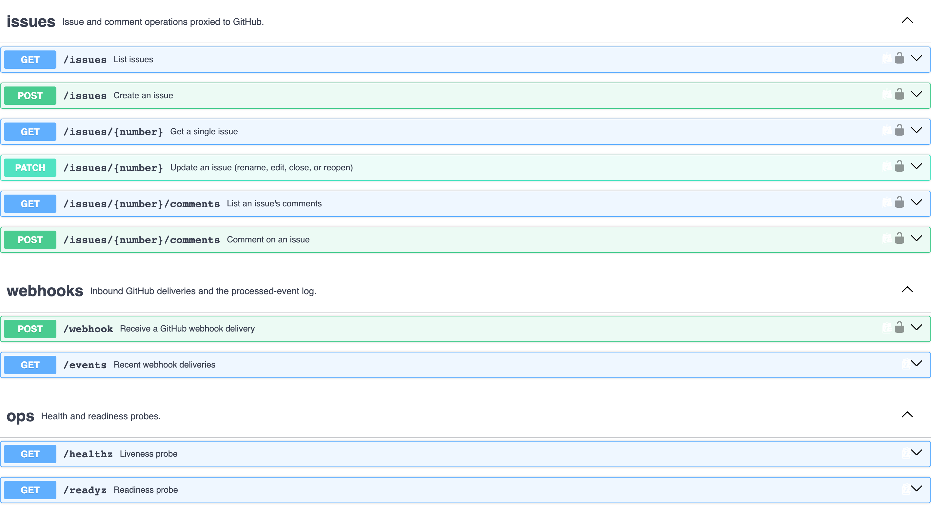

3. The two credentials, declared in the contract
The two credentials the contract declares. githubToken is the server-side PAT the gateway uses to call GitHub; webhookSignature is the HMAC header GitHub sends. Neither is ever accepted from a client of this API.
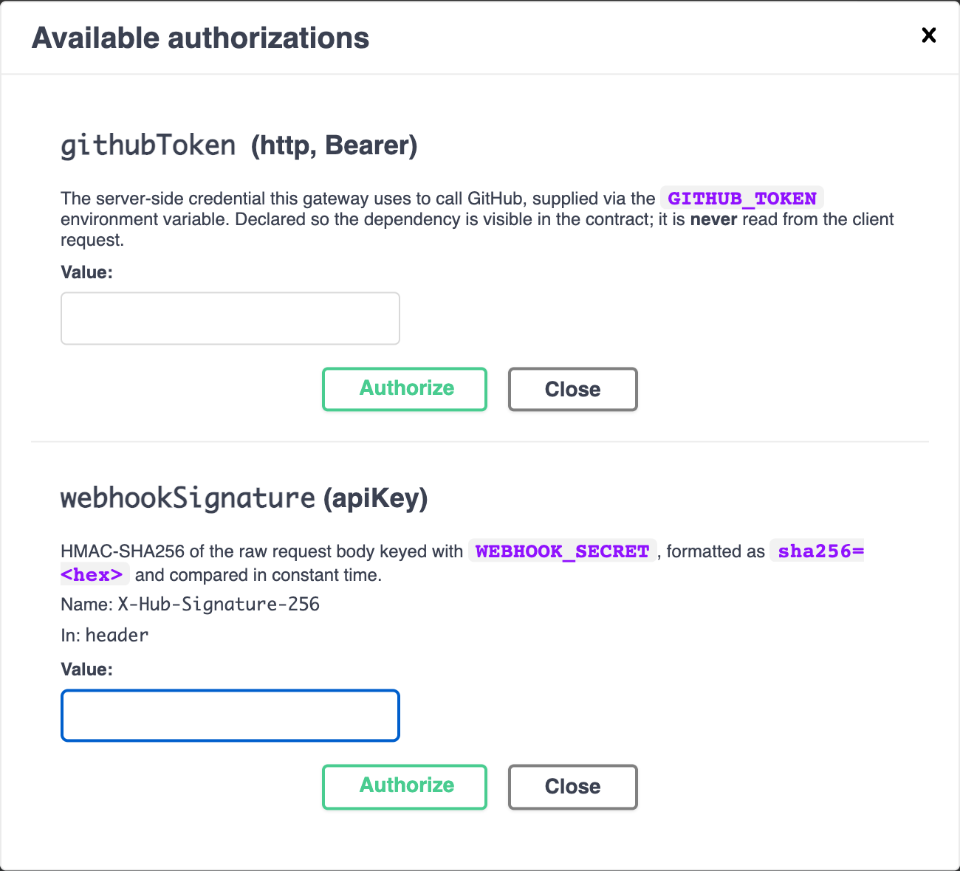

4. Creating an issue: the request
POST /issues, filled in through Try it out. The editor is pre-populated from the contract's CreateIssueRequest schema, which is why the field names and types are already correct.
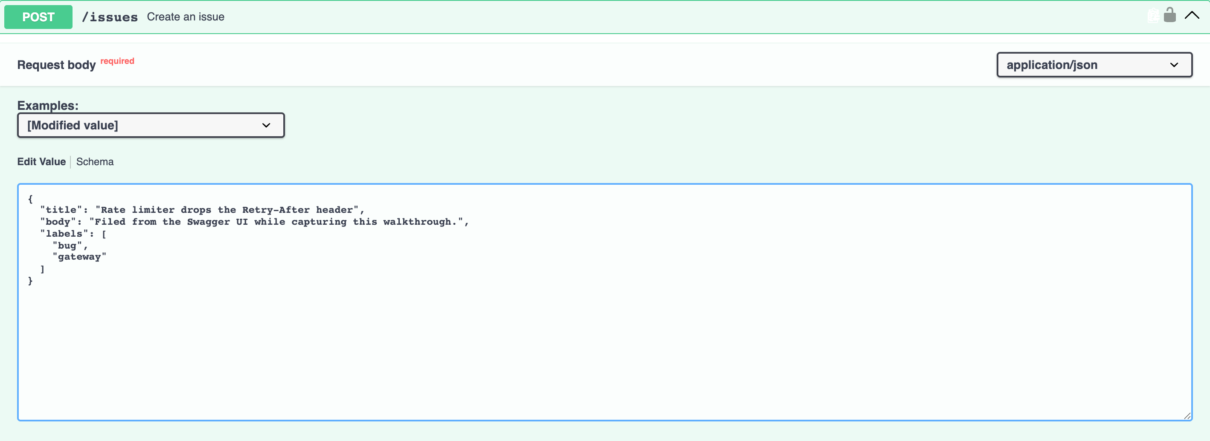

5. Creating an issue: 201 Created — HTTP 201
201 Created. The Location header points at /issues/79 on this service, and X-RateLimit-Remaining is GitHub's own budget passed through so a caller can pace itself.
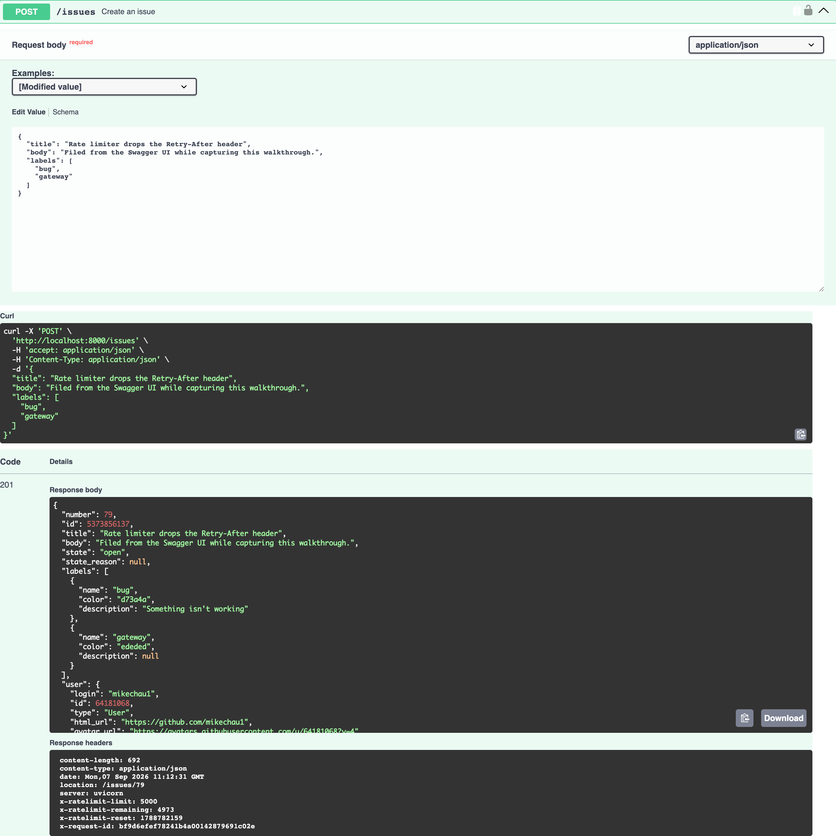

6. The same call, rejected: 400 Bad Request — HTTP 400
The same endpoint with the title omitted: 400, not FastAPI's default 422, because the contract specifies 400. The details array names the offending field, and no GitHub call was made -- invalid input costs no rate-limit budget.
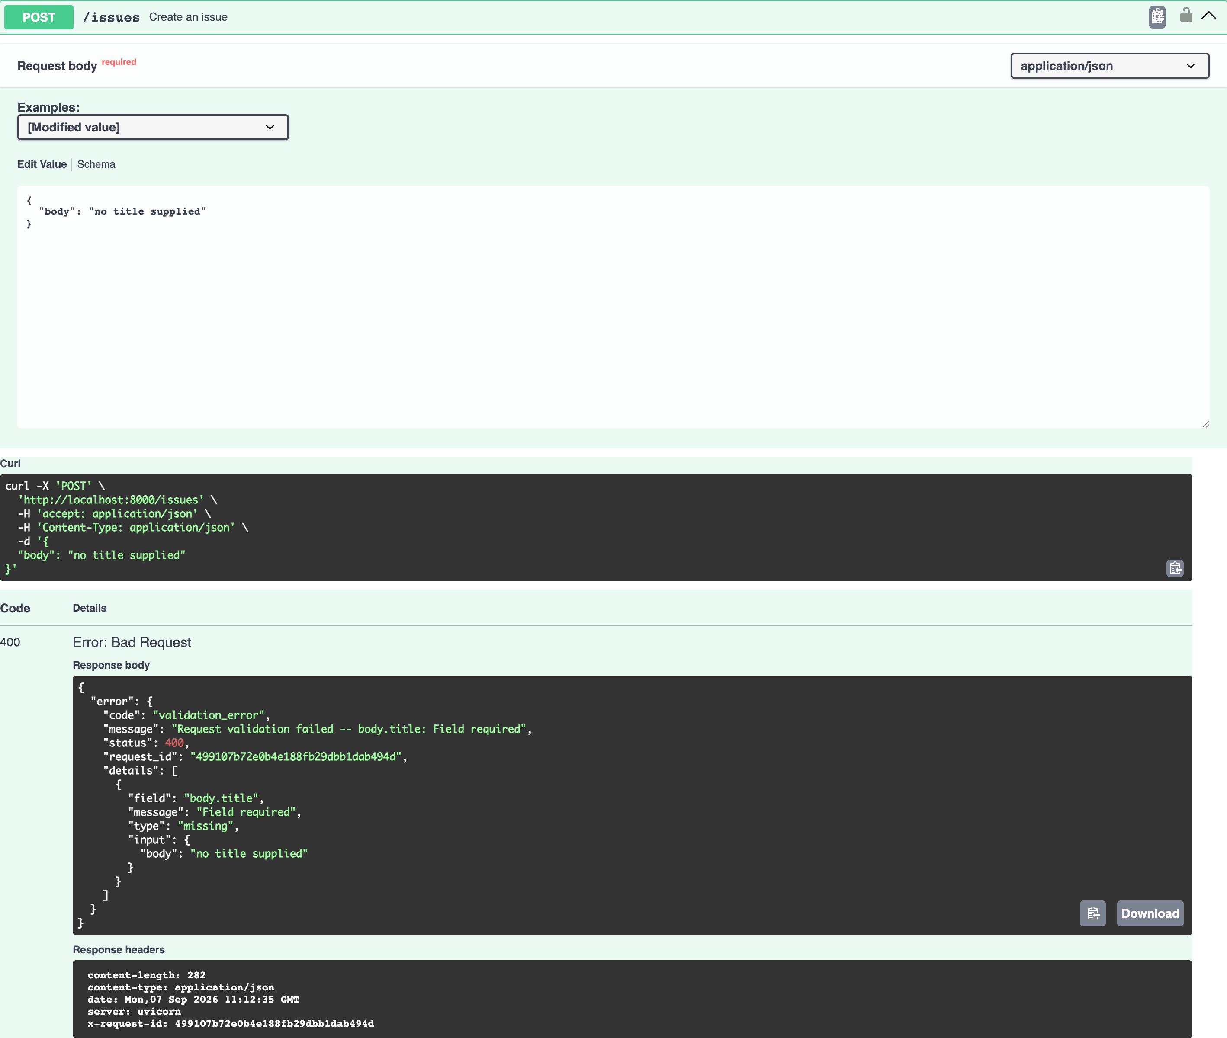

7. Listing issues, with pagination headers — HTTP 200
GET /issues with per_page=3. In the response headers: Link, rewritten to point back at this service instead of api.github.com; ETag, for conditional GET; and X-Page / X-Per-Page echoing what was applied.
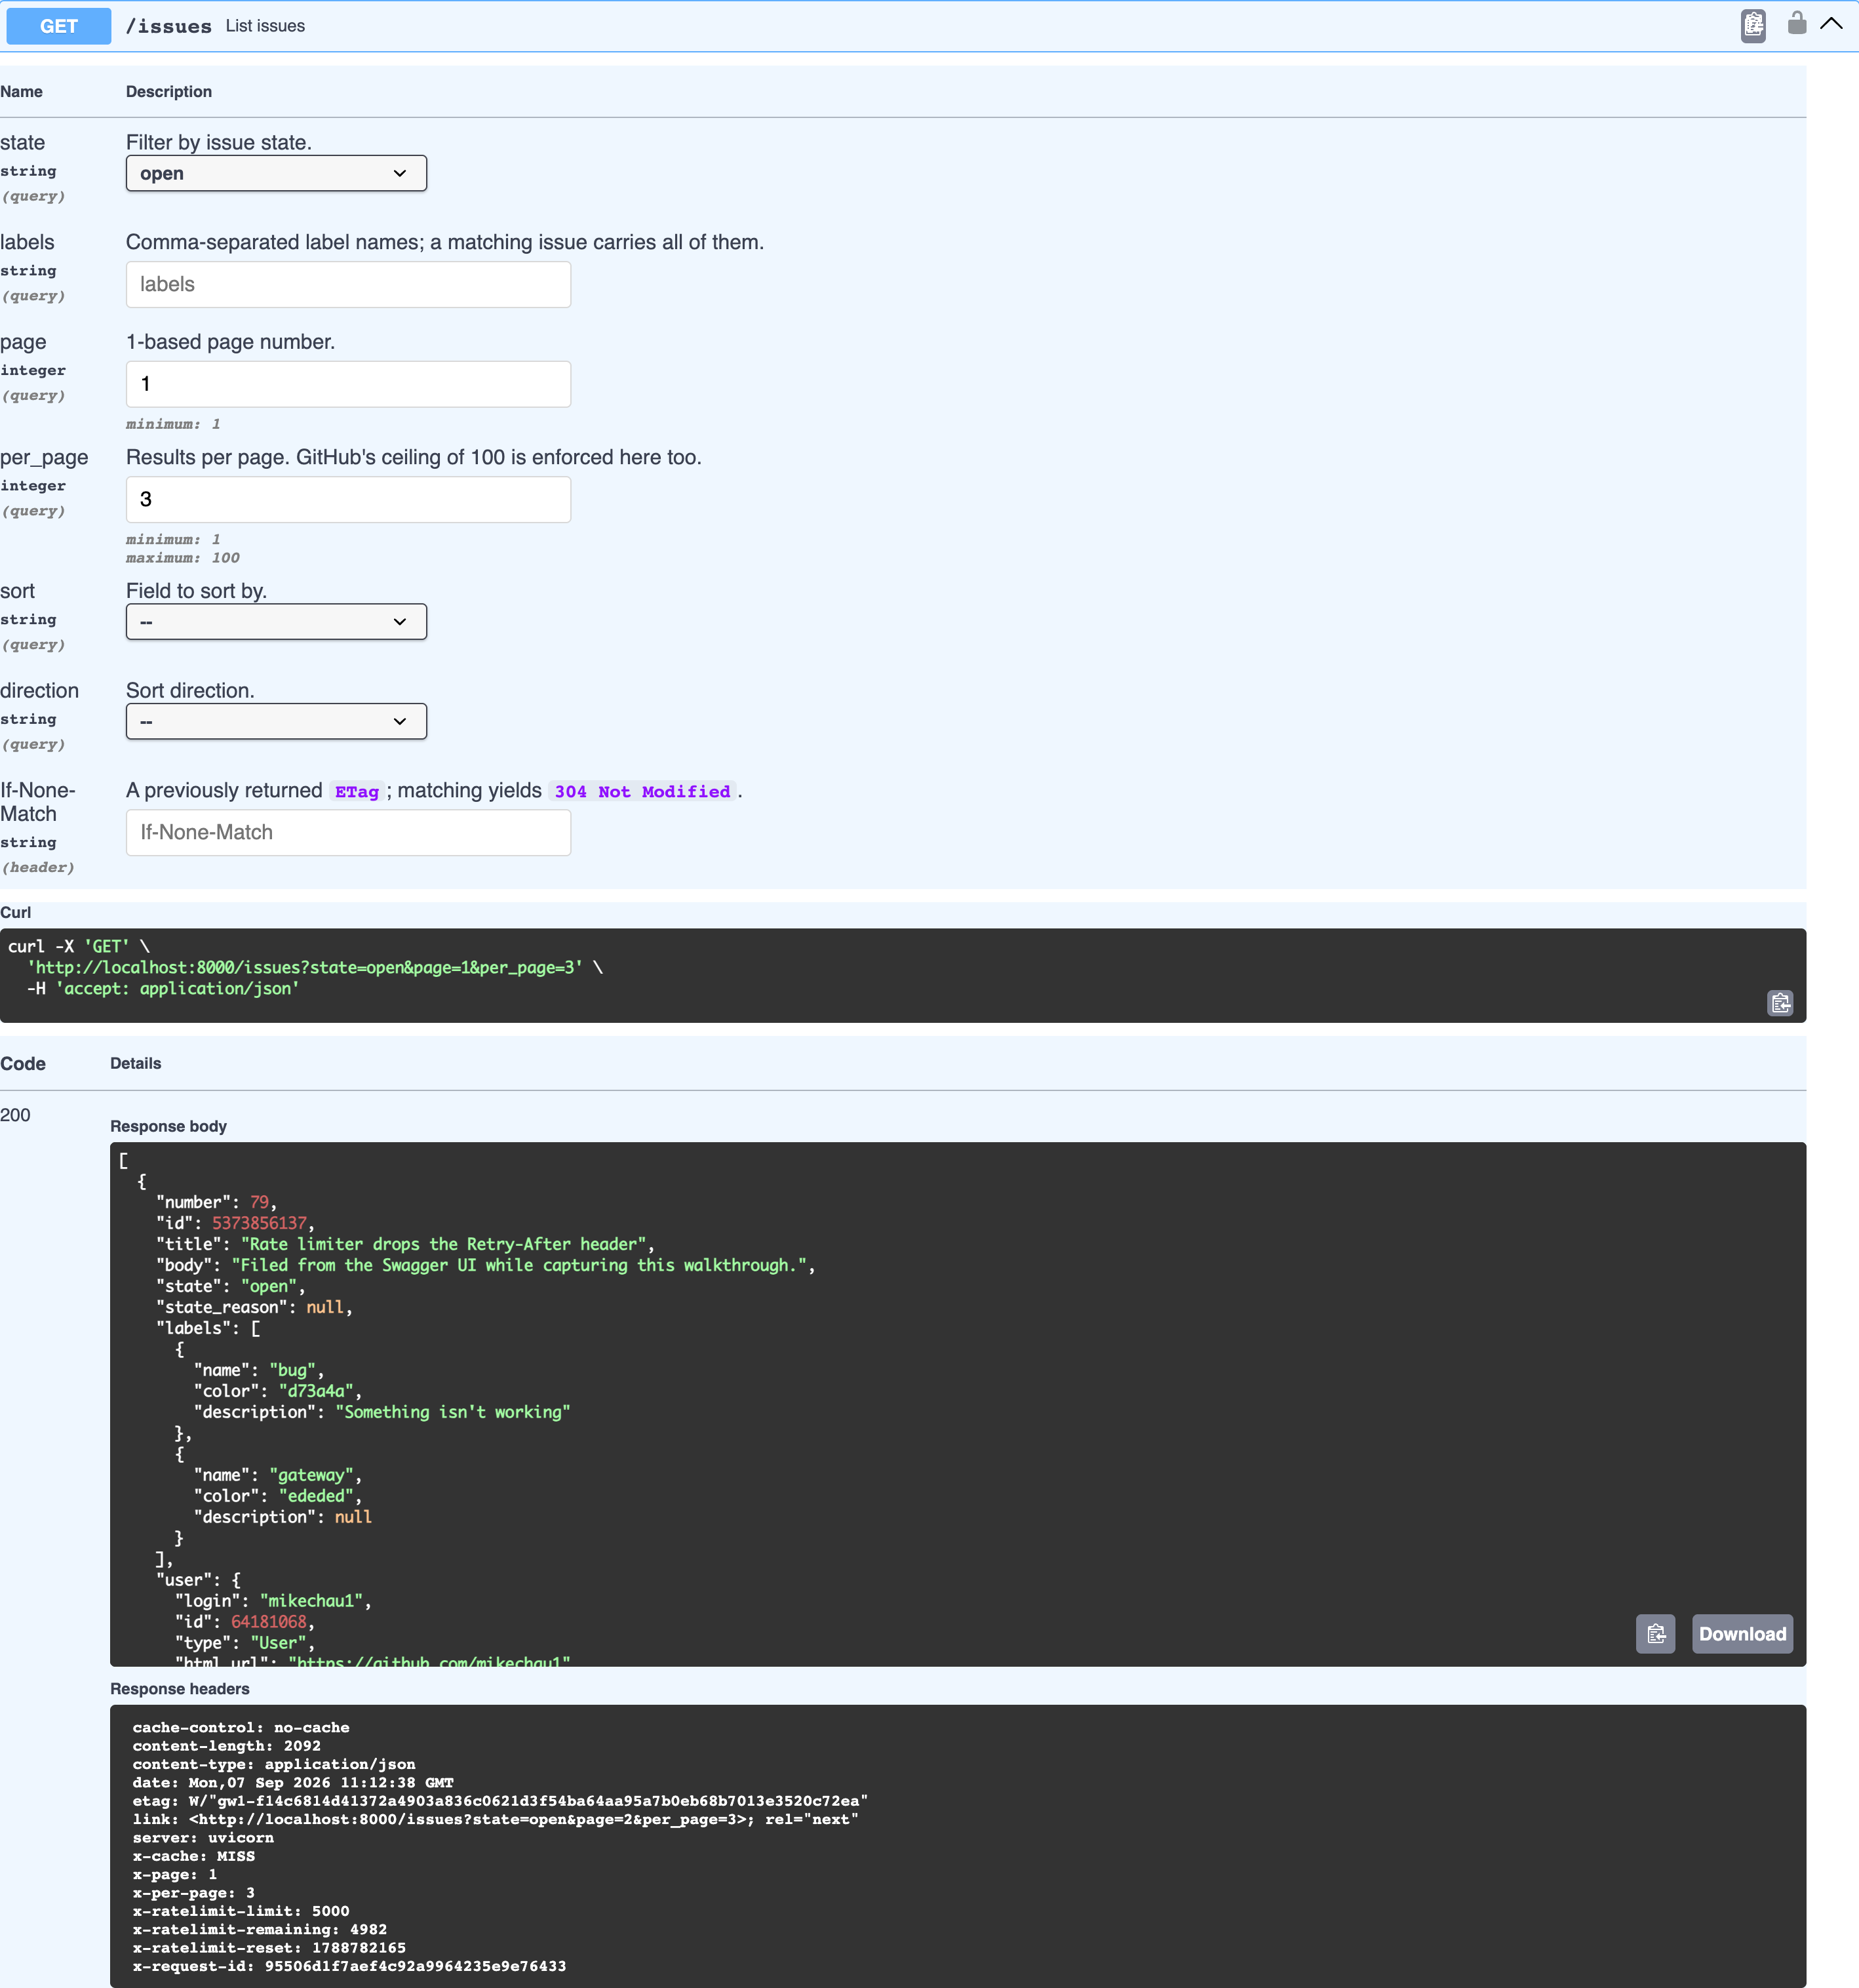

8. Reading a single issue — HTTP 200
GET /issues/79 returns the issue just created, projected onto the fields the contract documents rather than GitHub's raw payload.
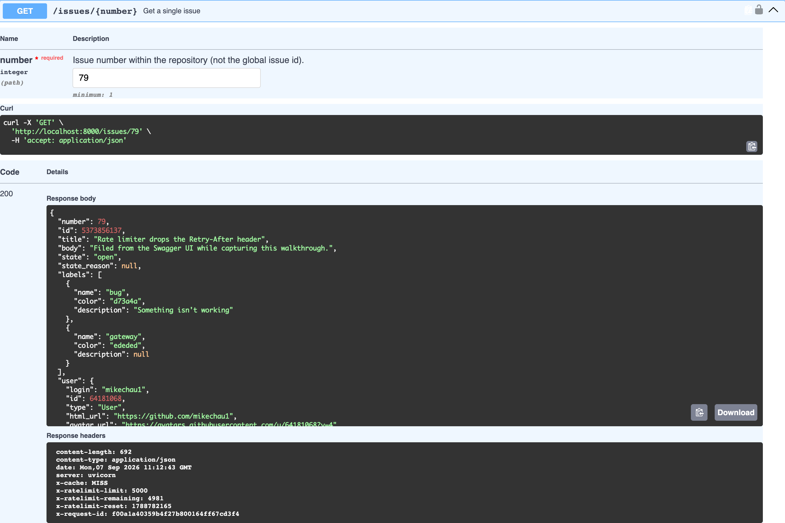

9. Closing an issue: this API's DELETE — HTTP 200
PATCH with {"state": "closed"} -- the D in CRUD. GitHub has no delete-issue endpoint, so closing is how this API deletes. Note closed_at is now set.
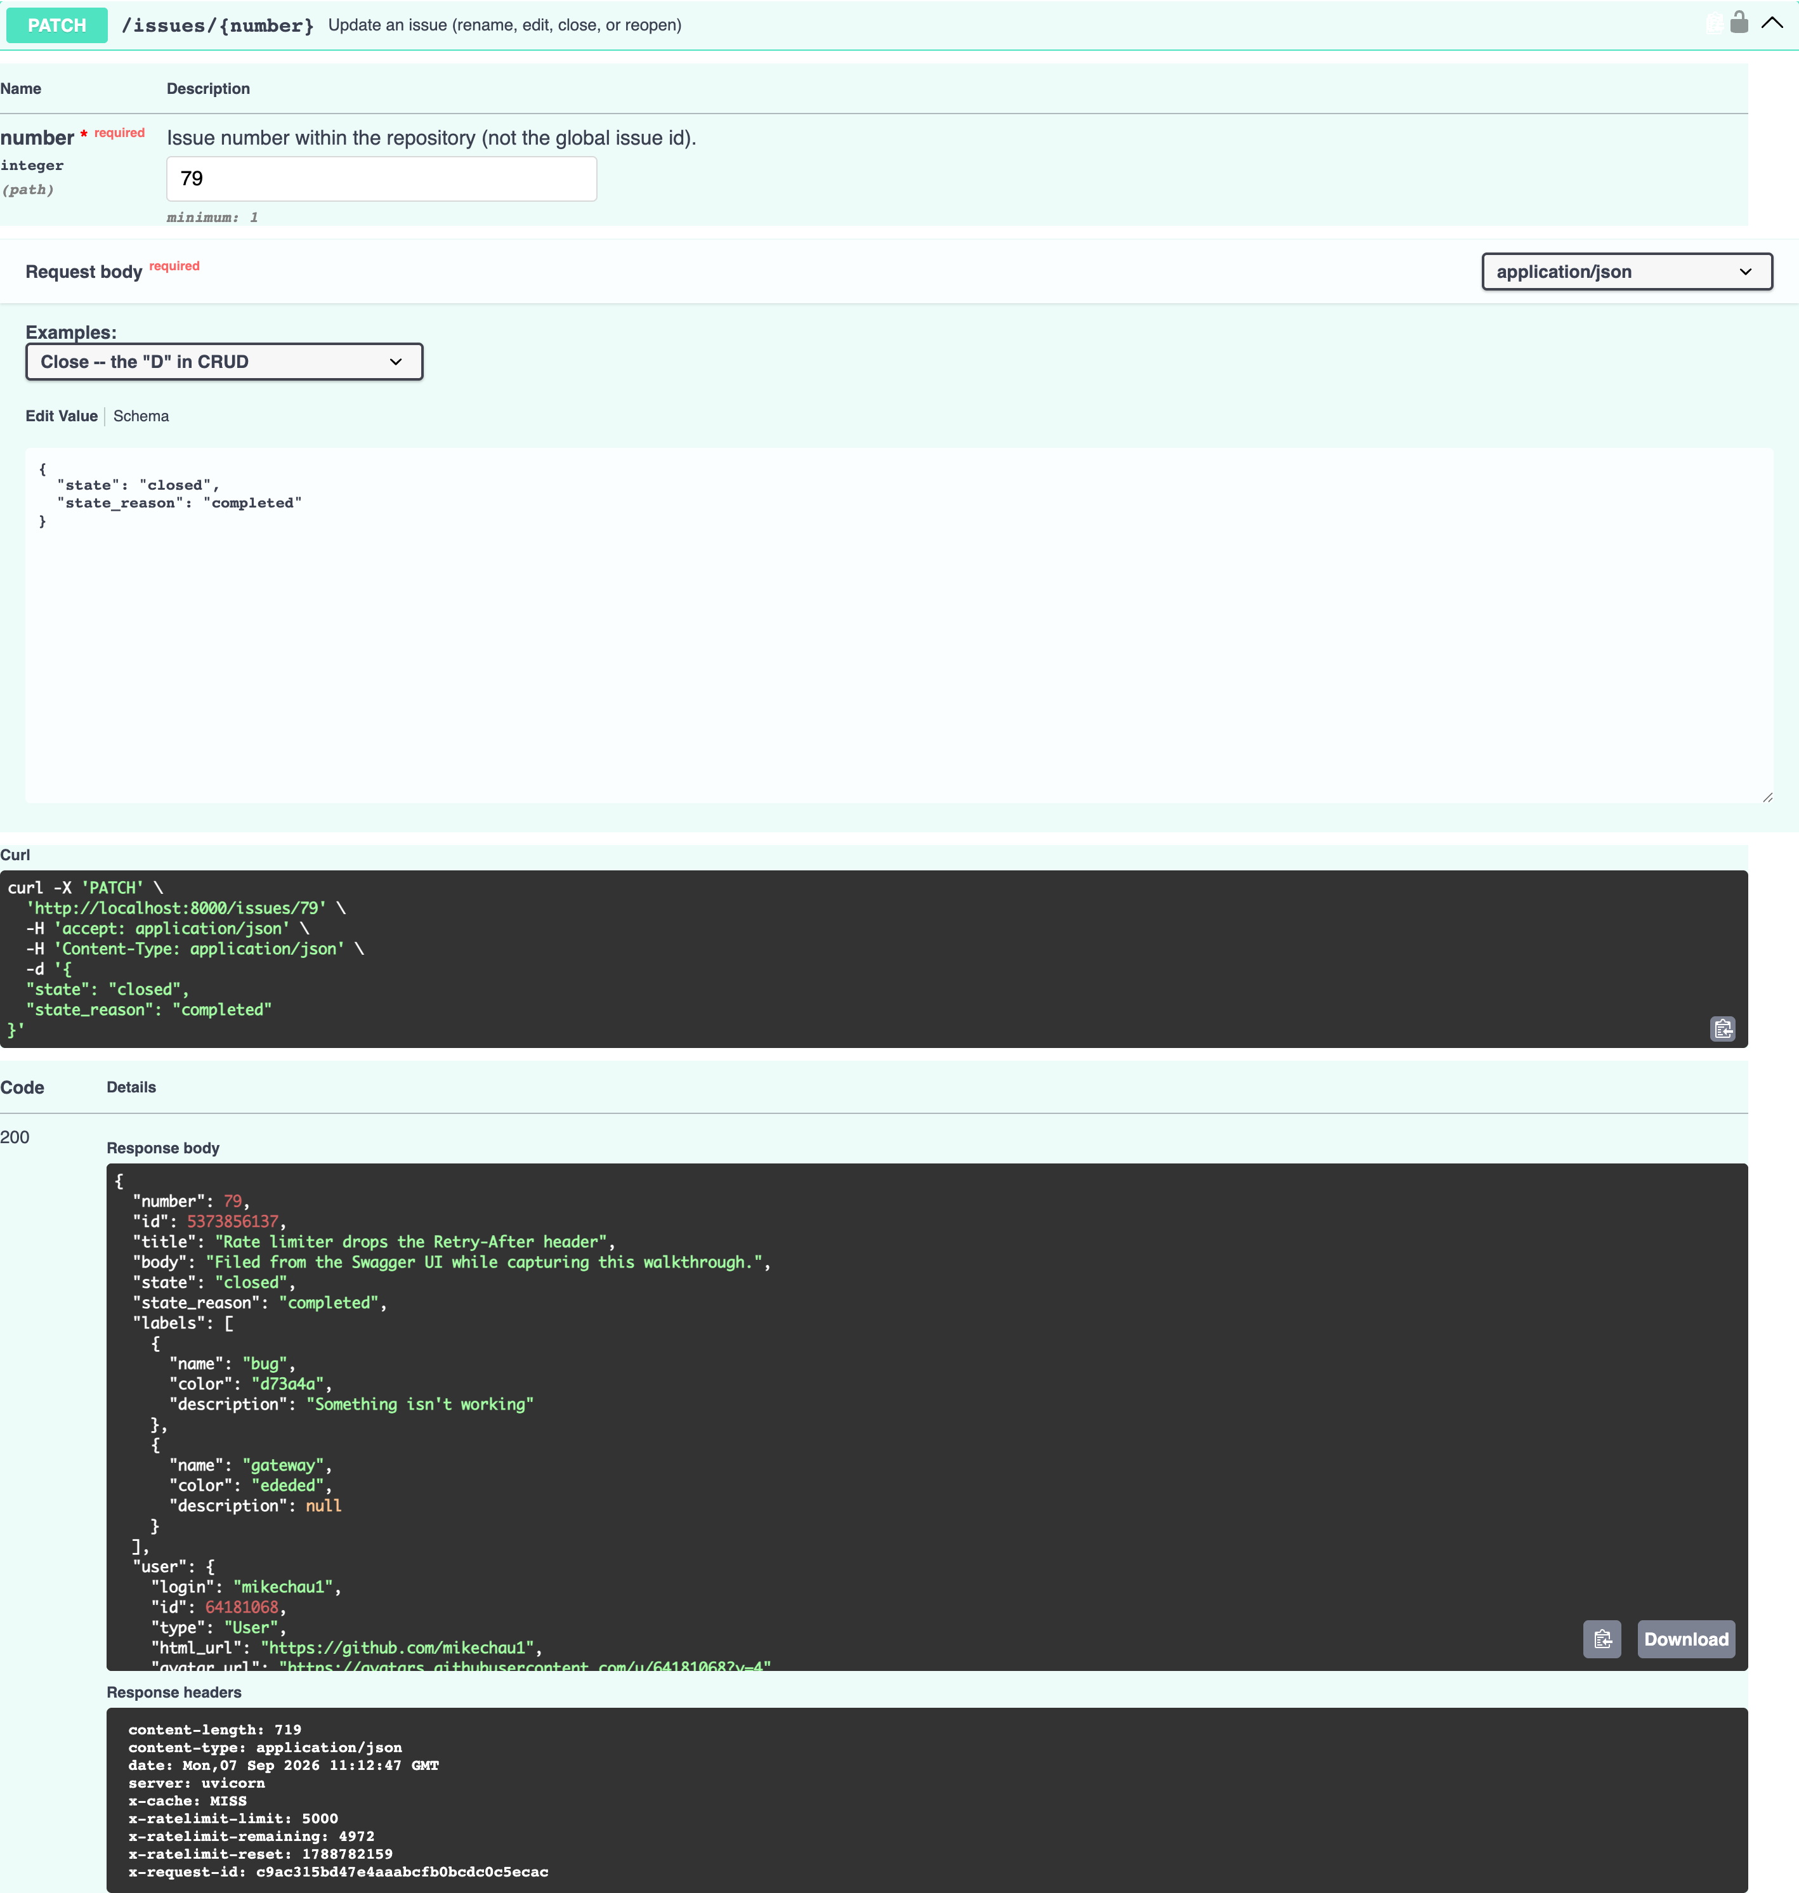

10. Reopening the same issue — HTTP 200
Reopening the same issue. closed_at is back to null, which is how you can tell the close really was reversible -- the reason modelling delete as close is honest rather than a workaround.
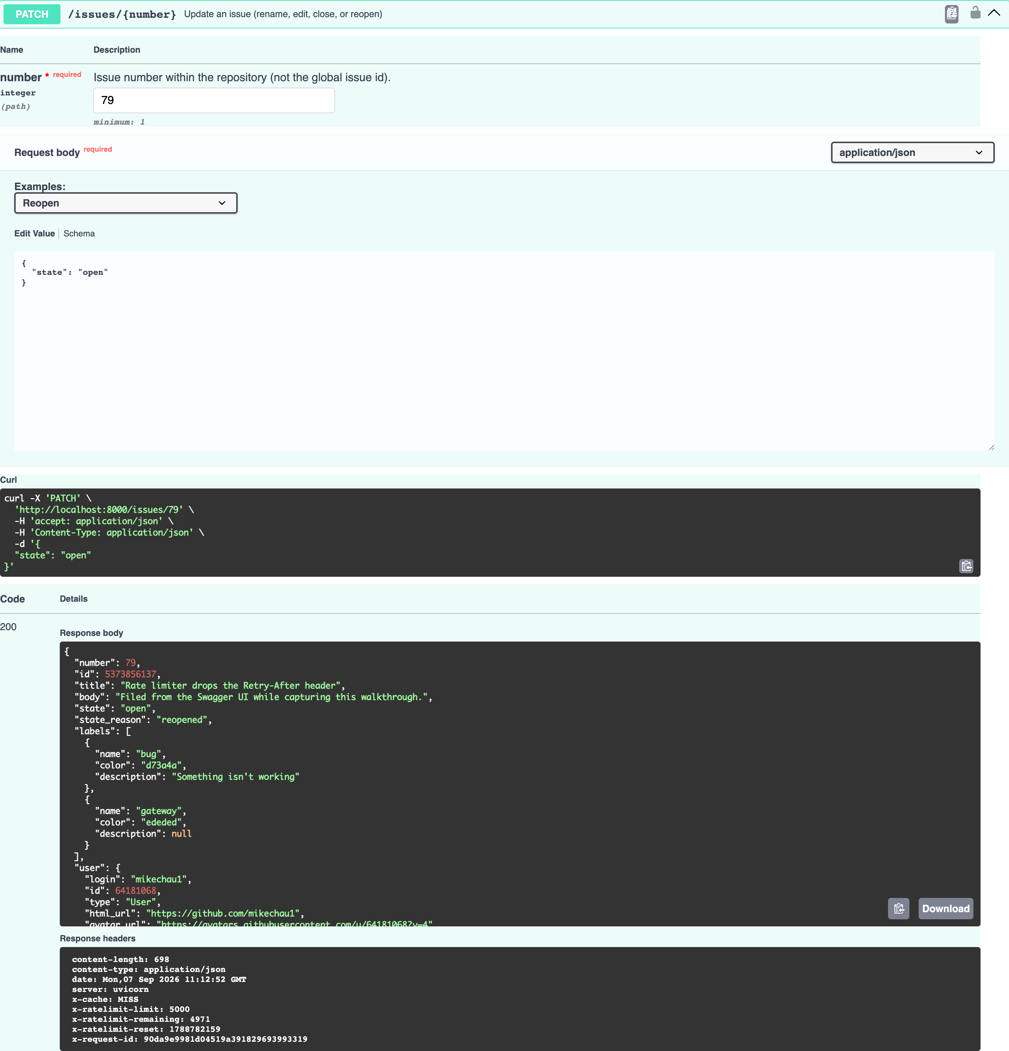

11. Commenting on an issue — HTTP 201
201 Created for a comment, with a Location header pointing at the issue's comment collection.
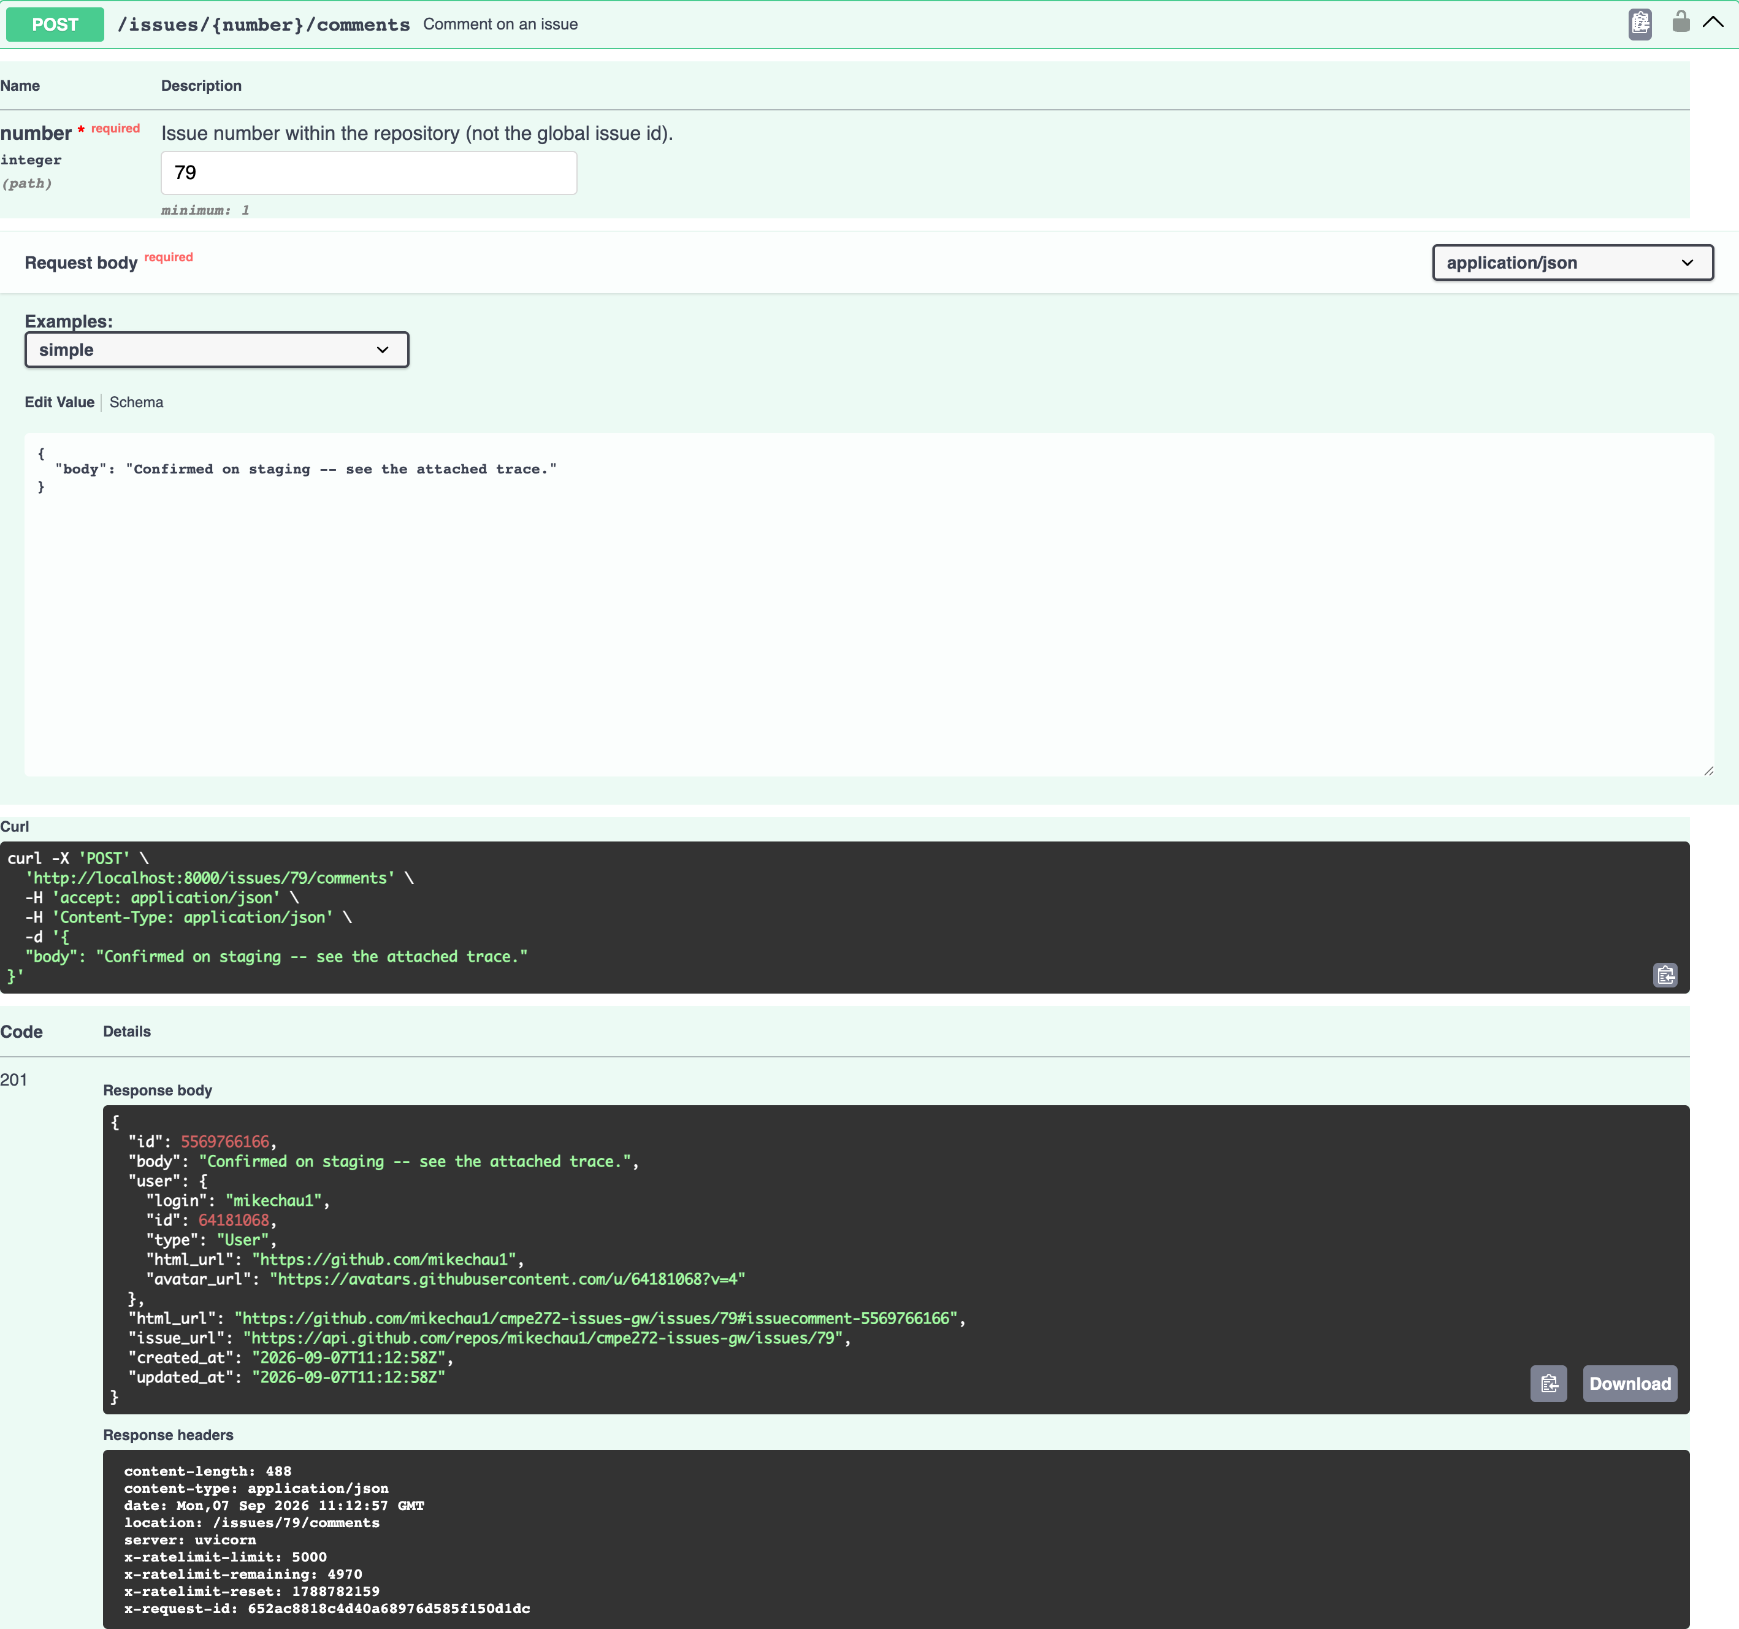

12. Reading the comment back — HTTP 200
The comment read back from GitHub, confirming the write landed and is visible through the same gateway that created it.
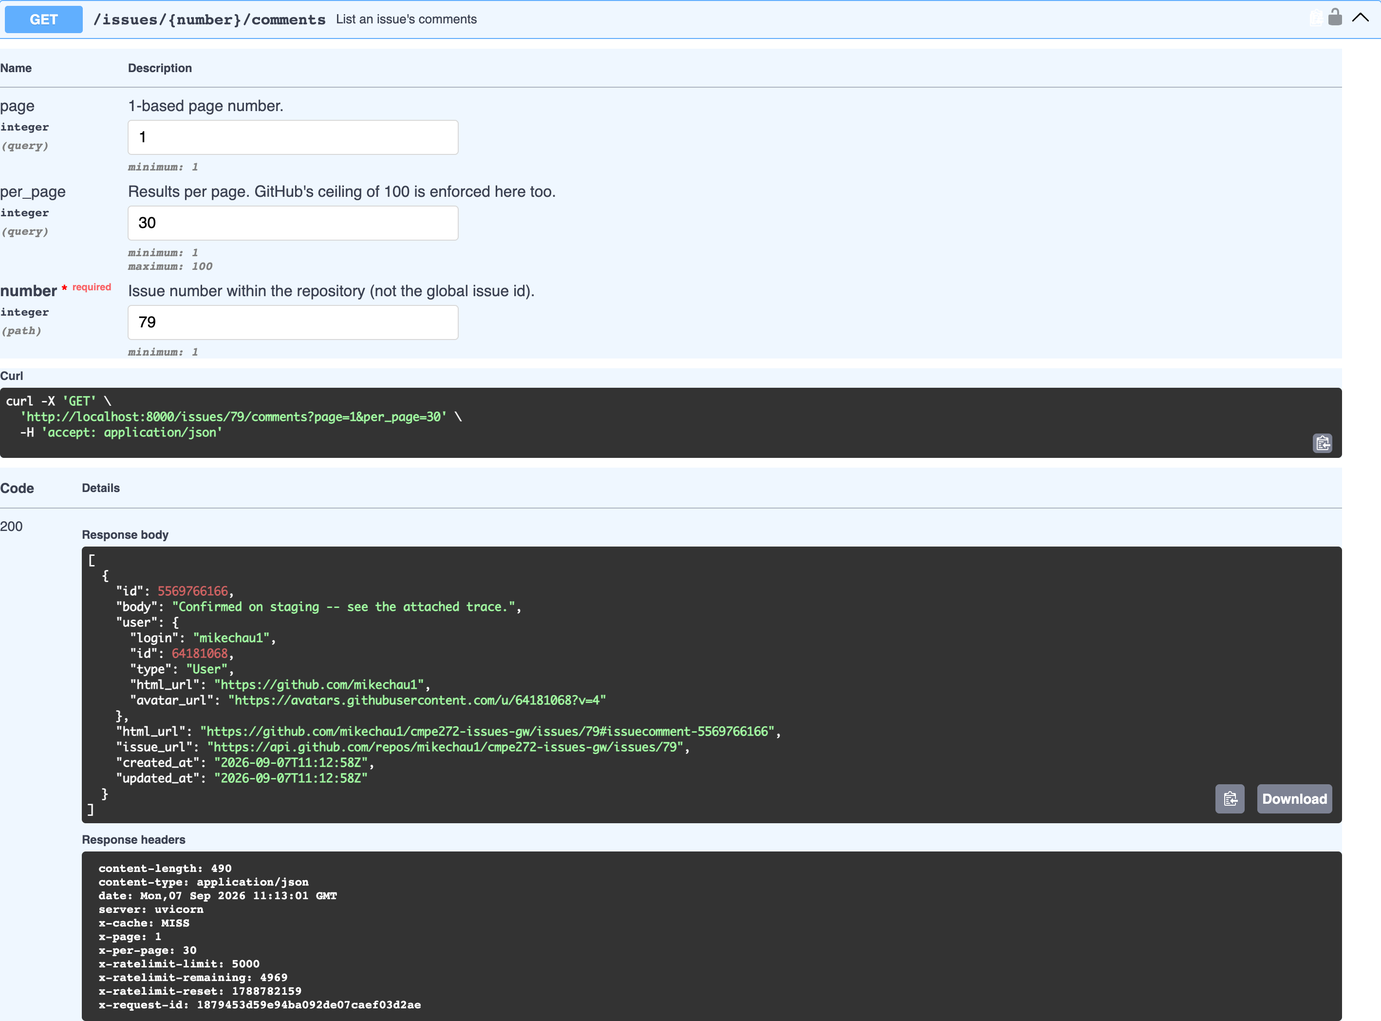

13. A correctly signed webhook delivery: 204 — HTTP 204
A correctly signed delivery: 204 No Content, no body. The gateway verified the HMAC, stored the delivery, and acked before doing any interpretation -- GitHub gives a receiver ten seconds.
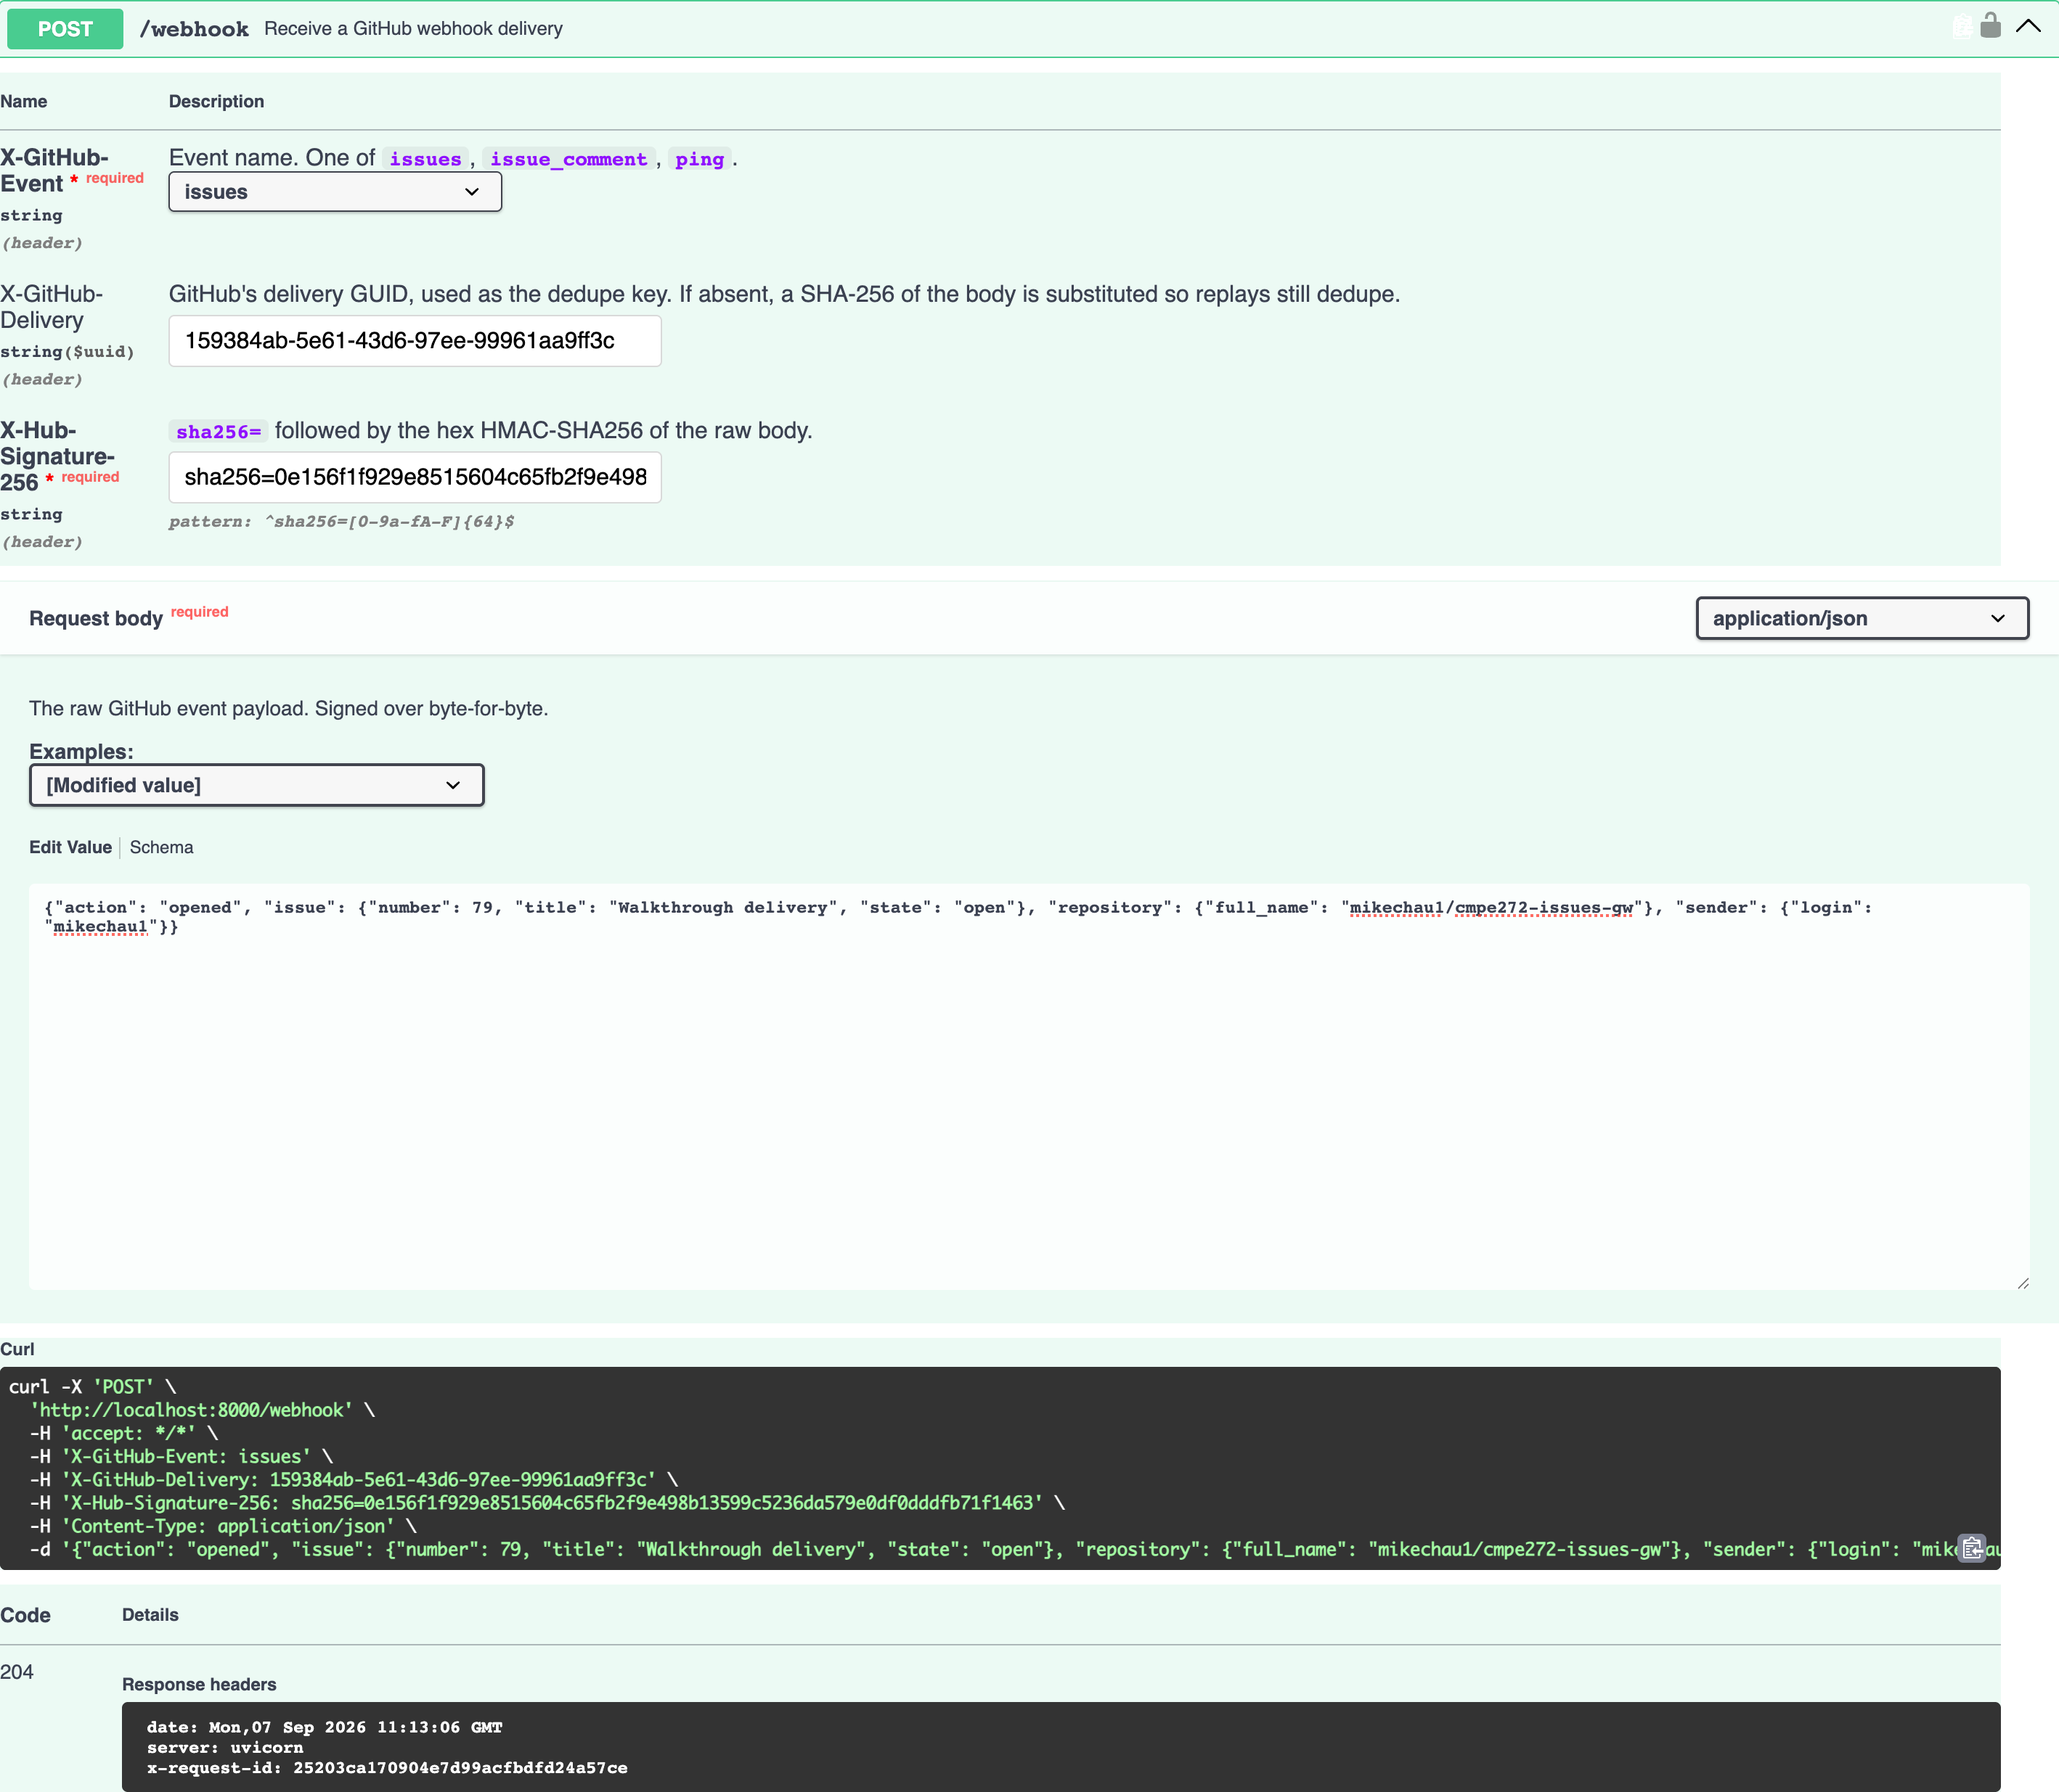

14. A tampered delivery: 401 Unauthorized — HTTP 401
The same signature against a body with one word changed: 401. This is the check that separates a webhook receiver from an open write endpoint. The comparison is constant-time, and the signature is never echoed back or logged.
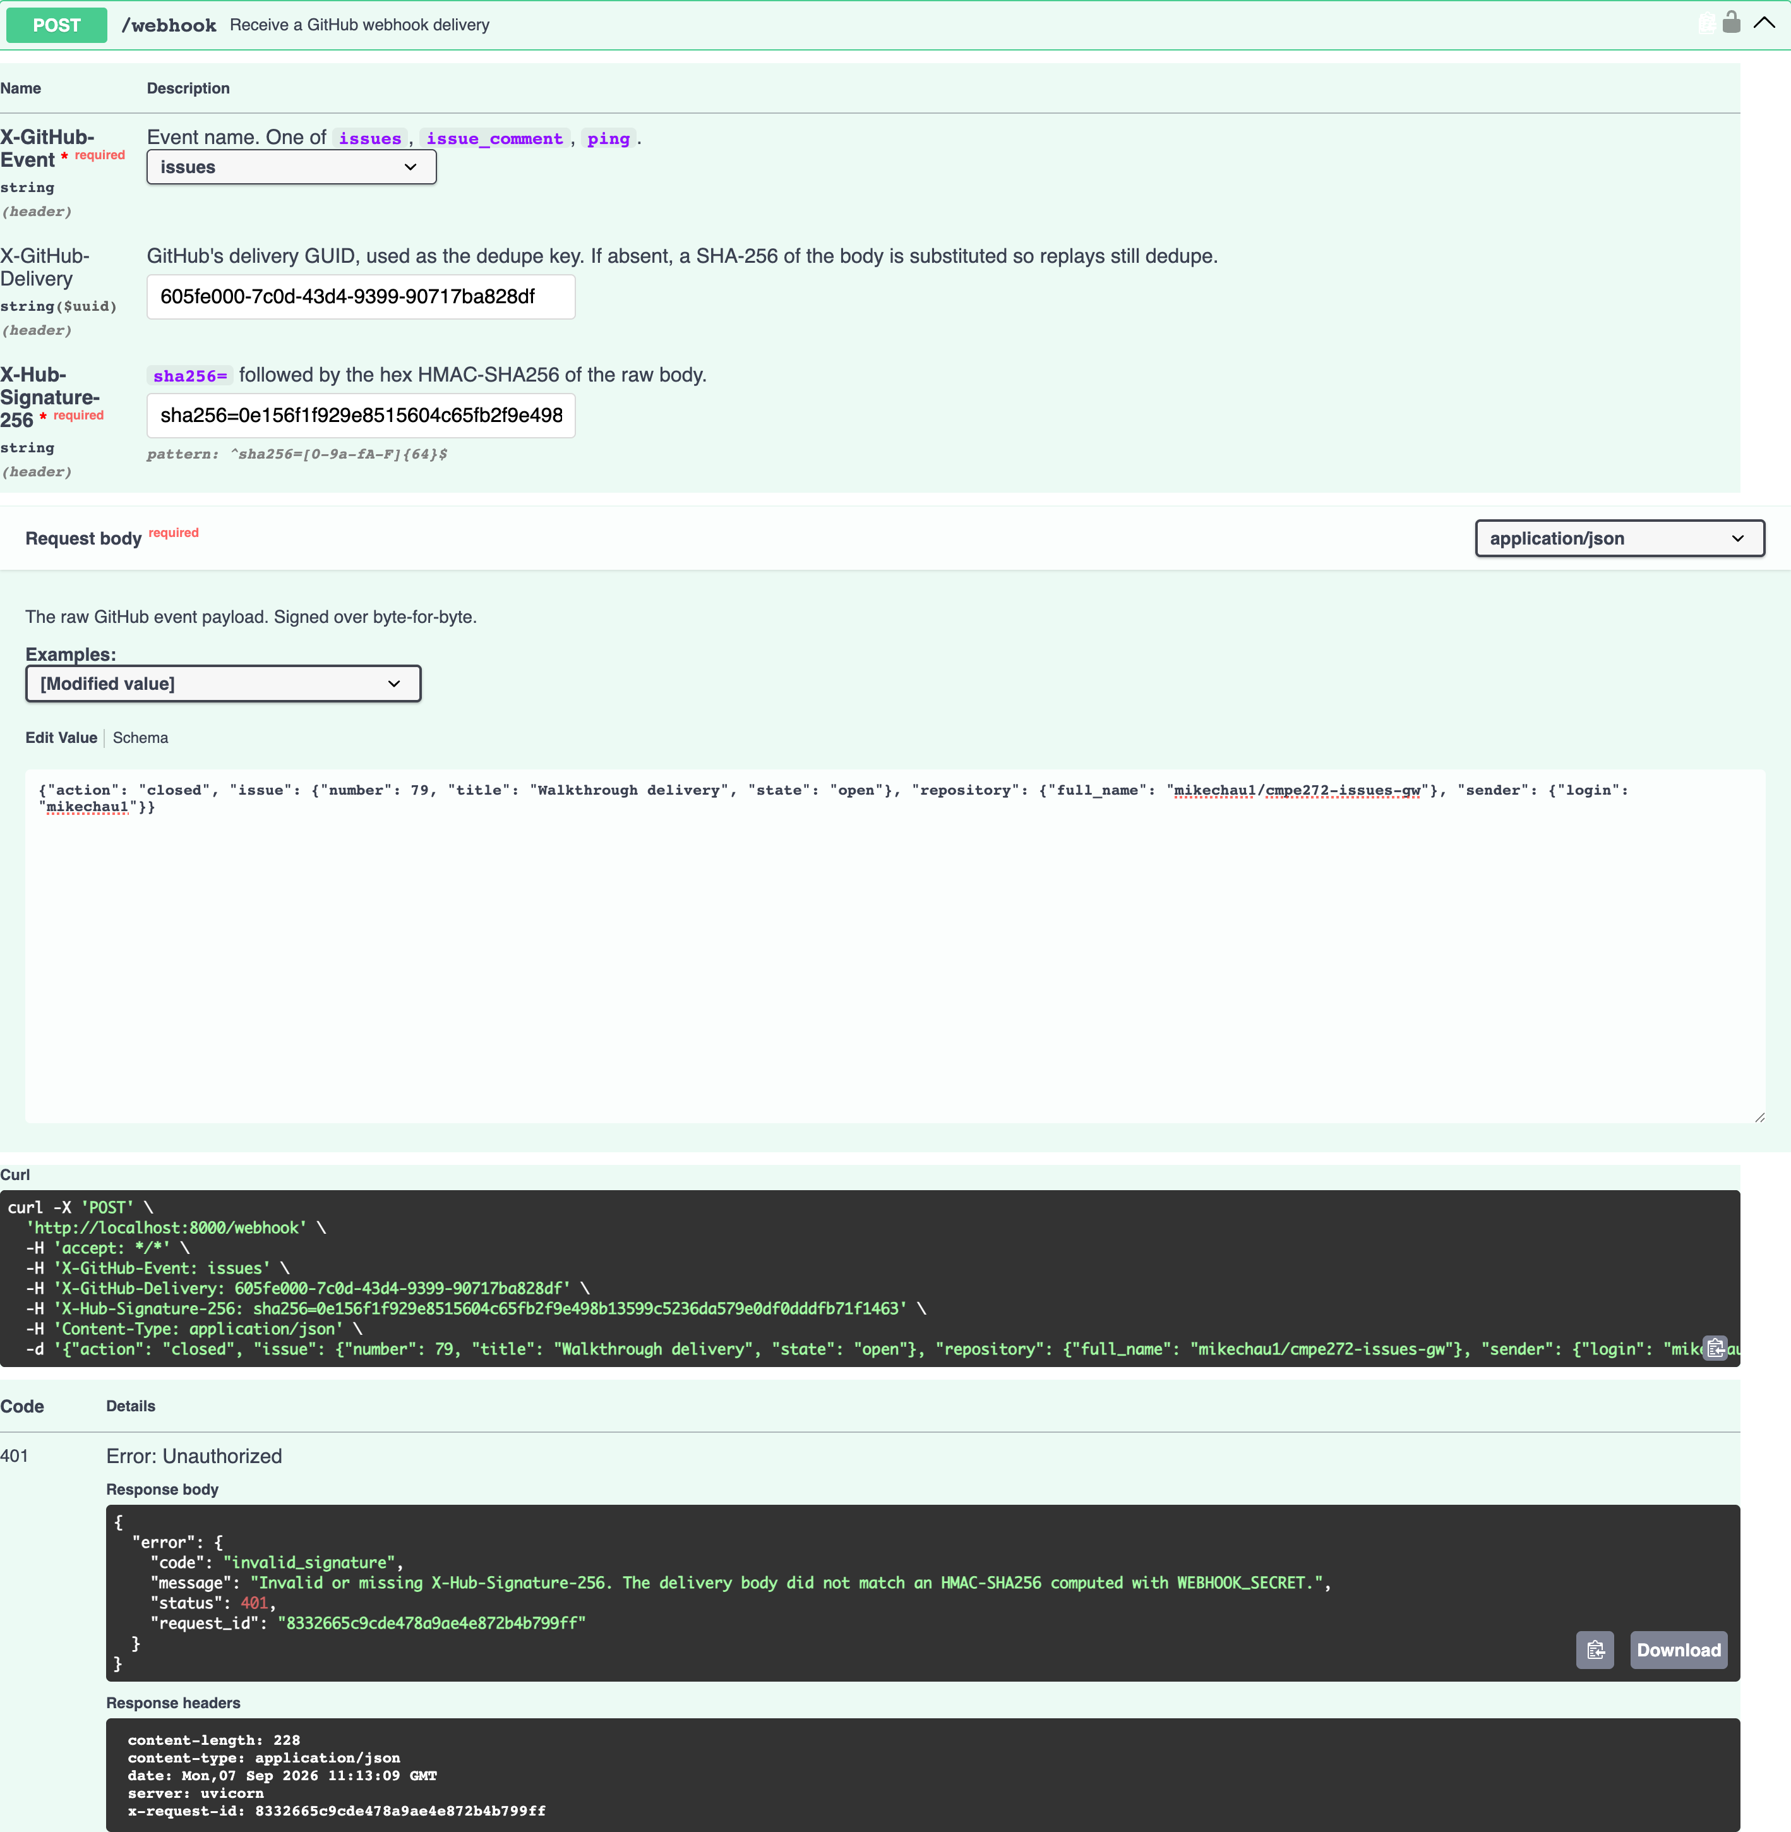

15. The delivery log — HTTP 200
GET /events shows the accepted delivery with status 'processed'. The tampered one is absent: it never got past the signature check, so it was never stored.
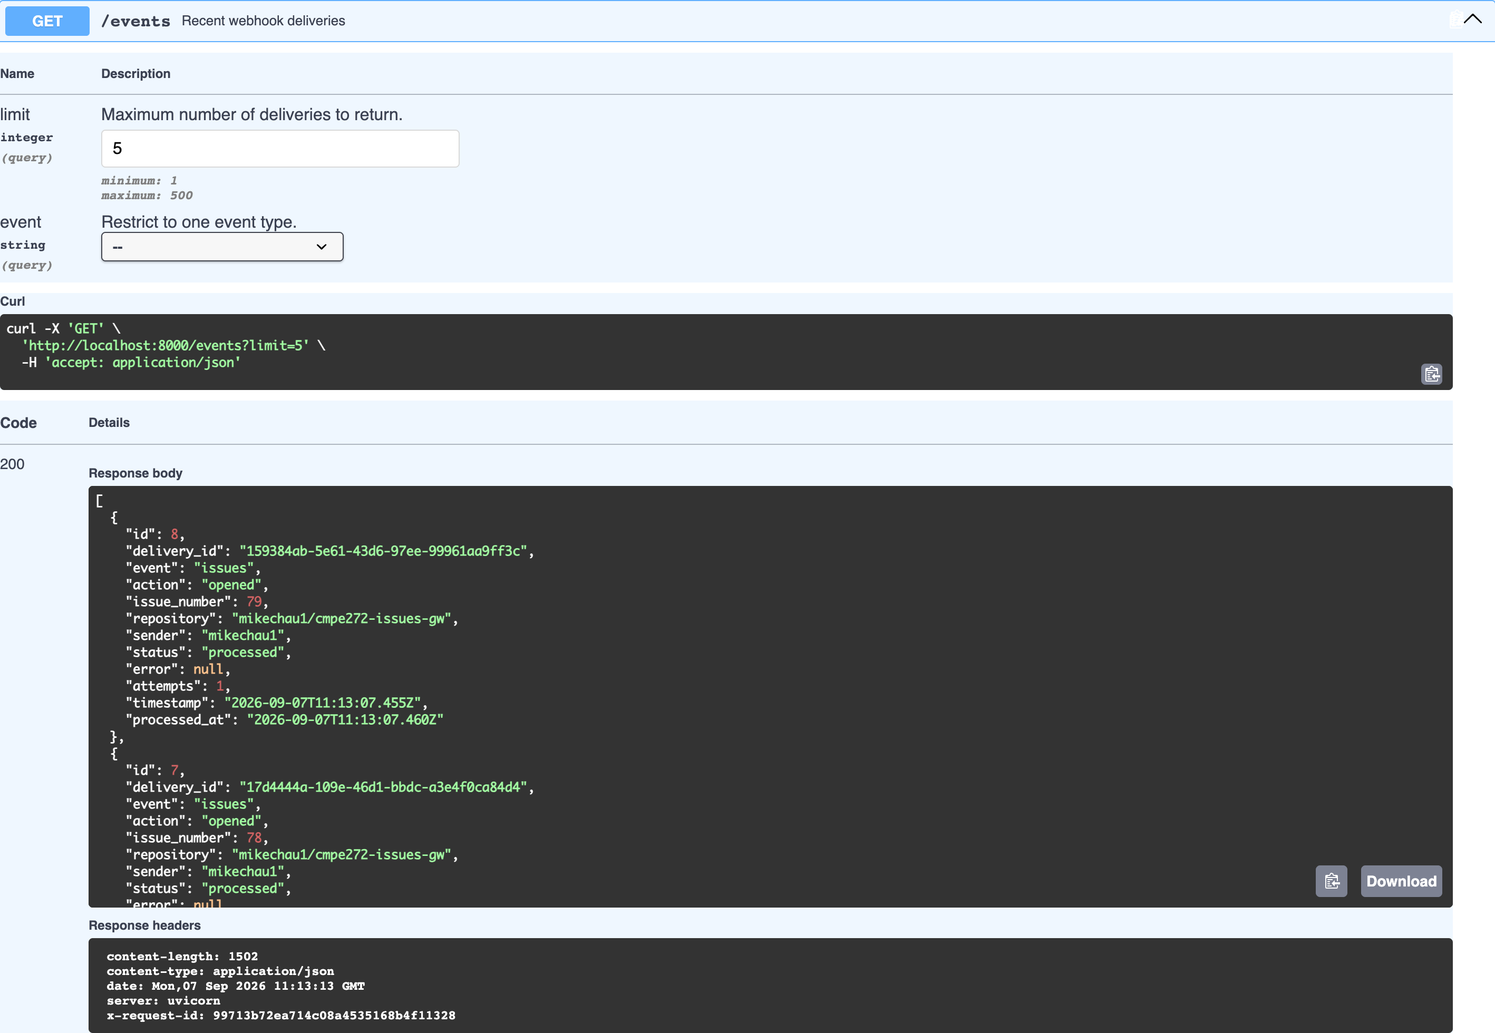

16. Health, without depending on GitHub — HTTP 200
/healthz reports process health and configuration completeness without calling GitHub, so an upstream outage or an exhausted rate limit cannot make an orchestrator kill a healthy container.
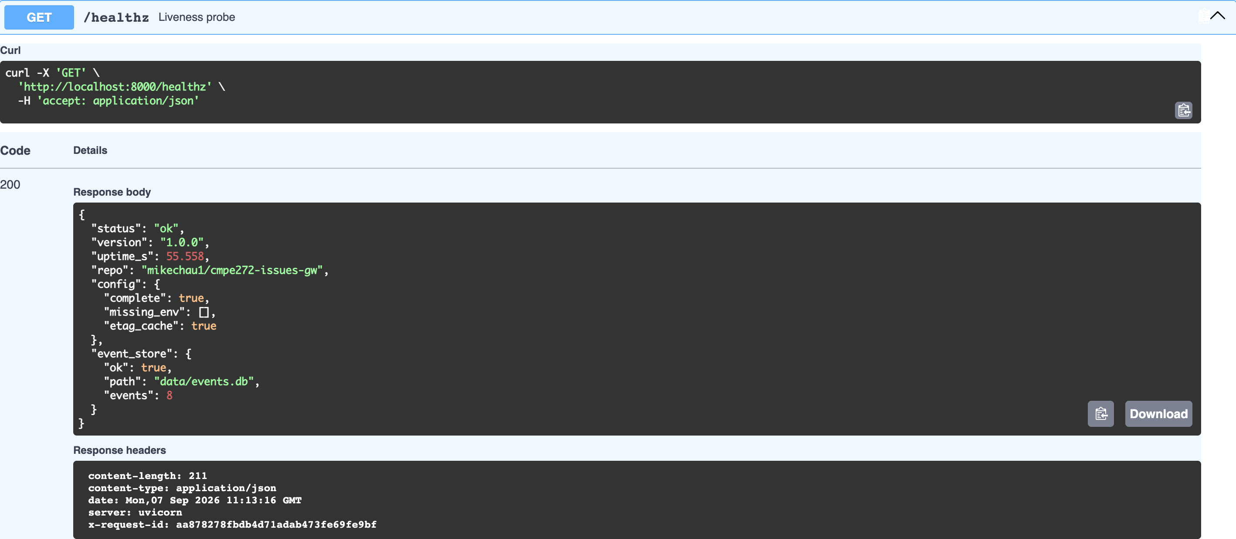

17. The reusable schemas
The reusable components/schemas the contract defines: Issue, Comment, Error and the request models. Every response in the document above is an instance of one of these.
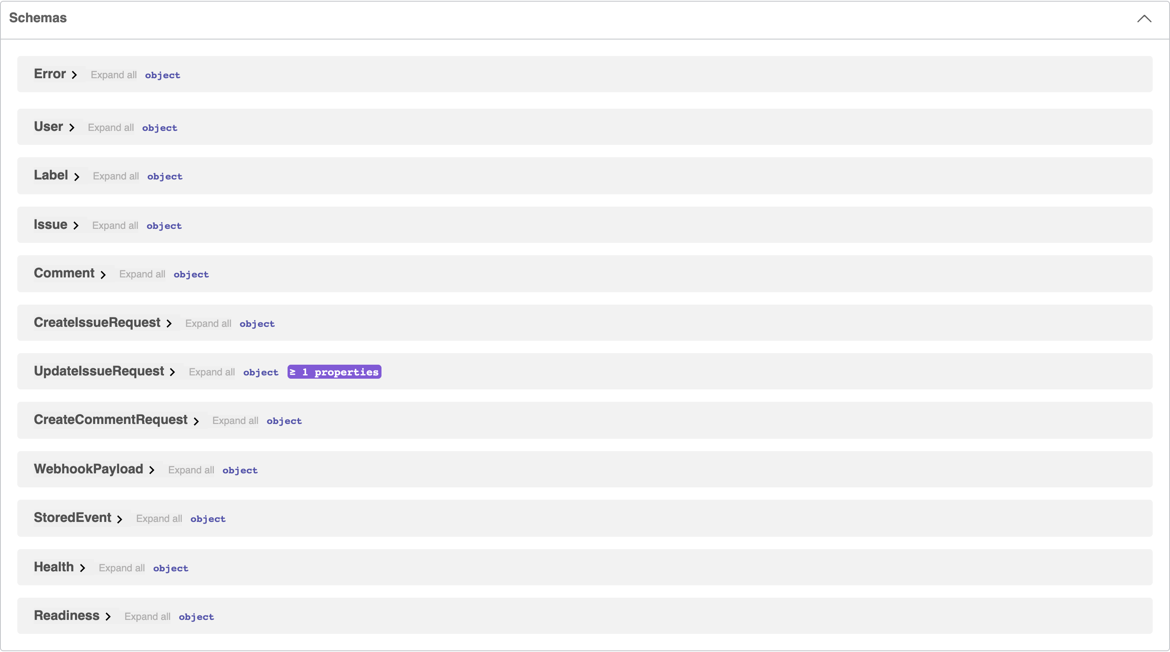

18. The same contract in ReDoc
The same openapi.yaml rendered by ReDoc at /redoc. Two renderers, one contract, no second source of truth to drift.
