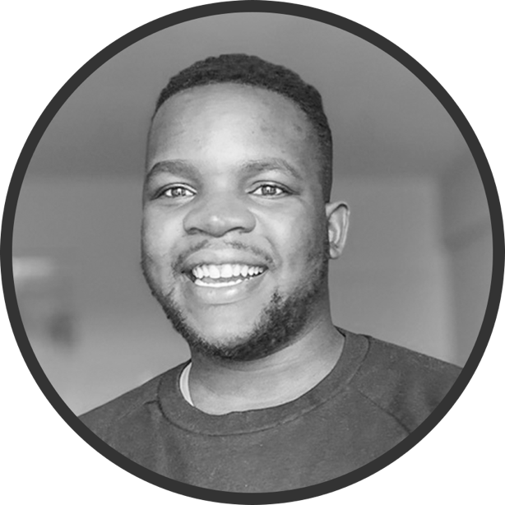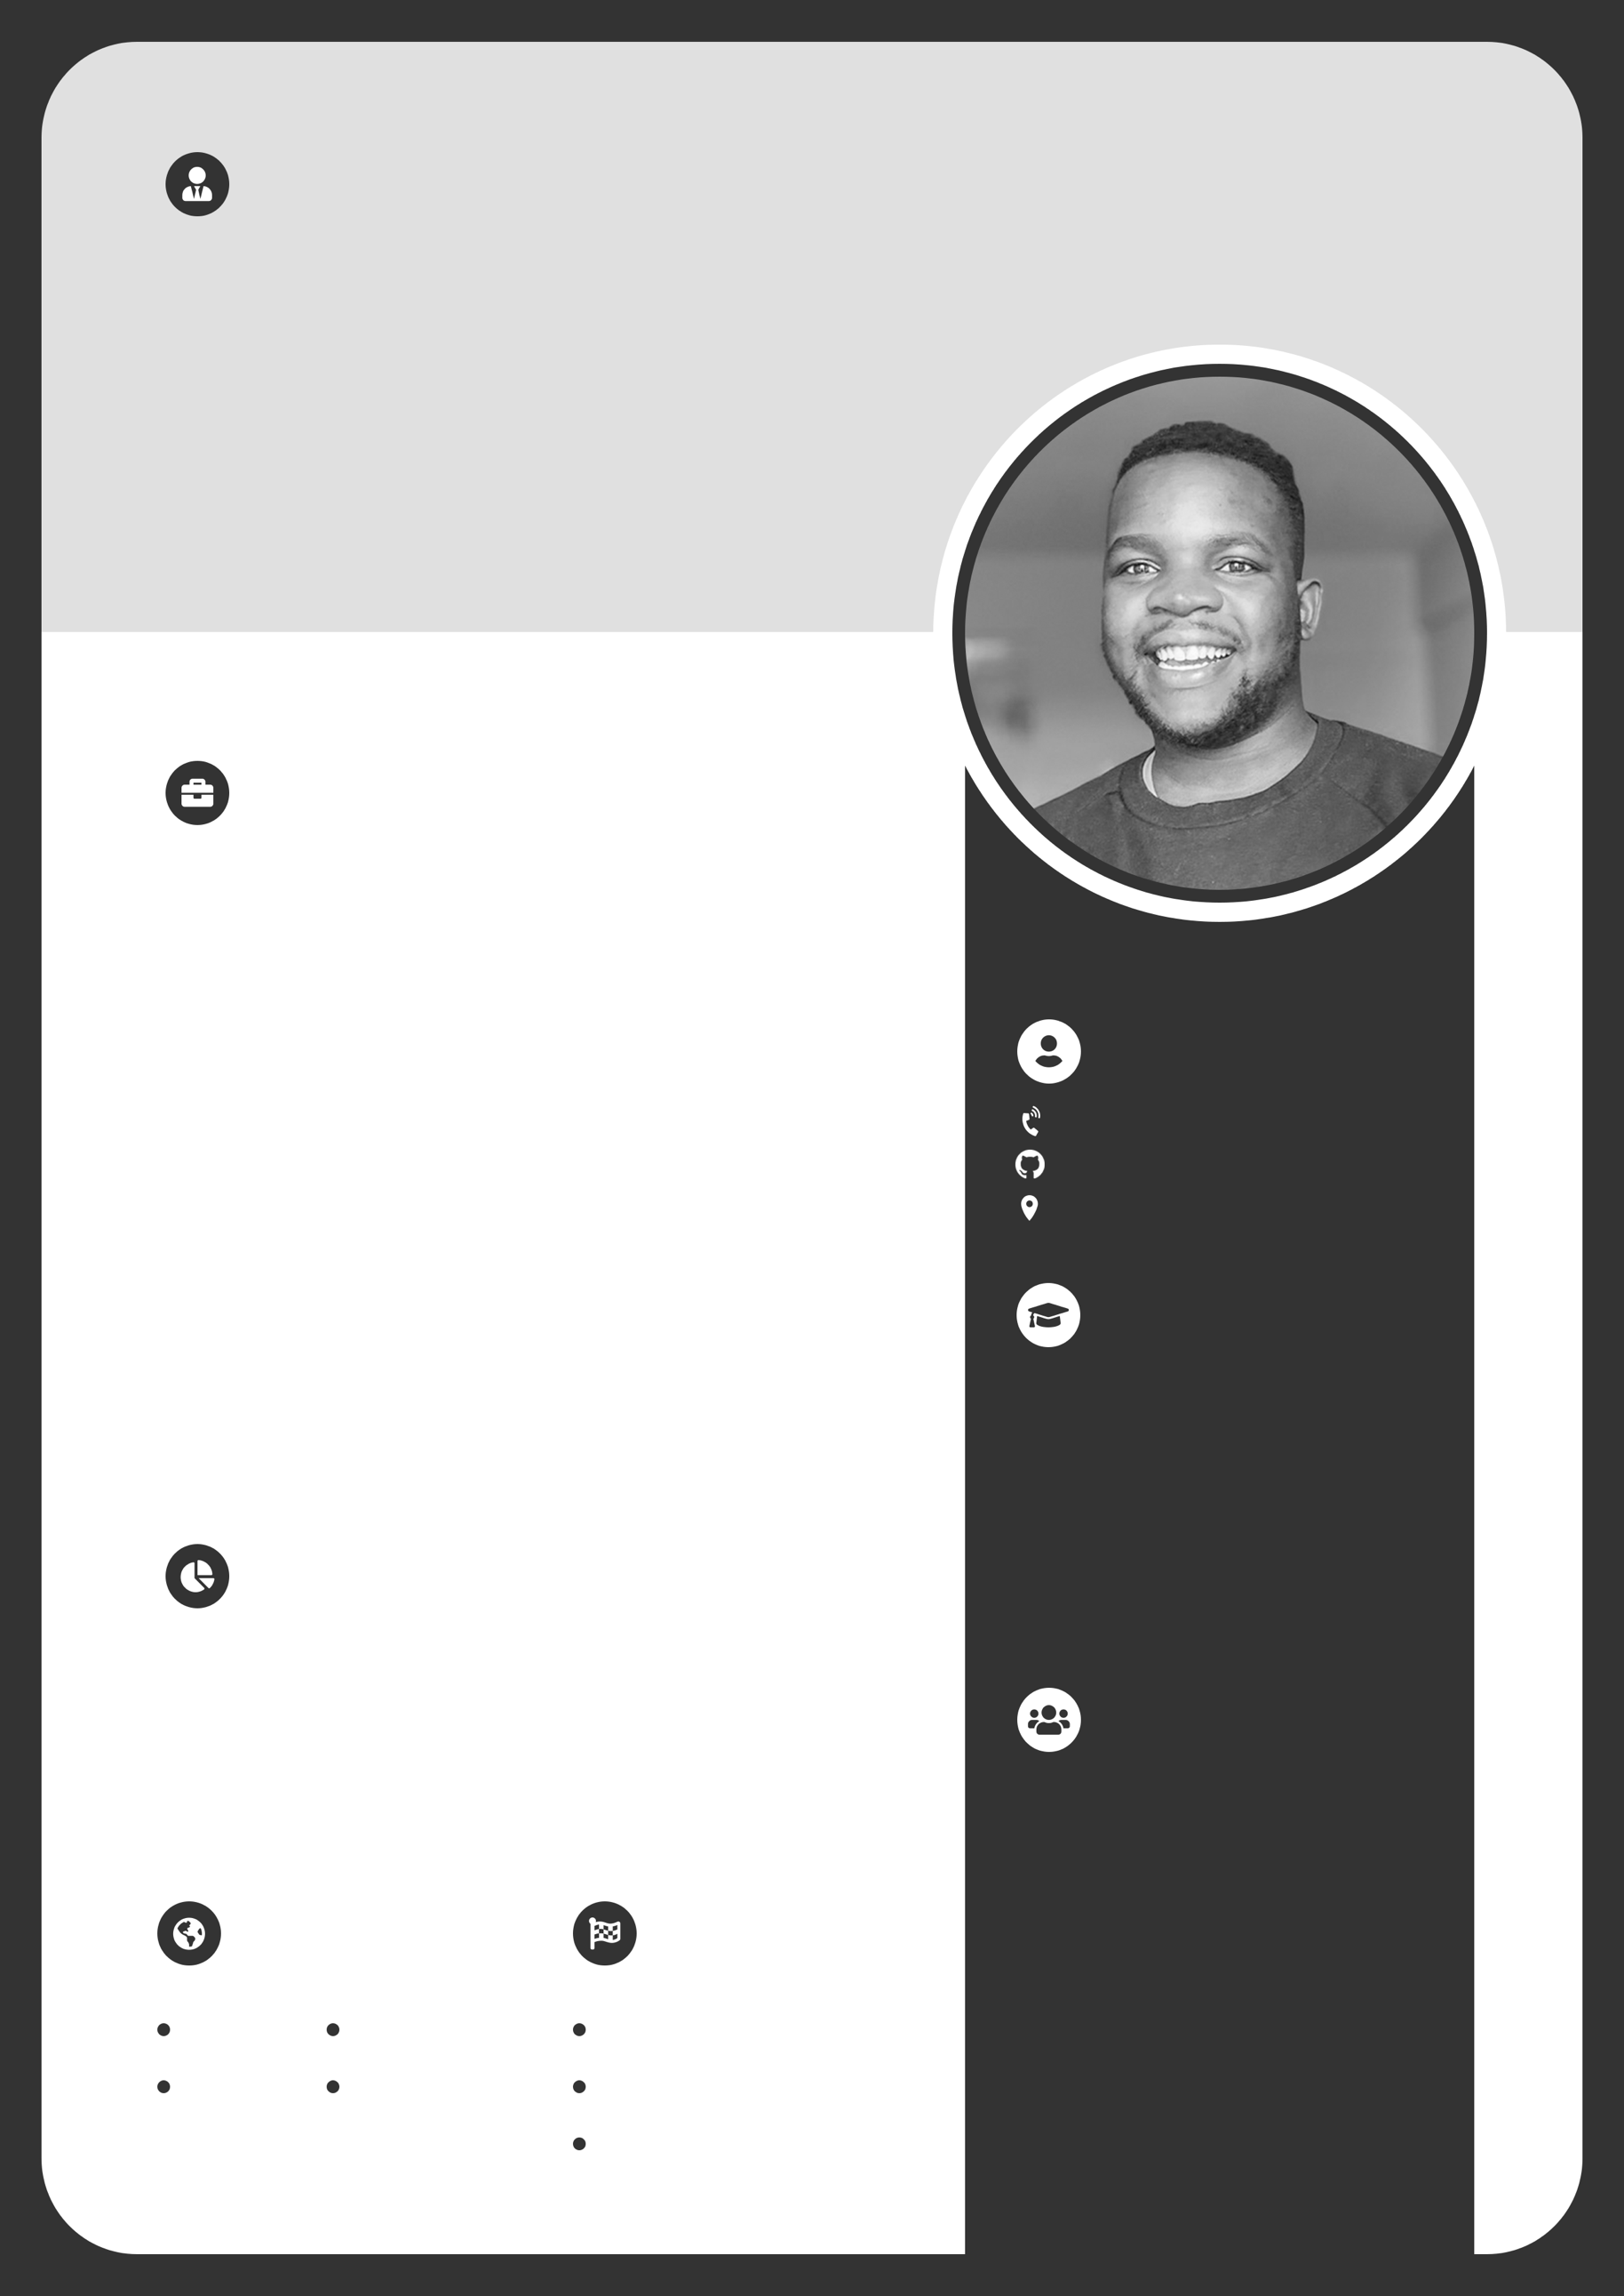

www.mikechiloane.live

**PROFFESIONAL SOFTWARE TESTING**

Lambda Test – 2023

2018 – 2022

**JAVA SPRING**

TestDome – 2023

2018 – 2022

**MICROSERVICES WITH SPRINGBOOT**

Google Cloud (Minnesota) – 2022

2018 – 2022

**SCRUM MASTER + AGILE SCRUM**

Noble Work Foundation – 2022

2018 – 2022

**Bsc Computer Science**

**University of Limpopo**

2018 – 2022

**CERTIFICATIONS**

**Matric**

**Sekwai Secondary School**

2013 - 2017

**EDUCATION**

**CONTACT ME**

github.com/mikechiloane

Pretoria, South Africa

072 738 8632

**HOBBIES**

**LANGUAGES**

**Chess**

**Reading**

**Travelling**

**Zulu**

**English**

**Sotho**

**Sepedi**

**Java SE . Java EE 6 . EJB . Hibernate . Spring . Spring boot**

**AWS . Kafka . JSP . Wildify . DB(relational & NOSQL) JavaScript . React . Angular . Node js . Jenkins . Docker Kubernetes . Maven . Git . GitHub . Python . HTML . CSS**

**TECH STACK**

**FULL STACK WEB DEBVELOPER**

**2018 - 2023**

***Maphori Express/Polokwane***

Responsible for developing and maintaining mobile and web applications to manage residential operations, including rent collection, visitor management, announcements, and business analysis for projections. Also responsible for API integration with identity verification and payment gateway systems.

***Convergence/Pretoria***

Assisting in the design and development of Full Stack Web Applications using React and Spring Boot micro-services, Contributing to the creation of QA Tools, Collaborating on the design and implementation of CRM Workflows with Apex and Visual Code, Supporting the crafting of Python UI Interfaces for Simulations, and Assisting in building Pipelines for CI/CD.

**2023 - present**

**JAVA SOFTWARE ENGINEER**

**JOB EXPERIENCE**

Software engineer with a strong drive and initiative, I can work independently or with minimal guidance while following best practices. I have a solid background in programming analysis, application analysis and design, as well as proficiency in various development tools and languages. I also collaborate well with others and contribute to team success.

**ABOUT ME**

JAVA SOFTWARE ENGINEER

**CHILOANE MIKE**