|  |  |
| --- | --- |
| **DOKUMENTASI EKSTERNAL**  ***External Documentation*** |  |
| **PROYEK**  ***Project*** |
| **MATAKULIAH MOBI6021 – MOBILE PROGRAMMING**  ***Subject*** |
| SEMESTER GENAP 2019/2020 ***Even Semester Year 2019/2020*** |

## Judul Proyek

*Project**Title*

* Gold Experience

## Pendahuluan

*Introduction*

* **Gold Experience** is an application that will make a simple plan based on a list of interesting places, provided by the application. The plan could be personalized by registering their own profile, and keeping it secret within their own account. Since it has been developed in a mobile version, **Gold Experience** will be a handy application in any situation.

## Dokumentasi

*Report / Documentation*

* Activity List
  + Login Form
  + Register Form
  + Place List Activity
  + Place Detail Activity
  + Plan List Activity
  + My Profile Activity
* Creative Thinking
  + Use GoldExperience as the main class and the main data controller
  + Use MVP architecture as its clean architecture to support clean code, with the view layer and the presenter layer merged (to simplify the project complexity)
  + Use utils/* as helper classes
  + Use Place, User, and Plan inside data/model as the data's container class
  + Use template XML and abstract class for multiple usage of profile form (and prevent a lot of duplicate codes)
  + Use res/values/strings to store all texts instead of hard-coded those texts
  + Throw an exception whenever there is invalid data on registration or update profile form (including duplicate email addresses).
  + Auto fill email after register or logout
  + This application does not need any location permission since the application only uses location from the database, not the user's current location.
* Device Specifications

Here a list of devices used in testing phase

* + API 28 Android 9: Asus ZenFone Max Pro M1
  + API 24 Android 7.0: Nexus 5X (*Emulator*)
  + API 24 Android 7.0: Pixel 2 (*Emulator*)
  + API 23 Android 6.0: Nexus S (*Emulator*)
  + API 27 Android 8.1.0: Pixel 2 (*Emulator*)
  + API 23 Android 6.0: phone

## Referensi

*References*

* Here a list of URLs that had been accessed and (maybe) give some insights to this project
  + https://android--code.blogspot.com/2015/08/android-radiogroup-set-selected-index.html
  + https://developer.android.com/guide/topics/ui/dialogs#java
  + https://developer.android.com/reference/android/content/Context.html#getString%28int%29
  + https://developer.android.com/reference/android/support/design/widget/BottomNavigationView
  + https://mkyong.com/android/android-radio-buttons-example/
  + https://stackoverflow.com/questions/14933330/datepicker-how-to-popup-datepicker-when-click-on-edittext
  + https://stackoverflow.com/questions/16076985/listview-row-buttons-how-do-i-create-a-custom-adapter-that-connects-a-view-oncl/16077840#16077840
  + https://stackoverflow.com/questions/18677421/android-relativelayout-in-scrollview
  + https://stackoverflow.com/questions/1944656/android-global-variable
  + https://stackoverflow.com/questions/24992936/how-to-check-if-a-radiobutton-is-checked-in-a-radiogroup-in-android
  + https://stackoverflow.com/questions/3438276/how-to-change-the-text-on-the-action-bar
  + https://stackoverflow.com/questions/3676095/relativelayout-height-to-fill-remaining-space/30149147
  + https://stackoverflow.com/questions/5271387/get-color-int-from-color-resource/32253801#32253801
  + https://www.journaldev.com/17899/java-simpledateformat-java-date-format
  + https://stackoverflow.com/questions/18097748/how-to-get-row-count-in-sqlite-using-android/18098603#18098603
  + https://stackoverflow.com/questions/11776356/android-sqlite-contraint-conflict-try-catch-couldnt-catch/12725468#12725468
  + https://developer.android.com/training/data-storage/sqlite#PersistingDbConnection
* (Maybe) Unrelated, but could be related in the future
  + http://www.programmersought.com/article/1187676681/
* The only image used in this project
  + https://www.flaticon.com/free-icon/g-logo-circle_7719
  + https://www.flaticon.com/free-icon/contract_2285296
  + https://www.flaticon.com/free-icon/user_1077063

**Disiapkan Oleh,**

*Prepared by,*

* 2001561184 - Edward Keitaro Heru
* 2001566840 - Andreas Martin
* 2001572080 - Mike Christ Heru

1. **Login Form**

This is an activity whenever a guest opens the application. It asks the user to provide a valid credential in order to log in to the application. It will show a proper warning, or will display the place list (see the 3rd activity). If the guest does not have a credential and wants to register a new one, he/she could press the register button and will be brought to the register form.

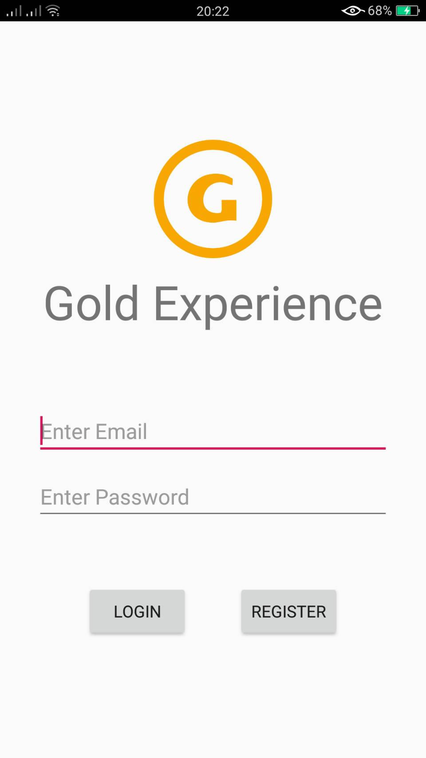 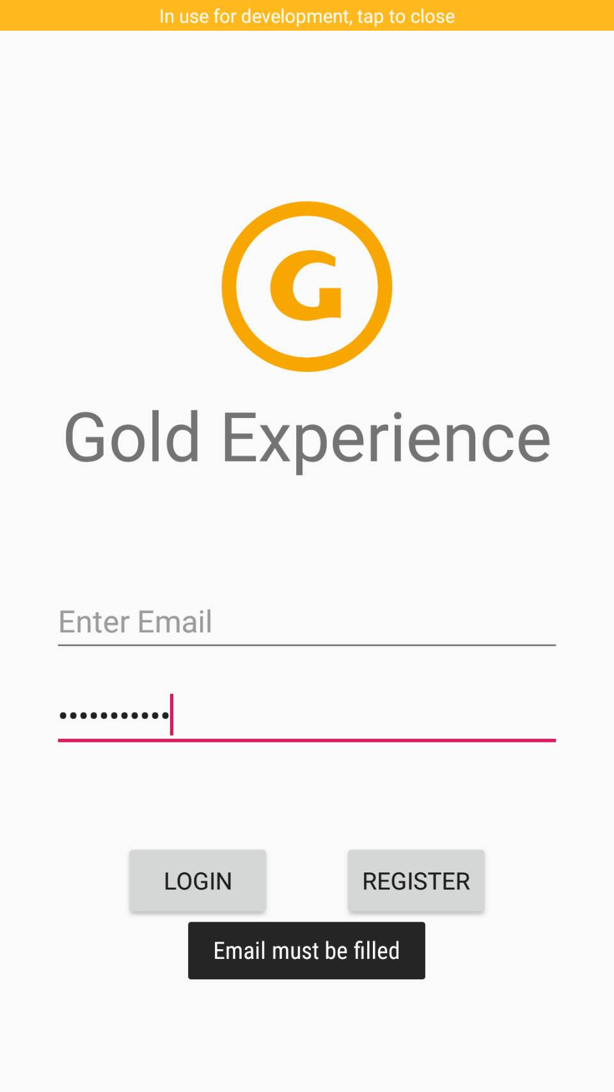 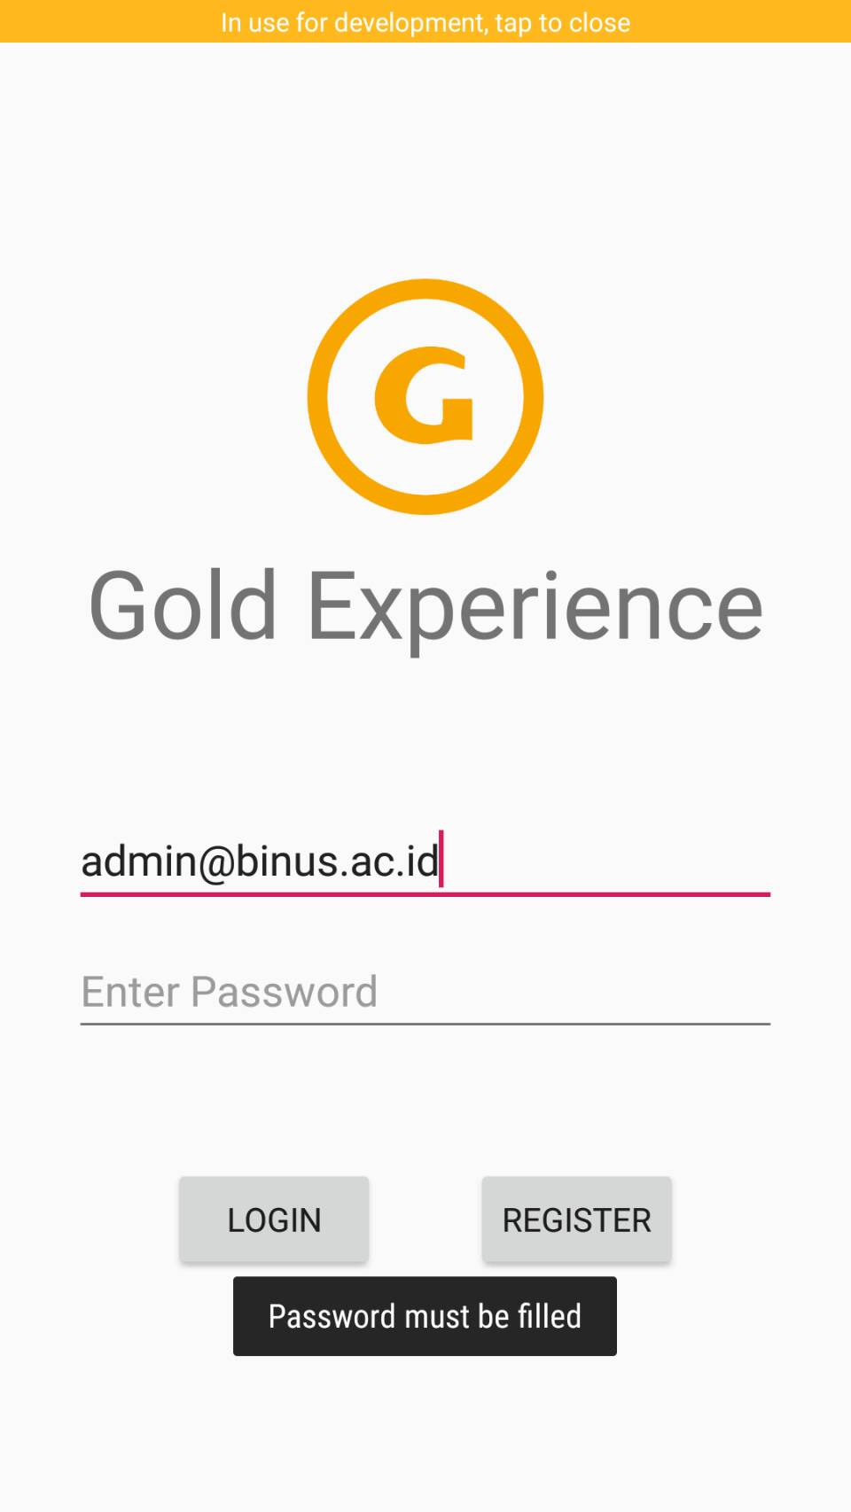

**Figure 1** **Figure 2** **Figure 3**

Login Activity Empty email warning Empty password warning

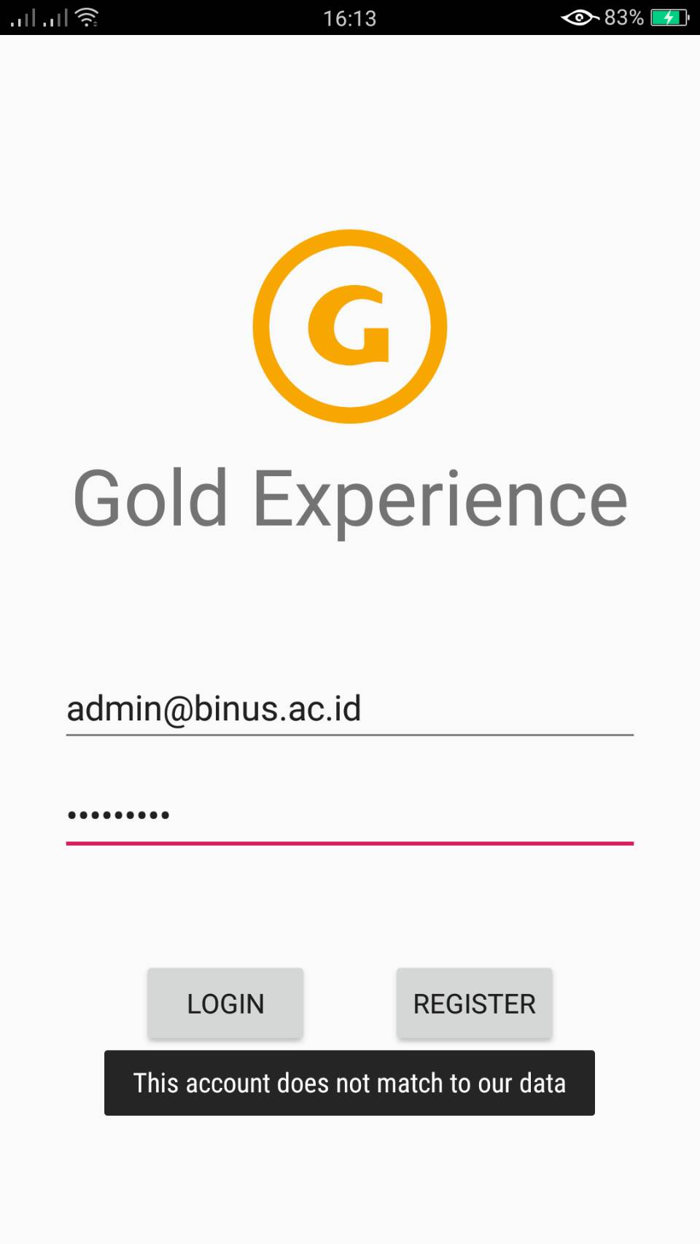

**Figure 4**

Invalid credentials warning

1. **Register Form**

This is an activity whenever a guest decides to register his/her personal account. It asks some details to be filled in and the application will show a proper warning if necessary. In order to complete the registration, the user needs to input a confirmation code sent to their phone number. Once the registration is completed, the application will send a welcome message and will show a login form once more.

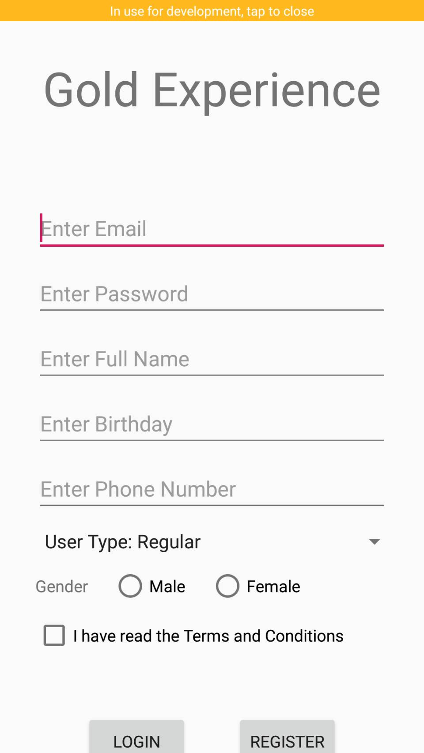 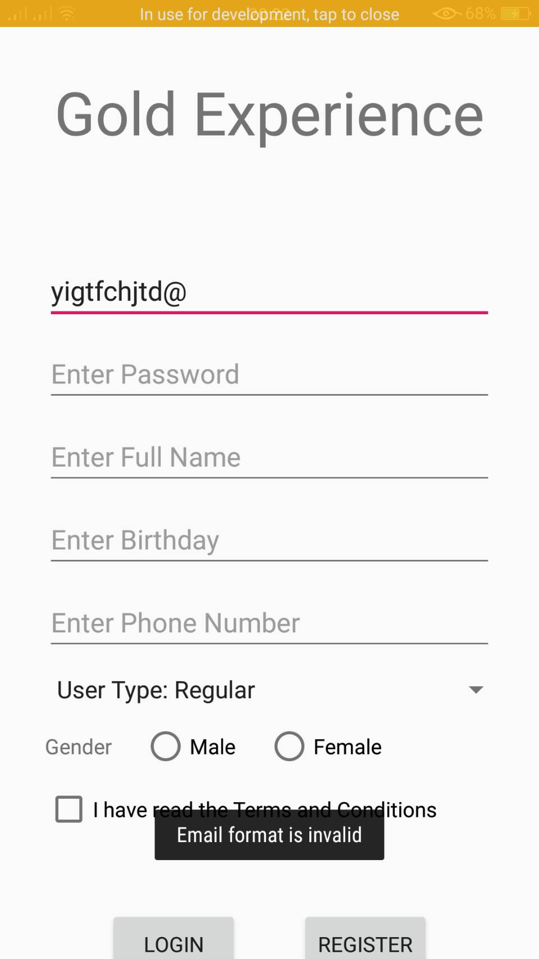 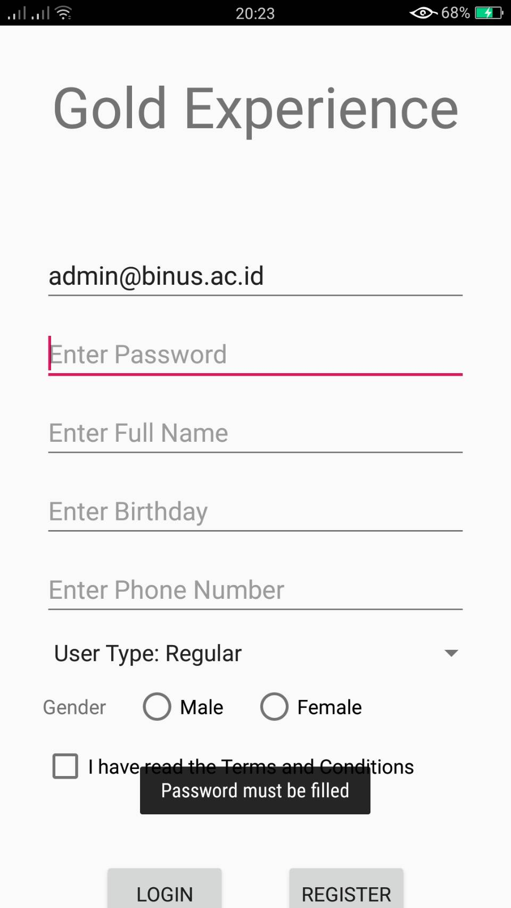

**Figure 5 Figure 6 Figure 7**

Register Activity Invalid email warning Empty password warning

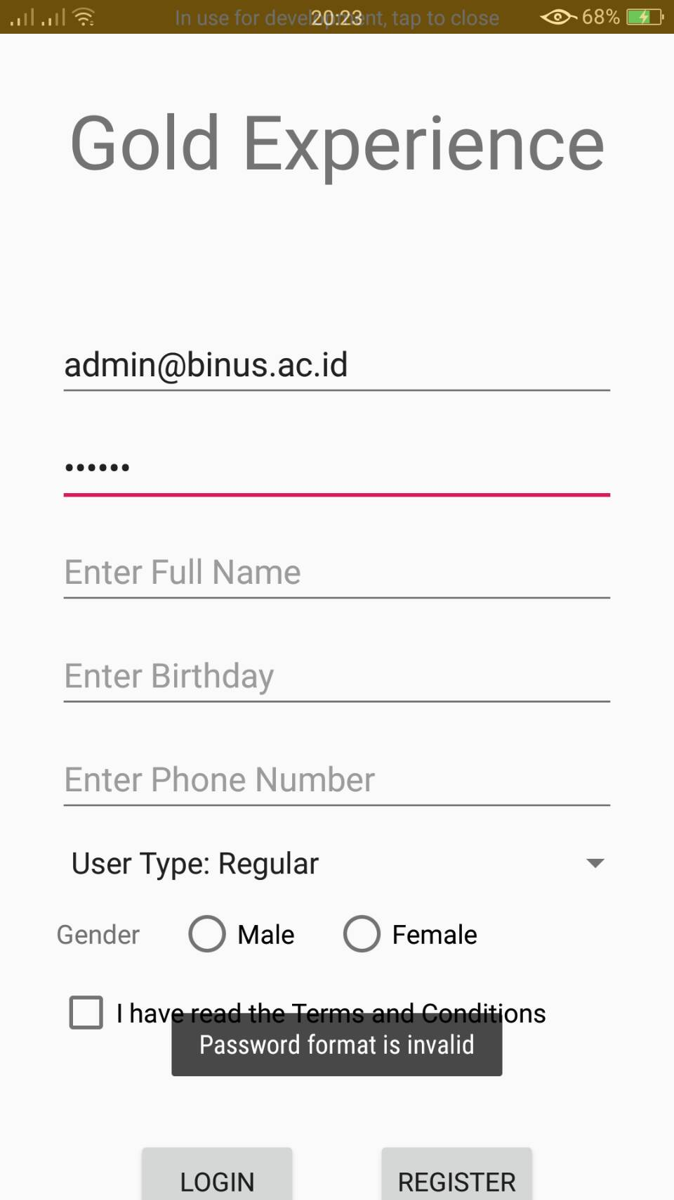 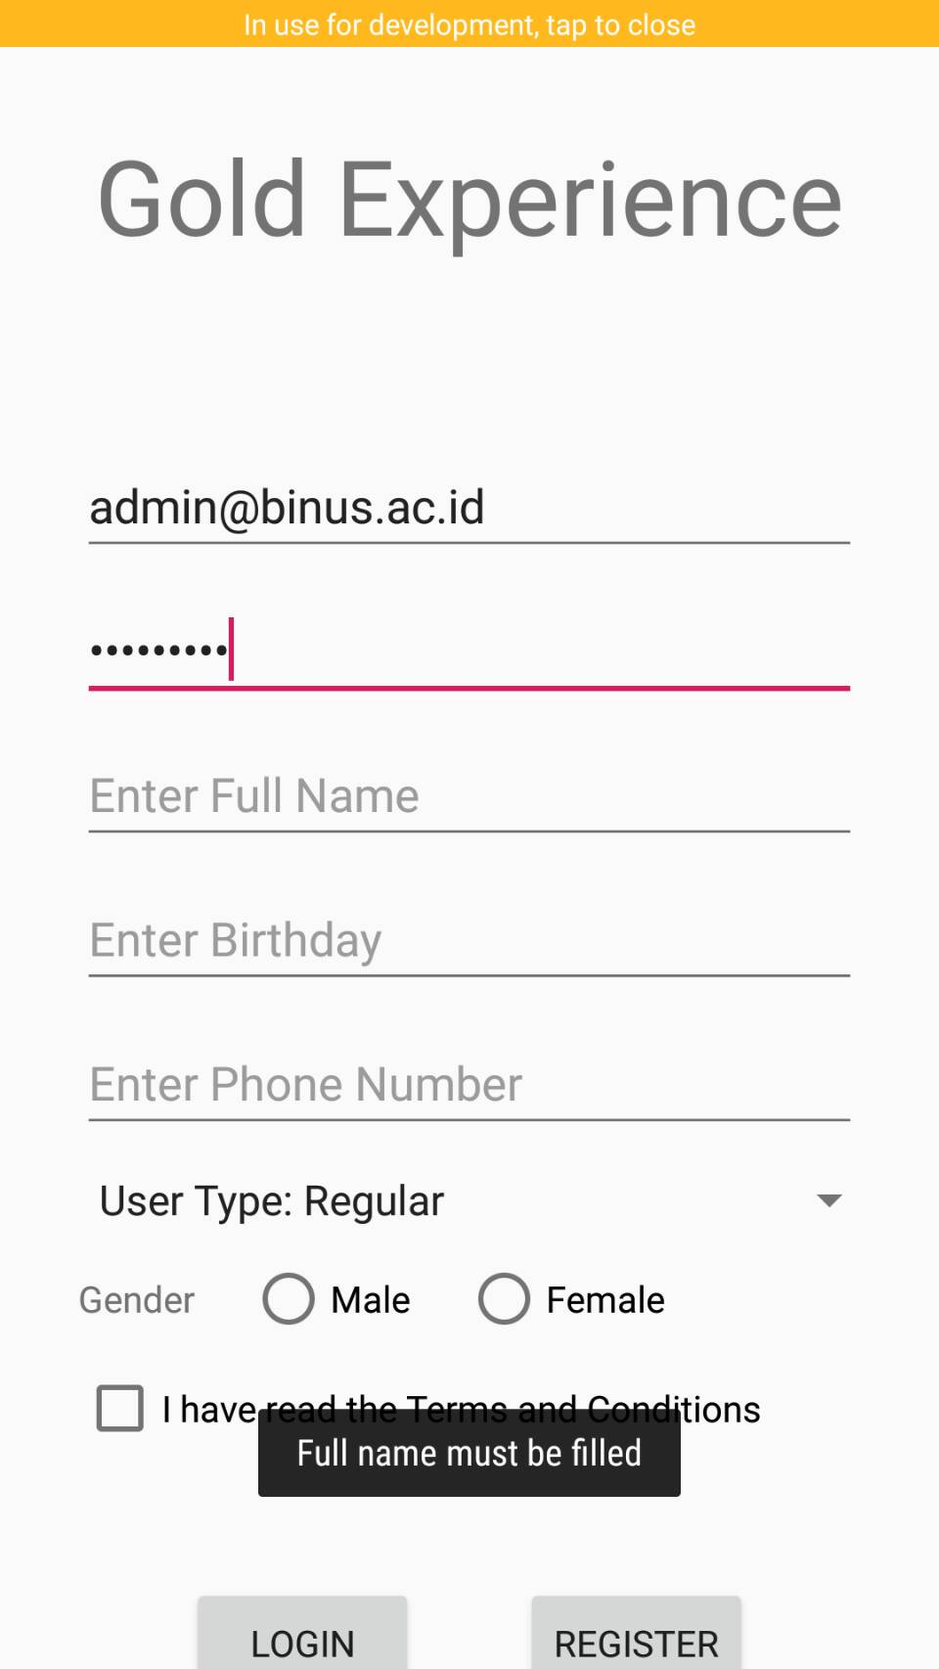 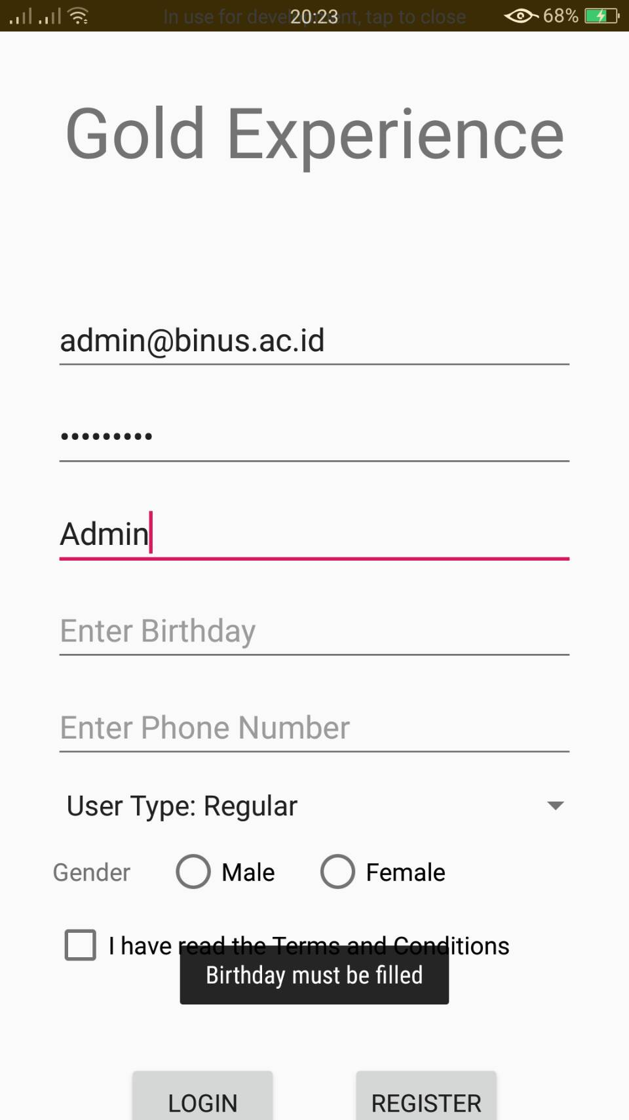

**Figure 8 Figure 9 Figure 10**

Invalid password warning Empty full name warning Empty birthday warning

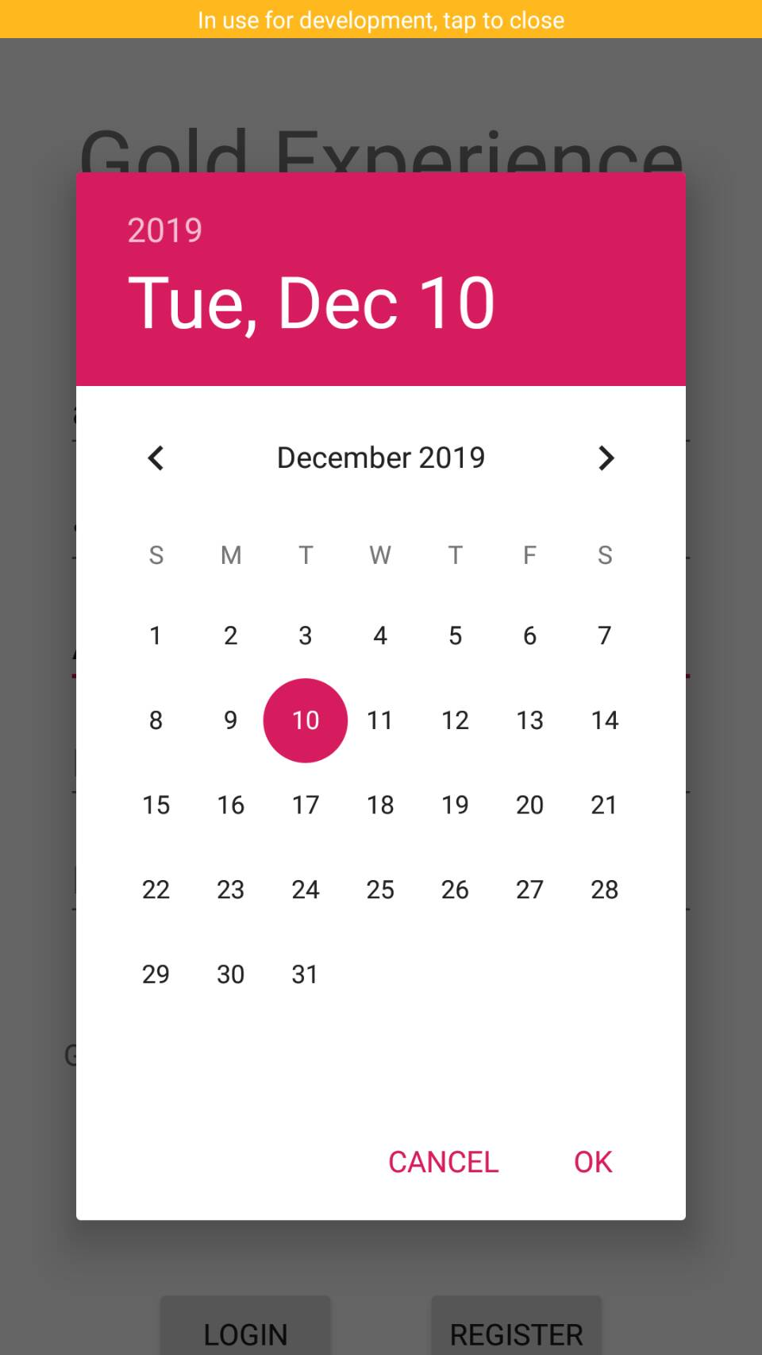 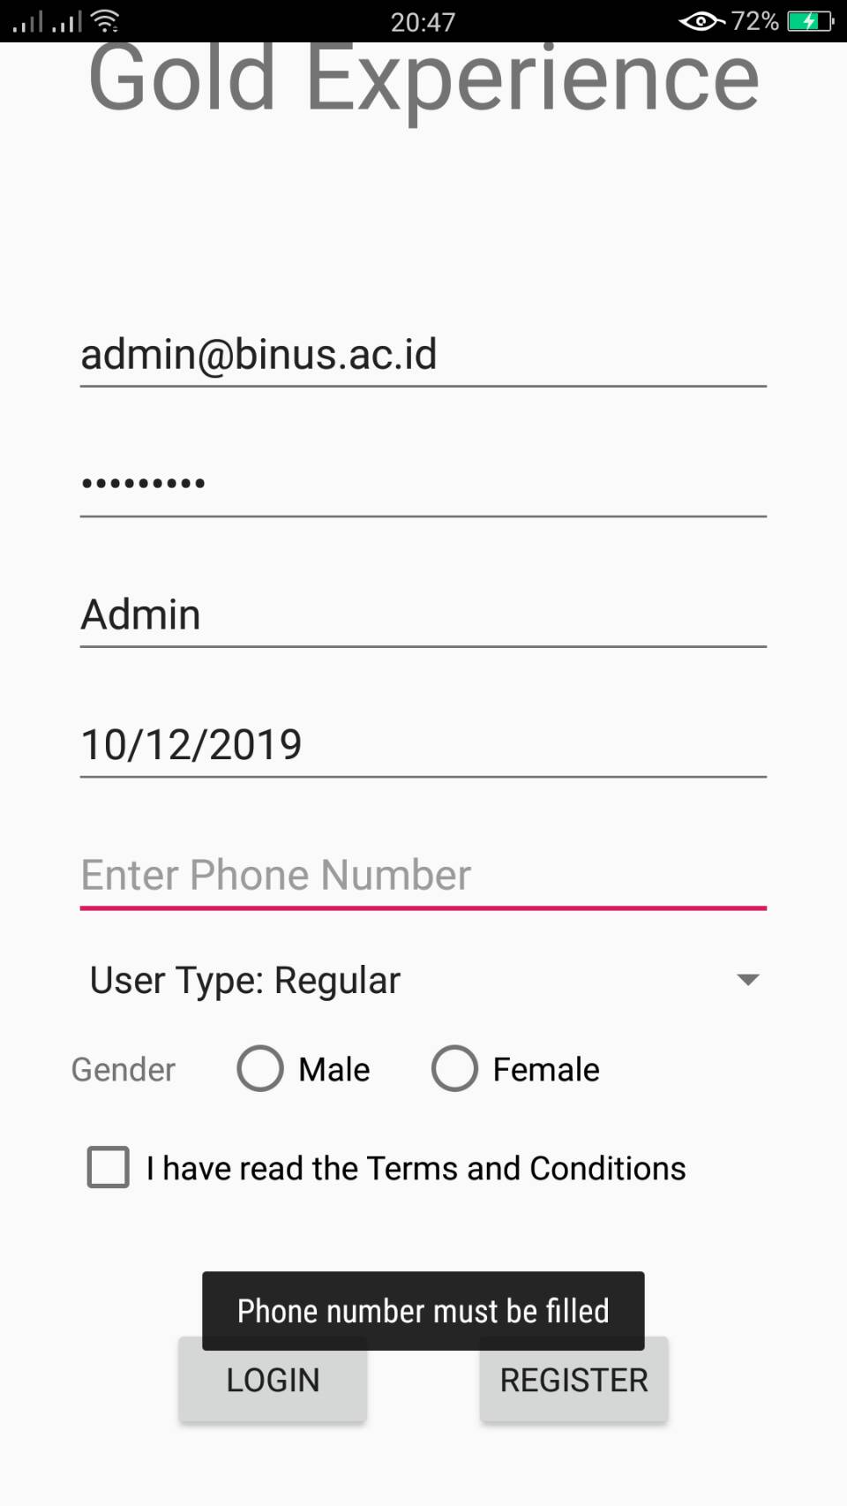 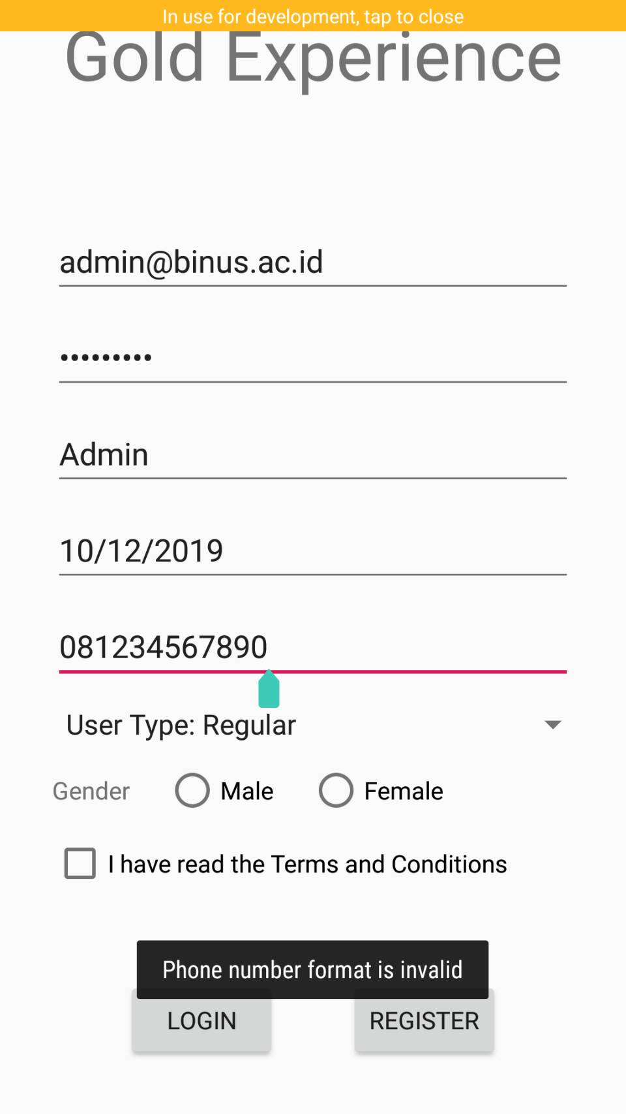

**Figure 11 Figure 12 Figure 13**

Birthday picker dialog Empty phone number warning Invalid phone number warning

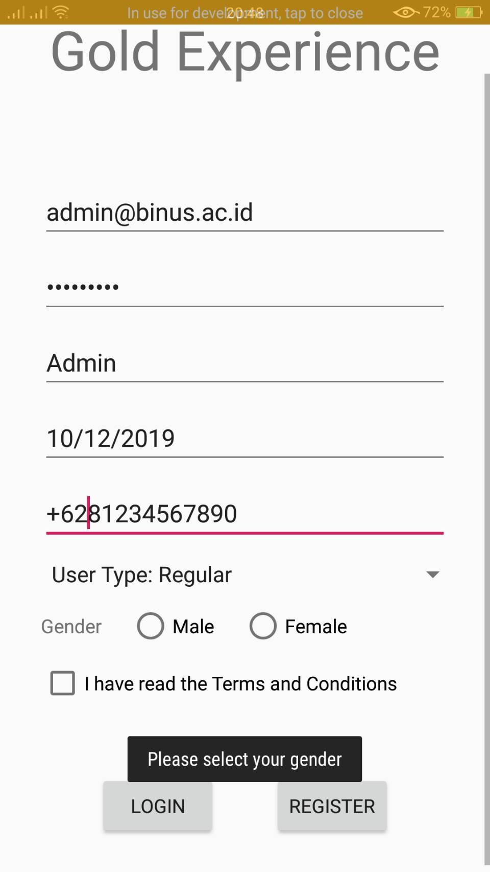 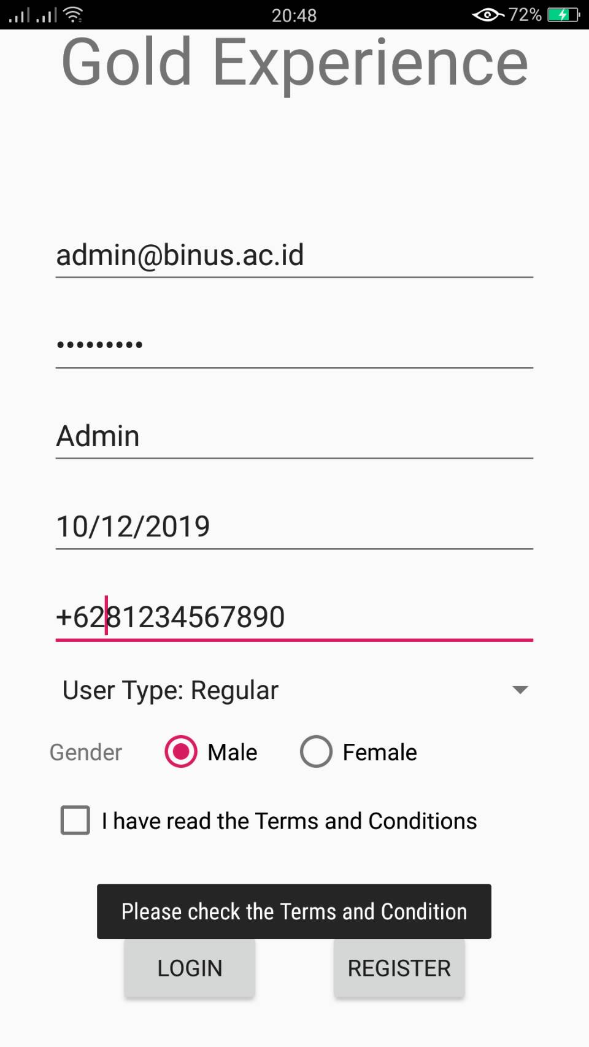 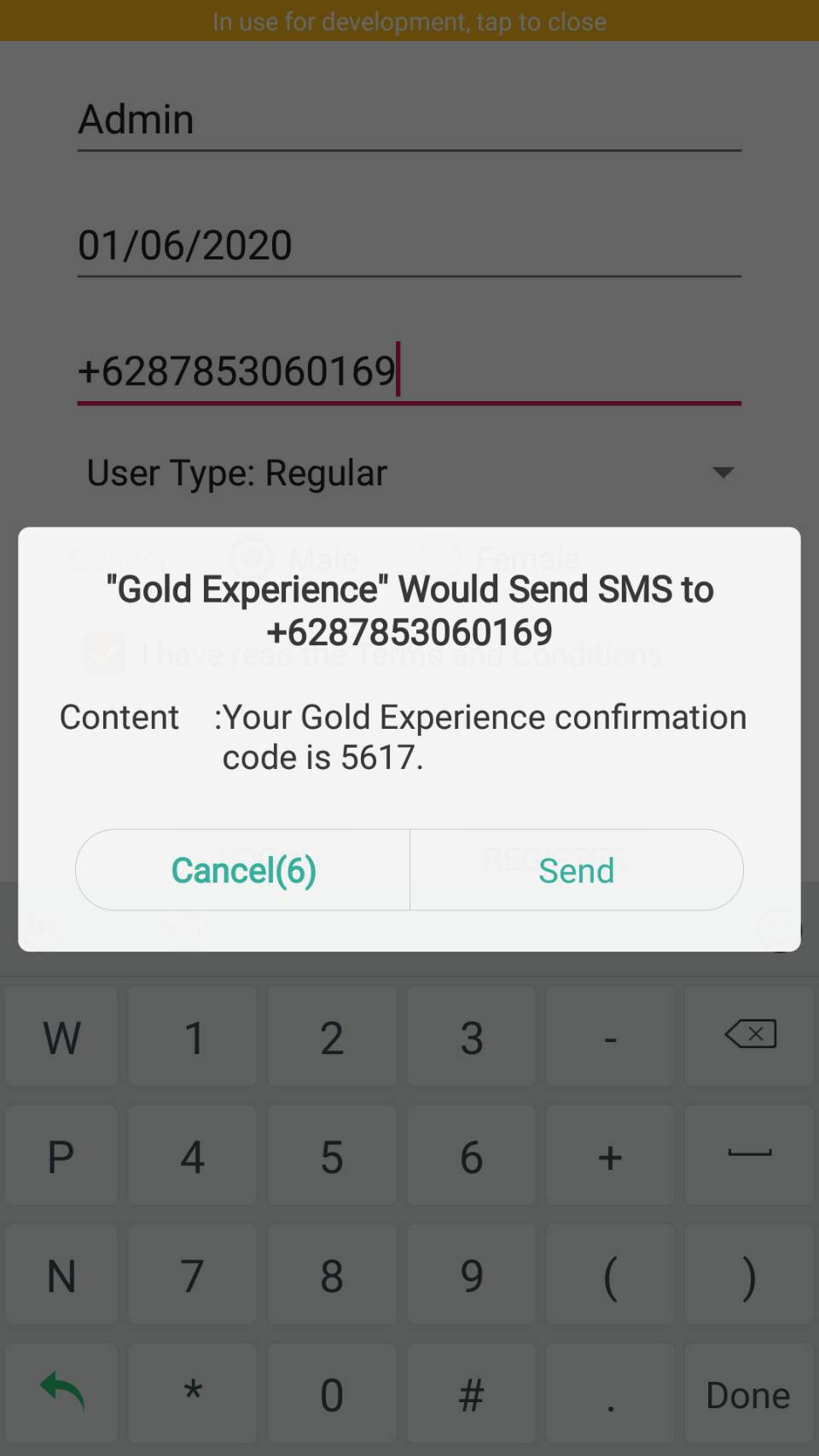

**Figure 14 Figure 15 Figure 16**

Unselected gender warning Unchecked TnC warning SMS permission request

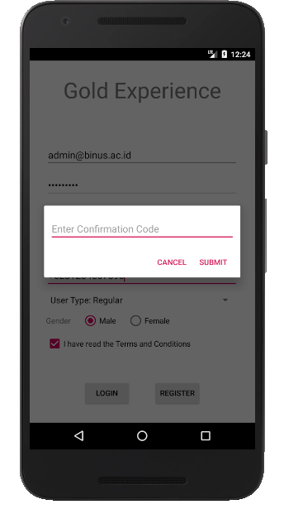 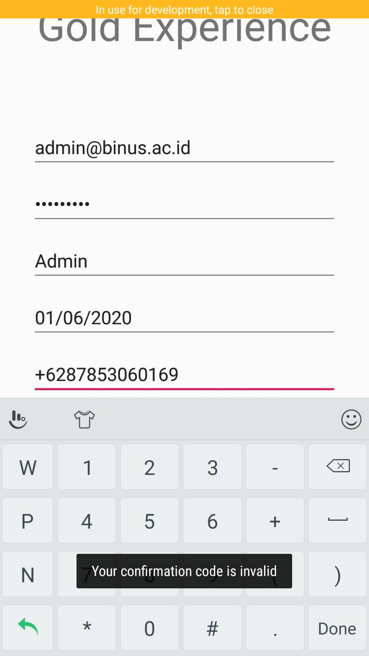

**Figure 17 Figure 18**

Confirmation code dialog Invalid confirmation code warning

1. **Place List Activity**

This is an activity whenever a logged-in-user opens the application. It will display a list of interesting places. Whenever the user wants to see a detail of the place, he/she could simply tap it and the details will be shown. The list itself is stored online, so the application may delay and will show a loading bar.

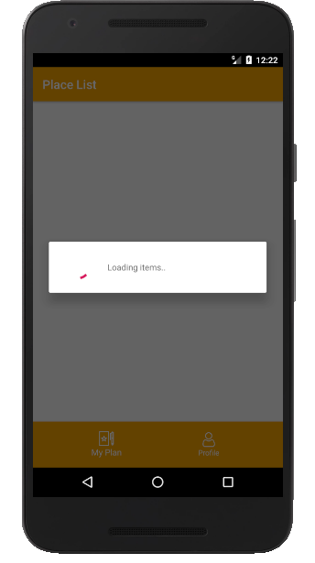 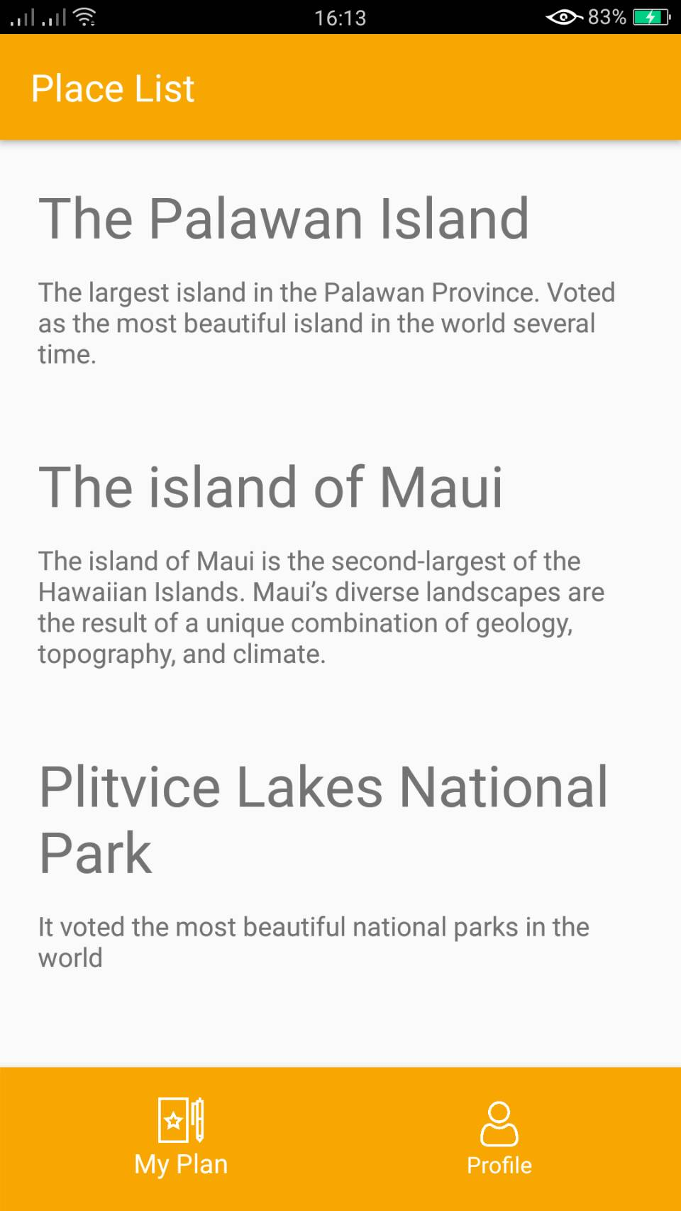

**Figure 19 Figure 20**

Loading items Place List Activity

1. **Place Detail Activity**

This is an activity whenever the user taps one of the places provided. It will show a detail and a map of the location. If the user wants to add the selected place to his/her plan, the form will be shown after the “Add to My Plan” button was pressed.

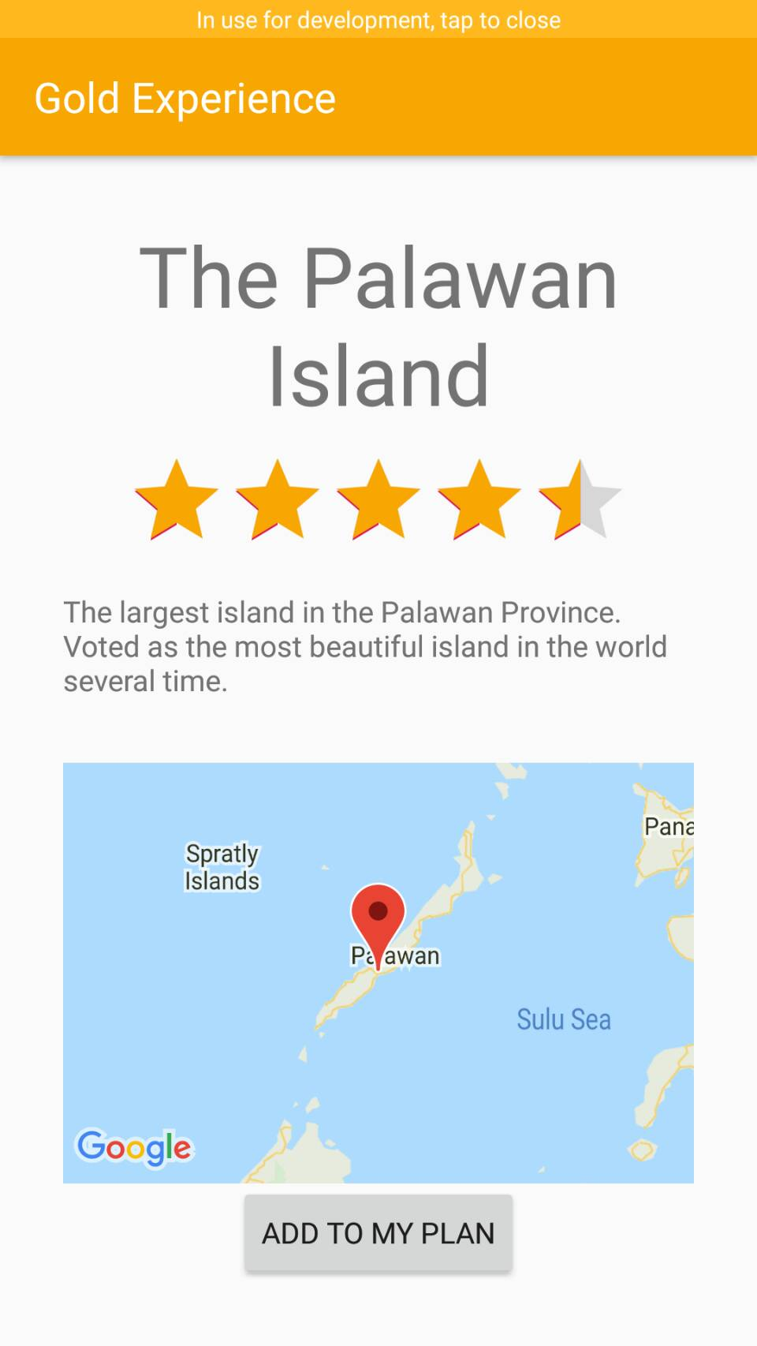 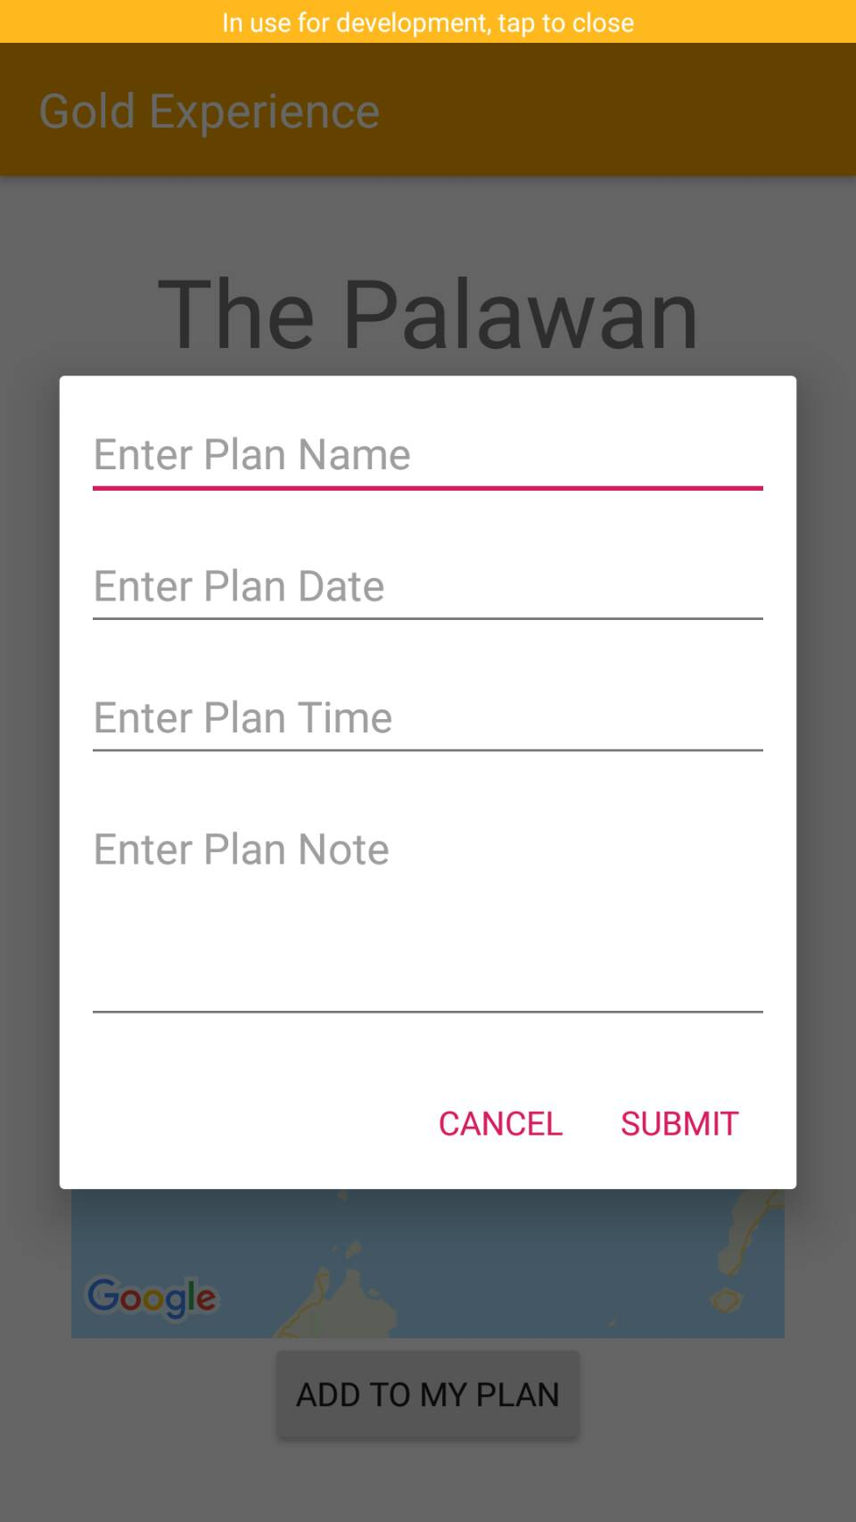

**Figure 21 Figure 22**

Place Detail Activity Add plan dialog

1. **My Plan List Activity**

This activity will display a list of created plans. The user may delete his/her own plans if necessary. This list also displays past events with a red background to differ them with upcoming events.

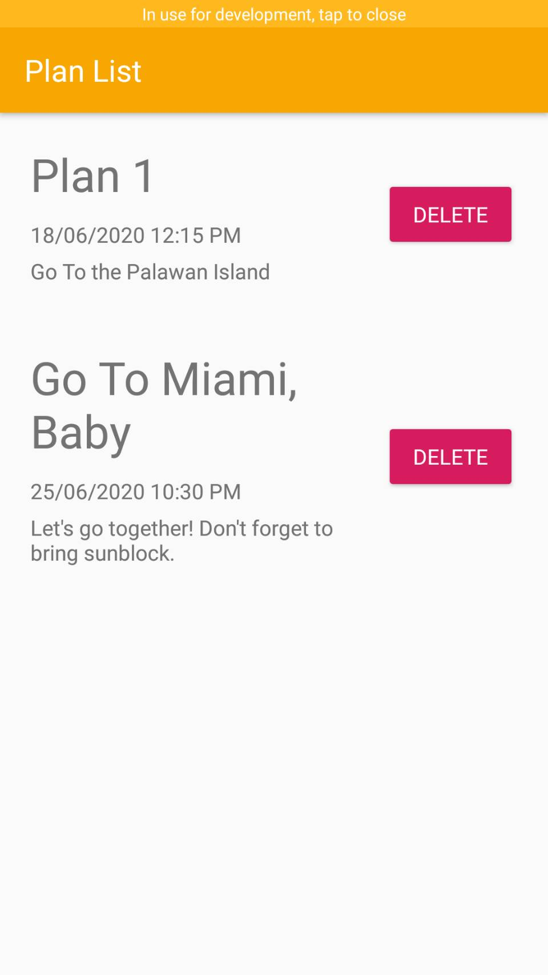 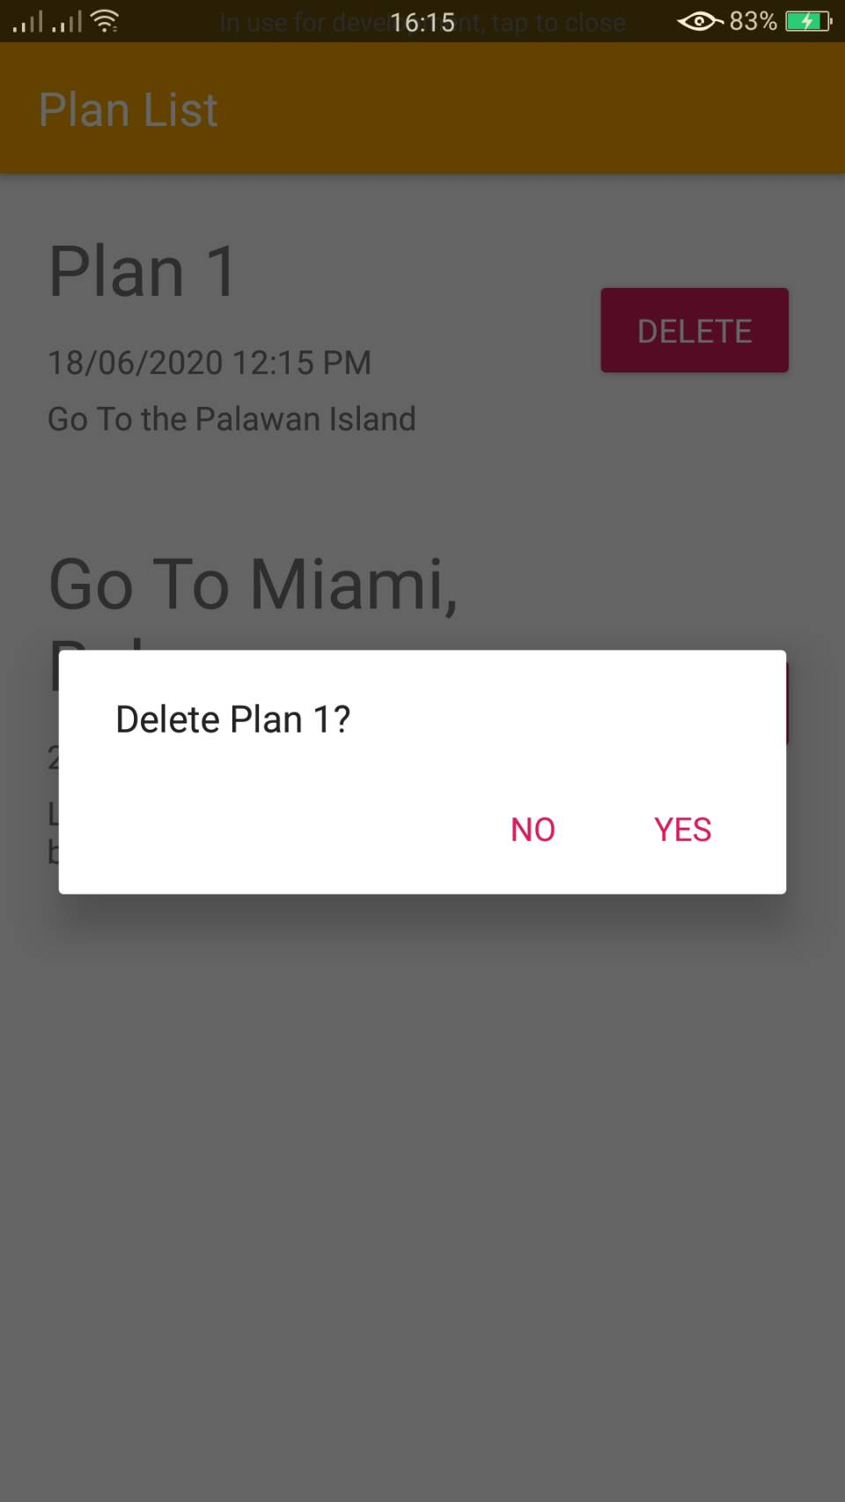 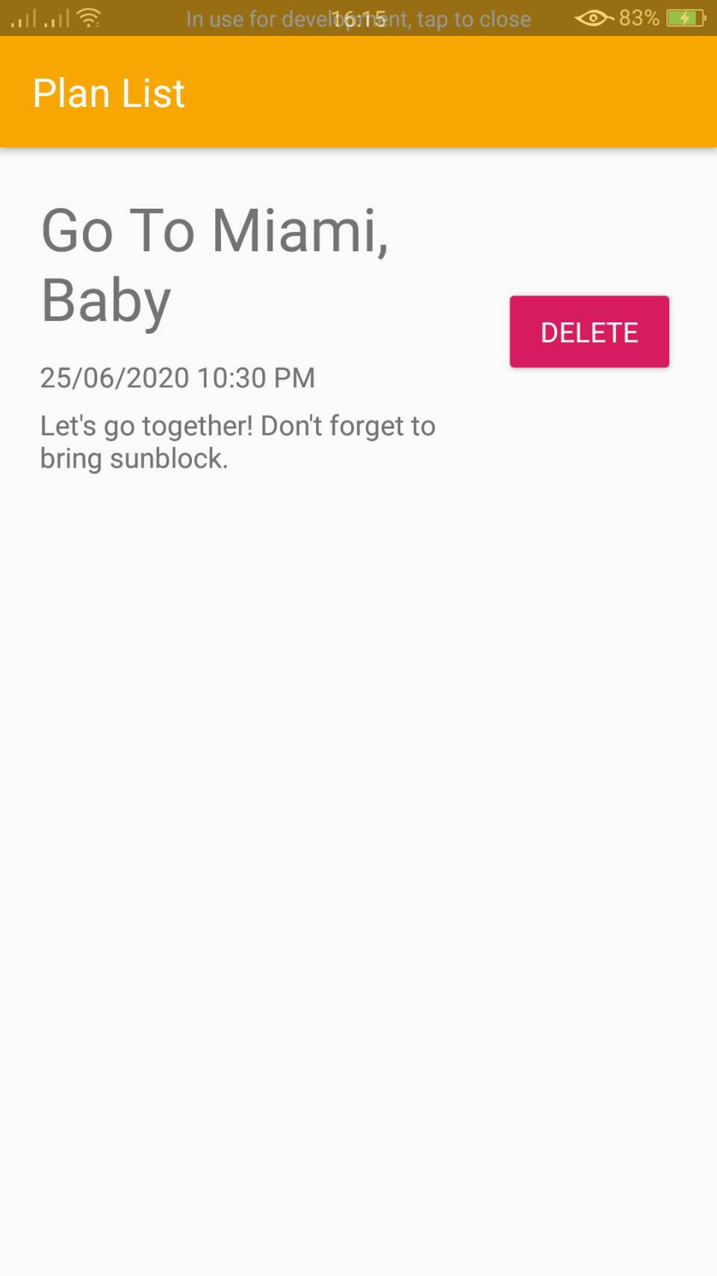

**Figure 23 Figure 24 Figure 25**

My Plan List Activity Delete plan dialog Plan list after deletion

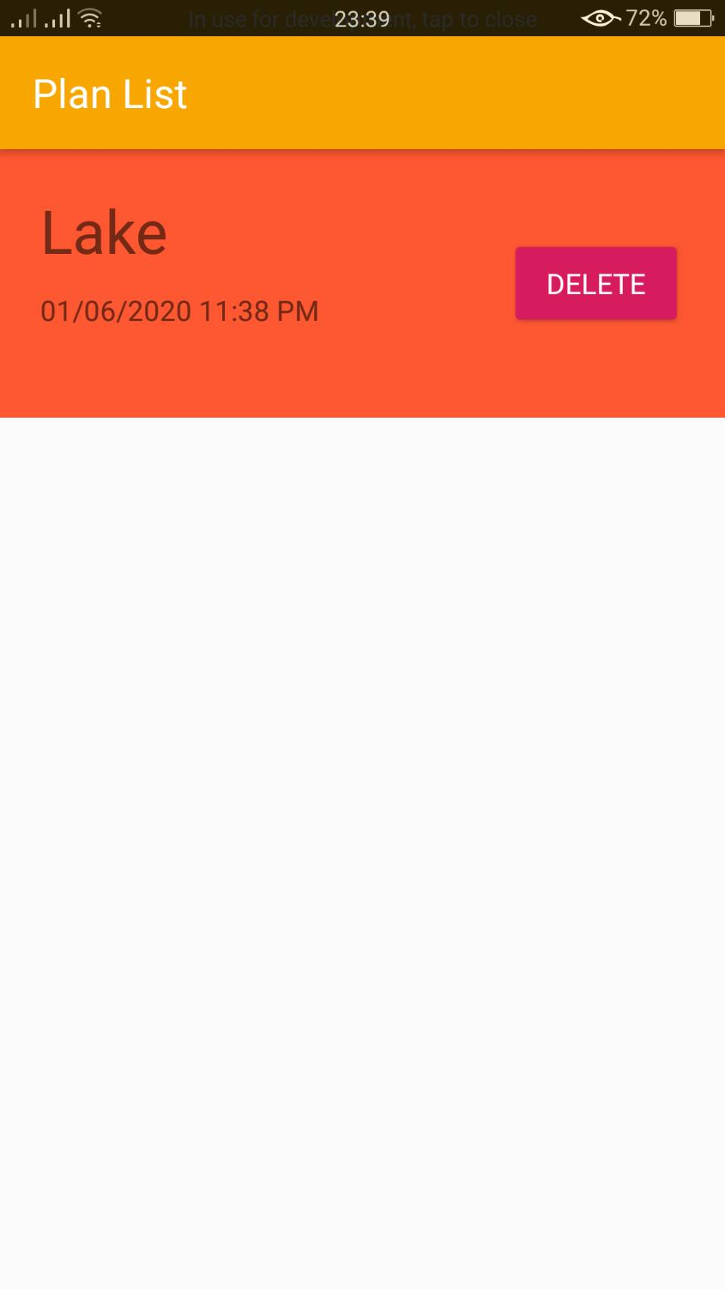

**Figure 26**

An example of a past event

1. **My Profile Activity**

This is an activity to view or update current user profiles. The user also could logout from the application through the suitable button.

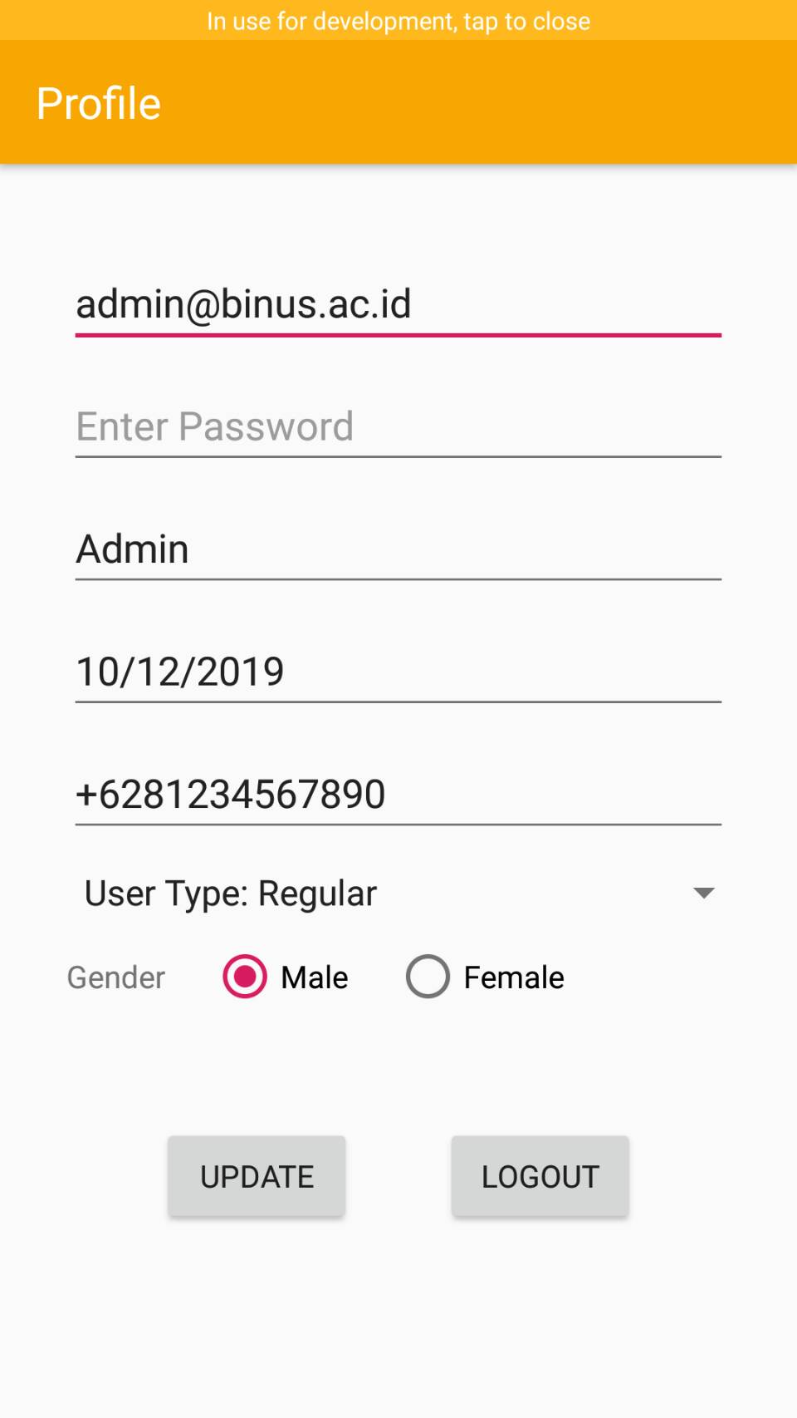

**Figure 27**

My Profile Activity