

Architecture

Estimated time for completion: 30 minutes

Overview:

In this lab, you will install MongoDB as a service and restore a database

Goals:

* Install MongoDB as a service
* Install RoboMongo
* Use mongorestore and mongodump

Part 1 – Install MongoDB

1. Go to <http://www.mongodb.org/> (not <http://www.mongodb.com>) and download the latest version of MongoDB. Unzip it in an executable directory – typically: c:\mongodb\program
2. To make working with MongoDB easier, add this folder to your path. Need some help? [Look here](http://www.computerhope.com/issues/ch000549.htm).
3. You should see the following files: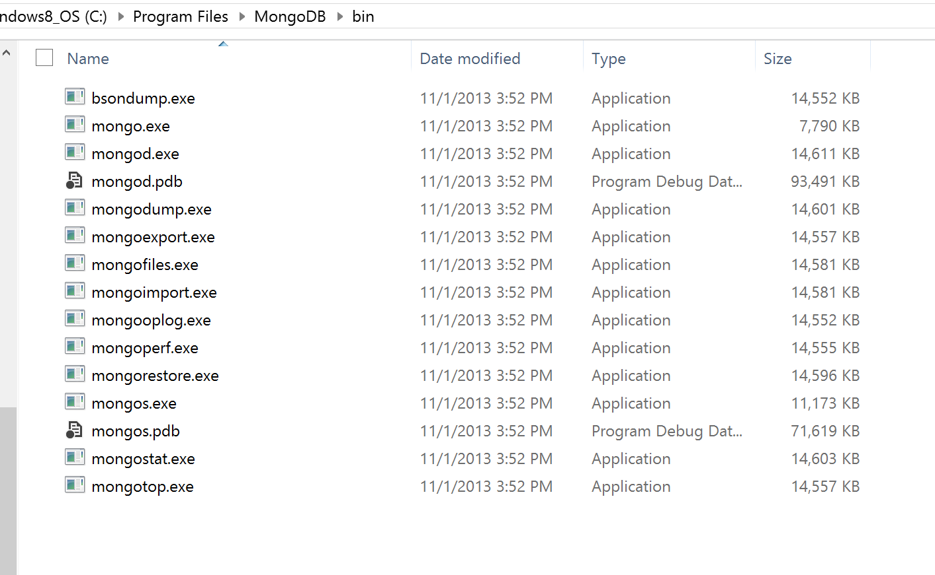
4. Create a directory where mongodb should store its data files, for example: C:\MongoDB\data
5. Create a directory where mongodb should store its log files, for example: C:\ MongoDB\log
6. Our goal is to install MongoDB as a Windows Service. But it is much easier to debug setup issues in the command prompt. Try starting mongod.exe in the command prompt using this command (altered for an path changes you chose):

mongod --dbpath "C:\MongoDB\data" --directoryperdb --bind_ip 127.0.0.1

1. You should see mongo running in your shell:  
     
   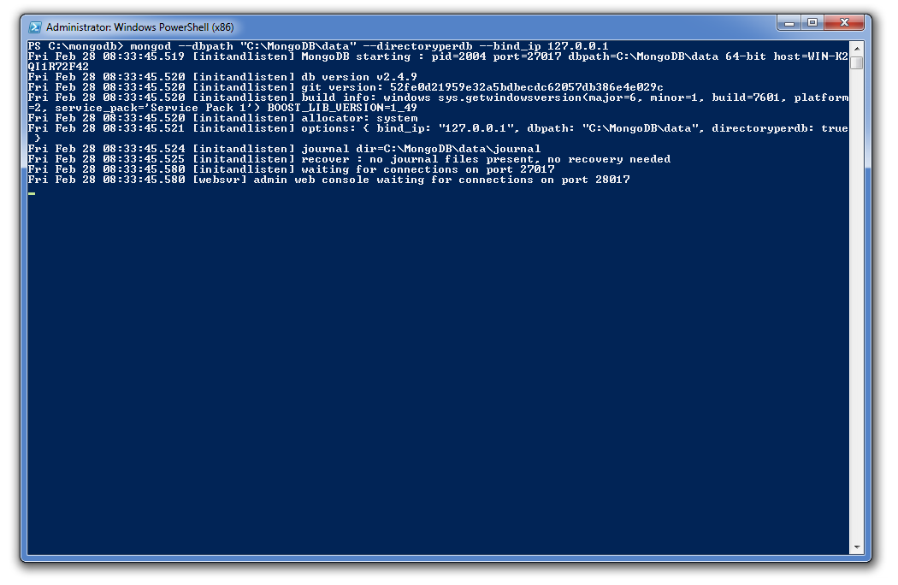
2. Open a command prompt as an administrator. Add --install to your arguments and mongodb will be setup as a Windows Service:

mongod --install --logpath "C:\MongoDB\log\mongo-service-log.txt" --logappend --dbpath "C:\MongoDB\data" --directoryperdb --bind_ip 127.0.0.1

Open your local services and verify that MongoDB is installed:

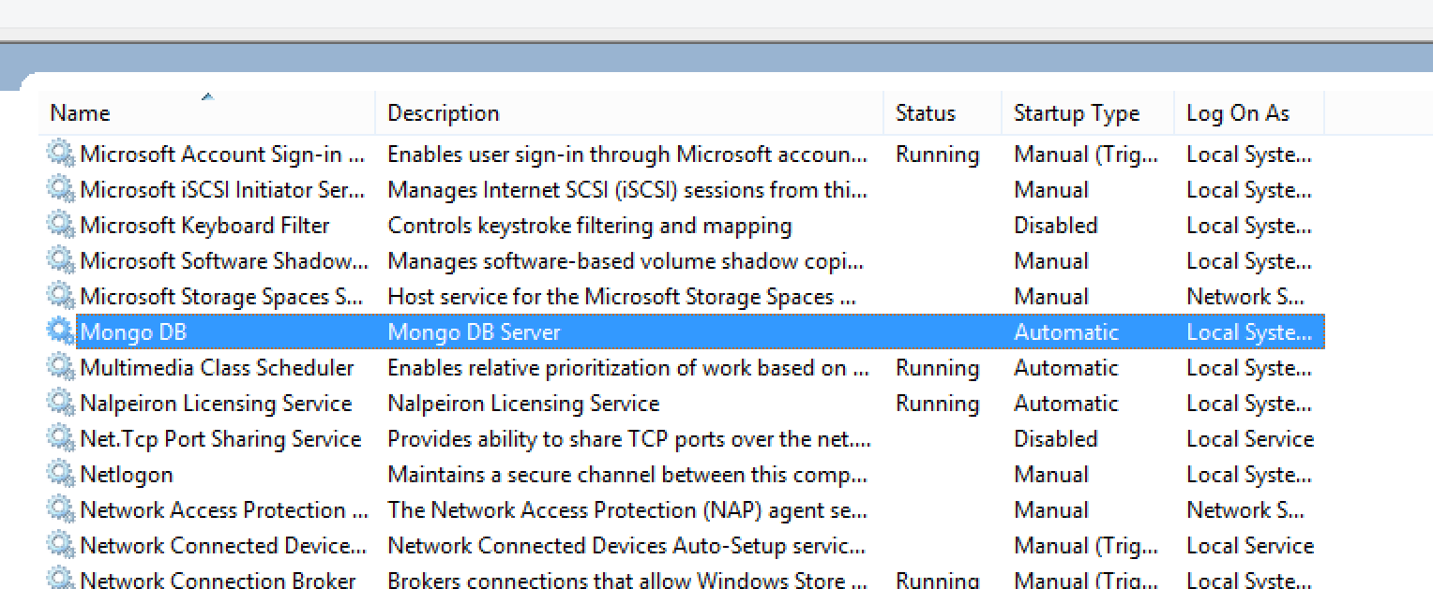

1. Now start the service (either via the command prompt or services UI):  
     
   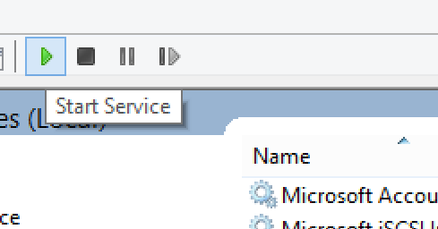

Part 2 – Install Robomongo

1. Go to <http://robomongo.org/>; download and install RoboMongo.
2. Run RoboMongo.
3. Choose ‘create’ to create a new connection. Use any name you want to describe the local connection and chose localhost for the machine.
4. Now connect to the MongoDB server:  
     
   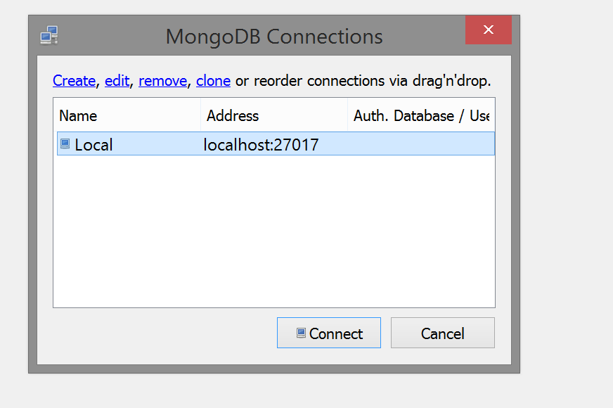

Part 3 – Restore a mongo database

* Locate the directory that contains the serialized bookstore database. This is likely:   
  labs\01 - Architecture\bookstore.zip
* Notice this is a zip file. You will need to decompress it. Choose “Unzip here” and a folder named bookstore will be created. To get a sense of what this data looks like just open that folder and check out the files in there. (No need to open them directly)
* Create the BookStore db by running the following command line:

mongorestore --db BookStore "bookstore" –drop

* Of course, you should be in the folder that contains bookstore
* Refresh RoboMongo and verify that you can see the restored database

