RG

1) Catenation ofRGx?

S -> aA|bB|b

A 🡪 aA|a

B 🡪 bB|b

**Union of RGs?**

Example G1:

Step1 S1 🡪 aA1|bB1

A1 🡪a A1|a|ϵ

B1 -🡪bB1|b | ϵ

Example G2:

S2 🡪aA2|bS2

A2🡪a| ϵ

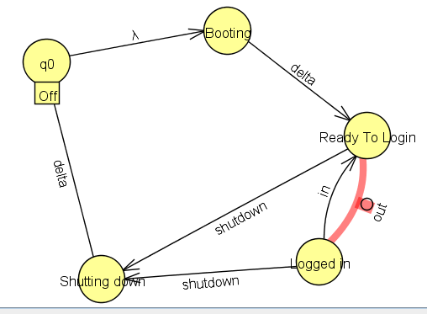Step2 add new starting NTS:- S 🡪 aA1|bB1|aA2|bS2

**Design PL using FSA directly? Asynchronous FSA?**

**FSA Definitions?**

1. S: finite set of states

2. A: Input alphabets

3. T: Transition function that determining what will be the next state given the current input symbol

4. S0 Start States(s0 subset of S)

5. F: Final States( F subset of S)