**Introduction**

This ia an application that allows for the management of digital assets i.e. files such as pictures, video, and text. You will be able to upload and download files to and from the database depending on the permissions assigned by the administrator.

**Basic User:**

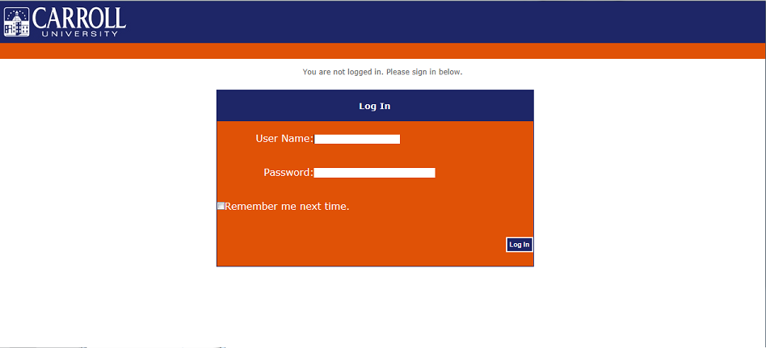(Figure 1)

An administrator will supply you with login information. Visiting the site will prompt you to enter the supplied username and password to log in. (Figure 1)

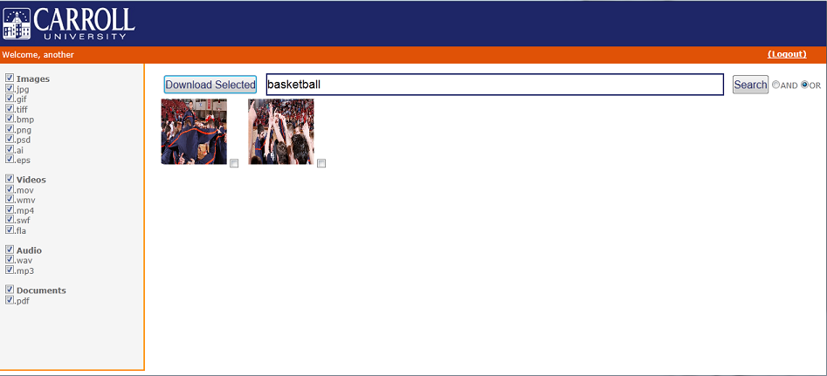(Figure 2)

The basic user only has the ability to search for files and download them. In Figure 2, you will see that along the left side of the page there is a list of file types. Here you can specify file types for your searches. This ensures that you can limit your search to the only file type you need. Next, there is the search bar; here you will enter a tag. A tag is a word associated with the files stored, for example, "Basketball" would be a tag for pictures that are associated with "Basketball". You are allowed to enter multiple tags in for searching. Because of this you can also choose if you want to search for either of the tags you entered using an "or" search or searching for files associated with all of the tags you entered using an "and" search. After typing in at least one tag, you can hit the search button that will bring up associated files if any. Here you will see a small preview of each file, clicking on the file enlarges it so you can get a better view of the file. To download files you must put a check in the boxes next to the files you want to download. After you have selected all of the files, you want, you can hit "Download Selected" and the application will prompt you to save the files.

**Administrator:**

Administrators will be added to the application on deployment. These accounts have much more functionality than the basic user accounts. The functionalities include being able to upload files, search (refer to instructions on searching in the basic user section), create user accounts, and view reports related to users on the application.

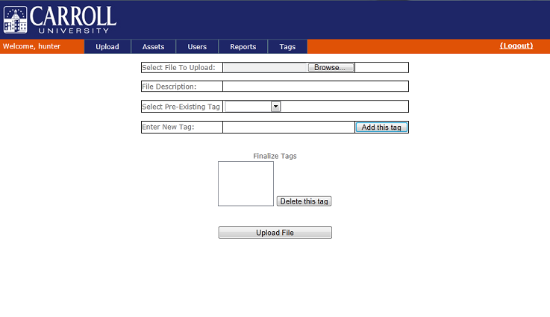(Figure 3)

**Upload**

Figure 3 shows the upload page for administrators. The first step here is to select a file to upload. From there you can enter a File Description, this could be a small sentence about the file, anything important you want noted about the file. You then have the option to select a pre existing tag to add to the file, after selecting a Pre-Existing tag, the tag will appear in the enter new tag box and you can hit the "Add this tag" button to add it to the list of tags that will applied to the file. You also can skip the Pre-Existing tags and just type in a Tag and add it to the list. Repeat these steps until you have added all the tags you wanted for the file. Then if you accidently added a tag you did not want, select it from the list and hit "Delete this tag". Finally hitting upload will add the file to the database with the specified tags.

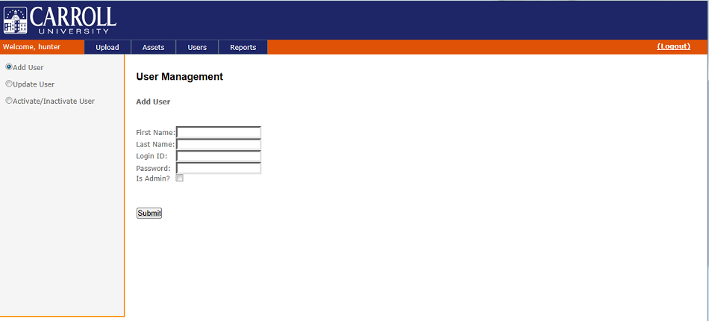(Figure 4)

**Users**

Administrators are able to create new accounts for users, and specifying if those accounts have administrator privileges. To add a new account the Administrator must enter the first and last name of the user, and then specify a login id and password for the user to be able to log in. The update user section just allows the administrator to fix information, change login ids and passwords if needed. The final thing that can be done is the ability to activate and deactivate accounts. (Figure 4)

**Reports**

The last functionality that is available to administrators is the ability to view User Activity and what files are downloaded. They have the option to export the data to excel if needed, along with this they can look at all of the users at the same time, or single out users using the drop down menu. This way they the administrators can see who is downloading files and uploading files. (Figure 7)(Figure 8) 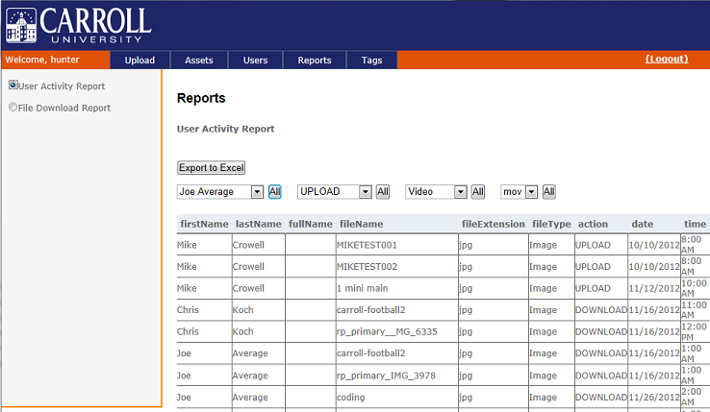(Figure 7)

**Tags**

The last functionality that the administrator has relates to the tags associated to each file. Here administrators have can add, modify and deactivate tags. Selecting the add option gives the administrator the ability to add tags, so that they will show up in the pre-existing tags list for those uploading files. The modify option allows the administrator to select a tag and change the spelling for that tag. Finally, there is the option to activate and deactivate tags that no longer will be used, or need to be used again.

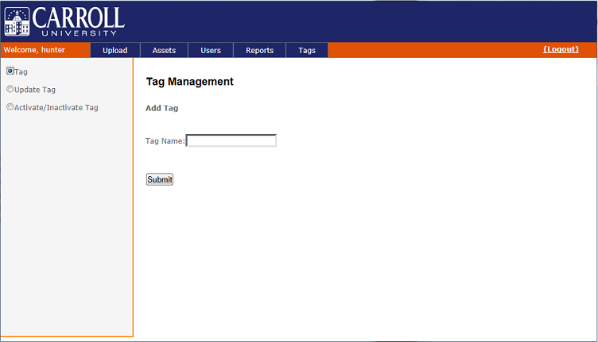(Figure 8)