Software Requirements Specification

for

Digital Asset Management Application

**Table of Contents**

**Table of Contents**

**Revision History**

**1. Introduction**

1.1 Purpose

1.2 Project Scope

**2. Overall Description**

2.1 Product Perspective

2.2 Product Features

2.3 User Classes and Characteristics

2.4 Operating Environment

2.5 Design and Implementation Constraints

2.6 User Documentation

**3. System Features**

3.1 Upload and store digital assets

3.2 Search for files

3.3 Download files

3.4 Download History

3.5 Preview Files

**4. External Interface Requirements**

4.1 User Interfaces

4.2 Software Interfaces

4.3 Communications Interfaces

**5. Other Nonfunctional Requirements**

5.1 Security Requirements

5.2 Software Quality Attributes

**Revision History**

|  |  |  |  |
| --- | --- | --- | --- |
| **Name** | **Date** | **Reason For Changes** | **Version** |
| **Hunter Giesfeldt** | **9/20/12** | **Initial Document** |  |
| **Hunter Giesfeldt** | **9/23/12** | **Updated features** |  |
| **Hunter Giesfeldt** | **11/11/12** | **Rewrite of previous information** |  |
| **Hunter Giesfeldt** | **12/14/2012** | **Final Clean up of information** |  |

# Introduction

## Purpose

This document will outline an application that will be used for the management of digital assets for Carroll University.

## Project Scope

This project will allow the Public Relations department to manage the University's digital assets. They will be in control of uploading assets to a database, managing users who will have access to these assets, and keep track of files being uploaded and downloaded through the web application .

# Overall Description

## Product Perspective

The University needs a better and more efficient way to handle all of their digital assets; this involves storage of the assets and retrieval of the assets.

## Product Features

This application allows for two types of users. The administrator who has the ability to upload files to the database, create new users, activate and deactivate accounts, review reports of user activity, and download files from the database. The basic user only has access to the search feature and can search the database by specifying a file type and entering a tag into the search bar. Each file uploaded to the database will have at least one tag that identifies the file for searching.

## User Classes and Characteristics

The target audience of this application will be faculty of the various departments at Carroll University. Because of this, the users will have a wide range of web and computer background. But in general the users will be using this application to retrieve different files from the schools database that may be used in many of the University's events and projects.

## Operating Environment

This application will be running over the School’s network on Windows 7, Mac, and potentially Linux Machines. It will be used in Internet Explorer, Firefox, Chrome, Safari, and potentially Opera web browsers.

## Design and Implementation Constraints

Cross browser, support may cause issues with the development of this application since it will be a web application. This could have an effect on the style and potentially some of the functionality of the application.

## User Documentation

A manual is included outlining the functionality of the application.

# System Features

**3.1.** Upload and store digital assets

**3.1.1** This application must allow for the ability to upload many different files into the database so that they can be accessed.

**3.1.2** Associated file types that can be uploaded

.mov

wmv

mp4

swf

fla

wav

mp3

jpg

gif

tiff

bmp

png

psd

ai

eps

pdf

**3.1.3** An administrator will be able to log into their administrator account and have an option to upload file(s) which will direct them to a window where they can select certain files in which they can add to the database and then give tags to the file so that they can be searched for.

**3.2** Search for files

**3.2.1** User and administrators can search for the files they want

**3.2.2** Files can be searched through tags, and file type

**3.2.3** A user/admin can type a generic term into the search window that is associated with the type of image they are looking for, and the application will bring up files with related tags.

**3.3** Download files

**3.3.1** Users and administrators can download the files they search for

**3.3.2** Select files one at a time, or in groups

**3.3.3** A user/admin can after finding a file they want to download select the file and choose to download the file onto their hard drive.

**3.4** Download History

**3.4.1** Users and administrators have access to download histories

**3.4.2** Users can only access their own history; administrators can access any users and their own histories

**3.4.3** A user who has downloaded a file but deleted it on accident can check their history and retrieve it without having to search the entire database again. Administrators can keep track of what users are downloading what files.

**3.5** Preview Files

**3.5.1** Whenever a file is highlighted a preview will appear in a TBD location.

**3.5.2** Previews for movies, images, sound

**3.5.3** When a user selects a video, the video will show up in the preview window and they will be able to play the video. An image is selected and the user will see a nice sized preview of the image. Or if an audio file is selected they will have the ability to play it from the preview window

# External Interface Requirements

## User Interfaces

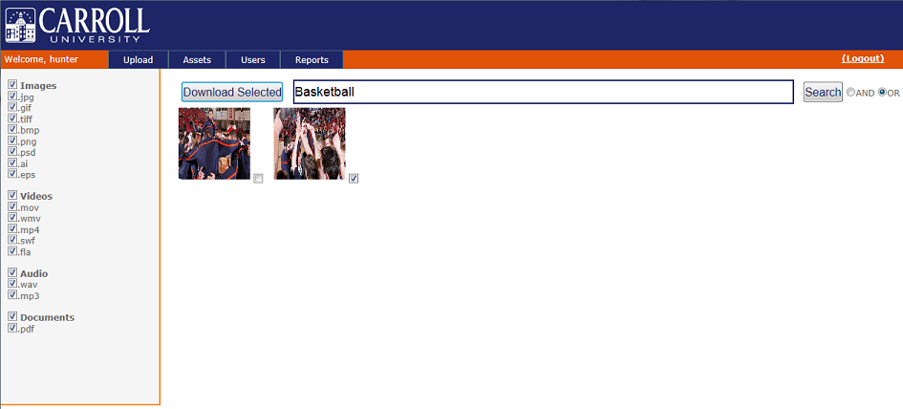

Above is the sample of the products GUI

## Software Interfaces

This is a .NET web application that connects to an MSSQL 2008 database, which serves as the storage place for all of the Universities’ assets, such as images, videos, audio, and many other files.

## Communications Interfaces

This application will use a web browser for the user interface. Users will communicate with the web server using HTTP. To connect the user to a database owned by Carroll that contains all the files they will be able to search for.

# Other Nonfunctional Requirements

## Security Requirements

Each account will be password protected. Along with that administrators will have the ability to make accounts for users, along with activate and deactivate those accounts as needed.

## Software Quality Attributes

This application will display a simple interface that will aid the most basic of users, while supplying the administrators with the control they need.